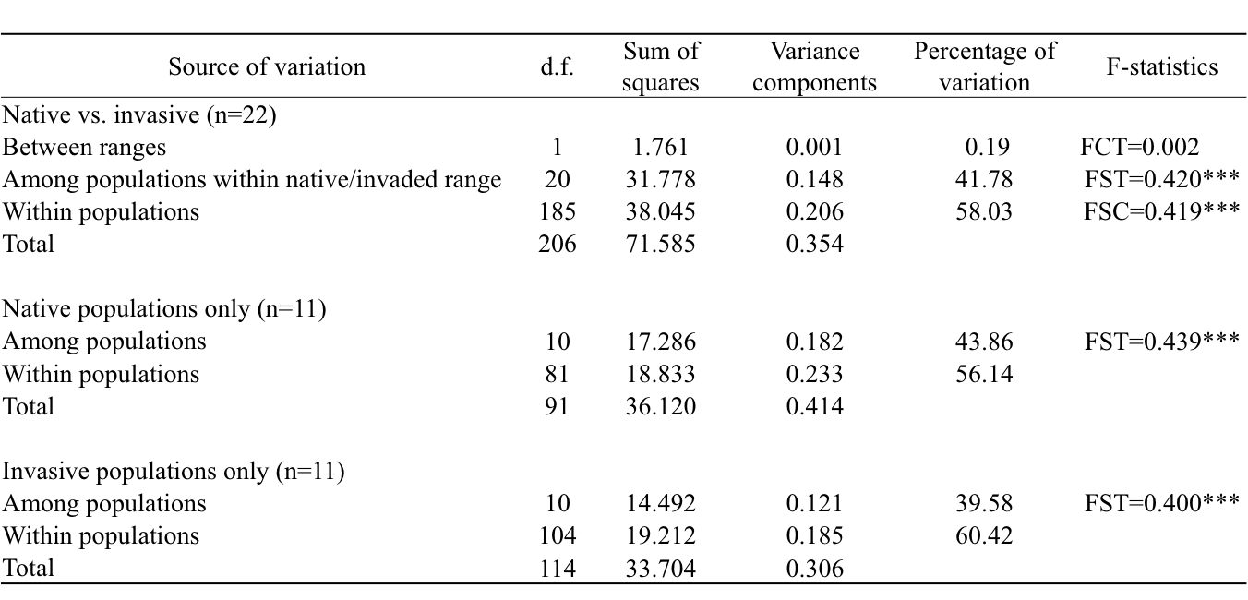
Table S5 Analysis of molecular variance for populations of S. alterniflora

