Supplementary Table 1 Completed sampling information across 51 sampling sites in the acidic soil region of southern China.
Code | Location | Soil parent material | Land use  pattern | Longitude (E) | Latitude (N) | Plant samples | Replicates
1 | QY | Red clay | Tea garden | 111°52′16″ | 26°45′35″ | Camellia sinensis Linn. | 8
2 | QY | Red clay | Orchard | 111°52′24″ | 26°45′36″ | Citrus reticulata Blanco. | 4
3 | QY | Red clay | Woodland | 111°52′27″ | 26°45′37″ | Lespedeza davidii Franch. | 4
4 | QY | Red clay | Grassland | 111°52′27″ | 26°45′37″ | Imperata cylindrica Linn. | 4
5 | QY | Red clay | Woodland | 111°52′29″ | 26°45′40″ | Dicranopteris linearis Burm. | 4
6 | QY | Red clay | Woodland | 111°52′26″ | 26°45′41″ | / | /
7 | QY | Red clay | Farmland | 111°52′10″ | 26°45′46″ | Zea mays Linn. | 4
8 | QY | Red clay | Farmland | 111°52′10″ | 26°45′46″ | Zea mays Linn. | 4
9 | QY | Red clay | Farmland | 111°52′10″ | 26°45′46″ | Zea mays Linn. | 4
10 | QY | Red clay | Farmland | 111°52′06″ | 26°45′41″ | Arachis hypogaea Linn. | 4
11 | QY | Red clay | Woodland | 111°52′01″ | 26°45′42″ | Dalbergia hupeana Hance. | 4
12 | QY | Red clay | Woodland | 111°52′05″ | 26°45′42″ | Liquidambar formosana Hance. | 4
13 | QY | Red clay | Orchard | 111°52′05″ | 26°45′41″ | Citrus reticulata Blanco. | 4
14 | QY | Red clay | Grassland | 111°52′07″ | 26°45′43″ | Imperata cylindrica Linn. | 4
15 | QY | Red clay | Farmland | 111°53′04″ | 26°45′23″ | Zea mays Linn. | 4
16 | QY | Red clay | Woodland | 111°53′05″ | 26°45′21″ | Dicranopteris linearis Burm. | 4
17 | QY | Red clay | Tea garden | 111°52′43″ | 26°45′33″ | Camellia oleifera Abel. | 8
18 | JH | Red clay | Woodland | 119°37′08″ | 29°01′03″ | Osmanthus fragrans Thunb. | 8
19 | JH | Red sandstone | Tea garden | 119°35′35″ | 29°00′35″ | Camellia sinensis Linn. | 4
20 | JH | Red clay | Woodland | 119°35′41″ | 29°00′28″ | Phyllostachys heterocycla Carr. | 4
21 | JH | Red clay | Woodland | 119°35′37″ | 28°59′56″ | Osmanthus fragrans Thunb. | 3
22 | JH | Red clay | Orchard | 119°35′34″ | 29°00′12″ | Eriobotrya japonica Thunb. | 4
23 | JH | Red clay | Orchard | 119°35′36″ | 29°00′07″ | Prunus salicina Lindl. | 4
24 | JH | Red clay | Orchard | 119°35′34″ | 29°00′12″ | Amygdalus persica Linn. | 4
25 | JH | Red clay | Orchard | 119°28′55″ | 29°01′51″ | Citrus maxima Burm. | 4
26 | JH | Red clay | Woodland | 119°28′57″ | 29°01′48″ | Dicranopteris pedata Houtt. | 4
27 | JH | Red clay | Woodland | 119°29′46″ | 29°01′42″ | Carya cathayensis Sarg. | 4
28 | JH | Red clay | Woodland | 119°29′46″ | 29°01′42″ | / | /
29 | YT | Red sandstone | Farmland | 116°55′02″ | 28°14′18″ | Arachis hypogaea Linn. | 4
30 | YT | Red sandstone | Woodland | 116°55′02″ | 28°14′42″ | Castanea mollissima Bl. | 4
31 | YT | Red sandstone | Orchard | 116°54′45″ | 28°15′18″ | Citrus reticulata Blanco. | 4
32 | YT | Red sandstone | Woodland | 116°54′45″ | 28°15′18″ | Dicranopteris pedata Houtt. | 4
33 | YT | Red sandstone | Grassland | 116°54′01″ | 28°15′43″ | Pinus massoniana Lamb. | 4
34 | YT | Red sandstone | Woodland | 116°54′01″ | 28°15′43″ | Castanea mollissima Bl. | 4
35 | YT | Red sandstone | Farmland | 116°54′01″ | 28°15′43″ | Manihot esculenta Crantz | 4
36 | YT | Red sandstone | Woodland | 116°54′40″ | 28°15′07″ | Dicranopteris pedata Houtt. | 4
37 | YT | Red sandstone | Farmland | 116°54′40″ | 28°15′07″ | Oryza sativa Linn. | 4
38 | YT | Red clay | Woodland | 116°56′08″ | 28°12′24″ | / | /
39 | YT | Red clay | Grassland | 116°56′16″ | 28°12′37″ | Pinus massoniana Lamb. | 8
40 | YT | Red clay | Woodland | 116°56′08″ | 28°12′31″ | Pinus elliotti Engelm. | 4
41 | YT | Red clay | Woodland | 116°55′55″ | 28°12′32″ | Lespedeza bicolor Turcz. | 4
42 | YT | Red clay | Farmland | 116°55′49″ | 28°12′24″ | Oxalis corniculata Linn. | 4
43 | YT | Red clay | Orchard | 116°55′58″ | 28°12′51″ | Citrus reticulata Blanco. | 4
44 | ZQ | Plate shale | Tea garden | 112°32′17″ | 23°10′46″ | Camellia sinensis Linn. | 8
45 | ZQ | Plate shale | Tea garden | 112°32′20″ | 23°10′46″ | Dicranopteris linearis Burm. | 4
46 | ZQ | Plate shale | Woodland | 112°32′06″ | 23°10′57″ | Phyllostachys heterocycla Carr. | 4
47 | ZQ | Plate shale | Woodland | 112°32′06″ | 23°10′57″ | Dicranopteris linearis Burm. | 4
48 | ZQ | Plate shale | Woodland | 112°32′27″ | 23°10′14″ | Clausena lansium Lour. | 4
49 | ZQ | Plate shale | Woodland | 112°32′30″ | 23°10′12″ | / | /
50 | ZQ | Plate shale | Farmland | 112°33′19″ | 23°09′50″ | Amaranthus tricolor Linn. | 4
51 | ZQ | Plate shale | Grassland | 112°33′23″ | 23°09′55″ | Dicranopteris linearis Burm. | 4
Total |  |  |  |  |  |  | 207
In abbreviations, QY: Qiyang, Hunan Province; JH: Jinhua, Zhejiang Province; YT: Yingtan, Jiangxi Province; ZQ: Zhaoqing, Guangdong Province.
/ indicates no plant sample. Plant samples of four sampling sites were not collected, because plant diversity was so high that the representative species were not identified.
Replicate numbers per plant at a sampling site are shown in the last column.
Supplementary Table 2 Primers, program, and reaction composition used for qPCR in the present study.
Target gene | Primer | Sequence (5'-3') | Size (bp) | Reference | Program | Reaction composition
16S rRNA | Eub338 | ACTCCTACGGGAGGCAGCAG | 196 | Fierer et al. (2005) | 95°C 30 S, 50°C 30 S,  72°C 30 S, 40 cycles | 1.0 μl DNA, 0.4 μl forward primers, 0.4 μl reverse primers, 5.0 μl SYBR Premix ExTaq, 3.2 μl sterile distill water
 | Eub518 | ATTACCGCGGCTGCTGG
ITS | ITS1f | TCCGTAGGTGAACCTGCGG | 290 | Fierer et al. (2005) | 95°C 30 S, 55°C 30 S,  72°C 30 S, 40 cycles
 | 5.8s | CGCTGCGTTCTTCATCG
phoC | phoc-A-F1 | CGGCTCCTATCCGTCCGG | 155 | Fraser et al. (2017) | 95°C 10 S, 58°C 30 S,  72°C 30 S, 40 cycles
 | phoc-A-R1 | CAACATCGCTTTGCCAGTG

Supplementary Table 3 Summary of usable sequences after quality filtering and operational taxonomic units (OTUs) across 51 soil samples.
Code | Location | Sequence number | OTU number
1 | QY | 85007 | 79
2 | QY | 58909 | 77
3 | QY | 48790 | 56
4 | QY | 46601 | 96
5 | QY | 15463 | 34
6 | QY | 38314 | 49
7 | QY | 65936 | 87
8 | QY | 54427 | 54
9 | QY | 60927 | 89
10 | QY | 49741 | 76
11 | QY | 87437 | 75
12 | QY | 61898 | 55
13 | QY | 66348 | 123
14 | QY | 54721 | 134
15 | QY | 51404 | 81
16 | QY | 39458 | 86
17 | QY | 31283 | 123
18 | JH | 38341 | 81
19 | JH | 45791 | 72
20 | JH | 52109 | 122
21 | JH | 66258 | 126
22 | JH | 57273 | 157
23 | JH | 65280 | 142
24 | JH | 114746 | 130
25 | JH | 119786 | 83
26 | JH | 72910 | 52
27 | JH | 77756 | 69
28 | JH | 96625 | 226
29 | YT | 65044 | 188
30 | YT | 80199 | 224
31 | YT | 106460 | 236
32 | YT | 73008 | 184
33 | YT | 125132 | 246
34 | YT | 98183 | 219
35 | YT | 89830 | 190
36 | YT | 198317 | 250
37 | YT | 174773 | 277
38 | YT | 195755 | 266
39 | YT | 221629 | 245
40 | YT | 171188 | 208
41 | YT | 184666 | 258
42 | YT | 175462 | 226
43 | YT | 194502 | 219
44 | ZQ | 129953 | 213
45 | ZQ | 127813 | 243
46 | ZQ | 197775 | 281
47 | ZQ | 127330 | 243
48 | ZQ | 149958 | 221
49 | ZQ | 131909 | 240
50 | ZQ | 115222 | 208
51 | ZQ | 146925 | 233
Average |  | 98129±52984 | 156±76
In abbreviations, QY: Qiyang, Hunan Province; JH: Jinhua, Zhejiang Province; YT: Yingtan, Jiangxi Province; ZQ: Zhaoqing, Guangdong Province.

Supplementary Table 4 The Monte Carlo test of constrained canonical analysis (CCA) based on phoC-harboring bacterial community structure and soil variables.
Variables | r² | p
pH | 0.162 | 0.016*
TC | 0.022 | 0.476
TN | 0.019 | 0.556
C/N | 0.136 | 0.021*
NO₃⁻-N | 0.681 | 0.001**
NH₄⁺-N | 0.686 | 0.015*
TP | 0.014 | 0.667
AP | 0.048 | 0.271
TK | 0.016 | 0.610
AK | 0.075 | 0.144
** indicates significantly correlations at p < 0.01; * indicates significantly correlations at p < 0.05

Supplementary Figure 1. Plant TN (A), TP (B), TK (C), TN/TP ratio (D), TN/TK ratio (E), and TP/TK ratio (F) of all collected plant samples.
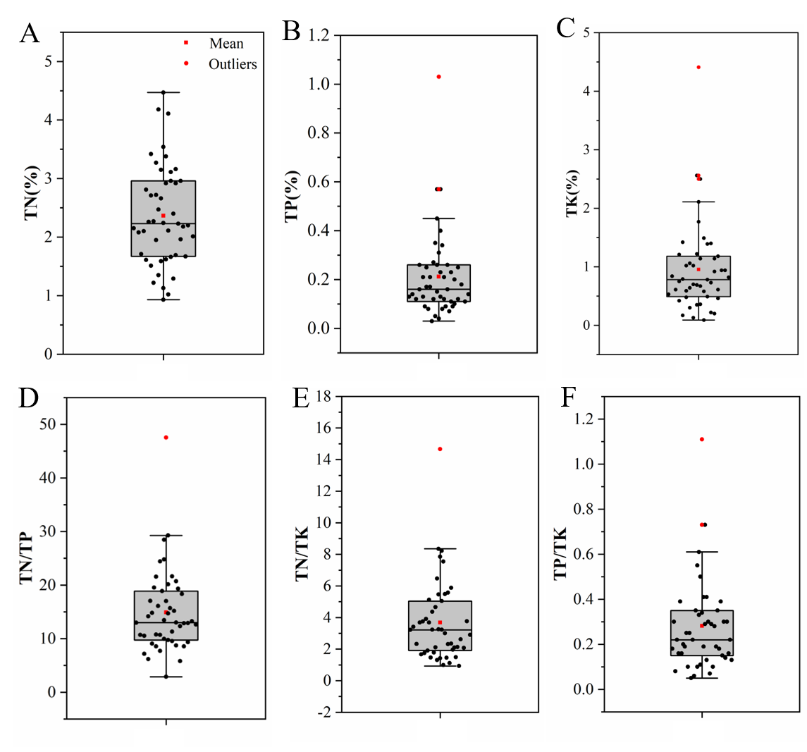

Supplementary Figure 2. Soil pH (A), TC (B), TN (C), C/N ratio (D), NO₃⁻-N (E), NH₄⁺-N (F), TP (G), AP (H), TK (I), and AK (J) across 51 soil samples.
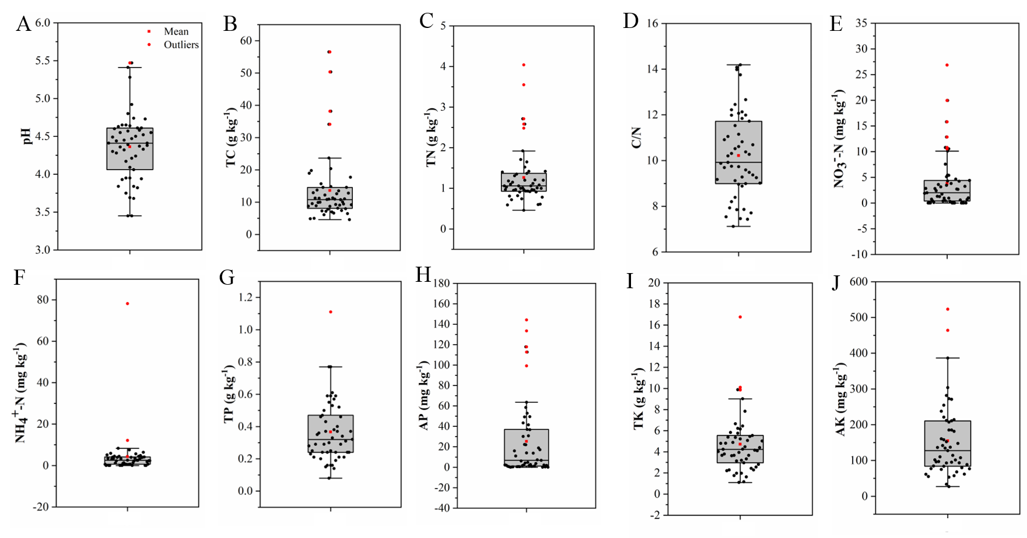

Supplementary Figure 3. Gene copy number of 16S rRNA (A), ITS (B), and phoC (C) across 51 soil samples.

Supplementary Figure 4. Spearman’s correlations between OTU number, Shannon index, Simpson index, Chao1 and soil variables across 51 soil samples. ACP indicates ACP activity. * indicates significantly correlations at p < 0.05. Blue dots indicate positive correlations, and red dots indicate negative correlations.

Supplementary Figure 5. Spearman’s correlations between the relative abundances of the dominant phoC-harboring bacterial genera and soil variables across 51 soil samples. ACP indicates ACP activity. ** indicates significant correlations at p < 0.01; * indicates significantly correlations at p < 0.05. Blue dots indicate positive correlations, and red dots indicate negative correlations.

References
Fierer, N., Jackson, J.A., Vilgalys, R., and Jackson, R.B. (2005). Assessment of soil microbial community structure by use of Taxon-Specific quantitative PCR assays. Appl. Environ. Microbiol. 71, 4117-4120. doi: 10.1128/AEM.71.7.4117-4120.2005
Fraser, T.D., Lynch, D.H., Gaiero, J., Khosla, K., and Dunfield, K.E. (2017). Quantification of bacterial non-specific acid (phoC) and alkaline (phoD) phosphatase genes in bulk and rhizosphere soil from organically managed soybean fields. Appl. Soil Ecol. 111, 48-56. doi: 10.1016/j.apsoil.2016.11.013

