Supplementary Material

Boldness in male and female zebrafish (Danio rerio) is dependent on strain and test
Arshi Mustafa^{1,2}, Erika Roman^{3,4,#}, Svante Winberg^{1,#,*}
¹ Department of Neuroscience, Behavioral Neuroendocrinology Group, Uppsala University, P.O. Box 593, SE-751 24 Uppsala, Sweden
² Department of Organismal Biology, Uppsala University, Norbyvägen 18A, SE-752 36, Sweden
³ Department of Pharmaceutical Biosciences, Division of Pharmacology, Neuropharmacology, Addiction and Behavior Unit, Uppsala University, P.O. Box 591, SE-751 24 Uppsala, Sweden
⁴ Department of Anatomy, Physiology and Biochemistry, Division of Anatomy and Physiology, Swedish University of Agricultural Sciences, P.O. Box 7011, SE-750 07 Uppsala, Sweden
# Shared senior authorship
* Correspondence:
Corresponding Author
svante.winberg@neuro.uu.se

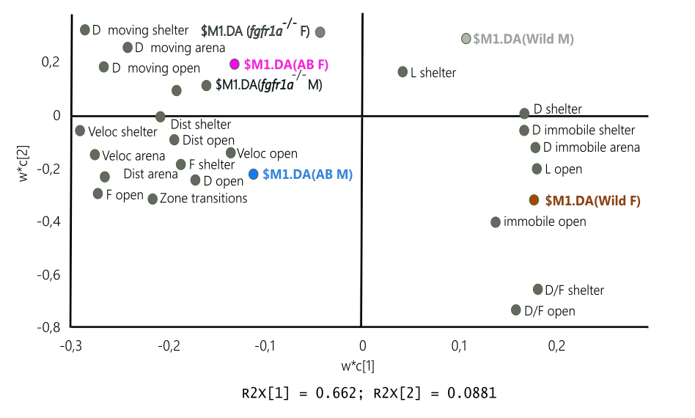
Supplementary Figure 1. Scatter plot of variable loadings from the PLS-DA from the shelter test in male (M) and female (F) adult offspring of wild-caught (wild), AB and fgfr1a ^{-/} zebrafish. The model generated one significant component (R²X=0.662, R²Y=0.145, Q²=0.131) and a second, non-significant component (R²X=0.08, R²Y=0.0468, Q²= -0.022) was added to obtain a two-dimensional model for visualization.
Abbreviations: D, duration (s); D/F, duration per visit (s); Dist, total distance (cm); F, frequency; L, latency (s); Veloc, mean velocity (cm/s).

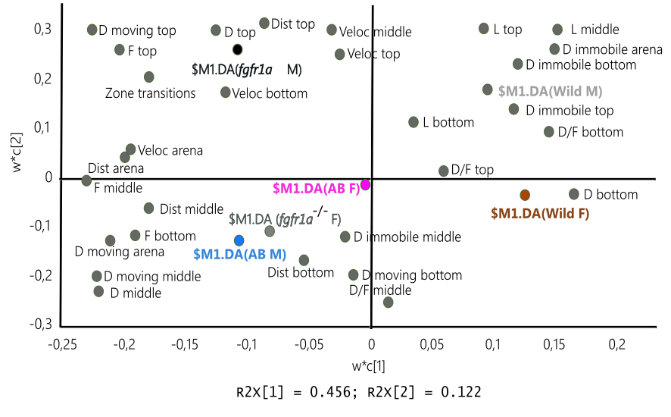
Supplementary Figure 2. Scatter plot of variable loadings from the PLS-DA (three significant components, R²X(cum)=0.713, R²Y=0.213 (cum), Q² (cum)=0.0861) of the novel tank diving test in male (M) and female (F) adult offspring of wild-caught (wild), AB and fgfr1a ^{-/-} zebrafish.
Abbreviations: D, duration (s); D/F, duration per visit (s); Dist, total distance moved (cm); F, frequency; L, latency (s); Veloc, mean velocity (cm/s).

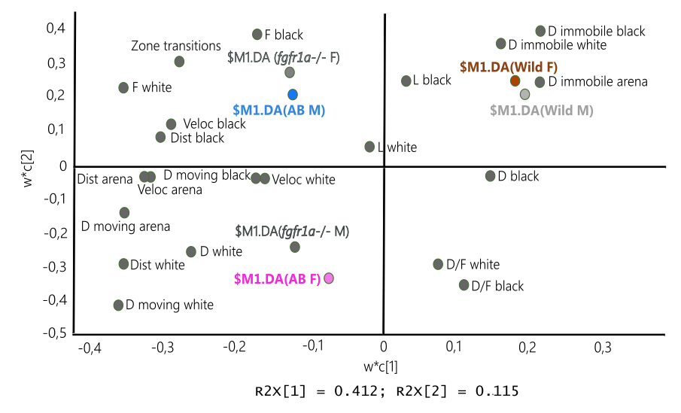
Supplementary Figure 3. Scatter plot of variable loadings from the PLS-DA (no significant component; first component (R²X=0.412, R²Y=0.072, Q²=0.035), second component (R²X=0.115, R²Y = 0.06, Q²=-0.003) of the scototaxis test in male (M) and female (F) adult offspring of wild-caught (wild), AB and fgfr1a ^{-/-} zebrafish.
Abbreviations: D, duration (s); D/F, duration per visit (s); Dist, total distance (cm); F, frequency; L, latency (s); Veloc, mean velocity (cm/s).

Supplementary Table 1. Behavioral data from the shelter test in male (M) and female (F) adult offspring of wild-caught (wild), AB and fgfr1a ^{-/-} zebrafish.
Zone | Sex | Wild | AB | fgfr1a ^{-/-}
Open area
Occurrence | M | 9/9 | 9/9 | 9/9
 | F | 6/9 | 9/9 | 9/9
Latency (s) | M | 104.0 (279.5) | 60.0 (4.0) ww | 60.0 (4.0) ww
 | F | 172.5 (577.3) | 67.0 (19.5) | 61.0 (18.5)
Frequency | M | 30.0 (36.0) | 78.0 (31.0) *, www | 67.0 (14.5) ww, a
 | F | 13.0 (22.8) | 68.0 (25.5) ww | 56.0 (27.5) ww
Duration (s) | M | 246.2 (434.9) | 472.6 (206.9) | 391.2 (121.9)
 | F | 261.9 (460.2) | 413.6 (197.2) | 434.8 (179.6)
Duration per visit (s) | M | 5.7 (7.3) | 5.1 (3.1) | 5.3 (2.1)
 | F | 9.9 (24.5) | 6.1 (2.9) | 6.1 (4.2)
Distance (cm) | M | 398.0 (1050.1) | 1675.1 (1186.5) www | 1473.4 (468.8) w
 | F | 227.4 (547.9) | 1307.8 (555.2) ww | 1432.1 (931.0) ww
Velocity (cm/s) | M | 2.5 (1.7) | 4.7 (1.8) *, ww | 3.4 (0.8)
 | F | 2.5 (2.0) | 3.3 (1.6) w | 3.0 (0.8)
Duration moving (s) | M | 91.8 (251.3) | 346.8 (162.9) ww | 350.4 (107.6) ww
 | F | 52.4 (116.2) | 346.8 (158.9) ww | 382.6 (207.6) ww
Duration immobile (s) | M | 75.0 (200.3) | 46.0 (96.2) | 50.8 (20.4)
 | F | 89.5 (404.3) | 46.4 (75.6) | 59.4 (87.0)
Sheltered area
Latency (s) | M | 60.0 (0.0) | 60.0 (2.4) | 61.6 (5.3)
 | F | 60.0 (0.0) | 60.0 (3.0) | 60.0 (2.9)
Frequency | M | 31.0 (35.0) | 79.0 (29.5) *, www | 67.0 (14.0) ww, a
 | F | 7.0 (16.5) | 69.0 (26.0) www | 55.0 (27.5) www
Duration (s) | M | 593.8 (434.9) | 367.4 (206.9) | 448.8 (121.9)
 | F | 776.2 (445.2) | 426.4 (197.2) | 405.2 (179.6)
Duration per visit (s) | M | 21.8 (177.5) | 4.7 (3.9) | 6.2 (3.7)
 | F | 110.9 (822.6) | 6.2 (4.4) | 5.8 (5.6)
Distance (cm) | M | 752.5 (507.3) * | 1530.8 (1376.8) ww | 1660.3 (480.0) **, ww
 | F | 255.4 (371.1) | 1694.9 (928.3) www | 1246.8 (618.2) www
Velocity (cm/s) | M | 1.3 (2.1) | 4.7 (1.6) ww | 3.7 (1.0) *, ww
 | F | 0.3 (1.4) | 3.4 (1.5) www | 2.9 (1.6) www
Duration moving (s) | M | 172.2 (132.5) | 310.6 (228.1) ww | 393.8 (70.0) **, www
 | F | 51.4 (103.8) | 389.2 (155.1) www | 307.6 (128.1) www
Duration immobile (s) | M | 421.6 (626.6) | 48.2 (41.1) ww | 40.6 (51.5) ww
 | F | 724.8 (625.9) | 44.4 (54.4) www | 82.6 (168.7) ww
Activity
Total activity | M | 61.0 (71.0) | 157.0 (60.5) *, www | 133.0 (28.5) ww, a
 | F | 13.0 (34.0) | 137.0 (51.5) www | 111.0 (55.0) www
Distance arena (cm) | M | 1154.8 (1487.0) | 3922.3 (1517.1) www | 3007.2 (735.5) *, ww
 | F | 432.9 (734.9) | 2660.4 (1323.7) www | 2259.0 (1007.4) www
Velocity arena (cm/s) | M | 1.4 (1.8) | 4.7 (1.8) www | 3.6 (0.9) *, ww
 | F | 0.5 (0.9) | 3.2 (1.6) www | 2.7 (1.2) www
Duration moving arena (s) | M | 267.8 (371.2) | 739.0 (107.2) www | 733.6 (34.7) www
 | F | 95.4 (177.7) | 728.4 (96.8) www | 633.8 (222.0) www
Duration immobile arena (s) | M | 572.2 (371.2) | 101.0 (107.1) www | 106.4 (34.7) www
 | F | 744.6 (177.7) | 111.6 (96.8) www | 206.2 (221.9) www
Zone transitions open to shelter | M | 11.0 (12.5) | 43.0 (27.0) www | 40.0 (10.5) ww
 | F | 2.0 (4.5) | 30.0 (13.5) www | 19.0 (26.5) ww
Zone transitions shelter to open | M | 11.0 (13.5) * | 43.0 (29.0) www | 41.0 (10.5) ww
 | F | 1.0 (5.5) | 29.0 (13.0) www | 19.0 (26.5) ww
Data are presented as median (quartile range). If a fish did not visit a zone this was considered a missing value in the statistical analysis and occurrence (fish entering a zone/number of tested fish) is shown for the zones that were not visited by all fish. ^{w}p<0.05, ^{ww}p<0.01, ^{www}p<0.001 compared to wild zebrafish within the respective sex; ªp<0.05 compared to AB fish within the respective sex; *p<0.05, **p<0.01 compared to females within the respective line (Mann-Whitney U-test).

Supplementary Table 2. Summary of statistical analyses of behavioral data from the shelter test in male (M) and female (F) adult offspring of wild-caught (wild), AB and fgfr1a ^{-/-} zebrafish.
Open area |  | Wild vs AB | Wild vs fgfr1a ^{-/-} | AB vs fgfr1a ^{-/-} | KW
Latency (s) | M | U=6.5; p<0.01 | U=11.5; p<0.01 | n.s. | H=11.3, N=27; p<0.01
 | F | n.s. | n.s. | n.s. | n.s.
Occurrence | M | 9/9 | 9/9 | 9/9
 | F | 6/9 | 9/9 | 9/9
Frequency | M | U=2.0; p≤0.001 | U=7.0; p<0.01 | U=16.0; p<0.05 | H=16.3, N=27; p<0.001
 | F | U=1.5; p<0.01 | U=2.5; p<0.01 | n.s. | H=11.5, N=24; p<0.010
Duration (s) | M | n.s. | n.s. | n.s. | n.s.
 | F | n.s. | n.s. | n.s. | n.s.
Duration per visit (s) | M | n.s. | n.s. | n.s. | n.s.
 | F | n.s. | n.s. | n.s. | n.s.
Distance (cm) | M | U=4.0; p≤0.001 | U=12.00; p<0.05 | n.s. | H=12.5, N=27; p<0.01
 | F | U=2.0; p<0.01 | U=4.0, p<0.01 | n.s. | H=10.3, N=24; p<0.01
Velocity (cm/s) | M | U=9.0; p<0.01 | n.s. | n.s. | H=9.0, N= 27; p<0.05
 | F | U=10.0; p<0.05 | n.s. | n.s. | n.s.
Duration moving (s) | M | U=5.0; p<0.01 | U=6.0; p<0.01 | n.s. | H=13.1, N=27; p<0.01
 | F | U=3.0; p<0.01 | U=4.0; p<0.01 | n.s. | H=9.8, N=24; p<0.01
Duration immobile (s) | M | n.s. | n.s. | n.s. | n.s.
 | F | n.s. | n.s. | n.s. | n.s.
Sheltered area
Latency (s) | M | n.s. | n.s. | n.s. | n.s.
 | F | n.s. | n.s. | n.s. | n.s.
Frequency | M | U=2.0; p≤0.001 | U=7.0; p<0.01 | U=15.5; p<0.05 | H=16.4, N=27; p<0.001
 | F | U=2.0; p≤0.001 | U=2.5; p≤0.001 | n.s. | H=15.8, N=27; p<0.001
Duration (s) | M | n.s. | n.s. | n.s. | n.s.
 | F | n.s. | n.s. | n.s. | n.s.
Duration per visit (s) | M | U=5.0; p<0.01 | U=10.5; p<0.01 | n.s. | H=12.8, N=27; p<0.01
 | F | U=2.0; p≤0.001 | U=5.0; p<0.01 | n.s. | H=14.6, N= 27; p<0.001
Distance (cm) | M | U=8.0; p<0.01 | U=8.0; p<0.01 | n.s. | H=11.2, N=27; p<0.01
 | F | U=1.0; p <0.001 | U=2.0; p≤0.001 | n.s. | H=17.7, N=27; p<0.001
Velocity (cm/s) | M | U=5.0; p<0.01 | U=10.0; p<0.01 | n.s. | H=13.4, N=27; p<0.01
 | F | U=0.0; p<0.001 | U=4.0; p≤0.001 | n.s. | H=17.5, N=27; p<0.001
Duration moving (s) | M | U=7.0; p<0.01 | U=3.0; p<0.001 | n.s. | H=13.9, N=27; p<0.001
 | F | U=2.0; p≤0.001 | U=4.0; p≤0.001 | n.s. | H=16.2, N= 27; p<0.001
Duration immobile (s) | M | U=5.0; p<0.01 | U=5.0; p<0.01 | n.s. | H=13.4, N=27; p<0.01
 | F | U=3.0; p≤0.001 | U=9.0; p<0.01 | n.s. | H=13.4, N=27; p<0.01
Activity
Total activity | M | U=2.0; p≤0.001 | U=7.0; p<0.01 | U=16.0; p<0.05 | H=16.3, N=27; p<0.001
 | F | U=3.0; p≤0.001 | U=2.5; p≤0.001 | n.s. | H=15.8, N=27; p<0.001
Distance arena (cm) | M | U=3.0; p≤0.001 | U=9.0; p<0.01 | n.s. | H=14.4, N=27; p<0.001
 | F | U=1.0; p<0.001 | U=2.0; p≤0.001 | n.s. | H=17.1, N=27; p<0.001
Velocity arena (cm/s) | M | U=3.0; p≤0.001 | U=9.0; p<0.01 | n.s. | H=14.4, N=27; p<0.001
 | F | U=1.0; p<0.001 | U=2.0; p≤0.001 | n.s. | H=17.1, N=27; p<0.001
Duration moving arena (s) | M | U=3.0; p≤0.001 | U=1.0; p<0.001 | n.s. | H=15.7, N=27; p<0.001
 | F | U=0.0; p<0.001 | U=4.0; p≤0.001 | n.s. | H=16.7, N=27; p<0.001
Duration immobile arena (s) | M | U=3.0; p≤0.001 | U=1.0; p<0.001 | n.s. | H=15.7, N=27; p<0.001
 | F | U=0.0; p<0.001 | U=4.0; p≤0.001 | n.s. | H=16.7, N= 27; p<0.001
Zone transitions open to shelter | M | U=4.0; p≤0.001 | U=7.0; p<0.01 | n.s. | H=13.3, N=27; p<0.01
 | F | U=2.0; p≤0.001 | U=5.0; p<0.01 | n.s. | H=15.2, N=27; p<0.001
Zone transitions shelter to open | M | U=4.5; p≤0.001 | U=7.5; p<0.01 | n.s. | H=12.9, N=27; p<0.01
 | F | U=2.0; p≤0.001 | U=5.0; p<0.01 | n.s. | H=15.1, N=27; p<0.001

Data from the three different strains were compared within sex using a Kruskal-Wallis analysis of variance (KW) whereas the Mann-Whitney U-test was applied for pairwise comparisons between strains within sex. Values presented are Mann-Whitney U-values (U) and p-values, and Kruskal-Wallis (KW) H-value (H), total number of fish (N) and p-values. Non-significant results are indicated by n.s. If a fish did not visit a zone this was considered a missing value in the statistical analysis and occurrence (fish entering a zone/number of tested fish) is shown for the zones that were not visited by all fish.

Supplementary Table 3. Behavioral data from the novel tank diving test in male (M) and female (F) adult offspring of wild-caught (wild), AB and fgfr1a ^{-/-} zebrafish.
Zone | Sex | Wild | AB | fgfr1a ^{-/-}
Bottom zone
Frequency | M | 8.0 (28.5) | 26.0 (20.0) *, w | 32.0 (18.5) w
 | F | 1.0 (14.5) | 16.0 (9.5) | 34.0 (27.5) w
Duration (s) | M | 319.0 (156.0) | 107.0 (96.5) ww | 113.0 (46.5) **, ww
 | F | 360.0 (133.0) | 137.0 (248.0) | 215.0 (87.0)
Duration per visit (s) | M | 17.7 (353.7) | 4.8 (3.5) *, w | 3.6 (2.6) *, ww
 | F | 360.0 (342.5) | 8.3 (26.4) w | 5.8 (14.8) w
Distance (cm) | M | 393.0 (1432.5) | 676.0 (519.0) | 673.0 (541.0) *
 | F | 707.0 (990.5) | 685.0 (673.5) | 1535.0 (909.5) w, a
Velocity (cm/s) | M | 4.0 (7.0) | 6.0 (3.5) | 7.0 (2.5)
 | F | 3.0 (3.5) | 5.0 (2.5) w | 6.0 (2.0) ww
Duration moving (s) | M | 76.0 (200.5) | 107.0 (89.5) | 108.0 (41.5) **
 | F | 125.0 (195.5) | 130.0 (111.0) | 204.0 (96.0)
Duration immobile (s) | M | 111.0 (350.0) | 4.0 (8.0) ww | 6.0 (6.0) **, w
 | F | 190.0 (233.0) | 9.0 (108.5) w | 16.0 (9.5) www
Middle zone
Occurrence | M | 6/9 | 9/9 | 9/9
 | F | 4/9 | 8/9 | 8/9
Latency | M | 106.8 (169.4) | 19.6 (17.8) ww | 27.0 (33.3) w
 | F | 140.9 (204.0) | 24.6 (44.3) | 28.8 (31.1)
Frequency | M | 32.0 (41.5) | 55.0 (43.5) w | 81.0 (43.5) ww, a
 | F | 26.5 (61.5) | 41.1 (50.5) | 59.5 (33.8)
Duration (s) | M | 47.5 (81.8) | 136.0 (76.5) ww | 101.0 (33.5) w, a
 | F | 47.0 (83.3) | 108.5 (98.5) | 96.0 (29.0)
Duration per visit (s) | M | 1.4 (0.8) | 2.2 (1.2) w | 1.2 (0.4) *, aa
 | F | 1.6 (0.9) | 1.5 (2.1) | 1.5 (0.5)
Distance (cm) | M | 377.0 (687.0) | 653.0 (869.0) | 868.0 (479.0)
 | F | 240.5 (506.8) | 545.5 (899.5) | 749.5 (477.0)
Velocity (cm/s) | M | 9.5 (9.0) | 6.0 (4.5) | 8.0 (2.5)
 | F | 5.5 (3.3) | 9.5 (6.3) | 8.5 (3.8)
Duration moving (s) | M | 47.0 (74.5) | 131.0 (89.5) w | 99.0 (33.0) w
 | F | 42.5 (73.3) | 101.0 (96.0) | 92.5 (29.5)
Duration immobile (s) | M | 0.5 (3.3) | 2.0 (15.0) | 2.0 (1.5)
 | F | 4.5 (9.3) | 0.5 (6.8) | 1.0 (1.8)
Top
Occurrence | M | 6/9 | 9/9 | 9/9
 | F | 4/9 | 8/9 | 8/9
Latency | M | 85.7 (186.9) | 24.8 (15.3) | 65.2 (77.3)
 | F | 154.0 (142.6) | 35.6 (147.8) | 41.1 (51.1)
Frequency | M | 15.5 (17.3) | 27.0 (26.5) | 60.0 (27.0) **, ww, aa
 | F | 17.0 (38.3) | 25.0 (41.5) | 21.0 (14.0)
Duration (s) | M | 34.0 (136.5) | 105.0 (46.5) | 139.0 (66.0) **, w, a
 | F | 86.0 (69.8) | 112.5 (121.5) | 33.0 (40.0)
Duration per visit (s) | M | 1.4 (6.7) | 2.8 (1.9) | 3.0 (1.6)
 | F | 2.8 (5.8) | 2.8 (3.9) | 1.9 (1.8)
Distance (cm) | M | 271.5 (1529.5) | 545.0 (451.0) | 1102.0 (440.0) **, w, aa
 | F | 273.0 (482.3) | 543.0 (993.0) | 266.0 (202.3)
Velocity (cm/s) | M | 11.5 (5.5) * | 6.0 (4.5) | 8.0 (4.0)
 | F | 4.0 (3.5) | 9.0 (9.5) | 8.5 (3.8)
Duration moving (s) | M | 34.0 (73.8) | 80.0 (38.0) | 137.0 (37.0) **, ww, aa
 | F | 39.0 (68.5) | 110.5 (107.3) | 32.5 (39.3)
Duration immobile (s) | M | 0.5 (63.5) | 2.0 (20.0) | 4.0 (3.0) ***
 | F | 21.5 (53.5) | 2.5 (6.0) | 0.5 (1.0)
Activity
Total activity | M | 41.0 (88.5) | 110.0 (86.0) ww | 170.0 (89.5) *, www, a
 | F | 1.0 (57.0) | 79.0 (111.5) | 111.0 (102.0) w
Distance arena (cm) | M | 1720.0 (3112.5) | 2310.0 (1436.5) | 2605.0 (947.0)
 | F | 1044.0 (1280.0) | 1736.0 (1615.0) w | 2817.0 (1009.0) www
Velocity arena (cm/s) | M | 5.0 (8.5) | 6.0 (3.5) | 7.0 (3.0)
 | F | 3.0 (3.5) | 5.0 (4.5) w | 8.0 (3.0) www
Duration moving arena (s) | M | 125.0 (325.5) | 350.0 (41.0) w | 349.0 (8.5) ww
 | F | 169.0 (257.0) | 325.0 (106.5) w | 344.0 (12.5) www
Duration immobile arena (s) | M | 235.0 (325.5) | 10.0 (41.0) w | 11.0 (8.5) ww
 | F | 191.0 (257.0) | 35.0 (106.5) w | 16. 0 (12.5) www
Zone transitions bottom-middle-top | M | 1.0 (4.0) | 4.0 (7.0) | 6.0 (4.0)
 | F | 0.0 (4.0) | 3.0 (3.5) | 4.0 (4.5)
Zone transitions top-middle-bottom | M | 0.0 (4.5) | 3.0 (4.5) w | 11.0 (9.0) ww, aa
 | F | 0.0 (4.5) | 6.0 (8.0) | 7.0 (7.5)
Zone transitions bottom-middle | M | 2.0 (11.5) | 9.0 (4.5) | 19.0 (10.5) ww, aaa
 | F | 0.0 (9.0) | 9.0 (10.0) | 12.0 (12.5)
Zone transitions middle-bottom | M | 2.0 (11.5) | 9.0 (5.0) | 18.0 (10.5) ww, aa
 | F | 0.0 (8.0) | 9.0 (10.5) | 12.0 (13.0)
Zone transitions bottom-top | M | 7.0 (12.0) | 15.0 (7.5) w | 24.0 (8.5) www, a
 | F | 0.0 (12.5) | 11.0 (11.5) | 15.0 (15.0)
Zone transitions top-bottom | M | 6.0 (11.5) | 15.0 (6.5) w | 23.0 (8.5) www, a
 | F | 0.0 (12.0) | 10.0 (11.5) | 14.0 (15.5)
Zone transitions middle-top | M | 3.0 (10.0) | 9.0 (5.0) | 23.0 (12.5) *, www, aa
 | F | 0.0 (9.0) | 12.0 (14.0) | 12.0 (8.5)
Zone transitions top-middle | M | 4.0 (9.5) | 9.0 (5.0) | 22.0 (12.5) *, www, aa
 | F | 0.0 (8.5) | 12.0 (13.5) | 12.0 (8.0)
Data are presented as median (quartile range). If a fish did not visit a zone this was considered a missing value in the statistical analysis and occurrence (fish entering a zone/number of tested fish) is shown for the zones that were not visited by all fish. ^{w}p<0.05, ^{ww}p<0.01, ^{www}p<0.001 compared to wild zebrafish within the respective sex; ªp<0.05, ^{aa}p<0.01 compared to AB fish within the respective sex; *p<0.05, **p<0.01, ***p<0.001 compared to females within the respective line (Mann-Whitney U-test).

Supplementary Table 4. Summary of statistical analyses of behavioral data from the novel tank diving test in male (M) and female (F) adult offspring of wild-caught (wild), AB and fgfr1a ^{-/-} zebrafish.
Zone | Sex | Wild vs AB | Wild vs fgfr1a ^{-/-} | AB vs fgfr1a ^{-/-} | KW
Bottom zone
Frequency | M | U=17.0; p<0.05 | U=13.5; p<0.05 | n.s. | H=6.8, N=27; p<0.05
 | F | n.s. | U=14.5; p<0.05 | n.s. | H=7.3, N=27; p<0.05
Duration (s) | M | U=11.0; p<0.01 | U=9.0; p<0.01 | n.s. | H=9.9, N=27; p<0.01
 | F | n.s. | n.s. | n.s. | n.s.
Duration per visit (s) | M | U=12.0; p<0.05 | U=9.0; p<0.01 | n.s. | H=9.8, N=27; p<0.01
 | F | U=17.5; p<0.05 | U=15.5; p<0.05 | n.s. | H=6.4, N=27; p<0.05
Distance (cm) | M | n.s. | n.s. | n.s. | n.s.
 | F | n.s. | U=15.0; p<0.05 | U=17.0; p<0.05 | H=6.4, N=27; p<0.05
Velocity (cm/s) | M | n.s. | n.s. | n.s. | n.s.
 | F | U=15.5; p<0.05 | U=4.5; p≤0.001 | n.s. | H=12.5, N=27; p<0.01
Duration moving (s) | M | n.s. | n.s. | n.s. | n.s.
 | F | n.s. | n.s. | n.s. | n.s.
Duration immobile (s) | M | U=10.5; p<0.01 | U=13.5; p<0.05 | n.s. | H=9.3, N=27; p<0.01
 | F | U=13.5; p<0.05 | U=2.5; p≤0.001 | n.s. | H=11.3, N=27; p<0.01
Middle zone
Occurrence | M | 6/9 | 9/9 | 9/9
 | F | 4/9 | 8/9 | 8/9
Latency | M | U=5.0; p<0.01 | U=10; p<0.05 | n.s. | H=7.5, N=24; p<0.01
 | F | n.s. | n.s. | n.s. | n.s.
Frequency | M | U=9.0; p<0.05 | U=2.0; p<0.01 | U=17.0; p<0.05 | H=11.5, N=24; p<0.01
 | F | n.s. | n.s. | n.s. | n.s.
Duration (s) | M | U=4.0; p<0.01 | U=7.0; p<0.05 | U=18.0; p<0.05 | H=10.8, N=24; p<0.01
 | F | n.s. | n.s. | n.s. | n.s.
Duration per visit (s) | M | U=7.0; p<0.05 | n.s. | U=5.0; p<0.01 | H=11.5, N=24; p<0.01
 | F | n.s. | n.s. | n.s. | n.s.
Distance (cm) | M | n.s. | n.s. | n.s. | n.s.
 | F | n.s. | n.s. | n.s. | n.s.
Velocity (cm/s) | M | n.s. | n.s. | n.s. | n.s.
 | F | n.s. | n.s. | n.s. | n.s.
Duration moving (s) | M | U=6.0; p<0.05 | U=7.0; p<0.05 | n.s. | H=8.3, N=24; p<0.05
 | F | n.s. | n.s. | n.s. | n.s.
Duration immobile (s) | M | n.s. | n.s. | n.s. | n.s.
 | F | n.s. | n.s. | n.s. | n.s.
Top
Occurrence | M | 6/9 | 9/9 | 9/9
 | F | 4/9 | 8/9 | 8/9
Latency | M | n.s. | n.s. | n.s. | n.s.
 | F | n.s. | n.s. | n.s. | n.s.
Frequency | M | n.s. | U=0.5; p<0.01 | U=9.5; p<0.01 | H=13.8, N=24; p<0.001
 | F | n.s. | n.s. | n.s. | n.s.
Duration (s) | M | n.s. | U=9.0; p<0.05 | U=14.0; p<0.05 | H=8.3, N=24; p<0.05
 | F | n.s. | n.s. | n.s. | n.s.
Duration per visit (s) | M | n.s. | n.s. | n.s. | n.s.
 | F | n.s. | n.s. | n.s. | n.s.
Distance (cm) | M | n.s. | U=9.0; p<0.05 | U=8.0; p<0.01 | H=9.3, N=24; p<0.01
 | F | n.s. | n.s. | n.s. | n.s.
Velocity (cm/s) | M | n.s. | n.s. | n.s. | n.s.
 | F | n.s. | n.s. | n.s. | n.s.
Duration moving (s) | M | n.s. | U=2.0; p<0.01 | U=6.0; p<0.01 | H=14.2, N=24; p<0.001
 | F | n.s. | n.s. | n.s. | n.s.
Duration immobile (s) | M | n.s. | n.s. | n.s. | n.s.
 | F | n.s. | n.s. | n.s. | n.s.
Activity
Total activity | M | U=10.0; p<0.01 | U=2.0; p≤0.001 | U=17.0; p<0.05 | H=15.3, N=27; p<0.001
 | F | n.s. | U=15.5; p<0.05 | n.s. | H=6.4, N=27; p<0.05
Distance arena (cm) | M | n.s. | n.s. | n.s. | n.s.
 | F | U=16.0; p<0.05 | U=3.0; p≤0.001 | n.s. | H=11.6, N=27; p<0.01
Velocity arena (cm/s) | M | n.s. | n.s. | n.s. | n.s.
 | F | U=13.5; p<0.05 | U=3.5; p≤0.001 | n.s. | H=12.0, N=27; p<0.01
Duration moving arena (s) | M | U=12.0; p<0.05 | U=11.0; p<0.01 | n.s. | H=9.0, N=27; p<0.05
 | F | U=12.0; p<0.05 | U=1.0; p<0.001 | n.s. | H=13.2, N=27; p<0.01
Duration immobile arena (s) | M | U=12.0; p<0.05 | U=11.0; p<0.01 | n.s. | H=9.0, N=27; p<0.05
 | F | U=12.0; p<0.05 | U=1.0; p<0.001 | n.s. | H=13.2, N=27; p<0.01
Zone transitions bottom-middle-top | M | n.s. | n.s. | n.s. | n.s.
 | F | n.s. | n.s. | n.s. | n.s.
Zone transitions top-middle-bottom | M | U=18.5; p<0.05 | U=6.5; p<0.01 | U=10.5; p<0.01 | H=13.1, N=27; p<0.01
 | F | n.s. | n.s. | n.s. | n.s.
Zone transitions bottom-middle | M | n.s. | U=5.0; p<0.01 | U=4.0; p≤0.001 | H=14.7, N=27; p<0.001
 | F | n.s. | n.s. | n.s. | n.s.
Zone transitions middle-bottom | M | n.s. | U=6.0; p<0.01 | U=6.0; p<0.01 | H=13.7, N=27; p<0.001
 | F | n.s. | n.s. | n.s. | n.s.
Zone transitions bottom-top | M | U=15.5; p<0.05 | U=2.0; p≤0.001 | U=13.0; p<0.05 | H=14.9, N=27; p<0.001
 | F | n.s. | n.s. | n.s. | n.s.
Zone transitions top-bottom | M | U=3.0; p<0.05 | U=2.5; p≤0.001 | U=12.5; p<0.05 | H=15.3, N=27; p<0.001
 | F | n.s. | n.s. | n.s. | n.s.
Zone transitions middle-top | M | n.s. | U=4.0; p≤0.001 | U=7.0; p<0.01 | H=14.7, N=27; p<0.001
 | F | n.s. | n.s. | n.s. | n.s.
Zone transitions top-middle | M | n.s. | U=4.0; p≤0.001 | U=7.0; p<0.01 | H=14.7, N=27; p<0.001
 | F | n.s. | n.s. | n.s. | n.s.
Data from the three different strains were compared within sex using a Kruskal-Wallis analysis of variance (KW) whereas the Mann-Whitney U-test was applied for pairwise comparisons between strains within sex. Values presented are Mann-Whitney U-values (U) and p-values, and Kruskal-Wallis (KW) H-value (H), total number of fish (N) and p-values. Non-significant results are indicated by n.s. If a fish did not visit a zone this was considered a missing value in the statistical analysis and occurrence (fish entering a zone/number of tested fish) is shown for the zones that were not visited by all fish.

Supplementary Table 5. Behavioral data from the scototaxis test in male (M) and female (F) adult offspring of wild-caught (wild), AB and fgfr1a ^{-/-} zebrafish.
Zone | Sex | Wild | AB | fgfr1a ^{-/-}
White compartment
Occurrence | M | 8/9 | 8/8 | 7/9
 | F | 8/9 | 8/9 | 9/9
Latency (s) | M | 137.0 (116.0) | 208.5 (279.8) | 220.0 (365.0)
 | F | 183.5 (241.5) | 114.5 (127.0) | 91.0 (176.0)
Frequency | M | 12.5 (19.3) | 25.0 (34.8) | 33.0 (31.0) w
 | F | 12.5 (14.3) | 20.5 (14.3) | 20.0 (49.0)
Duration (s) | M | 275.2 (677.0) | 511.4 (333.6) | 578.2 (527.2)
 | F | 487.9 (411.9) | 650.4 (249.7) | 448.6 (263.5)
Duration per visit (s) | M | 27.6 (85.5) | 20.7 (29.5) | 13.8 (14.3)
 | F | 33.5 (46.5) | 32.5 (54.0) | 10.4 (128.8)
Distance (cm) | M | 573.5 (1902.5) | 2433.5 (3481.0) w | 4469.0 (4504.0) w
 | F | 1673.0 (2042.0) | 3731.0 (1023.0) w | 2660.0 (2726.0) *, aa
Velocity (cm/s) | M | 2.5 (4.8) | 6.0 (2.8) | 8.0 (1.0) w
 | F | 6.0 (5.5) | 6.0 (1.0) | 6.0 (4.4)
Duration moving (s) | M | 52.0 (276.0) | 413.0 (221.5) w | 459.0 (434.5) w
 | F | 191.0 (259.3) | 570.0 (190.0) w | 414.0 (395.5) aa
Duration immobile (s) | M | 196.2 (648.6) | 36.8 (69.5) | 8.0 (32) w
 | F | 120.7 (561.0) | 17.5 (108.7) | 21.0 (45.5)
Black compartment
Occurrence | M | 8/9 | 8/8 | 9/9
 | F | 9/9 | 8/9 | 9/9
Latency (s) | M | 60.0 (37.5) | 60.0 (9.3) | 60.0 (0.0)
 | F | 60.0 (0.0) | 60.0 (3.8) | 60.0 (31.0)
Frequency | M | 12.5 (19.8) | 25.0 (35.3) | 33.0 (35.0)
 | F | 12.0 (13.5) | 20.0 (15.0) | 20.0 (50.0)
Duration (s) | M | 700.3 (452.8) | 328.6 (333.6) | 407.4 (623.6)
 | F | 365.0 (556.0) | 246.4 (577.6) | 391.4 (263.5)
Duration per visit (s) | M | 53.3 (258.7) | 7.3 (21.9) | 12.4 (456.7)
 | F | 15.4 (98.6) | 10.1 (18.7) | 7.7 (36.2)
Distance (cm) | M | 584.5 (3019.3) | 1847.0 (2614.5) | 2069.0 (2553.5)
 | F | 1004.0 (1491.0) | 1417.0 (3156.5) | 3021.0 (2499.0)
Velocity (cm/s) | M | 4.5 (13.0) | 9.0 (7.0) | 7.0 (4.5)
 | F | 3.0 (3.2) | 5.5 (2.8) w | 8.0 (3) w
Duration moving (s) | M | 61.5 (461.0) | 282.0 (310.8) | 327.0 (490)
 | F | 98.0 (234.0) | 184.5 (592.0) | 387.0 (402)
Duration immobile (s) | M | 160.6 (519.9) | 26.5 (81.3) | 11.0 (152.5)
 | F | 129.0 (487.0) | 37.0 (78.5) w | 16.3 (57.1) w
Activity
Total activity | M | 14.0 (41.0) | 50.0 (70.0) | 65.0 (70.5)
 | F | 24.0 (27.5) | 38.0 (42.0) | 40.0 (99.0)
Distance arena (cm) | M | 1074.4 (4442.9) | 4896.9 (3768.0) | 6240.4 (2916.5) w
 | F | 1901.6 (3654.6) | 4769.1 (1376.1) | 4704.4 (2057.7)
Velocity arena (cm/s) | M | 1.3 (5.3) | 5.8 (4.5) | 7.4 (3.5) w
 | F | 2.3 (4.4) | 5.7 (1.6) | 5.6 (2.5)
Duration moving arena (s) | M | 135.0 (576.5) | 734.0 (236.8) w | 798.0 (264.5) ww
 | F | 156.0 (548.5) | 766.0 (147.5) ww | 798.0 (164.0) ww
Duration immobile arena (s) | M | 705.0 (576.5) | 106.0 (236.8) w | 42.0 (264.5) ww
 | F | 684.0 (548.5) | 74.0 (147.5) ww | 42.0 (164.0) ww
Zone transitions white-black | M | 4.0 (12.0) | 13.0 (32.0) | 15.0 (22.5)
 | F | 6.0 (7.0) | 8.0 (11.5) | 17.0 (32.5)
Zone transitions black-white | M | 5.0 (10.5) | 13.5 (31.3) | 16.0 (23.5)
 | F | 7.0 (7.0) | 9.0 (12.0) | 18.0 (32.0)
Data are presented as median (quartile range). If a fish did not visit a zone this was considered a missing value in the statistical analysis and occurrence (fish entering a zone/number of tested fish) is shown for the zones that were not visited by all fish. ^{w}p<0.05, ^{ww}p<0.01 compared to wild zebrafish within the respective sex; ^{aa}p<0.01 compared to AB fish within the respective sex; *p<0.05 compared to females within the respective line (Mann-Whitney U-test).

Supplementary Table 6. Summary of statistical analyses of behavioral data from the scototaxis test in male (M) and female (F) adult offspring of wild-caught (wild), AB and fgfr1a ^{-/-} zebrafish.
Zone | Sex | Wild vs AB | Wild vs fgfr1a ^{-/-} | AB vs fgfr1a ^{-/-} | KW
White compartment
Occurrence | M | 8/9 | 8/8 | 7/9
 | F | 8/9 | 8/9 | 9/9
Latency (s) | M | n.s. | n.s. | n.s. | n.s.
 | F | n.s. | n.s. | n.s. | n.s.
Frequency | M | n.s. | U=8.5; p<0.05 | n.s. | H=6.0, N=23; p<0.05
 | F | n.s. | n.s. | n.s. | n.s.
Duration (s) | M | n.s. | n.s. | n.s. | n.s.
 | F | n.s. | n.s. | n.s. | n.s.
Duration per visit (s) | M | n.s. | n.s. | n.s. | n.s.
 | F | n.s. | n.s. | n.s. | n.s.
Distance (cm) | M | U=10.0; p<0.05 | U=7.0; p<0.05 | n.s. | H=7.8, N=23; p<0.05
 | F | U=12.0; p<0.05 | n.s. | U=8.0; p<0.01 | H=7.9, N=25; p<0.05
Velocity (cm/s) | M | n.s. | U=8.5; p<0.05 | n.s. | H=6.9, N=23; p<0.05
 | F | n.s. | n.s. | n.s. | n.s.
Duration moving (s) | M | U=8.0; p<0.05 | U=6.0; p<0.05 | n.s. | H=8.9, N=23; p<0.05
 | F | U=10.0; p<0.05 | n.s. | U=6.0; p<0.01 | H=9.3, N=25; p<0.01
Duration immobile (s) | M | n.s. | U=9.5; p<0.05 | n.s. | H=6.7, N=23; p<0.05
 | F | n.s. | n.s. | n.s. | n.s.
Black compartment
Occurrence | M | 8/9 | 8/8 | 9/9
 | F | 9/9 | 8/9 | 9/9
Latency (s) | M | n.s. | n.s. | n.s. | n.s.
 | F | n.s. | n.s. | n.s. | n.s.
Frequency | M | n.s. | n.s. | n.s. | n.s.
 | F | n.s. | n.s. | n.s. | n.s.
Duration (s) | M | n.s. | n.s. | n.s. | n.s.
 | F | n.s. | n.s. | n.s. | n.s.
Duration per visit (s) | M | n.s. | n.s. | n.s. | n.s.
 | F | n.s. | n.s. | n.s. | n.s.
Distance (cm) | M | n.s. | n.s. | n.s. | n.s.
 | F | n.s. | n.s. | n.s. | n.s.
Velocity (cm/s) | M | n.s. | n.s. | n.s. | n.s.
 | F | U=14.0; p<0.05 | U=13.0; p<0.05 | n.s. | H=7.8, N=26; p<0.05
Duration moving (s) | M | n.s. | n.s. | n.s. | n.s.
 | F | n.s. | n.s. | n.s. | n.s.
Duration immobile (s) | M | n.s. | n.s. | n.s. | n.s.
 | F | U=15.0; p<0.05 | U=13.0; p<0.05 | n.s. | H=6.9, N=26; p<0.05
Activity
Total activity | M | n.s. | n.s. | n.s. | n.s.
 | F | n.s. | n.s. | n.s. | n.s.
Distance arena (cm) | M | n.s. | U=13.0; p<0.05 | n.s. | H=6.5, N=26; p<0.05
 | F | n.s. | n.s. | n.s. | n.s.
Velocity arena (cm/s) | M | n.s. | U=13.0; p<0.05 | n.s. | H=6.5, N=26; p<0.05
 | F | n.s. | n.s. | n.s. | n.s.
Duration moving arena (s) | M | U=12.0; p<0.05 | U=10.0; p<0.01 | n.s. | H=9.0, N=26; p<0.05
 | F | U=5.0; p<0.01 | U=11.0; p<0.01 | n.s. | H=11.4, N=27; p<0.01
Duration immobile arena (s) | M | U=12.0; p<0.05 | U=10.0; p<0.01 | n.s. | H=9.0, N=26; p<0.05
 | F | U=5.0; p<0.01 | U=11.0; p<0.01 | n.s. | H=11.4, N=27; p<0.01
Zone transitions white-black | M | n.s. | n.s. | n.s. | n.s.
 | F | n.s. | n.s. | n.s. | n.s.
Zone transitions black-white | M | n.s. | n.s. | n.s. | n.s.
 | F | n.s. | n.s. | n.s. | n.s.
Data from the three different strains were compared within sex using a Kruskal-Wallis analysis of variance (KW) whereas the Mann-Whitney U-test was applied for pairwise comparisons between strains within sex. Values presented are Mann-Whitney U-values (U) and p-values, and Kruskal-Wallis (KW) H-value (H), total number of fish (N) and p-values. Non-significant results are indicated by n.s. If a fish did not visit a zone this was considered a missing value in the statistical analysis and occurrence (fish entering a zone/number of tested fish) is shown for the zones that were not visited by all fish.

