SUPPLEMENTAL MATERIAL
Supplementary Table I: Selected survey results stratified by case volume (≥75 cases versus <75 cases per year).

 | ≥75 cases (N,%) | <75 Cases (N,%) | P-value
Current IA Lytic Use (N=44) (N=60)
Never | 15 (34.1) | 26(43.3) | 0.42
1-5 cases | 22 (50.0) | 27 (45.0) | 0.69
6-10 cases | 1 (2.3) | 5 (8.3) | 0.4
11-20 cases | 4 (9.9) | 0 (0) | 0.03
>20 cases | 2 (4.5) | 2 (3.3) | 1.0
IA-TNK Trial (N=37) (N=48)
Yes | 30 (81.1) | 35 (72.9) | 0.46
No | 1 (2.7) | 6 (12.5) | 0.13
Maybe | 6 (16.2) | 7 (14.6) | 1.0
Future of IA Lytic? (N=37) (N=48)
Yes | 16 (43.2) | 16 (33.3) | 0.38
No | 5 (13.5) | 6 (12.5) | 1.0
Maybe | 16 (43.2) | 26 (54.2) | 0.38
IA, intra-arterial; TNK, tenecteplase

Supplementary Table II: Selected survey results stratified by years in neuro-interventional practice (<10 years versus ≥10 years).

 | <10 years (N,%) | ≥10 years (N,%) | P-value
Case volume (N=63) (N=41)
≥75 cases | 23 (36.5) | 21 (51.2) | 0.16
<75 cases | 40 (63.5) | 20 (48.8) | 0.16
Current IA Lytic Use (N=63) (N=41)
Never | 25 (39.7) | 16 (39.0) | 1.0
1-5 cases | 32 (50.8) | 17 (41.5) | 0.42
6-10 cases | 3 (4.8) | 3 (7.3) | 0.68
11-20 cases | 1 (1.6) | 3 (7.3) | 0.30
>20 cases | 2 (3.2) | 2 (4.9) | 0.65
IA-TNK Trial (N=51) (N=34)
Yes | 42 (82.4) | 23 (67.6) | 0.13
No | 2 (3.9) | 5 (14.7) | 0.11
Maybe | 7 (13.7) | 6 (17.6) | 0.76
IA Lytic Future? (N=51) (N=34)
Yes | 37 (72.5) | 12 (35.3) | 0.008
No | 1 (2.0) | 7 (20.6) | 0.006
Maybe | 13 (25.4) | 15 (44.1) | 0.10
Yes/Maybe | 50 (98.0) | 27 (79.4) | 0.006
IA, intra-arterial; TNK, tenecteplase

SUPPLEMENTAL FIGURES
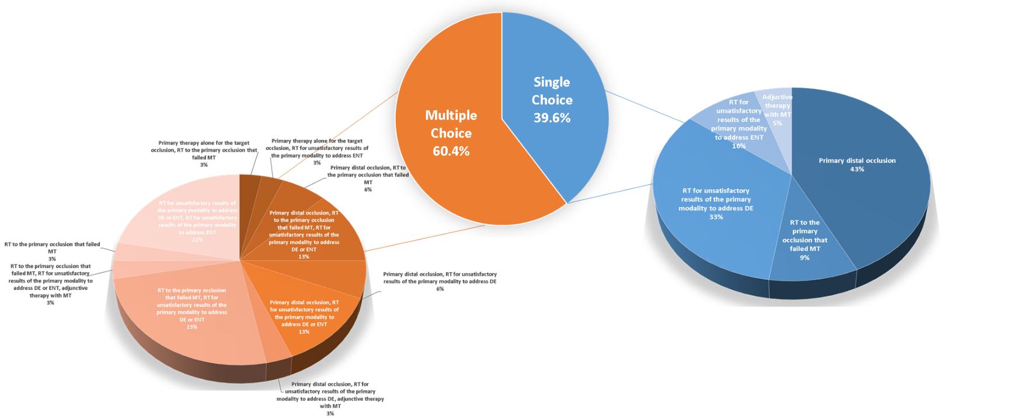

Supplementary Figure I: IA rt-PA current practices. Responses for how IA rtPA is used in current practices were collated as multiple choice or single choice (center pie chart), then further stratified by specific responses in each category for question 18. DE, distal embolization; ENT, embolization into new territory; MT, mechanical thrombectomy; RT, rescue therapy

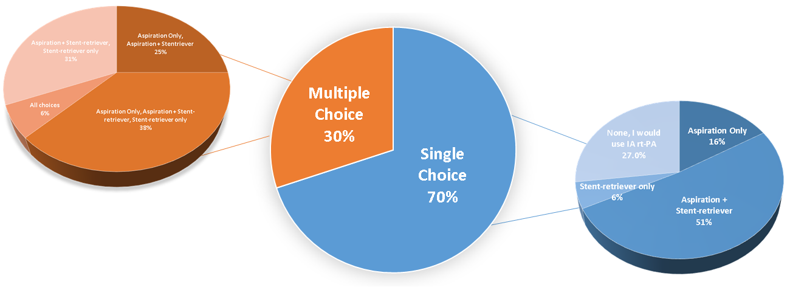

Supplementary Figure II. Type (s) of mechanical thrombectomy used with IA rt-PA. Responses for question 16 were collated as multiple choice or single choice (center pie chart), then further stratified by specific responses in each category for question 16.

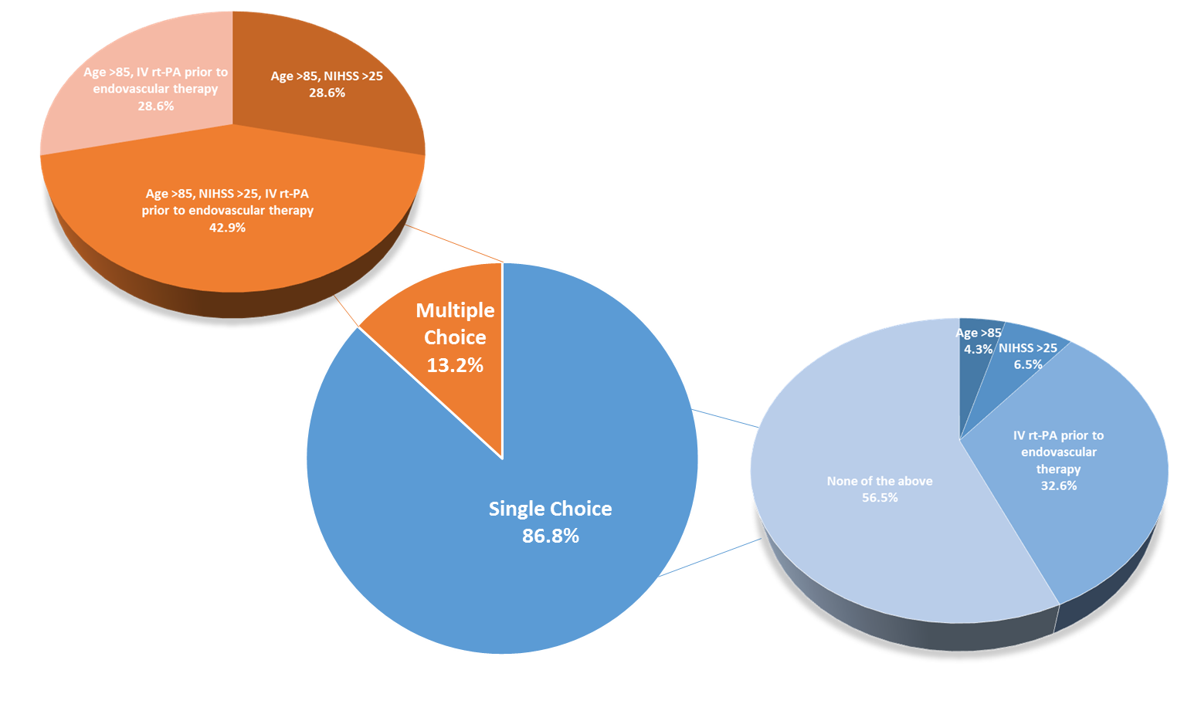

Supplementary Figure III: Criteria for not administering IA rt-PA. Responses for scenarios in which respondents would not feel comfortable using IA rt-PA were collated as multiple choice or single choice (center pie chart), then further stratified by specific responses in each category for question 17.

