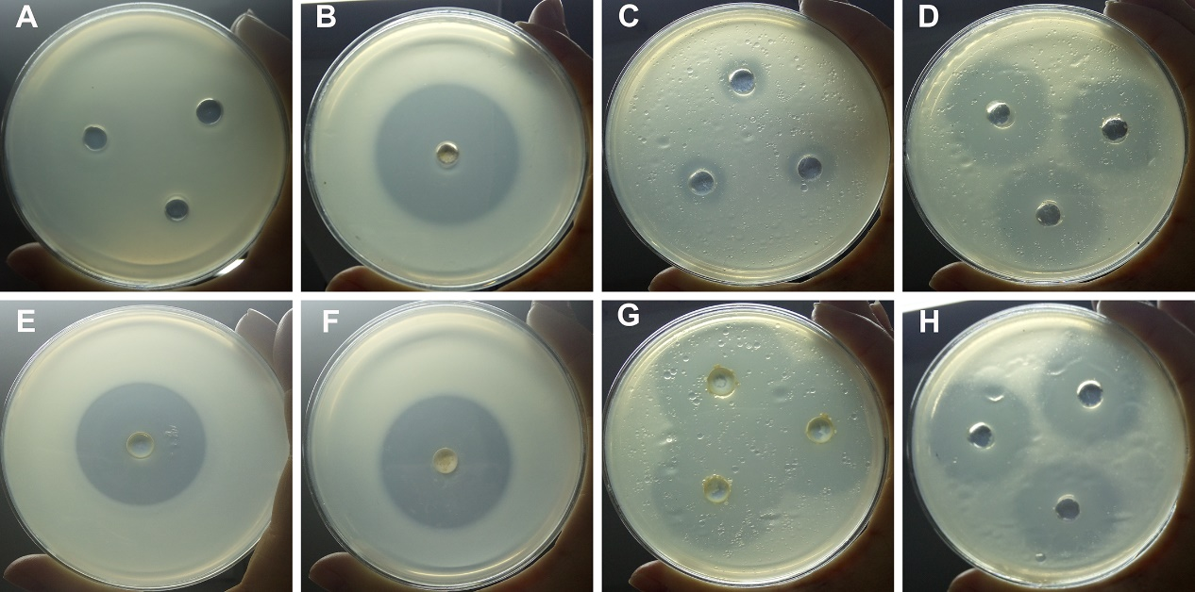
Figure S1. The proteolytic and lipolytic activity of S. maltophilia 4–1 at 4°C and 25°C. (A) and (B) show proteolysis at 4°C, induced by 4–1 and neutral protease, respectively; (C) and (D) show lipolysis at 4°C, induced by 4–1 and lipase, respectively; (E) and (F) show proteolysis at 25°C, induced by 4–1 and neutral protease, respectively; (G) and (H) show lipolysis at 25°C, induced by 4–1 and lipase, respectively.
Figure S2. Antibacterial activities of seven polyphenols against S. maltophilia 4–1. CK1 = solvent control, CK2 = NB medium control.

