FRONTIERS IN PLANT SCIENCE

Evaluation of the efficacy of two new biotechnological-based freeze-dried fertilizers for sustainable Fe deficiency correction of soybean plants grown in calcareous soils

Supplementary Materials

- Carlos M.H. Ferreira^{1,2,3}, Sandra López-Rayo⁴, Juan J. Lucena^{4*}, Eduardo V. Soares^{2,3}, Helena M.V.M. Soares^{1*}
¹⁻REQUIMTE/LAQV, Departamento de Engenharia Química, Faculdade de Engenharia, Universidade do Porto, rua Dr. Roberto Frias, 4200-465, Porto, Portugal
²⁻Bioengineering Laboratory-CIETI, Chemical Engineering Department, ISEP-School of Engineering of Polytechnic Institute of Porto, rua Dr António Bernardino de Almeida, 431, 4249-015 Porto, Portugal
³⁻CEB-Centre of Biological Engineering, University of Minho, Campus de Gualtar, 4710-057 Braga, Portugal
⁴⁻Departamento de Química Agrícola y Bromatología, Facultad de Ciencias, Universidad Autónoma de Madrid, 28049-Madrid, Spain

*Corresponding authors:
hsoares@fe.up.pt (Helena M.V.M. Soares);
juanjose.lucena@uam.es (Juan J. Lucena)

- Culture media composition
Bacillus subtilis was kept in minimal medium (MM) agar while Azotobacter vinelandii was kept in Burk´s medium (BM) agar (Newton et al., 1953), at 4º C. MM agar contained per liter: 10 g glucose, 1.47 g glutamic acid, 3.0 g potassium hydrogenophosphate (K₂HPO₄), 1.0 g potassium dihydrogenophosphate (KH₂PO₄), 0.5 g ammonium chloride (NH₄Cl), 0.1 g ammonium nitrate (NH₄NO₃), 0.1 g sodium sulphate (Na₂SO₄), 10 mg magnesium sulphate heptahydrate (MgSO₄.7H₂O), 1 mg manganese(II) sulphate tetrahydrate (MnSO₄.4H₂O), 0.5 mg calcium chloride (CaCl₂) and 20 g agar. BM agar was prepared as previously described (HiMedia Laboratories, 2015) replacing sucrose by glucose; the medium contained per liter: 10 g glucose, 0.8 g K₂HPO₄, 0.2g KH₂PO₄, 0.20 g MgSO₄.7H₂O, 0.253 mg sodium molybdate (Na₂MoO₄), 0.13 g calcium sulphate (CaSO₄) and 20 g agar.
Liquid media were of the same composition, without agar addition. The final pH of the media was set to 7.0 ± 0.1. For iron-replete media, 29 mg of iron(III) chloride (FeCl₃) was also added.
Table S1 –Nutrient solutions used to balance the macronutrients.
 | Nutrient concentration (mol L⁻¹)
Solution | Ca(NO₃)₂ | KH₂PO₄ | K₂HPO₄ | MgSO₄
A | 0.57 | - | - | -
B | - | 0.16 | 0.04 | -
C | - | - | - | 0.04
D | - | 0.22 | 0.10 | -

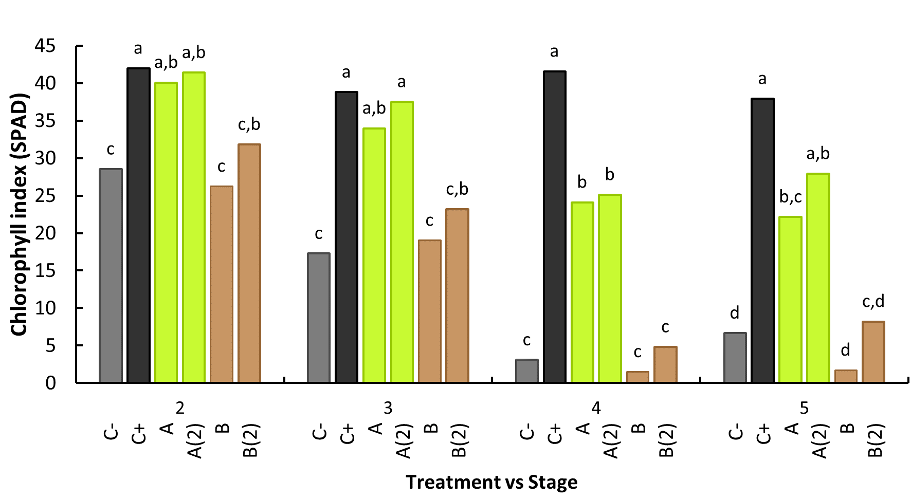
Figure S1. Intra-leaf stage (from 2nd to 5th stage) treatment comparison of average SPAD read at DAT 21. Different letters denote a significant difference of SPAD levels within each leaf stage within 95% confidence interval, as shown by Tuckey HSD test. C-: no iron treatment (negative control); C+: EDDHA (positive control); A: A. vinelandii ISS; B: B. subtilis ISS. Treatments with (2) represent plants with a second application performed 15th day after the first treatment (n=5).

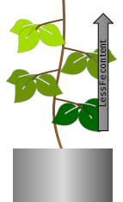
Figure S2. General model of leaf SPAD and Fe content progression on Azotobacter vinelandii ISS treated plants.

- Bibliography
HiMedia Laboratories, 2015. Burks Medium - M707. Mumbai, India. http://himedialabs.com/TD/M707.pdf. Accessed 15 May 2015
Newton, J.W., Wilson, P.W., Burris, R.H., 1953. Direct demonstration of ammonia as an intermediate in nitrogen fixation by Azotobacter. J. Biol. Chem. 204, 445–451.

