New insight on the formation of Sodium Titanates
1D nanostructures and its application on CO₂ Hydrogenation
J.N. Díaz de León^{*,1}, J. R. Rodríguez¹, J. Rojas¹, Y. Esqueda-Barrón¹, L. Cardenas², Ch. Ramesh-Kumar¹, G. Alonso-Nuñez¹, S. Fuentes¹

Fig. S1 A Right)) X-ray diffraction patterns for the TiO₂-ref, b)Ti-nR-0 and c)Ti-nR-1 samples along with simulated patterns for anatase and rutile phases. B left) Diffraction patterns for: d) Ti-nR-5, e)Ti-nR-10, f)Ti-nR-15, g)Ti-nR-30 samples and simulated patterns for Na₂Ti₃O₇ and Na₂Ti₃O₁₃
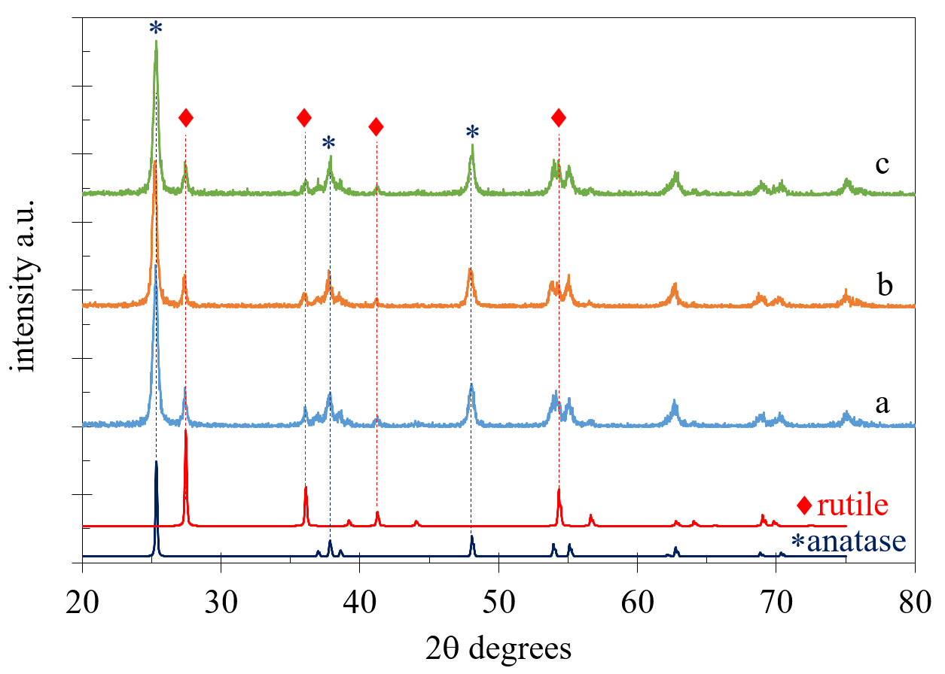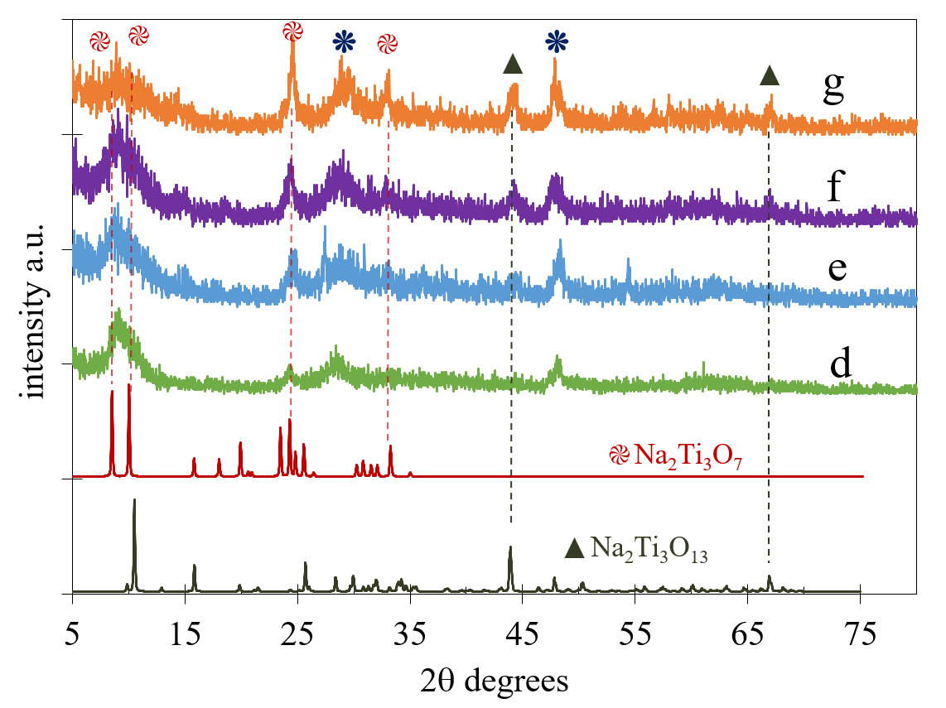
Fig S2. Nitrogen physisorption analysis (A) adsorption-desorption isotherms and (B) pore size distribution curves.
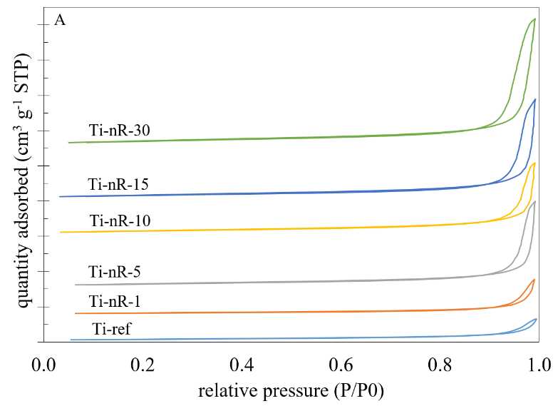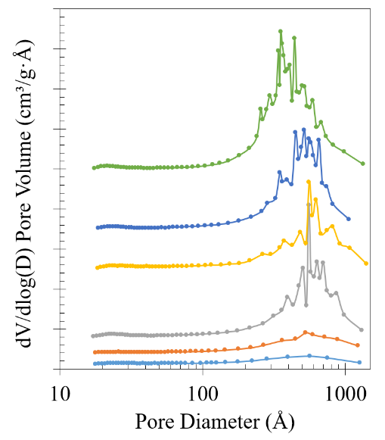

Fig. S3 CO₂ conversion and product selectivity over Ti-ref catalys
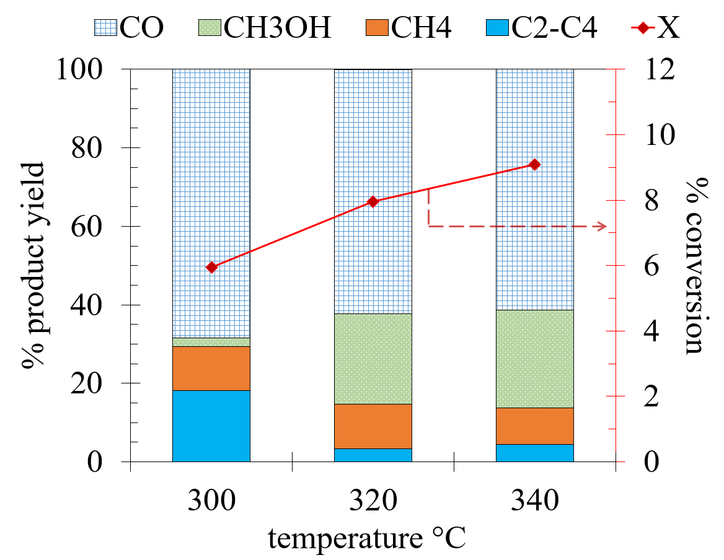

Table S1.- Raman vibrational modes assignment.
ref | Ti-nR-1 | Ti-nR-2.5 | Ti-nR-5 | Ti-nR-10 | Ti-nR-15 | Ti-nR-30 | Silva et al | Zhang et al. | Related to
- | - | - | 127 | 130 | 130 | - | (Ag) - αNa₂ | - | Na compounds
144 | 145 | 145 | - | - | - | - | B1g | - | TiO₂ anatase phase
197 | 198 | 197 | - | - | - | - | Eg | - | TiO₂ anatase pase
- | - | - | 203 | 205 | 205 | 202 | (Bg) - τO₁-Ti₃-O₂ | - | Na₂TiO₃O₇
- | - | - | 278 | 277 | 279 | 279 | τO₅-Ti₂-O₆ | Na-O-Ti | Na₂TiO₃O₇
396 | 397 | 397 | - | - | - | - | B1g | - | TiO₂ anatase phase
- | - | - | - | - | 418 | - | - | - | -
- | 444 | 444 | 445 | 431 | 462 | 454 | σO₅-Ti₁-O₄ | Ti-O-Ti | TiO₂ rutile phase
517 | 517 | 517 | - | - | - | - | A1g | - | TiO₂ anatase phase
638 | 638 | 639 | 646 | 639 | 637 | 639 | Eg | Ti-O-Ti of TiO₆ | TiO₂ anatase phase
- | - | - | 701 | - | - | - | - | Ti-O-Ti of TiO₆ | -
- | - | - | 902 | - | - | 910 | Ti-O bond | Ti-O associated  to Na ions | Na₂TiO₃O₇

Table S2 Chemical composition results for Ti-nR-x samples from the ICP analysis.
sample | Ti wt % | Na wt % | Ti/Na
Ti-ref | 60.9 | - | -
Ti-nR-1 | 55.5 | 8.4 | 6.6
Ti-nR-5 | 44.1 | 10.7 | 4.1
Ti-nR-10 | 43.3 | 11.3 | 3.8
Ti-nR-15 | 42.6 | 11.8 | 3.6
Ti-nR-30 | 42.1 | 12.0 | 3.5

Table S3 Steady state reaction rates for reactant and products as a function of reaction temperature.
 |  | steady state reaction rates x10⁻⁸ mol_{i} g_{cat}⁻¹ s⁻¹
Catalysts | T°C | CO | CH₄ | C2-C4 | CH₃OH | CO₂
Ti-nR-5 | 300 | 106.3 | 10.7 | 0.0 | 53.3 | 170.4
 | 320 | 148.4 | 13.7 | 0.0 | 96.9 | 259.1
 | 340 | 169.2 | 11.8 | 0.0 | 146.3 | 327.2
Ti-nR-10 | 300 | 250.2 | 61.2 | 15.3 | 123.3 | 449.9
 | 320 | 278.6 | 65.4 | 25.0 | 162.7 | 531.7
 | 340 | 335.1 | 55.0 | 33.4 | 231.0 | 654.4
Ti-nR-15 | 300 | 254.3 | 109.0 | 34.8 | 92.8 | 490.8
 | 320 | 313.6 | 122.3 | 50.8 | 140.5 | 627.2
 | 340 | 317.7 | 104.3 | 61.4 | 198.4 | 681.7
Ti-nR-30 | 300 | 277.0 | 103.7 | 27.1 | 123.9 | 531.7
 | 320 | 336.1 | 126.9 | 47.2 | 164.7 | 674.9
 | 340 | 358.2 | 98.8 | 64.6 | 221.4 | 743.1
Ti-Ref | 300 | 277.8 | 45.4 | 73.8 | 8.5 | 405.6
 | 320 | 336.6 | 61.2 | 18.4 | 125.2 | 541.4
 | 340 | 380.3 | 57.1 | 27.9 | 155.1 | 620.4

