Supplementary Material.
Moreno Switt et al., 2019
Supplementary Table 1. Information for strains in the study for antimicrobial resistance test and whole genome sequencing (64).
Strain name | CFSAN number | Accession number | Original Name | Source | Serotype | Isolation year
SAL4628 | CFSAN024726 | LIIZ00000000 | SEN2 | Eggs | Enteritidis | 2009
SAL4629 | CFSAN024727 | LILV00000000 | SEN5 | Eggs | Enteritidis | 2009
SAL4630 | CFSAN024728 | LILU00000000 | SEN7 | Eggs | Enteritidis | 2009
SAL4631 | CFSAN024729 | LILT00000000 | SEN21 | Human | Enteritidis | 2010
SAL4632 | CFSAN024730 | LILS00000000 | SEN22 | Human | Enteritidis | 2010
SAL4633 | CFSAN024731 | LILR00000000 | SEN31 | Eggs | Enteritidis | 2011
SAL4634 | CFSAN024732 | LILQ00000000 | SEN47 | Eggs | Enteritidis | 2012
SAL4635 | CFSAN024733 | LILP00000000 | SEN49 | Human | Enteritidis | 2012
SAL4636 | CFSAN024734 | LILO00000000 | SEN53 | Human | Enteritidis | 2012
SAL4637 | CFSAN024735 | LILN00000000 | SEN63 | Human | Enteritidis | 2012
SAL4638 | CFSAN024736 | LIMD00000000 | SEN71 | Human | Enteritidis | 2012
SAL4639 | CFSAN024737 | LIMC00000000 | SEN72 | Human | Enteritidis | 2012
SAL4640 | CFSAN024738 | LIMB00000000 | SEN73 | Human | Enteritidis | 2012
SAL4641 | CFSAN024739 | LIMA00000000 | SEN77 | Human | Enteritidis | 2012
SAL4642 | CFSAN024740 | LILZ00000000 | SEN78 | Human | Enteritidis | 2012
SAL4643 | CFSAN024741 | LILY00000000 | SEN79 | Human | Enteritidis | 2012
SAL4644 | CFSAN024742 | LILX00000000 | SEN82 | Eggs | Enteritidis | 2012
SAL4645 | CFSAN024743 | LILW00000000 | SEN87 | Eggs | Enteritidis | 2012
SAL4646 | CFSAN024744 | LIOP00000000 | SEN88 | Eggs | Enteritidis | 2012
SAL4647 | CFSAN024745 | LIOQ00000000 | SEN89 | Eggs | Enteritidis | 2012
SAL4648 | CFSAN024746 | LIOR00000000 | SEN95 | Franklin gull | Enteritidis | 2011
SAL4649 | CFSAN024747 | LIOS00000000 | SEN97 | Kelp gull | Enteritidis | 2012
SAL4650 | CFSAN024748 | LIOZ00000000 | SEN98 | Kelp gull | Enteritidis | 2012
SAL4651 | CFSAN024749 | LIOY00000000 | SEN99 | Kelp gull | Enteritidis | 2012
SAL4652 | CFSAN024750 | LIPA00000000 | SEN101 | Kelp gull | Enteritidis | 2012
SAL4653 | CFSAN024751 | LIOX00000000 | SEN107 | Kelp gull | Enteritidis | 2012
SAL4654 | CFSAN024752 | LIOW00000000 | SEN110 | Kelp gull | Enteritidis | 2012
SAL4655 | CFSAN024753 | LIOV00000000 | SEN111 | Kelp gull | Enteritidis | 2012
SAL4656 | CFSAN024754 | LIOU00000000 | SEN112 | Kelp gull | Enteritidis | 2012
SAL4657 | CFSAN024755 | LIOT00000000 | SEN127 | Kelp gull | Enteritidis | 2012
SAL4658 | CFSAN024756 | JWQW00000000 | SAG1 | Penguin | Agona | 2012
SAL4659 | CFSAN024757 | JWQV00000000 | SAG2 | Kelp Gull | Agona | 2012
SAL4660 | CFSAN024758 | JWQU00000000 | SAG3 | Penguin | Agona | 2012
SAL4661 | CFSAN024759 | JWQT00000000 | SAG4 | Human | Agona | 2012
SAL4662 | CFSAN024760 | JWQS00000000 | SAG5 | Human | Agona | 2012
SAL4663 | CFSAN024761 | JWQR00000000 | SAG6 | Penguin | Agona | 2012
SAL4664 | CFSAN024762 | JWQQ01000000 | SAN1 | Kelp Gull | Anatum | 2012
SAL4665 | CFSAN024763 | JWQP00000000 | SAN3 | Human | Anatum | 2012
SAL4666 | CFSAN024764 | JWQO00000000 | SAN4 | Human | Anatum | 2012
SAL4667 | CFSAN024765 | JWQN00000000 | SBR1 | Sea Lion | Brandenburg | 2012
SAL4669 | CFSAN024767 | JWQM00000000 | SDU1 | Kelp Gull | Dublin | 2012
SAL4670 | CFSAN024768 | JWQL00000000 | SDU2 | Human | Dublin | 2012
SAL4671 | CFSAN024769 | JWQK00000000 | SDU3 | Human | Dublin | 2012
SAL4672 | CFSAN024770 | JWQJ00000000 | SHA1 | Sea Lion | Havana | 2010
SAL4673 | CFSAN024771 | JWQI00000000 | SHA2 | Garuma Gull | Havana | 2012
SAL4674 | CFSAN024772 | JWQH00000000 | SHE1 | Kelp Gull | Heidelberg | 2012
SAL4675 | CFSAN024773 | JWQG00000000 | SHE2 | Kelp Gull | Heidelberg | 2012
SAL4676 | CFSAN024774 | JWQF00000000 | SHE3 | Kelp Gull | Heidelberg | 2012
SAL4678 | CFSAN024776 | JWQE00000000 | SHE5 | Human | Heidelberg | 2012
SAL4679 | CFSAN024777 | JWQD00000000 | SHE6 | Human | Heidelberg | 2012
SAL4680 | CFSAN024778 | JWQC00000000 | SIN1 | Kelp Gull | Infantis | 2010
SAL4681 | CFSAN024779 | JWQB00000000 | SIN2 | Kelp Gull | Infantis | 2010
SAL4682 | CFSAN024780 | JWQA00000000 | SIN3 | Kelp Gull | Infantis | 2012
SAL4683 | CFSAN024781 | JWPZ00000000 | SIN6 | Human | Infantis | 2012
SAL4684 | CFSAN024715 | JWRH00000000 | SIN7 | Human | Infantis | 2012
SAL4685 | CFSAN024716 | JWRG00000000 | SLI1 | Sea Lion | Livingstone | 2012
SAL4686 | CFSAN024717 | JWRF00000000 | SLI2 | Sea Lion | Livingstone | 2012
SAL4687 | CFSAN024718 | JWRE00000000 | SSE1 | Kelp Gull | Senftenberg | 2010
SAL4688 | CFSAN024719 | JWRD00000000 | SSE2 | Kelp Gull | Senftenberg | 2011
SAL4690 | CFSAN024721 | JWRB00000000 | SSE4 | Human | Senftenberg | 2012
SAL4691 | CFSAN024722 | JWRA00000000 | SSE5 | Human | Senftenberg | 2012
SAL4692 | CFSAN024723 | JWQZ00000000 | SSE6 | Kelp Gull | Senftenberg | 2012
SAL4693 | CFSAN024724 | JWQY00000000 | SSE7 | Kelp Gull | Senftenberg | 2012
SAL4694 | CFSAN024725 | JWQX00000000 | SGB1 | Kelp Gull | Paratyphi B | 2012
All strains were isolated in Chile
Supplementary Table 2. Salmonella isolates used in the screening of the detected plasmid (n=113)
Isolate | Serotype¹ | Origin² | Plasmid ³
DR-001 | Enteritidis | Poultry | -
DR-002 | Enteritidis | Poultry | -
DR-003 | Enteritidis | Poultry | -
DR-004 | Tennessee | Poultry | -
DR-005 | Infantis | Poultry | -
DR-006 | Infantis | Poultry | -
DR-007 | Typhimurium | Poultry | -
DR-008 | Enteritidis | Poultry | -
DR-009 | Typhimurium | Poultry | -
DR-012 | Kentucky | Poultry | -
DR-013 | Not identified | Poultry | -
DR-014 | Mbandaka | Poultry | -
DR-015 | Falkensee | Poultry | -
DR-016 | Enteritidis | Poultry | -
DR-017 | Enteritidis | Poultry | -
DR-018 | Enteritidis | Poultry | -
DR-019 | Enteritidis | Poultry | -
DR-020 | Enteritidis | Poultry | -
DR-021⁴ | Hadar | Poultry | Present⁴
DR-022⁴ | Hadar | Poultry farm environment | Present⁴
DR-023 | Typhimurium | Poultry | -
DR-024 | Typhimurium | Poultry | -
DR-025 | Typhimurium | Poultry | -
DR-026 | Typhimurium | Poultry | -
DR-027 | Typhimurium | Poultry | -
DR-028 | Enteritidis | Poultry | -
DR-029 | Infantis | Poultry | -
DR-030 | Infantis | Poultry | -
DR-031 | Infantis | Poultry | -
DP-006 | Not identified | reptile | -
DP-007 | Not identified | reptile | -
DP-009 | Not identified | reptile | -
RT 023 | B | wild bird | -
RT 024 | B | wild bird | Present
DP-010 | Not identified | reptile | -
DP-011 | Not identified | reptile | -
DP-013 | Not identified | reptile | -
DP-014 | Not identified | reptile | -
DP-015 | Not identified | reptile | -
DP-016 | Not identified | reptile | -
DP-017 | Not identified | reptile | -
PS 001 | Typhimurium | horse | -
PS 002 | Typhimurium | horse | -
PS 003 | Typhimurium | horse | -
PS 004 | Typhimurium | horse | -
PS 005 | Typhimurium | horse | -
PS 006 | Typhimurium | horse | -
PS 007 | Typhimurium | horse | -
PS 008 | Typhimurium | horse | -
PS 009 | Typhimurium | horse | -
PS 010 | Typhimurium | horse | -
PS 011 | Infantis | horse | -
PS 012 | Typhimurium | horse | -
PS 014 | Typhimurium | horse | -
PS 015 | Typhimurium | horse | -
PS 016 | Typhimurium | horse | -
PS 017 | Typhimurium | horse | -
PS 018 | Typhimurium | horse | -
PS 019 | Typhimurium | horse | -
PS 020 | Typhimurium | horse | -
PS 021 | Infantis | horse | -
PS 022 | Infantis | horse | -
PS 023 | Typhimurium | horse | -
PS 024 | Typhimurium | horse | -
PS 025 | Typhimurium | horse | -
PS 013 | Typhimurium | horse | Present
DP-001 | Not identified | reptile | -
DP-002 | Not identified | reptile | -
DP-004 | Not identified | reptile | -
DP-005 | Not identified | reptile | -
DP-008 | Not identified | reptile | -
DP-012 | Not identified | reptile | -
DP-003 | Not identified | reptile | -
DR 041 | Not identified | pig | -
DR 043 | Not identified | pig | -
DR 044 | Not identified | pig | -
DR 045 | Not identified | pig | -
DR 046 | Not identified | pig | -
DR 047 | Not identified | pig | -
DR 039⁴ | Typhimurium | pig | Present⁴
DR 040⁴ | Typhimurium | pig | Present⁴
DR 042 | B | pig | Present
RT 022 | B | wild bird | Present
RT 002 | Not identified | wild bird | -
RT 019 | Not identified | wild bird | -
FD 016 | Typhimurium | Cattle | -
FD 053 | Not identified | Cattle | -
FD P7-6 | Heidelberg | Cattle | -
RT 001 | Not identified | Thylamys elegans (marsupial) | -
RT 003 | Not identified | Thylamys elegans (marsupial) | -
RT 004 | Not identified | Thylamys elegans (marsupial) | -
RT 006 | Not identified | Thylamys elegans (marsupial) | -
RT 007 | Not identified | Thylamys elegans (marsupial) | -
RT 011 | Not identified | Thylamys elegans (marsupial) | -
RT 014 | Not identified | Thylamys elegans (marsupial) | -
RT 015 | Not identified | Thylamys elegans (marsupial) | -
RT 016 | Not identified | Thylamys elegans (marsupial) | -
RT 017 | Not identified | Thylamys elegans (marsupial) | -
RT 018 | Not identified | Thylamys elegans (marsupial) | -
RT 020 | Not identified | Thylamys elegans (marsupial) | -
RT 008 | C1 | wild bird | -
RT 009 | C1 | wild bird | -
RT 010 | C1 | wild bird | -
RT 012 | C1 | wild bird | -
RT 013 | C1 | wild bird | -
DR 038 | Enteritidis | wild bird | -
DR-032 | Heidelberg | wild bird | -
DR-033 | Infantis | wild bird | -
DR-034 | Heidelberg | wild bird | -
DR-035 | Heidelberg | wild bird | -
DR-036 | Heidelberg | wild bird | -
DR-037 | Heidelberg | wild bird | -
RT 025 | Not identified | wild bird | -
¹ Serotype was predicted using a molecular serotyping scheme described at Ranieri et al. 2013. In isolates with only serogroup or not identified, the serotype was not possible to be determined with the scheme.
² All samples were obtained in Chile. Samples from horses were also obtained from the environment of horse hospitals
³ Two PCR reactions were used to determine the presence of the plasmid
⁴Isolates were sequenced to obtain plasmid sequences. New identified plasmids were named after the isolate name.
Supplementary Table 3. Previously reported plasmids used for genetic comparison.
Plasmid | Size (bp) | Acc. Number | Bacterial host | Isolation country | Isolation year | Reference
pMK101 | 2,750 | HM070380.1 | Salmonella 6,7:d:- | Colombia | 2007 | (Karczmarczyk et al. 2010)
pSGI15 | 2,699 | FN428572.1 | Salmonella Typhimurium | Netherlands | 2001-2006 | (Hammerl et al.2010)
pPAB19-4 | 2,702 | JN995611.1 | Salmonella sp | Argentina | 2006 | (Tran et al.2012)
pN44358F | 2,699 | KY991368.1 | Salmonella Muenchen | United States | 2013 | (Tyson et al.2017)
pECY6-7 | 2,699 | GQ374156.1 | E. coli | Peru | 2005 | (Pallecchi et al.2010)
pHAD28 | 2,617 | KU674895.1 | Salmonella Hadar | Germany | 2010 | (Fiegen et al.2017)

Supplementary Table 4. Distance Matrix inferred by a ClustalW alignment of the plasmids nucleotide sequences.

 | pDR021 | pDR039 | pDR040 | pSAL4679 | pDR022 | pSAL4674 | pSAL4678 | pSAL4688 | pSAL4630 | pSAL4629 | pPAB19-4 | pHAD28 | pECY6-7 | pN44358F | pSGI15 | pMK101
pDR021 |  | 98.2 | 98.2 | 97.2 | 99.9 | 97.2 | 97.2 | 97.2 | 97.2 | 97.2 | 97.2 | 93.7 | 95.5 | 95.5 | 95.5 | 94.4
pDR039 | 98.2 |  | 100.0 | 95.5 | 98.2 | 95.5 | 95.5 | 95.5 | 95.5 | 95.5 | 95.5 | 92.0 | 93.9 | 93.9 | 93.9 | 92.8
pDR040 | 98.2 | 100.0 |  | 95.5 | 98.2 | 95.5 | 95.5 | 95.5 | 95.5 | 95.5 | 95.5 | 92.0 | 93.9 | 93.9 | 93.9 | 92.8
pSAL4679 | 97.2 | 95.5 | 95.5 |  | 97.2 | 98.4 | 98.4 | 98.4 | 98.4 | 98.4 | 98.4 | 94.8 | 96.7 | 96.7 | 96.7 | 95.5
pDR022 | 99.9 | 98.2 | 98.2 | 97.2 |  | 97.2 | 97.2 | 97.2 | 97.2 | 97.2 | 97.2 | 93.7 | 95.5 | 95.5 | 95.5 | 94.4
pSAL4674 | 97.2 | 95.5 | 95.5 | 98.4 | 97.2 |  | 100.0 | 100.0 | 100.0 | 100.0 | 100.0 | 96.4 | 98.3 | 98.3 | 98.3 | 97.1
pSAL4678 | 97.2 | 95.5 | 95.5 | 98.4 | 97.2 | 100.0 |  | 100.0 | 100.0 | 100.0 | 100.0 | 96.4 | 98.3 | 98.3 | 98.3 | 97.1
pSAL4688 | 97.2 | 95.5 | 95.5 | 98.4 | 97.2 | 100.0 | 100.0 |  | 100.0 | 100.0 | 100.0 | 96.4 | 98.3 | 98.3 | 98.3 | 97.1
pSAL4630 | 97.2 | 95.5 | 95.5 | 98.4 | 97.2 | 100.0 | 100.0 | 100.0 |  | 100.0 | 100.0 | 96.4 | 98.3 | 98.3 | 98.3 | 97.1
pSAL4629 | 97.2 | 95.5 | 95.5 | 98.4 | 97.2 | 100.0 | 100.0 | 100.0 | 100.0 |  | 100.0 | 96.4 | 98.3 | 98.3 | 98.3 | 97.1
pPAB19-4 | 97.2 | 95.5 | 95.5 | 98.4 | 97.2 | 100.0 | 100.0 | 100.0 | 100.0 | 100.0 |  | 96.4 | 98.3 | 98.3 | 98.3 | 97.1
pHAD28 | 93.7 | 92.0 | 92.0 | 94.8 | 93.7 | 96.4 | 96.4 | 96.4 | 96.4 | 96.4 | 96.4 |  | 94.7 | 94.7 | 94.7 | 93.5
pECY6-7 | 95.5 | 93.9 | 93.9 | 96.7 | 95.5 | 98.3 | 98.3 | 98.3 | 98.3 | 98.3 | 98.3 | 94.7 |  | 100.0 | 100.0 | 98.0
pN44358F | 95.5 | 93.9 | 93.9 | 96.7 | 95.5 | 98.3 | 98.3 | 98.3 | 98.3 | 98.3 | 98.3 | 94.7 | 100.0 |  | 100.0 | 98.0
pSGI15 | 95.5 | 93.9 | 93.9 | 96.7 | 95.5 | 98.3 | 98.3 | 98.3 | 98.3 | 98.3 | 98.3 | 94.7 | 100.0 | 100.0 |  | 98.0
pMK101 | 94.4 | 92.8 | 92.8 | 95.5 | 94.4 | 97.1 | 97.1 | 97.1 | 97.1 | 97.1 | 97.1 | 93.5 | 98.0 | 98.0 | 98.0

Estimation were made with plasmid sequences found in this study and previously reported sequences. The calculations were run with ClustalW in Geneious Prime 2019.1.1 (Biomatter, New Zealand).

Supplementary Table 5: Plasmid replicons present in Salmonella genomes in the study.
Strain | Replicon | Identity | Query / Template length | Contig | Position in contig | Accession number
SAL4629 | IncFIB(S) | 98.91 | 643 / 643 | 20 | 34322..34964 | FN432031
 | IncFII(S) | 100 | 262 / 262 | 21 | 9755..10016 | CP000858
SAL4630 | IncFIB(S) | 98.91 | 643 / 643 | 34 | 7047..7689 | FN432031
 | IncFII(S) | 100 | 262 / 262 | 31 | 3566..3827 | CP000858
 | IncN | 99.81 | 514 / 514 | 22 | 247..760 | AY046276
SAL4675 | IncX1 | 98.93 | 374 / 374 | 18 | 31865..32238 | EU370913
SAL4676 | IncI1 | 99.3 | 142 / 142 | 12 | 67302..67443 | AP005147
 | IncX1 | 98.93 | 374 / 374 | 14 | 25139..25512 | EU370913
SAL4678 | None
SAL4679 | None
SAL4674 | None
SAL4688 | IncL/M(pOXA-48) | 95.2 | 666 / 661 | 30 | 16154..16817 | JN626286
DR021 | Col440I | 95.18 | 83 / 114 | 67 | 1..83 | CP023920.1
DR022 | Col440I | 95.18 | 83 / 114 | 68 | 1..83 | CP023920.1
DR039 | None
DR040 | None
Search was performed with PlasmidFinder, DTU with default parameters for Enterobacteriaceae (Carattoli et al, 2014)

Supplementary Figure 1. Phylogeny inferred from 6 Chilean plasmids sequences and 6 similar plasmids from the NBCI database.
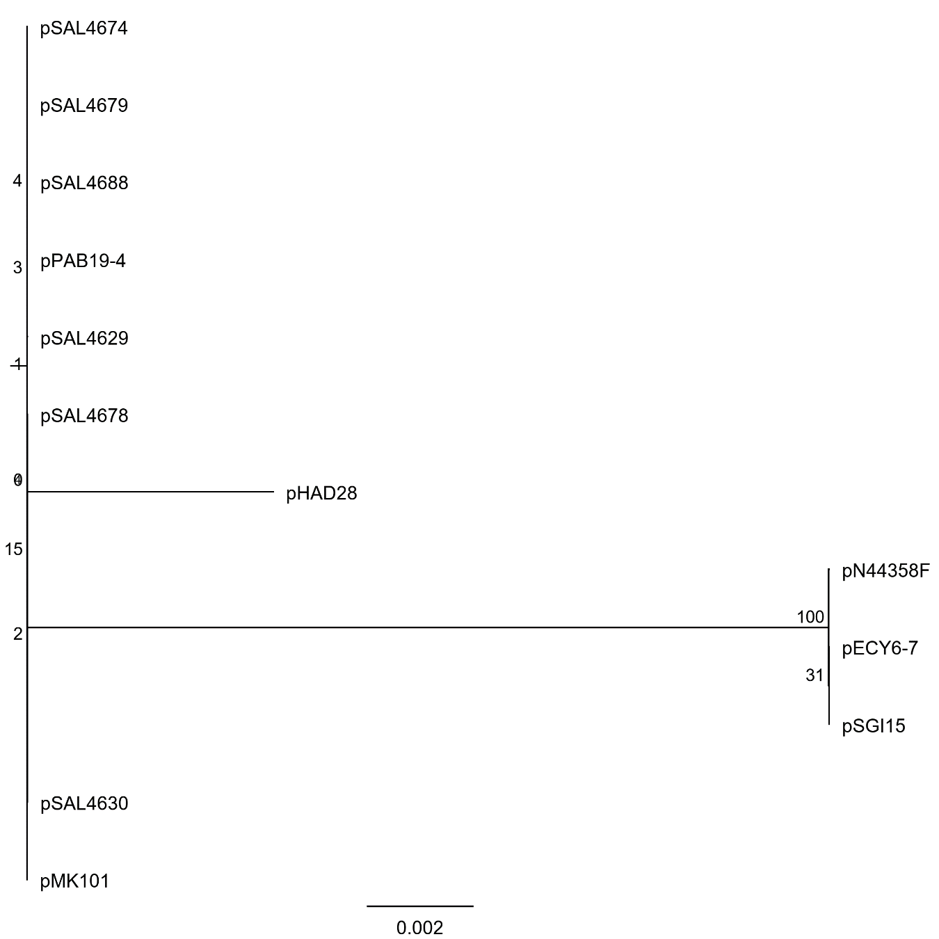
Alignment was performed with ClustalW with default parameters, and phylogeny was inferred with RAxML (Stamatakis, Hoover and Rougemont 2008) in Geneious (Biomatters, New Zealand) with 1,000 replicates. Phylogeny was used to define sequences to be used for primer design.
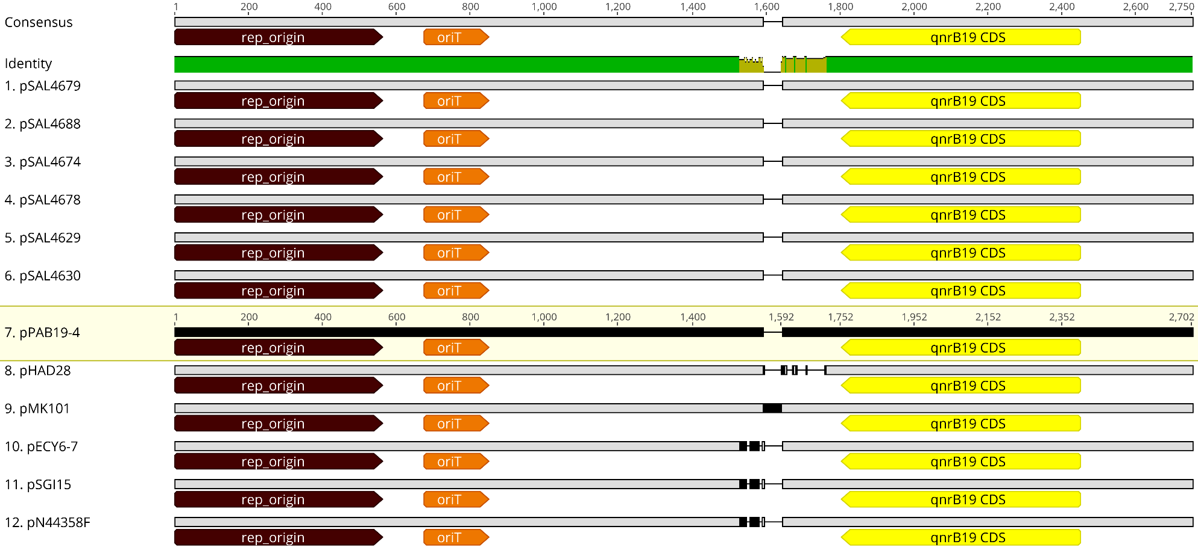
Supplementary Figure 2: Nucleotide alignment of qnrB19-carrying plasmids isolated in Chile (n=6) and from NCBI.
Alignment was performed with ClustalW using default parameters in Geneious Prime. Non-identities are located between nucleotides 1,529 and 1761 using consensus sequence as reference.
Green bar at the “consensus identity sequence” represents 100% identity, and red indicates <30% identity.

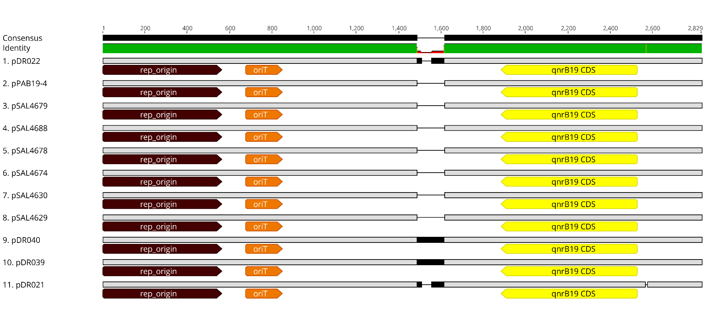Supplementary Figure 3: Nucleotide alignment of qnrB19-carrying plasmids isolated in Chile (n=10) and pPAB-19.
Alignment was performed with ClustalW using default parameters in Geneious Prime. Insertions are located in nucleotide 1,496 (Plasmid pPAB19-4 as a reference).
Green bar at the “consensus identity sequence” represents 100% identity, and red indicates <30% identity.

