Supplementary Material

Supplementary table 1. Primers used for vector construction
Name | Sequence
DTT-F | CTGGGATCCataaatcttgattgggatgtca
DTT-R | ACCACCAGAACCACCACCACCGGGACGATTATACGAATTATG
neoAg-F | cataattcgtataatcgtcccGGTGGTGGTGGTTCTGGTGGT
neoAg-R | CCGCTCGAGTTACATGTAGTTGTCTTTCAGA
CTB-neoAg-F | CCGGTGGAGGCGGGTCCTCCGGATGGCTGCCGCAGGCTAAAGTT
CTB-neoAg-R | CTGATCAGTTTTTGTTCGGATCCCATGTAGTTGTCTTTCAGACG
In DTT-F, BamH I site is underlined. In neoAg-R, Xho I sit is underlined. In CTB-neoAg-F, BspE I site is underlined. In CTB-neoAg-R, BamH I site is underlin

Supplementary table 2. Primers used for Quantitative PCR assay
Name | Sequence
mIFN-γ-F | ACAGCAAGGCGAAAAAGGATG
mIFN-γ-R | TGGTGGACCACTCGGATGA
mIL-12-F | AGACATCACACGGGACCAAAC
mIL-12-R | CCAGGCAACTCTCGTTCTTGT
mIL-4-F | GGTCTCAACCCCCAGCTAGT
mIL-4-R | GCCGATGATCTCTCTCAAGTGAT
mIL-10-F | GCTCTTACTGACTGGCATGAG
mIL-10-R | CGCAGCTCTAGGAGCATGTG

Supplementary table 3. The mutations of neoantigens
Label | Gene | Gene ID | cDNA mutation | DNA sequence | Protein  ID | Amino Acid  mutation | Neoantigen peptide
W1 | Pi4k2b | 67073  (991-1071) | G1031A | TGGCTTCCTCAAGCAAAGGTTCCTTTTTCTGAAGAGACTCGAAACTTGATTCTACCCTATATTTCTGACATGAACTTTGTA | AAH62144.1  (331-357) | R344Q | WLPQAKVPFSEETRNLILPYISDMNFV
M1 |  |  |  | TGGCTTCCTCAAGCAAAGGTTCCTTTTTCTGAAGAGACTCAAAACTTGATTCTACCCTATATTTCTGACATGAACTTTGTA |  |  | WLPQAKVPFSEETQNLILPYISDMNFV
W2 | Ddb1 | 13194  (1273-1353) | C1312A | TTGGTGCTCTCTTTTGTGGGCCAGACAAGAGTTCTCATGCTAAACGGAGAGGAAGTGGAAGAGACAGAACTGATGGGCTTT | NP_056550.1  (425-451) | L438I | LVLSFVGQTRVLMLNGEEVEETELMGF
M2 |  |  |  | TTGGTGCTCTCTTTTGTGGGCCAGACAAGAGTTCTCATGATAAACGGAGAGGAAGTGGAAGAGACAGAACTGATGGGCTTT |  |  | LVLSFVGQTRVLMINGEEVEETELMGF
W3 | Pcdhga11 | 93723  (205-285) | G244C | AGGGGACAATCGCAGCTTTTCTCTCTGAATCCGCGAGGCGGCAGCTTGGTCACTGCAGGTAGGATCGACCGTGAAGAGCTA | NP_291072.1  (69-95) | G82R | RGQSQLFSLNPRGGSLVTAGRIDREEL
M3 |  |  |  | AGGGGACAATCGCAGCTTTTCTCTCTGAATCCGCGAGGCCGCAGCTTGGTCACTGCAGGTAGGATCGACCGTGAAGAGCTA |  |  | RGQSQLFSLNPRGRSLVTAGRIDREEL
W4 | Atp11a | 50770  (1525-1605) | G1566C | TCCTCGCCTGATGAGGTTGCACTGGTCGAAGGCGTGCAGAGGCTTGGATTCACGTACCTGAGGCTGAAGGACAATTACATG | AAI38716.1  (509-535) | R522S | SSPDEVALVEGVQRLGFTYLRLKDNYM
M4 |  |  |  | TCCTCGCCTGATGAGGTTGCACTGGTCGAAGGCGTGCAGAGCCTTGGATTCACGTACCTGAGGCTGAAGGACAATTACATG |  |  | SSPDEVALVEGVQSLGFTYLRLKDNYM

Abbreviations
Abbreviation | Description
DTT | Diphtheria toxin T domain
CTB | Cholera toxin B subunit
DTT-neoAg | DTT-neoantigen
DTT-wtAg | DTT-Wild type
CTB-neoAg | CTB-neoantigen
CTB-wtAg | CTB-Wild type
neoAg-pep | Neoantigen peptide
TILs | Tumour infiltrating leucocytes
CTLs | Cytotoxic T lymphocytes
BMDCs | Bone marrow-derived dendritic cells
Alum | Aluminum hydroxide
GST | Glutathione S-transferase
IPTG | Isopropyl-ß-D-thiogalactoside
GM-CSF | Granulocyte-macrophage colony stimulating factor
LDH | Lactate dehydrogenase
H&E | Hematoxylin and eosin
SD | Standard deviation

FIGURE S1

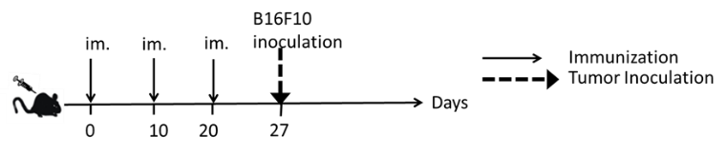
A

C
B
Figure S1. Anti-tumor effects of neoAg peptide and DTT-wtAg in the prophylactic mouse melanoma model. (A) The treatment schedule. C57BL/6 mice (n = 6-8) were immunized with PBS or neoAg-pep or DTT-wtAg formulated with Alum + CpG on day 0, day 10 and day 20. 7 days after the third immunization, 1×10⁵ B16 F10 cells were s.c. administered into the right flank of the mice. Green line: DTT-wtAg-treated mice, yellow line: neoAg-pep-treated mice, and black line: PBS-treated mice. (B) The tumor growth curves. The data are shown in means ± SEM, ns: P > 0.05, Student’s T test. (C) The Kaplan-Meier survival plot. The statistical significance was determined by Log-rank test. ns: P > 0.05.

FIGURE S2
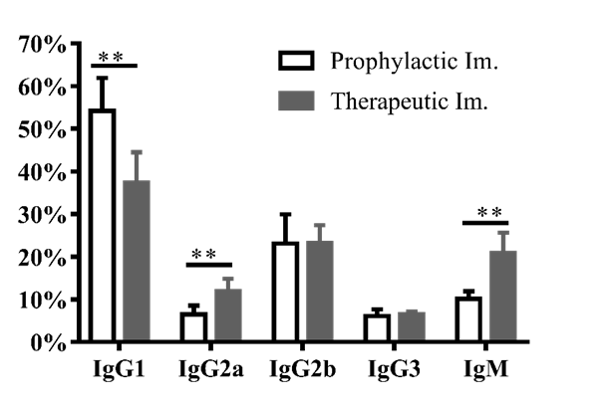
A
Figure S2. Comparison of anti-neoAg antibody subclasses from DTT-neoAg-treated mouse in the prophylactic vaccination and the therapeutic vaccination. The sera from DTT-treated mice in prophylactic model were collected 7 days after the third immunization. The mouse sera from the therapeutic model were collected from mice challenged with 2.5×10⁴ B16F10 tumor cells 7 days after the third immunization. (A) Anti-neoAg antibody subclasses of DTT-neoAg-treated mice were determined by ELISA with the sera diluted at 1:100. Analyses of the percentage of each antibody subclass among total IgGs. **: P < 0.01 by Student’s T test.

FIGURE S3
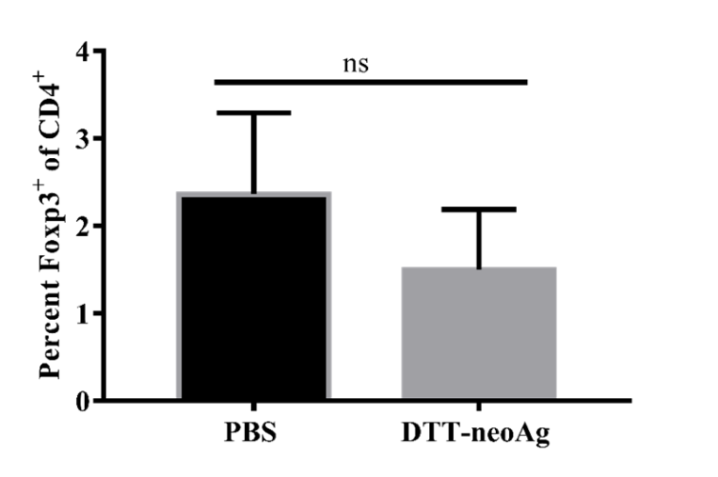
A
Figure S3. Foxp3⁺/CD4⁺ ratio in TILs. (A) The TILs from DTT-neoAg or PBS vaccinated mice were isolated and stained with anti-CD3ε-APC, anti-CD4- FITC. After permeabilization, intracellular cytokines were stained with anti-Foxp3-PE antibody and analyzed by flow cytometry. The statistical significances were determined by Student’s T test. ns: P > 0.05.

