**Supplementary Material**

**SOM Table 1. Secondary Statistical Analysis of Responses to Vi and tetanus toxoid**

|  |  |  |  |  |  |  |
| --- | --- | --- | --- | --- | --- | --- |
| **Isotype** | | **Analyte** | **Measure** | **Comparison** | **Visit Date** | **raw.p** |
| IgA | Vi-Biot | | Magnitude | Vaccine | D90 | *0.0427* |
| Vaccine | D180 | 0.2528 |
| Fold Change | Vaccine | D90 | *0.0489* |
| Vaccine | D180 | 0.4185 |
| Avidity Index | Vaccine | D90 | 0.3624 |
| Vaccine | D180 | 0.2867 |
| tetanus toxoid | | Magnitude | Vaccine | D0 | **3.13E-09** |
| Vaccine | D90 | **2.95E-06** |
| Vaccine | D180 | **0.0010** |
| Diagnosis Vi-PS | D0 | 0.8256 |
| Diagnosis Vi-TT | D0 | 0.8139 |
| Fold Change | Vaccine | D0 | **7.02E-13** |
| Vaccine | D90 | **2.61E-10** |
| Vaccine | D180 | **1.15E-05** |
| Diagnosis Vi-PS | D0 | 0.9714 |
| Diagnosis Vi-TT | D0 | 0.1406 |
| IgG1 | Vi-Biot | | Magnitude | Vaccine | D90 | **0.0006** |
| Vaccine | D180 | **0.0009** |
| Fold Change | Vaccine | D90 | **0.0012** |
| Vaccine | D180 | **0.0038** |
| Avidity Index | Vaccine | D90 | 0.1173 |
| Vaccine | D180 | 0.1814 |
| tetanus toxoid | | Magnitude | Vaccine | D0 | **7.14E-11** |
| Vaccine | D90 | **7.23E-08** |
| Vaccine | D180 | **2.04E-06** |
| Diagnosis Vi-PS | D0 | 0.1651 |
| Diagnosis Vi-TT | D0 | 0.1045 |
| Fold Change | Vaccine | D0 | **1.49E-11** |
| Vaccine | D90 | **4.93E-09** |
| Vaccine | D180 | **2.02E-07** |
| Diagnosis Vi-PS | D0 | 0.2509 |
| Diagnosis Vi-TT | D0 | 0.9173 |
| IgG2 | Vi-Biot | | Magnitude | Vaccine | D90 | *0.0484* |
| Vaccine | D180 | 0.3135 |
| Fold Change | Vaccine | D90 | *0.0143* |
| Vaccine | D180 | 0.1020 |
| Avidity Index | Vaccine | D90 | 0.6324 |
| Vaccine | D180 | 0.8128 |
| tetanus toxoid | | Magnitude | Vaccine | D0 | **7.82E-08** |
| Vaccine | D90 | **0.0004** |
| Vaccine | D180 | *0.0073* |
| Diagnosis Vi-PS | D0 | 0.1742 |
| Diagnosis Vi-TT | D0 | 0.2626 |
| Fold Change | Vaccine | D0 | **1.99E-12** |
| Vaccine | D90 | **2.35E-08** |
| Vaccine | D180 | **2.04E-05** |
| Diagnosis Vi-PS | D0 | *0.0206* |
| Diagnosis Vi-TT | D0 | 0.9375 |
| IgG3 | Vi-Biot | | Magnitude | Vaccine | D90 | **7.47E-06** |
| Vaccine | D180 | **1.94E-05** |
| Fold Change | Vaccine | D90 | **6.05E-06** |
| Vaccine | D180 | **1.66E-05** |
| Avidity Index | Vaccine | D90 | 0.0819 |
| Vaccine | D180 | NA |
| tetanus toxoid | | Magnitude | Vaccine | D0 | **5.13E-07** |
| Vaccine | D90 | **0.0004** |
| Vaccine | D180 | *0.0135* |
| Diagnosis Vi-PS | D0 | 0.1581 |
| Diagnosis Vi-TT | D0 | 0.2264 |
| Fold Change | Vaccine | D0 | **9.59E-12** |
| Vaccine | D90 | **1.22E-10** |
| Vaccine | D180 | **4.58E-07** |
| Diagnosis Vi-PS | D0 | *0.0359* |
| Diagnosis Vi-TT | D0 | 0.8933 |

Raw p values <0.005 **bolded** andraw p values <0.05 *italicized.* Avidity Index for tetanus toxoid not tested.

**SOM Figure 1A**



**SOM Figure 1B**

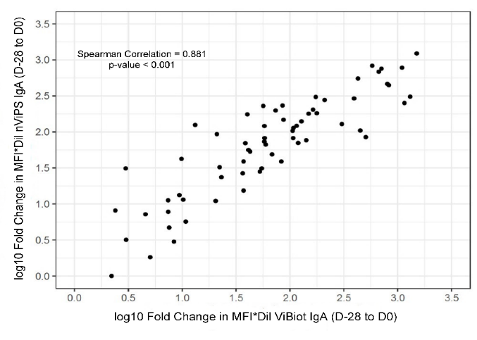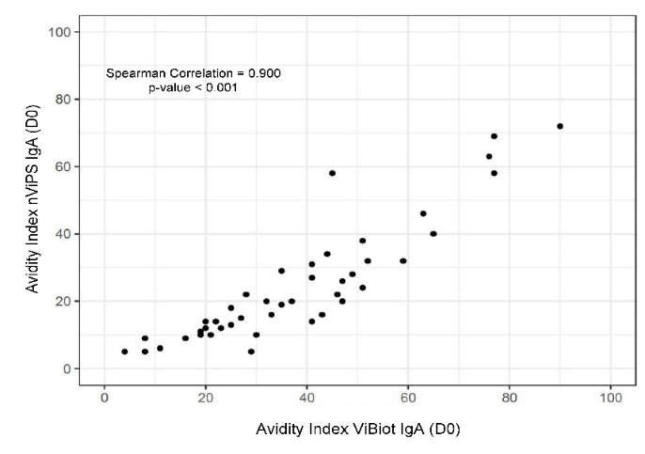

**SOM Figure 1. nViPS and ViBiot exhibit slight differences in antigenicity. (A)** Specific binding of mouse anti-human IgG1 (188L-8, SSI Diagnostica) monoclonal antibody (starting at 20 µg/ml titrated down 2-fold) to nViPS and ViBiot antigenic forms. **(B)** Spearman correlation for Vi IgA isotype antibody responses to nViPS and ViBiot for fold-change from baseline to day of challenge and avidity index.