Supplementary Figures:
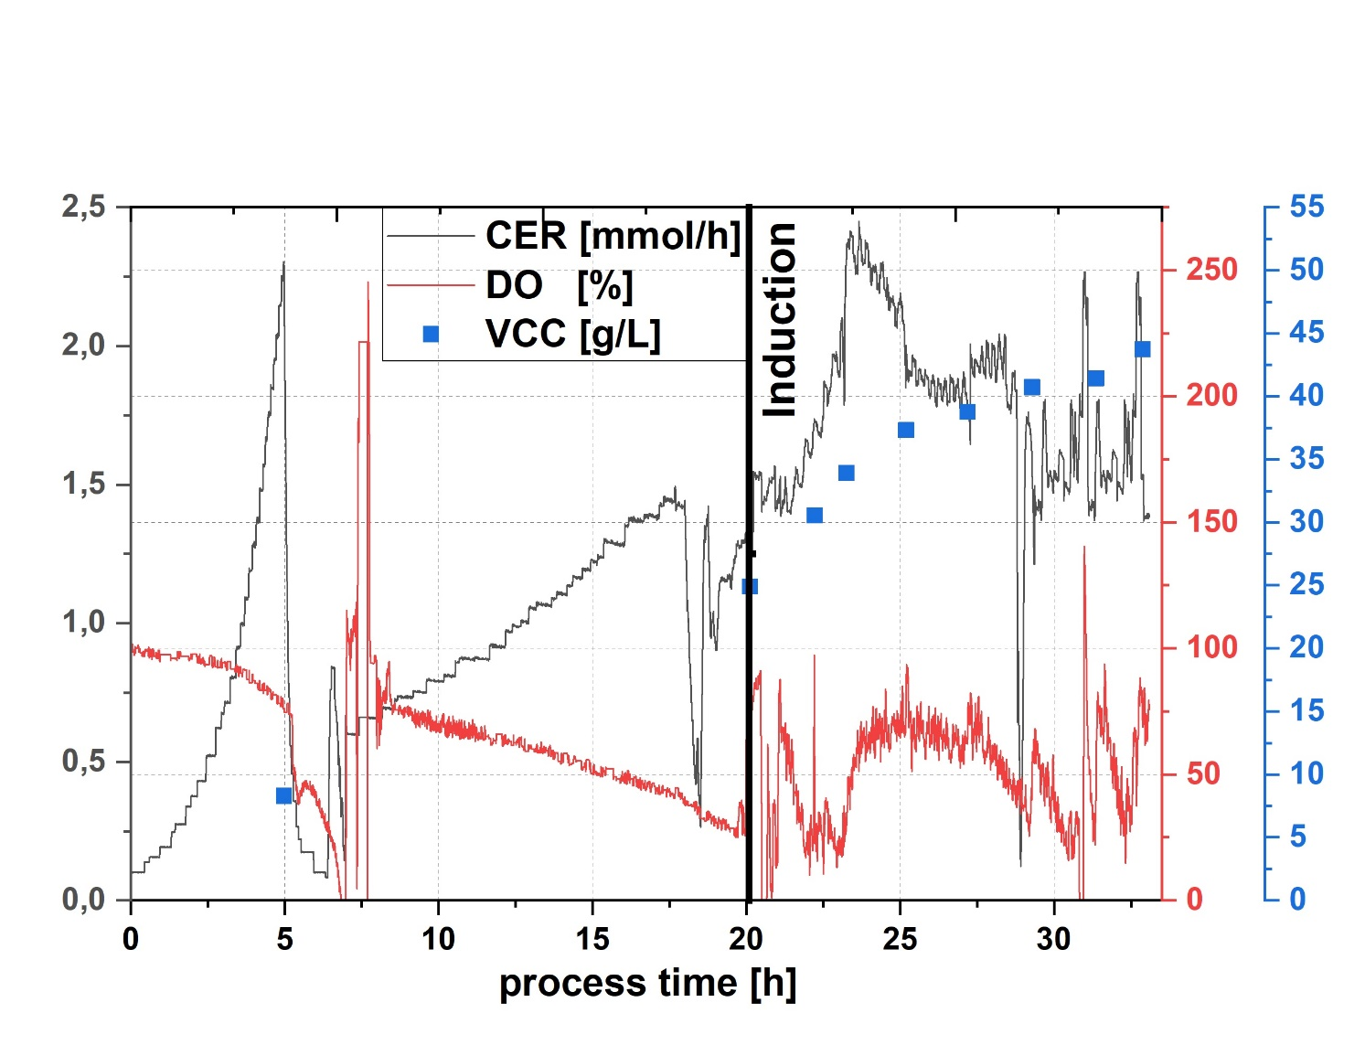
S1: Process data of a performed fed-batch process for the given recombinant protein. Induction lasted for 12 h with a µ of 0.18 h⁻¹. VCC is the viable cell concentration calculated via flow cytometry analysis. CER is the carbon evolution rate, DO the dissolved oxygen.

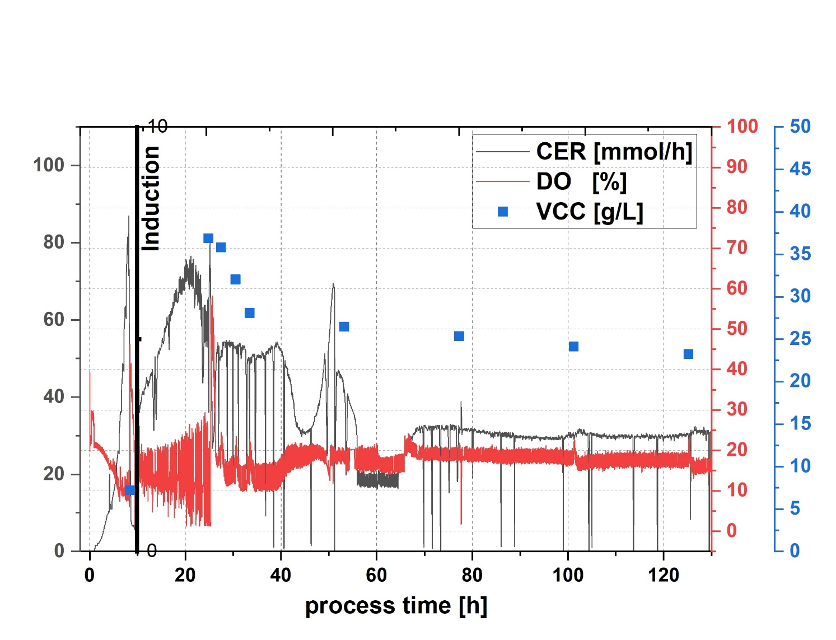
S2: Process data of a performed one-pot chemostat process for the given recombinant protein. Dilution rate was 0.09 h⁻¹. Induction was performed with lactose.

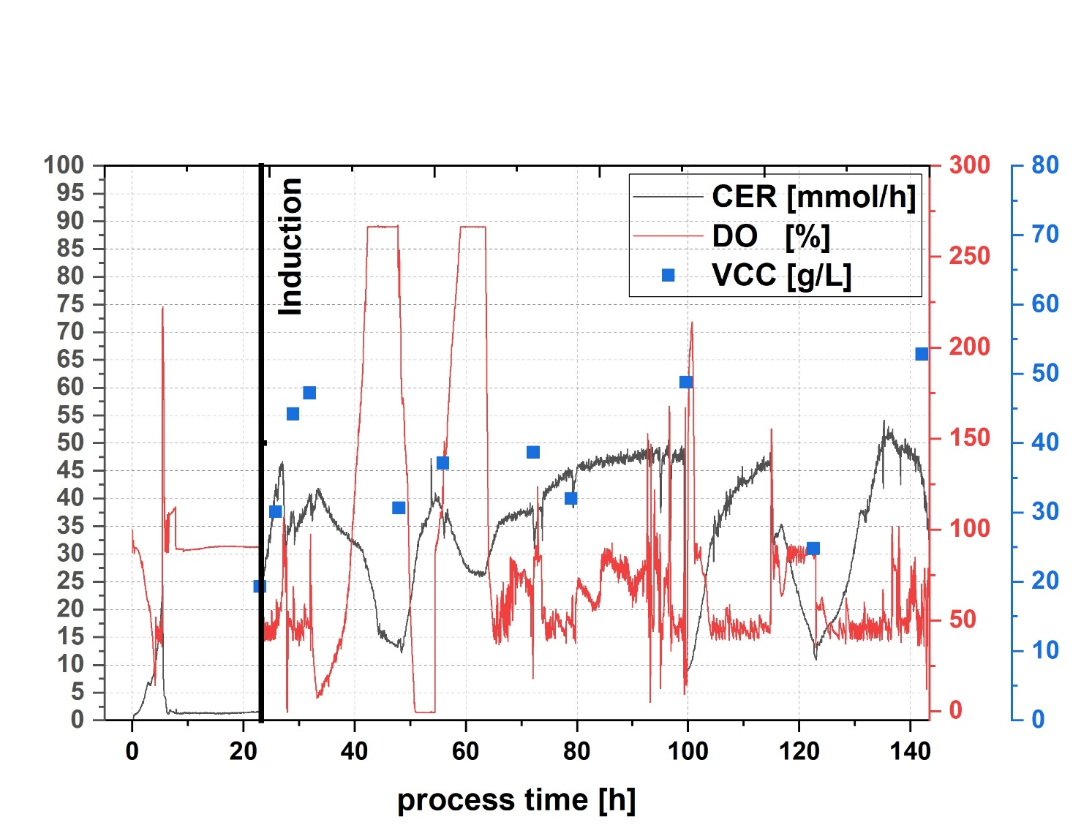
S3: Process data of a performed cascaded chemostat process for the given recombinant protein. Dilution rate was 0.16 h⁻¹. Induction was performed with lactose.

