**S1. The detailed description of the feature selection procedure.**

We assumed be a matrix that represents *l* features of  training samples, where matrix  is constructed by the individual functional connectivity features extracted from the previous analysis. Let be the  dimensional categorical target labels that we aim to predict (+1 = patients with BD; -1 = HCs). The linear regression model used for the prediction can be defined as follows:

 (1)

where denotes the regression coefficient vector, and indicates the predicted label vector. To estimate the regression coefficient vector, the following objective function should be minimized based on the k-support norm:

 (2)

whereis the regularization parameter controlling the degree of sparsity in the models, is the *i*-th largest element in the vectors, and *r* is the unique integer insatisfying

 (3)

As the structural connectivity matrix in our study were obtained on the entire group rather than on a single subject (i.e., the dimensions of the two matrices $a$ nd  are 1×l), we therefore replicated the size of  by the sample size of the patients with BD and the size of  by the sample size of the HCs to construct a new structural connectivity matrix . Let be a matrix that denotes the new generated anatomical connectivity, where p is the sample size of the patients with BD. The elements from 1 to *p* row vectors are the same, and the elements from  to  row vectors are identical.

In our proposed method, we utilized the complementary information conveyed by the structural connectivity features. We added the following inter-modality distance constraint:

 (4)

where  denotes the feature vectors of the functional connectivity features of the *i*-th subject and denotes the feature vectors of the anatomical connectivity features of the *i*-th subject. The relative distance between the inter-modality feature vectors is . Therefore, the object function of our proposed multi-modality feature selection model can be further defined as follows:

 (5)

where  and  control the sparseness and the degree of preservation of the inter-modality relationship, respectively. The proportion of different penalty terms were adjusted by controlling hyperparameter  and . For example, we can remove the effects of inter-modality relationship from the “feature selection” step by setting  =0. By adding , we can obtain a sparser X vector.

**Table S1.** The distribution of consensus connections.

|  |  |  |
| --- | --- | --- |
| **Index** | **Region 1** | **Region 2** |
| 1 | L ACC | L sMPFC |
| 2 | L ACC | L Superior Frontal Gyrus |
| 3 | L Caudate | L Supp Motor Area |
| 4 | L SupraMarginal | L Postcentral |
| 5 | L Hippocampus | L Middle Cingulum |
| 6 | L Inferior Occipital | R Calcarine |
| 7 | R Amygdala | L Supp Motor Area |
| 8 | L Paracentral Lobule | L Inferior Frontal Oper |
| 9 | L ParaHippocampal | R Middle Cingulum |
| 10 | L Middle Temporal | L ParaHippocampal |
| 11 | R Middle Temporal | L Cuneus |
| 12 | L Putamen | L Supp Motor Area |
| 13 | L Middle Temporal Pole | L Olfactory |
| 14 | R Superior Temporal Pole | L Rectus |
| 15 | L Precuneus | L Angular |
| 16 | L Amygdala | L sMPFC |
| 17 | R Amygdala | L sMPFC |
| 18 | L Caudate | R Inferior Frontal Triangle |
| 19 | R Caudate | R Paracentral Lobule |
| 20 | R Heschl | L Rectus |
| 21 | L Angular | R SupraMarginal |
| 22 | R Angular | L Lingual |
| 23 | R Superior Temporal Gyrus | L Amygdala |
| 24 | R Caudate | L Middle Frontal Orbit |
| 25 | L Angular | L Hippocampus |
| 26 | L Olfactory | R Superior Frontal Gyrus |
| 27 | L Angular | L Calcarine |
| 28 | R ACC | R sMPFC |
| 29 | R Middle Occipital Gyrus | L Lingual |
| 30 | L Middle Temporal Gyrus | R Superior Temporal Gyrus |
| 31 | L Hippocampus | L Supp Motor Area |
| 32 | L Middle Temporal Gyrus | L Medial Frontal Orbit |
| 33 | L Inferior Parietal | L Lingual |
| 34 | R Fusiform | L ParaHippocampal |
| 35 | L Superior Temporal Gyrus | R Heschl |
| 36 | R Caudate | R Precentral |
| 37 | L Middle Temporal Gyrus | R Rectus |
| 38 | L SupraMarginal | R Fusiform |
| 39 | L Lingual Gyrus | L Insula |
| 40 | L Middle Temporal Gyrus | L Precuneus |

†Note: **Consensus connections are arranged in descending order according to their discriminative ability in classification. ACC, anterior cingulate cortex; sMPFC, superior medial prefrontal cortex.**

**Table S2.**  The distribution of consensus nodes.

|  |  |
| --- | --- |
| **Index** | **Regions** |
| 1 | L ACC |
| 2 | L sMPFC |
| 3 | L Supp Motor Area |
| 4 | L Middle Temporal |
| 5 | L Angular |
| 6 | L ParaHippocampal |
| 7 | L Hippocampus |
| 8 | L Caudate |
| 9 | R Amygdala |

†Note: **Consensus nodes are arranged in descending order according to their discriminative ability in classification. ACC, anterior cingulate cortex; sMPFC, superior medial prefrontal cortex.**

**Table S3.** After controlling for age, gender, and educational years, functional connections showing significantly altered connections strength in patients with BD type I compared to HC.

|  |  |  |  |  |
| --- | --- | --- | --- | --- |
| **Connections** | **Patients with BD type I**  **(N =79)** | **Healthy Controls**  **(N = 94)** | ***P* value** | **FDR corrected** |
| **Corrected Structural Connections** | | | | |
| None |  |  |  |  |
| **Corrected Functional Connections** | | | | |
| L ACC--- L sMPFC | -0.1 ±0.23 | 0.09±0.23 | <0.0001 | 0.0017 |
| R ACC---L sMPFC | -0.09±0.27 | 0.08±0.26 | <0.0001 | 0.0368 |
| L ACC--- R sMPFC | -0.09±0.25 | 0.7±0.24 | <0.0001 | 0.0365 |
| R ACC---R sMPFC | -0.1±0.22 | 0.08+0.29 | <0.0001 | 0.0492 |

†Note: FDR corrected using Benjamini and Hochberg method.

‡Abbreviation: L, left; R, right; ACC, anterior cingulate cortex; sMPFC, superior medial prefrontal cortex.

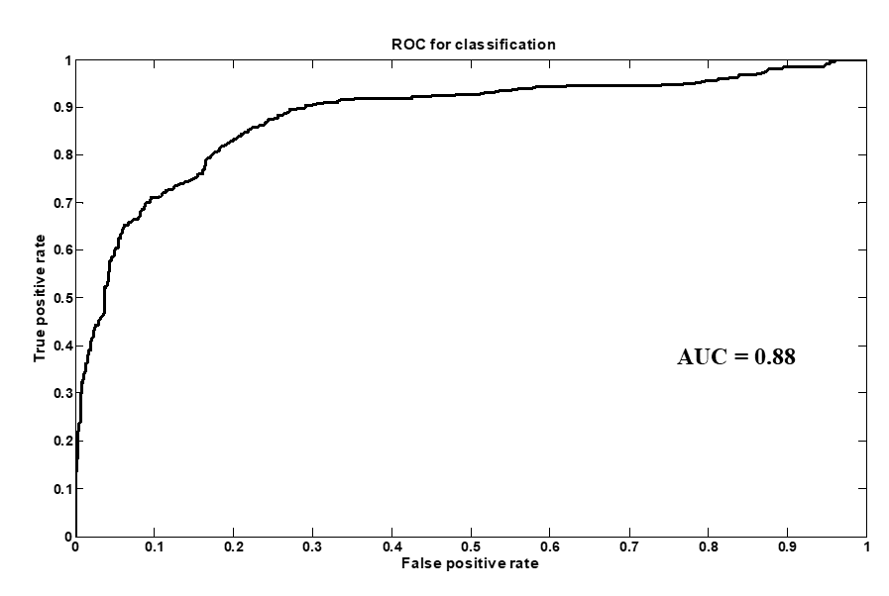

**Figure S1.** ROC curves of the classification.