Table S1 Distribution of 36 STs and allele genes
ST | CC | aspA | glnA | gltA | glyA | pgm | tkt | uncA
52 | ST-52 complex | 9 | 25 | 2 | 10 | 22 | 3 | 6
448 | U | 61 | 70 | 22 | 18 | 2 | 74 | 47
692 | ST-692 complex | 37 | 52 | 57 | 26 | 127 | 29 | 23
951 | U | 18 | 100 | 82 | 24 | 138 | 116 | 63
953 | U | 18 | 100 | 22 | 104 | 133 | 105 | 6
991 | ST-692 complex | 37 | 52 | 57 | 26 | 107 | 29 | 23
995 | U | 2 | 4 | 84 | 105 | 126 | 25 | 57
999 | U | 64 | 22 | 85 | 142 | 134 | 101 | 16
1540 | ST-1275 complex | 76 | 33 | 22 | 104 | 43 | 109 | 31
2367 | U | 2 | 28 | 29 | 28 | 74 | 267 | 124
3938 | U | 64 | 22 | 68 | 97 | 134 | 301 | 16
4069 | U | 18 | 2 | 22 | 104 | 1 | 86 | 31
4382 | U | 258 | 174 | 207 | 193 | 134 | 381 | 284
4571 | U | 80 | 22 | 72 | 325 | 116 | 423 | 305
6168 | U | 64 | 22 | 20 | 474 | 134 | 495 | 6
7805 | U | 64 | 22 | 85 | 98 | 134 | 101 | 16
9175 | U | 15 | 22 | 78 | 18 | 205 | 101 | 188
9176 | ST-952complex | 18 | 22 | 22 | 98 | 241 | 381 | 16
9177 | U | 61 | 70 | 22 | 18 | 43 | 74 | 31
9178 | U | 64 | 22 | 20 | 98 | 134 | 101 | 16
9179 | U | 64 | 22 | 85 | 142 | 134 | 17 | 16
9180 | U | 64 | 226 | 310 | 142 | 134 | 593 | 16
9181 | U | 64 | 22 | 203 | 100 | 134 | 301 | 16
9182 | U | 64 | 22 | 310 | 100 | 134 | 54 | 16
9183 | U | 64 | 22 | 20 | 142 | 134 | 495 | 6
9184 | U | 64 | 22 | 20 | 100 | 144 | 17 | 16
9185 | U | 258 | 174 | 31 | 193 | 241 | 160 | 131
9186 | U | 64 | 22 | 85 | 100 | 134 | 17 | 16
9190 | U | 37 | 673 | 29 | 64 | 127 | 718 | 23
9191 | ST-692 complex | 437 | 52 | 57 | 26 | 129 | 29 | 23
9192 | U | 484 | 33 | 77 | 100 | 885 | 269 | 16
9194 | U | 64 | 450 | 388 | 100 | 134 | 519 | 16
9195 | U | 64 | 226 | 85 | 100 | 134 | 719 | 16
9196 | U | 485 | 430 | 375 | 473 | 885 | 116 | 411
9197 | U | 18 | 22 | 22 | 754 | 345 | 86 | 47
9222 | U | 64 | 450 | 203 | 142 | 134 | 593 | 16
Note. ¹U, Unassigned clonal complex. ²Novel allele genes are indicated in bold.

Table S2 Antibiotic resistance pattern among different C.jejuni strains

 |  |  | Macrolides |  | Quinolones |  |  | Aminoglycosides Chloramphenicols Tetracyclines lincomides
Number | ST | CC | ERY | AZI | NAL |  | CIP | GEN | STR | CHL | FLO | TET | TEL | CLI
1 | 52 | ST-52 complex | R | R | R |  | R | R | R | R | R | R | R | R
2 | 448 | U | R | R | R |  | R | R | R | R | R | R | R | R
3 | 448 | U | R | R | R |  | R | R | R | R | R | R | R | R
4 | 448 | U | R | R | R |  | R | R | R | R | R | R | R | R
5 | 448 | U | S | R | R |  | R | R | R | S | R | R | S | R
6 | 692 | ST-692 complex | S | S | R |  | S | R | R | S | R | R | R | R
7 | 951 | U | S | R | S |  | S | R | R | S | R | R | R | R
8 | 951 | U | S | R | S |  | S | R | R | S | R | R | S | S
9 | 953 | U | S | S | S |  | S | R | R | R | R | R | R | R
10 | 991 | ST-692 complex | S | S | S |  | S | R | R | R | R | R | R | R
11 | 991 | ST-692 complex | S | S | S |  | S | R | R | S | R | R | R | R
12 | 995 | U | S | S | S |  | S | R | R | S | R | R | R | R
13 | 999 | U | S | S | S |  | S | R | R | R | S | R | R | R
14 | 1540 | ST-1275 complex | S | R | S |  | S | R | R | R | S | S | R | S
15 | 2367 | U | S | S | S |  | R | R | R | S | R | S | R | S
16 | 2367 | U | S | S | S |  | S | R | R | S | S | S | R | R
17 | 3938 | U | S | S | S |  | S | R | R | S | S | S | R | R
18 | 4069 | U | S | S | R |  | R | S | S | S | S | R | S | S
19 | 4382 | U | S | S | S |  | S | S | S | S | S | R | S | S
20 | 4382 | U | S | S | S |  | S | S | S | S | S | R | S | S
21 | 4571 | U | S | S | S |  | S | S | S | S | S | R | S | S
22 | 6168 | U | S | S | R |  | S | S | R | S | R | S | S | R
23 | 7805 | U | S | S | R |  | R | S | S | S | S | S | S | S
24 | 9175 | U | S | S | R |  | R | S | S | S | S | S | S | S
25 | 9175 | U | S | S | S |  | S | S | R | S | R | S | R | R
26 | 9175 | U | S | S | S |  | S | S | S | S | S | S | S | S
27 | 9175 | U | S | S | S |  | S | S | S | S | S | S | S | S
28 | 9176 | ST-952 complex | S | S | S |  | S | S | S | S | S | S | S | S
29 | 9176 | ST-952 complex | S | S | S |  | S | S | R | S | S | S | S | S
30 | 9177 | U | S | S | S |  | S | S | S | S | S | S | S | S
31 | 9177 | U | S | S | S |  | S | S | S | S | S | S | S | S
32 | 9178 | U | S | S | S |  | S | S | S | S | S | S | S | S
33 | 9178 | U | S | S | S |  | S | S | S | S | S | S | S | S
34 | 9179 | U | S | S | S |  | S | S | S | S | S | S | S | S
35 | 9180 | U | S | S | S |  | S | S | R | S | S | S | S | S
36 | 9180 | U | S | S | S |  | S | S | S | S | S | S | S | S
37 | 9181 | U | S | S | S |  | S | S | S | S | S | S | S | S
38 | 9182 | U | S | S | S |  | S | S | S | S | S | S | S | S
39 | 9183 | U | S | S | S |  | S | S | S | S | S | S | S | S
40 | 9183 | U | S | S | S |  | S | S | S | S | S | S | S | S
41 | 9184 | U | S | S | S |  | S | S | S | S | S | S | S | S
42 | 9185 | U | S | S | S |  | S | S | S | S | S | S | S | S
43 | 9185 | U | S | S | S |  | S | S | S | S | S | S | S | S
44 | 9186 | U | S | S | S |  | S | S | S | S | S | S | S | S
45 | 9190 | U | S | S | S |  | S | S | S | S | S | S | S | S
46 | 9190 | U | S | S | S |  | S | S | S | S | S | S | S | S
47 | 9191 | ST-692 complex | S | S | S |  | S | S | S | S | S | S | S | S
48 | 9192 | U | S | S | S |  | S | S | S | S | S | S | S | S
49 | 9192 | U | S | S | S |  | S | S | S | S | S | S | S | S
50 | 9194 | U | S | S | S |  | S | S | S | S | S | S | S | S
51 | 9195 | U | S | S | S |  | S | S | S | S | S | S | S | S
52 | 9196 | U | S | S | S |  | S | S | S | S | S | S | S | S
53 | 9196 | U | S | S | S |  | S | S | S | S | S | S | S | S
54 | 9197 | U | S | S | S |  | S | S | S | S | S | S | S | S
55 | 9197 | U | S | S | S |  | S | S | S | S | S | S | S | S
56 | 9222 | U | S | S | S |  | S | S | S | S | S | S | S | S
57 | 9222 | U | S | S | S |  | S | S | S | S | S | S | S | S
Note. ¹U, Unassigned clonal complex. ²R represents resistant, ³S represents sensitive. ⁴Full and abbreviation name of antibiotics were: azithromycin (AZI),
nalidixic acid (NAL), ciprofloxacin (CIP), gentamicin (GEN), streptomycin (STR), chloramphenicol (CHL), florfenicol (FLO), tetracycline (TET), telithromycin (TEL), and clindamycin (CLI),
erythromycin (ERY).

Figure S1| Phylogenetic relatedness of 57 Campylobacter jejuni isolates. The minimum spanning tree showing the relatedness of 57 Campylobacter jejuni strains and other Campylobacter jejuni strains from the pubMLST database which was based on the STs using Bionumerics software, version 7.6. Each ST is represented by a circle; the size of each circle is proportional to the number of isolate species comprising that ST. Circles (STs) are linked by lines indicating allelic variation. Background shading highlights clonal complexes. The colour of each ST indicates the animal host from which each isolate was recovered (red-human, green -wild bird, blue-chicken, yellow-dog, sky blue-monkey). Thick and short lines connect single-locus variants, thin and longer lines connect double-locus variants and dashed lines represent three or more allele differences.

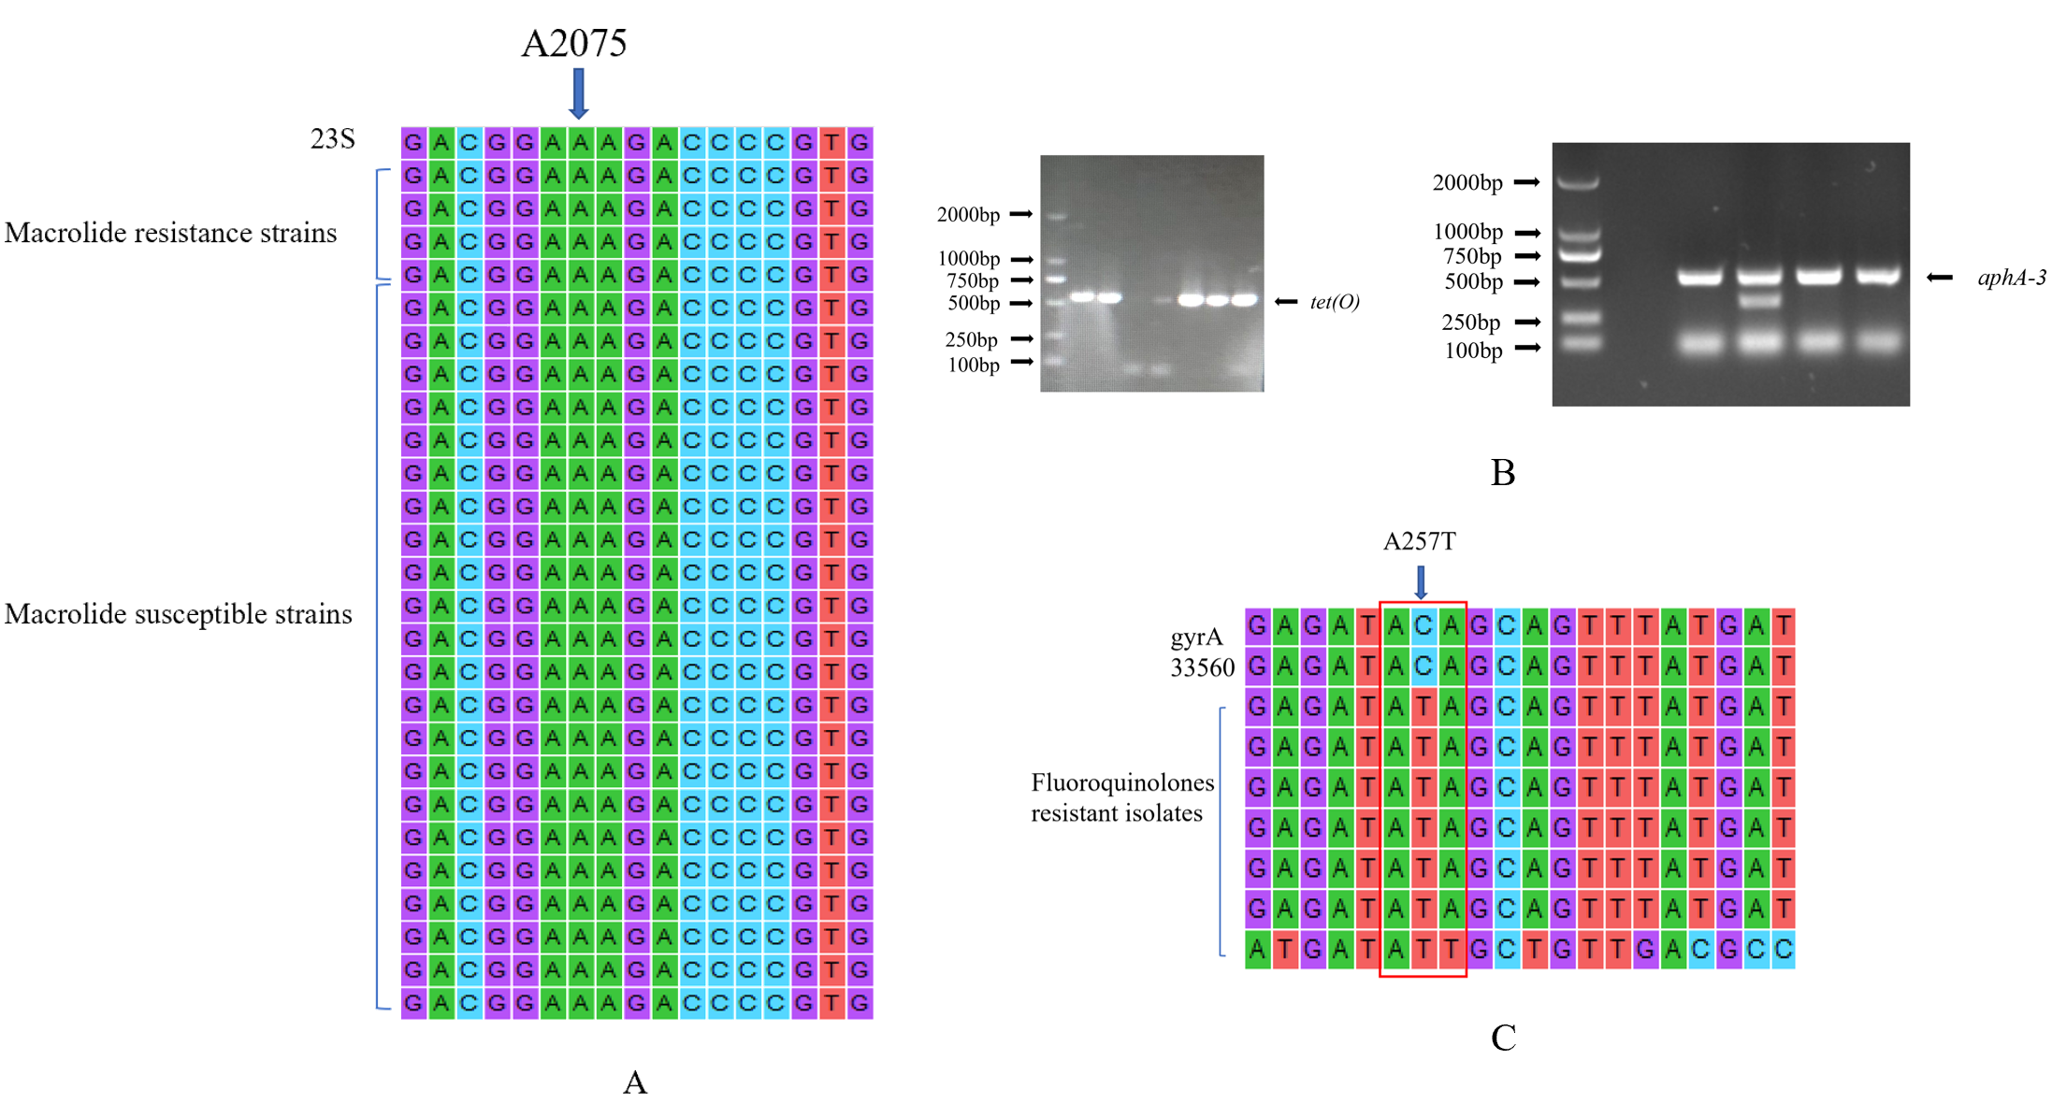
Figure S2 | Antibiotic resistance mechanism of Campylobacter jejuni. A. Nucleotide sequence alignment
of partial gene sequences of C. jejuni isolates compared to Campylobacter 23S rRNA sequences from the
GenBank database; B. Agarose gel of detection presence tet(O) gene and aphA-3 gene; C. A Nucleotide sequence alignment
of partial gene sequences of C. jejuni isolates compared to Campylobacter gyrA sequences from the GenBank
database.

