Supplementary Material

Supplementary Figures
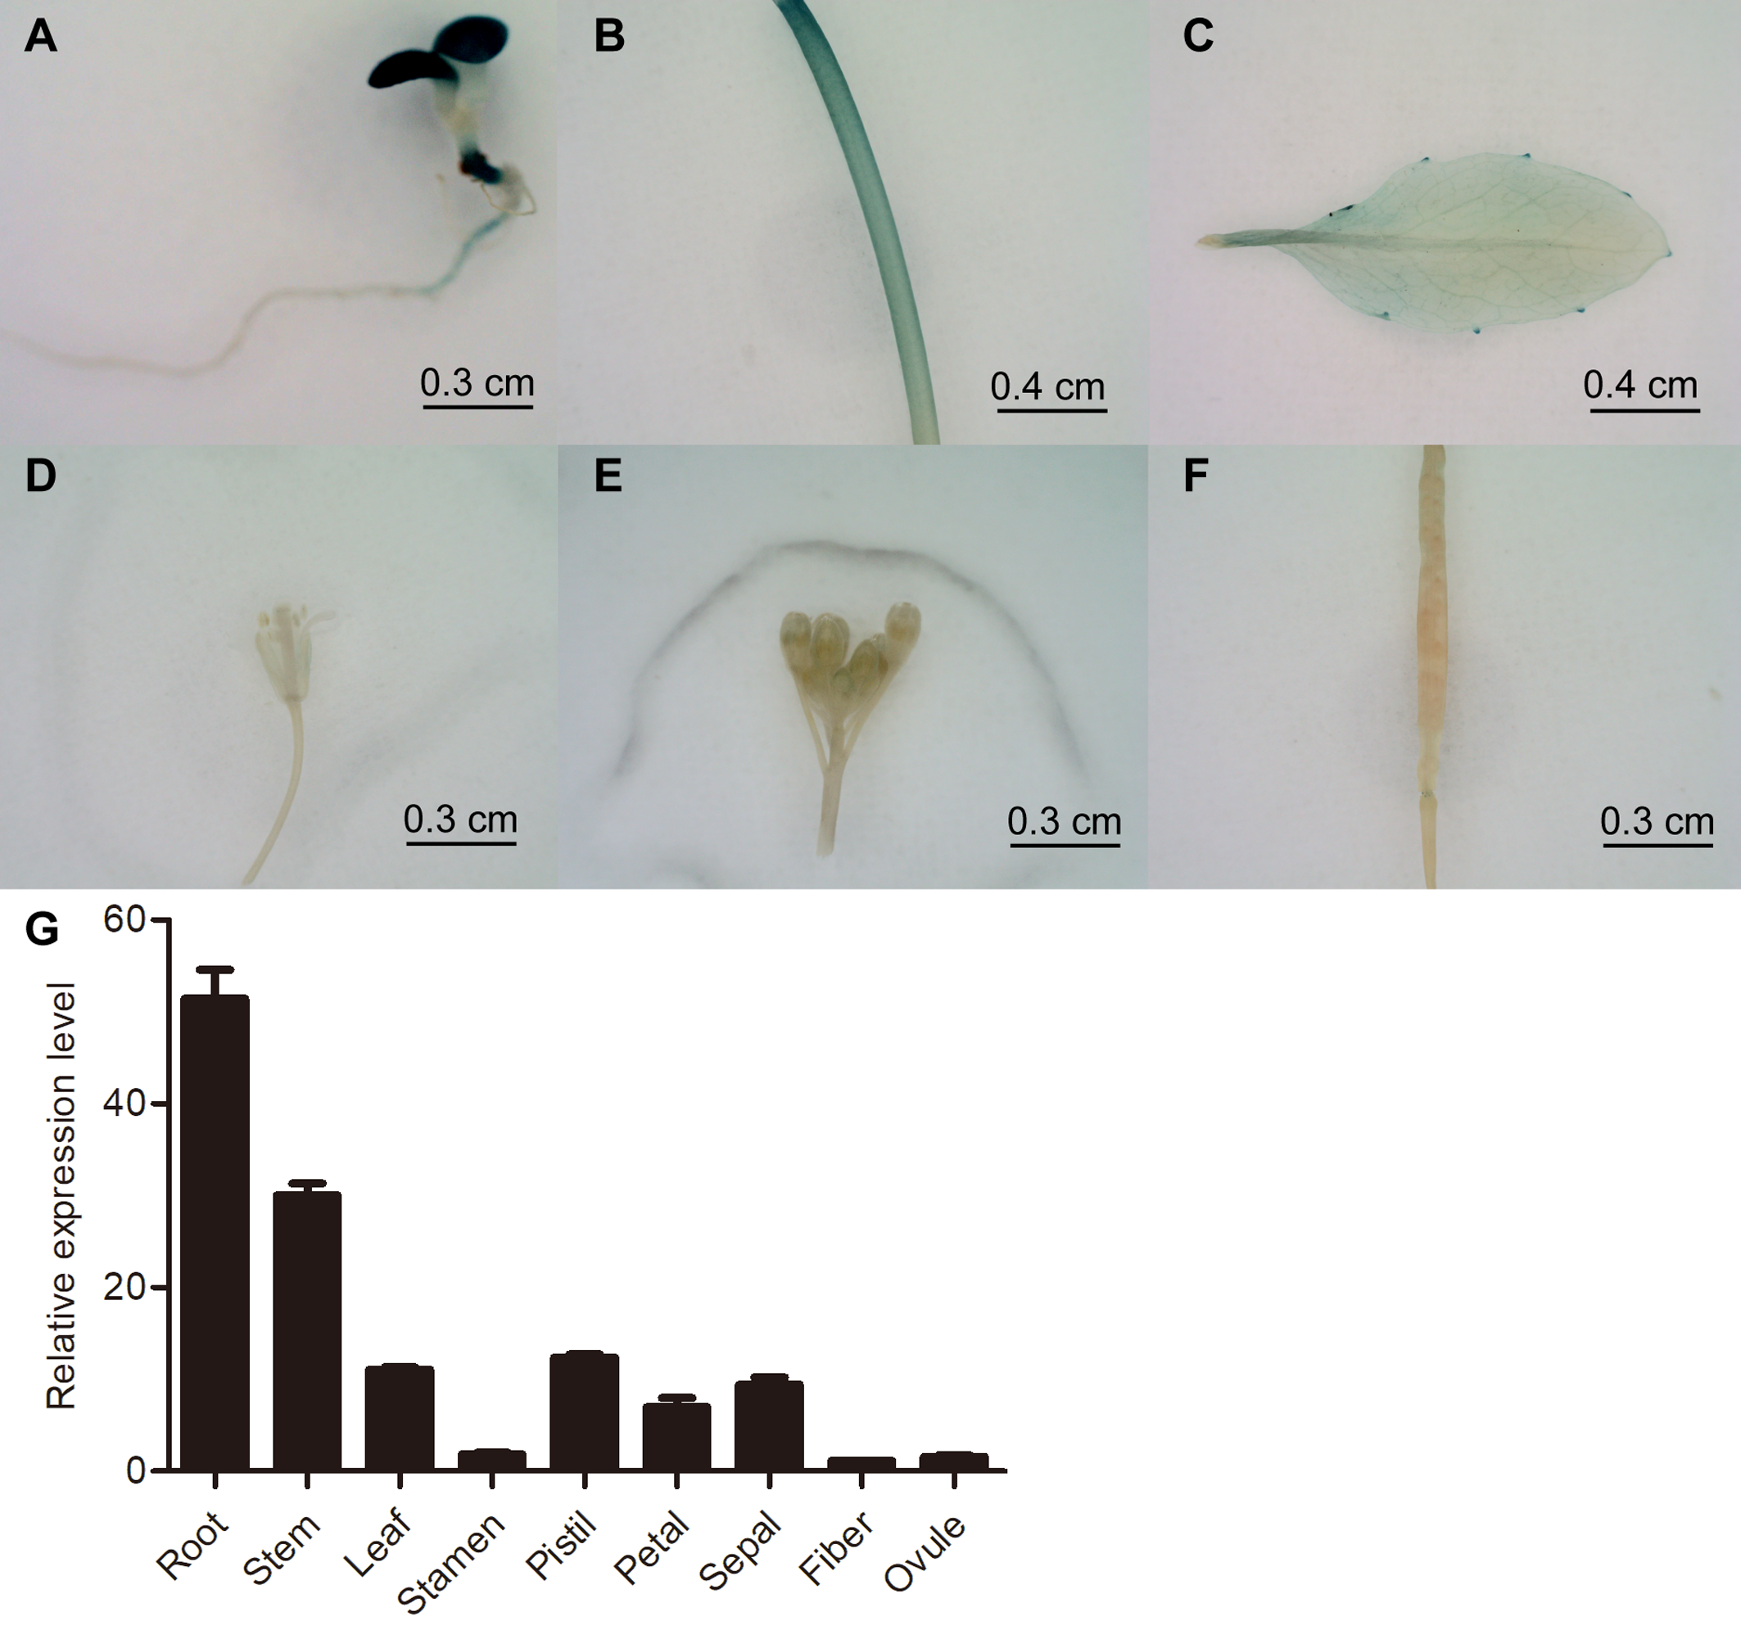
Supplementary Figure S1. Expression characteristics of GhWRKY91 in different tissues. (A-F) GUS staining of 8-day-old seedlings as well as stem, leaf, bud, flower and pod tissues of ProGhWRKY91::GUS transgenic Arabidopsis plants. (G) Tissue expression analysis of GhWRKY91 in the roots, stems, leaves, stamens, pistils, petals, sepals, fibre and ovules of the CCRI10 cotton variety. GhActin served as the reference gene. The data are the means ± SEs of three biological replicates.

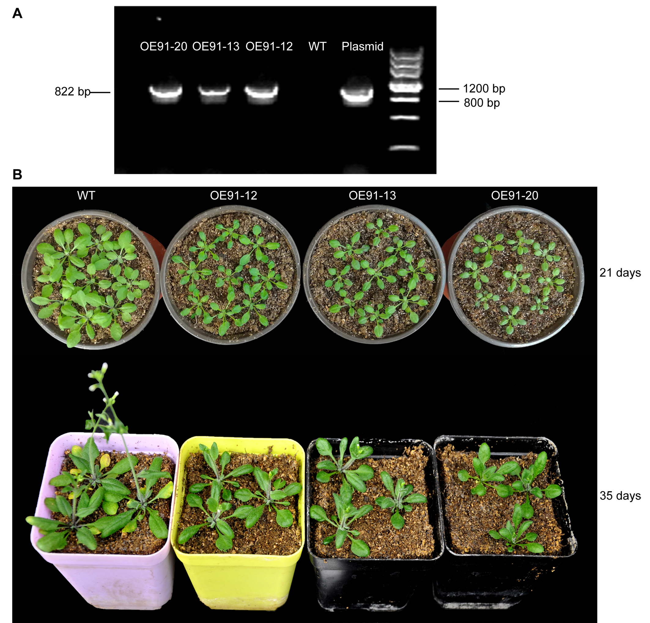
Supplementary Figure S2. PCR and phenotypic identification of GhWRKY91-overexpressing Arabidopsis plants. (A) Identification of GhWRKY91-overexpressing Arabidopsis plants via PCR. The plasmid represents the 35S::GhWRKY91 recombinant vector. (B) Phenotypic characteristics of the WT and transgenic plants grown for 21 and 35 days. The seeds of the WT and transgenic lines were germinated on 1/2MS agar media in a growth chamber at 22°C under a 16 h light/8 h dark photoperiod. Two-week-old seedlings were then transplanted into soil in a greenhouse at 22 ± 1 °C under a 16 h light/8 h dark photoperiod, and the natural growth phenotype was observed for 21-day-old and 35-day-old plants.

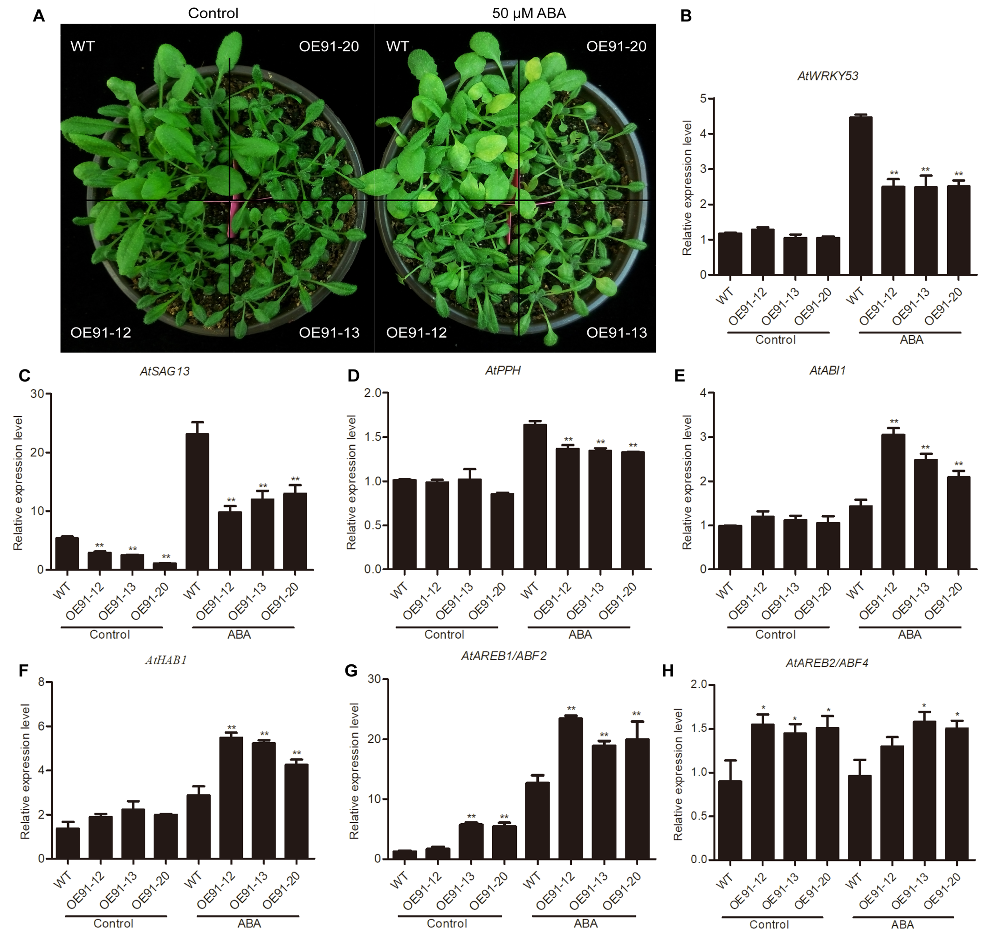
Supplementary Figure S3. Overexpression of GhWRKY91 in Arabidopsis delayed ABA-induced leaf senescence. (A) Phenotypic characteristics of WT and transgenic plants under control and ABA treatments. Three-week-old WT and transgenic plants grown in soil were sprayed with 50 μM ABA and then were allowed to grow normally for 2 days. Plants grown under normal growth conditions severed as controls. All the plants were grown in a greenhouse at 22 ± 1 °C under a 16 h light/8 h dark photoperiod. (B-D) Expression levels of SAGs in WT and transgenic plants. (E-H) Expression levels of ABA-responsive genes in WT and transgenic plants. AtUBQ10 was used as the reference control. The data are the means ± SEs of three biological replicates. ** P<0.01 and * P<0.05.

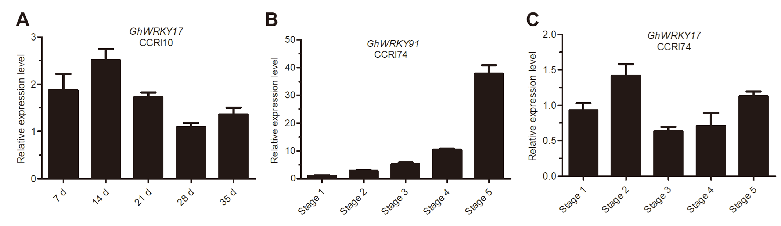
Supplementary Figure S4. Expression patterns of GhWRKY91 and GhWRKY17 during leaf senescence. (A) Expression levels of GhWRKY17 at different stages of leaf senescence in the CCRI10 variety. (B-C) Expression profiles of GhWRKY91 and GhWRKY17 in leaves displaying various degrees of leaf senescence. Stages 1-5 represent young leaves, mature leaves without leaf senescence, leaves showing less than 25% leaf senescence, leaves showing approximately 50% leaf senescence and leaves showing more than 75% leaf senescence, respectively. GhActin served as the reference gene. The data are the means ± SEs of three biological replicates.

SupplementaryTables
Supplementary Table S1. Primers used in this study
Primer name | Sequence ( 5’- 3’)
gene clone-WRKY91-F | ATGGACAGCGGTGGTAGT
gene clone-WRKY91-R | TCAGCAGATCCCAACCT
promoter-WRKY91-F | CACGACATCAACATGCACA
promoter-WRKY91-R | GGTCGATGATGATGAAGCG
qRT-PCR-GhActin-F | ATCCTCCGTCTTGACCTTG
qRT-PCR-GhActin-R | TGTCCGTCAGGCAACTCAT
qRT-PCR-WRKY91-F | AGACACAACAACACATCCGCT
qRT-PCR-WRKY91-R | CCATCCCTGAATCCGGTTCC
qRT-PCR-WRKY17-F | GACTGGTGTTTTAGAGCCTGGG
qRT-PCR-WRKY17-R | GGAGGTTTGCCATGAGAAGAAGG
qRT-PCR-AtUBQ10-F | AGATCCAGGACAAGGAAGGTATTC
qRT-PCR-AtUBQ10-R | CGCAGGACCAAGTGAAGAGTAG
qRT-PCR-AtHAB1-F | AACTGCTGTTGTTGCCTTG
qRT-PCR-AtHAB1-R | GGTTCTGGTCTTGAACTTTCT
qRT-PCR-AtABI1-F | ATGATCAGCAGAACAGAGAGT
qRT-PCR-AtABI1-R | TCAGTTCAAGGGTTTGCT
qRT-PCR-AtAREB1/ABF2-F | CATGATTGGCTGTTGCTGTT
qRT-PCR-AtAREB1/ABF2-R | AGGCTCAGAGTCAGAGTCAG
qRT-PCR-AtAREB2/ABF4-F | TACTCCCTTACCTTTGATGA
qRT-PCR-AtAREB2/ABF4-R | TGTTGCCTTCCAGGAGGCAC
qRT-PCR-AtP5CS-F | GAGGGGGTATGACTGCAAAA
qRT-PCR-AtP5CS-R | AACAGGAACGCCACCATAAG
qRT-PCR-AtP5CS1-F | AAGGCTTGTGATACGGATATGG
qRT-PCR-AtP5CS1-R | ATGCACAAGAAGGGTTTCCA
qRT-PCR-AtRD29A-F | ATCACTTGGCTCCACTGTTGTTC
qRT-PCR-AtRD29A-R | AAAACACACATAAACATCCAAAGT
qRT-PCR-AtCOR15A-F | ACTCAGTTCGTCGTCGTTTCT
qRT-PCR-AtCOR15A-R | CTTCTTTTCCTTTCTCCTCCAC
qRT-PCR-AtSAG12-F | TCCAATTCTATTCGTCTGGTGTGT
qRT-PCR-AtSAG12-R | CCACTTTCTCCCCATTTTGTTC
qRT-PCR-AtSAG13-F | GTGCCAGAGACGAAACTC
qRT-PCR-AtSAG13-R | GCTGTAAACTCTGTGGTC
qRT-PCR-AtORE1/ANAC029-F | CTTACCATGGAAGGCTAAGATGGG
qRT-PCR- AtORE1/ANAC029-R | TTCCAATAACCGGCTTCTGTCG
qRT-PCR-AtWRKY6-F | AGGAAGAACAAGATGATCGAACGGACG
qRT-PCR-AtWRKY6-R | TCACCAACTCATTTTTCGCACGCT
qRT-PCR-AtWRKY53-F | CAGACGGGGATGCTACGG
qRT-PCR-AtWRKY53-R | GGCGAGGCTAATGGTGGT
qRT-PCR-AtSGR1-F | TCCAAGAAGAAGAACCAATCGA
qRT-PCR-AtSGR1-R | GTATAGCCTATTTGCCCATCCT
qRT-PCR-AtPPH-F | CTCCGAAGCTTTATCTAGGTGT
qRT-PCR-AtPPH-R | ATCTTCTTTCCCCATAACGGTC
qRT-PCR-AtNYC1-F | TGTTATAACCGGAAGCACTAGG
qRT-PCR-AtNYC1-R | TTCTTTCTAGCTGACTCGCTAG
M13(-47) | TAATACGACTCACTATAGGG
35S | GACGCACAATCCCACTATCC
T7 | TAATACGACTCACTATAGGG
3’AD-R | AGATGGTGCACGATGCACAG
3’BD-R | AAGAGTCACTTTAAAATTTGTAT
pHIS2-R | TGCCTGCTCATTTTTTAGTATA
SK-WRKY91-F(BamHI) | AGAACTAGTGGATCCATGGACAGCGGTGGTAG
SK-WRKY91-R(XhoI) | GGGCCCCCCCTCGAGTCAGCAGATCCCAACCT
LUC-WRKY17-F(XhoI) | GGGCCCCCCCTCGAGTACTCTTTTATTGGGTCGATAT
LUC-WRKY17-R(BamHI) | AGAACTAGTGGATCCCTCTGCTCATACGAAAACAAA

Supplementary Table S2. Nucleic acid sequences of the potential target genes of GhWRKY91 used for the Y1H system
Gene ID | Gene Name | Nucleic acid sequences
Gh_A09G0118 | GhWRKY3 | ATATTATTATTGCTGTTATAATAATTGCATTGACTAATAAAATTCTTAAACCAAATATTATTATTGCTGTTATAATAATTGCATTGACTAATAAAATTCTTAAACCAAATATTATTATTGCTGTTATAATAATTGCATTGACTAATAAAATTCTTAAACCAA
Gh_A06G0179 | GhWRKY17 | AATTTCAAACGGCTAATCCCCACCTTTTGACCTTATCTCTTGTCAGTGACCCAAATTTCAAACGGCTAATCCCCACCTTTTGACCTTATCTCTTGTCAGTGACCCAAATTTCAAACGGCTAATCCCCACCTTTTGACCTTATCTCTTGTCAGTGACCCA
Gh_A05G3186 | GhWRKY25 | ATATACAAATTTATTATTAGCATGATTGACTAATTTAACAATAGTGTCTCTAACAATATACAAATTTATTATTAGCATGATTGACTAATTTAACAATAGTGTCTCTAACAATATACAAATTTATTATTAGCATGATTGACTAATTTAACAATAGTGTCTCTAACA
Gh_A08G2417 | GhWRKY27a | GCGACTTGGTCAGCAATTGGAGTTTTGACCTTACCTCACTCTTCAGTCCACGCGACTTGGTCAGCAATTGGAGTTTTGACCTTACCTCACTCTTCAGTCCACGCGACTTGGTCAGCAATTGGAGTTTTGACCTTACCTCACTCTTCAGTCCAC
Gh_Sca005564G01 | GhWRKY68 | GCACTGTTCAATATCCGTACAAGTGGTTGACCTACAATTGCCCGTCGATCCGCACTGTTCAATATCCGTACAAGTGGTTGACCTACAATTGCCCGTCGATCCGCACTGTTCAATATCCGTACAAGTGGTTGACCTACAATTGCCCGTCGATCC
Gh_A05G0863 | GhAPX1 | TCCCCGACGTTCCGACAAGTTTTGACTATTTTATTTTCTTAAAATAAAAAGCTCCCCGACGTTCCGACAAGTTTTGACTATTTTATTTTCTTAAAATAAAAAGCTCCCCGACGTTCCGACAAGTTTTGACTATTTTATTTTCTTAAAATAAAAAGC
Gh_D05G0507 | GhRD22 | AACACCAAAAGTTTAATATCTAGATTTTGACCATATTTACGTTAACAAAGTAAAACACCAAAAGTTTAATATCTAGATTTTGACCATATTTACGTTAACAAAGTAAAACACCAAAAGTTTAATATCTAGATTTTGACCATATTTACGTTAACAAAGTAA
Red indicates the W-box cis-element.

Supplementary Table S3. Predicted cis-acting elements in the promoter of GhWRKY91
Cis-element | Position | Sequence (5’-3’) | Function
Stress responsive elements
ABRE | -1576(-) | ACGTG | Cis-acting element involved in the ABA responsiveness
ARE | -1618(+) | AAACCA | Cis-acting regulatory element essential for the anaerobic induction
LTR | -124(+) | CCGAAA | Cis-acting element involved in low-temperature responsiveness
Light responsive elements
AE-box | -1683(-) | AGAAACAA | Part of a module for light response
Box 4 | -116(+) | ATTAAT | Part of a conserved DNA module involved in light responsiveness
I-box | -115(+) | GTATAAGGCC | Part of a light responsive element
G-box | -1576(+) | CACGTC | Cis-acting regulatory element involved in light responsiveness
GT1-motif | -1134(+) | GGTTAA | Light responsive element
Sp1 | -1650(+) | GGGCGG | Light responsive element
Development-related elements
O2-site | -1754(-) | GATGATGTGG | Cis-acting regulatory element involved in zein metabolism regulation
CAT-box | -269(-) | GCCACT | Cis-acting regulatory element related to meristem expression
Others
AT-rich element | -970(-) | ATAGAAATCAA | Binding site of AT-rich DNA binding protein (ATBP-1)
MBSI | -824(-) | TTTTTACGGTTA | MYB binding site involved in flavonoid biosynthetic genes regulation
W-box | -758(+) | TTGACC

