Supplementary Material

Supplementary Figure 1
qRT-PCRs, performed on three different REM_RNAi #T2.1 plants, to evaluate the specificity of the three fragments chosen for the RNA interference construct. Two genes were selected: REM37, which was the possible off target of one of the fragments, and REM39, that was chosen due to the fact that is the REM gene with the higher expression in the tissues of interest belonging to the same cluster as REM34, REM35 and REM36 (Mantegazza et al., 2014). Downregulation of neither REM37 nor REM39 was measured. The expression levels of REM34, RERM35 and REM36 were also measured, to make sure that the silencing of the target genes was maintained in the T2 generation.

Supplementary Figure 2
REM_RNAi T2 lines have a reduced seed set compared to the wild-type
(A) and (C) Graphs showing the mean number of ovules/silique in the wild-type and REM_RNAi #1T2.4a to REM_RNAi #1T2.4j and REM_RNAi #1T2.5a to REM_RNAi #1T2.5j plants resistant to the herbicide selection, divided in seeds and not fertilized ovules. Compared to the wild-type situation, in which each silique contains on average 50 ovules, the REM_RNAi siliques have on average 36.9 to 46.5 ovules. On average between 32.25% and 58.61% of ovules, depending from the analyzed line, failed to be fertilized, while no aborted ovules were detected in the wild type situation. Bars indicate the Standard deviation.
(B) and (D) For each line an evaluation of T-DNA abundancy in each of the 9 plants analyzed, is presented. The RT-PCR analyses shows a various amount of T-DNA amplicon which is clearly unrelated to the ovule abortions and the overall seed set in both REM_RNAi #1T2.4 and REM_RNAi #1T2.5 lines. The primers used are on ACTIN7 used as normalizer and the herbicide resistance gene BAR used to estimate the copy of T-DNA.

Supplementary Figure 3
Analysis of three different REM_RNAi T2 transgenic lines, all characterized by shorter siliques compared to the wild-type, a reduced seed set and ovule abortions. The majority of the embryo sacs of these lines showed a block in the earliest stages of megagametogenesis. Pollen collected from mature anthers is characterized by the presence of some degenerate grains, with no nucleus.
(White bar=5mm, black bar=20µm)

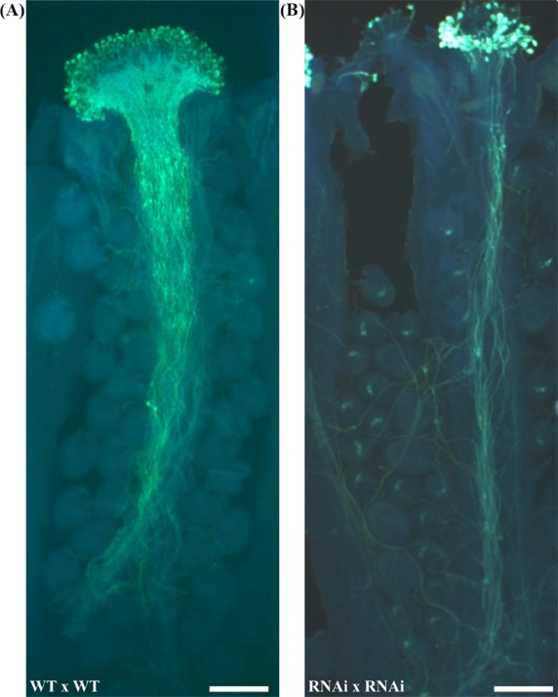

Supplementary Figure 4
REM_RNAi #T3.1 pollen germination test in vitro, showing a 30% decrease in the germination capability in the REM_RNAi line compared to the wild type.
Aniline staining was employed to visualize pollen grains adhesion to the stigma and pollen tube germination and growth. Compared to the wild-type situation (A), a lower number of REM_RNAi #1 grains were able to adhere to the stigma and to germinate (B). In both cases the pollen tubes grow correctly until the end of the transmitting tract, In REM_RNAi #1T3.1x REM_RNAi #1T3.1 cross, several ovules are not targeted by a pollen tube correlated to the fact that about 40% of the ovules are blocked in FG1 stage and so synergids are not properly formed (Bar=100μm).

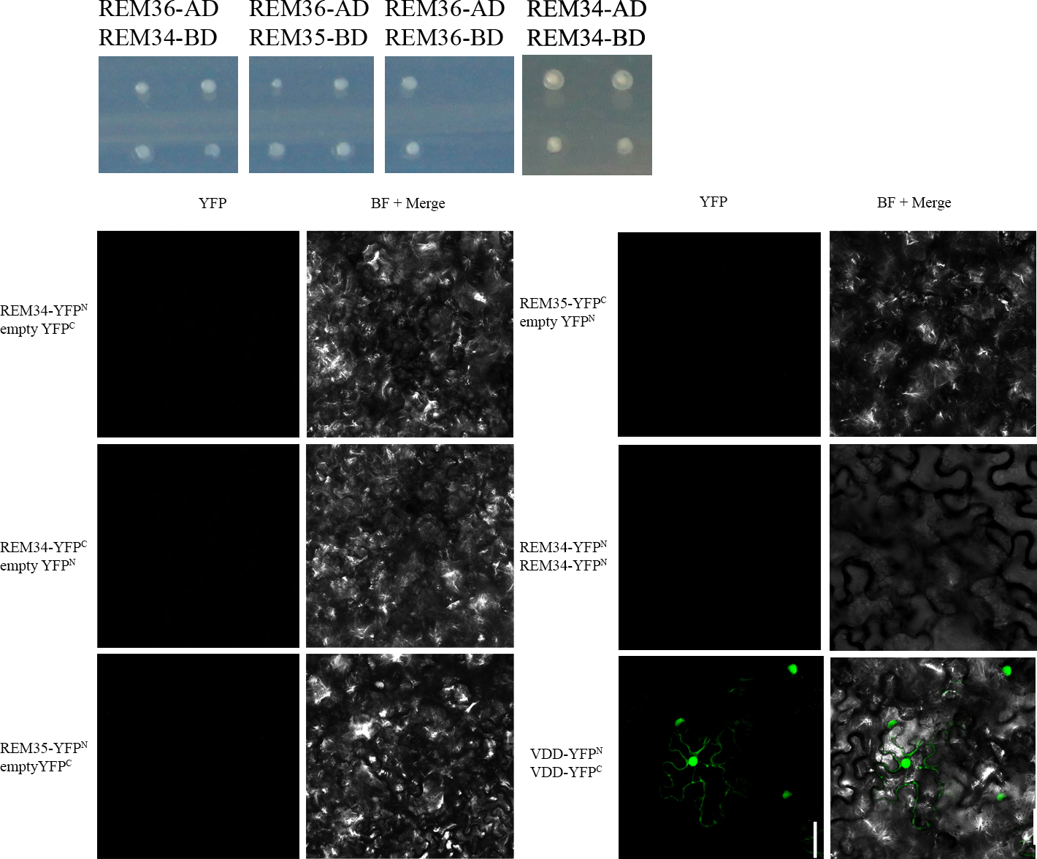
Supplementary Figure 5
In the Y2H assays, no interactions were detected for REM36 and REM34 homodimers.
Negative and positive controls for the BiFC experiment: all the constructs were cotranformed with the corresponding empty vector to test for false positive interaction. The REM34_REM34 interaction, which was found to be negative in the Y2H screening, was also employed as a negative control. Finally, as a positive control, the VDD_VDD interaction (M. Mendes et al, 2014) was tested.

Supplementary Figure 6
q-RTPCR on inflorescence on REM_EAR #T2.1 and #T2.7. Compared to the wild type, none of the REM genes analyzed were found to be downregulated.

Supplementary Table 1: PRIMERS
GGTCTCACACCTGAAGTTTCCAAAGGAAAGG | REM34 FW golden gate cloning
GGTCTCTATCTCTCTCCAACCTCTTC | REM34 REV golden gate cloning
GGTCTCAAGATTCCAAGTCCAAGGACAAG | REM35 FW golden gate cloning
GGTCTCGTGTCAACAATAATCTGTTTC | REM35 REV golden gate cloning
GGTCTCAGACATCATCAAGTCTAGAAGGGAAG | REM36 FW golden gate cloning
GGTCTCGCCTTAATCATCCCACAAGCACAC | REM36 REV golden gate cloning
CACCATGGCGGATCCACCACATTTC | REM34 FW for REM34_EAR fusion
CTAAGCAAATCCAAGTCTAAGTTCAAGATCAAGATCAAGAACCAGATTACTGCTGAGG | REM34 RV for REM34_EAR fusion
GGGGACAAGTTTGTACAAAAAAGCAGGCTTCATGGCGGATCCACCACATTTCTC | REM34 FW for CDS cloning GW
GGGGACCACTTTGTACAAGAAAGCTGGGTTCAAACCAGATTACTGCTGAGG | REM34 REV for CDS cloning GW
GGGGACAAGTTTGTACAAAAAAGCAGGCTTCATGGATGATCCAGCAATTTC | REM35 FW for CDS cloning GW
GGGGACAAGTTTGTACAAAAAAGCAGGCTTCATGGCGAATCATCCACTA | REM36 FW for CDS cloning GW
GGGGACCACTTTGTACAAGAAAGCTGGGTCTTACTTGAGGATTTTGTTGATTTCCG | REM35/REM36 RV for CDS cloning GW
CACTCAGGTTTCATCACAGCACG | REM34 FW in situ probe | From Mantegazza et al., 2014
TAATACGACTCACTATAGGGTAGCCCATTAGCGCAGCAGAAG | REM34 REV +T7 in situ probe | From Mantegazza et al., 2014
TCCTATGTAGCTTCTGGCGATGG | REM35 FW in situ probe | From Mantegazza et al., 2014
TAATACGACTCACTATAGGGAGTCTCCCCTCCTTCATCAAATGG | REM35 REV +T7 in situ probe | From Mantegazza et al., 2014
CTCACTGCTTCCAACCTACG | REM36 FW in situ probe | From Mantegazza et al., 2014
TAATACGACTCACTATAGGGAGCGTCCACGGATAAAAGCCTG | REM36 REV +T7 in situ probe | From Mantegazza et al., 2014
AGCTTGTGAGACTGCTCCAC | REM34 FW expression analysis
CCTGATCGGAGACTGAGCAC | REM34 REV expression analysis
CATTTGATGAAGGAGGGGAGAC | REM35 FW expression analysis
CTTTCTAGCTCTGACCGAATCC | REM35 REV expression analysis
TCACTTGCTGGACACACCTC | REM36 FW expression analysis
TCGTCTCGAAGACAGTGTGC | REM36 REV expression analysis
TGGCATAGAGTGGAAGTCGCATC | REM37 FW expression analysis
GTCATTCGGGGTTTCCTATCC | REM37 REV expression analysis
GGAGAAGTTTCTGCCGTGAG | REM39 FW expression analysis
GGTCACTGGCCACTCTTCTC | REM39 REV expression analysis
GCAAGCTCAGTGGTGACTAC | MDS FW expression analysis
ACATCCACTTTCTGACATGC | MDS REV expression analysis
GTTAACCGTTGCTCACAGAC | NLE FW expression analysis
GCCTTTGCAAGTAAACAATG | NLE REV expression analysis
AGTCGCCTGCTGCTAAGACAAA | RBR FW expression analysis
ATGACAGTCCTGAGCCACTTGG | RBR REV expression analysis
CTTCTGATTCATCACCGGACTC | KRP6 FW expression analysis | From Liu J et al. 2008
ACACCAAACGACGAACTGTTCT | KRP6 REV expression analysis | From Liu J et al. 2008
ATGGGATCGTCTGCGGATACA | HAM1 FW expression analysis | From Latrasse et al., 2008
GAATTCGTGAGAGCGAGTATCGCA | HAM1 REV expression analysis | From Latrasse et al., 2008
CCTTTAACTCCTGATCAAGCTAT | HAM2 FW expression analysis | From Latrasse et al., 2008
CTACAGCGCACTCTACTGAATC | HAM2 REV expression analysis | From Latrasse et al., 2008
ATCTCGGTGACGGGCAGGACC | BAR gene FW
TCTACACCCACCTGCTGAAG | BAR gene REV
CGTTTCGCTTTCCTTAGTGTTAGCT | Actin 7 FW
AGCGAACGGATCTAGAGACTCACCTTG | Actin 7 REV

