Supplementary Information:

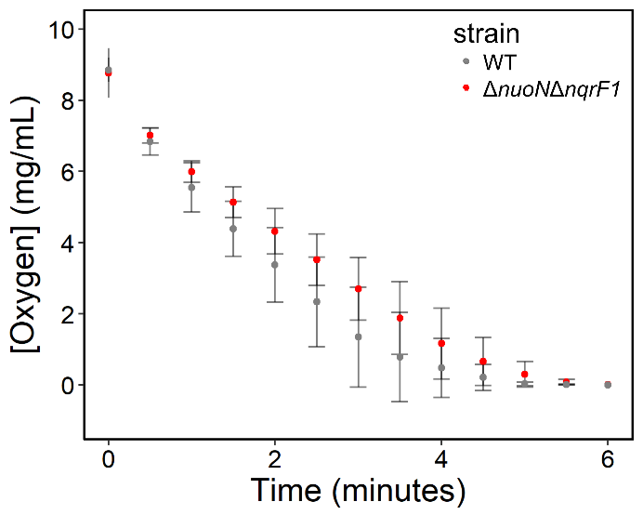
Figure S1: Oxygen consumption of WT and ΔnuoNΔnqrF1 grown in 50 mL culture volumes of M5 supplemented with 0.1% (w/v) tryptone and 20 mM d,l-lactate. 25 mL of oxygen saturated culture were transferred to a 50 mL conical tube and oxygen concentration was measured over time using an optical DO probe.

