Supplementary Material

1 Supplementary Figures
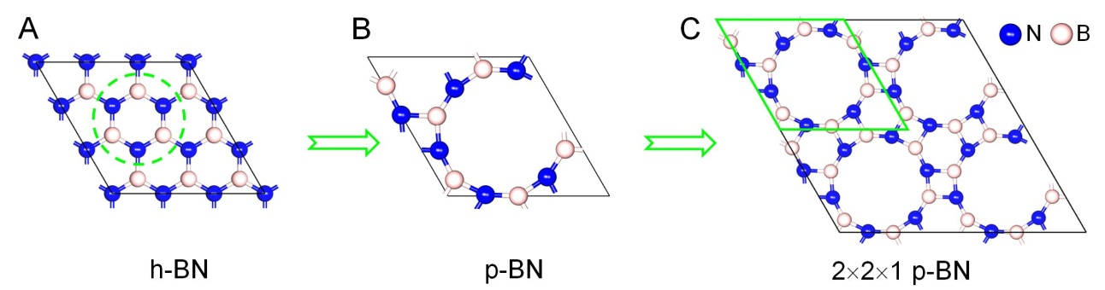
FIGURE S1│The geometries of original h-BN (A), optimized primitive cell porous BN (p-BN) (B), and supercell 2×2×1 p-BN (C), respectively.

FIGURE S2│The cohesive energies of isolated Au_{n} cluster, Au_{n}/p-BN-V_{N} (n=2~13) and Au bulk.

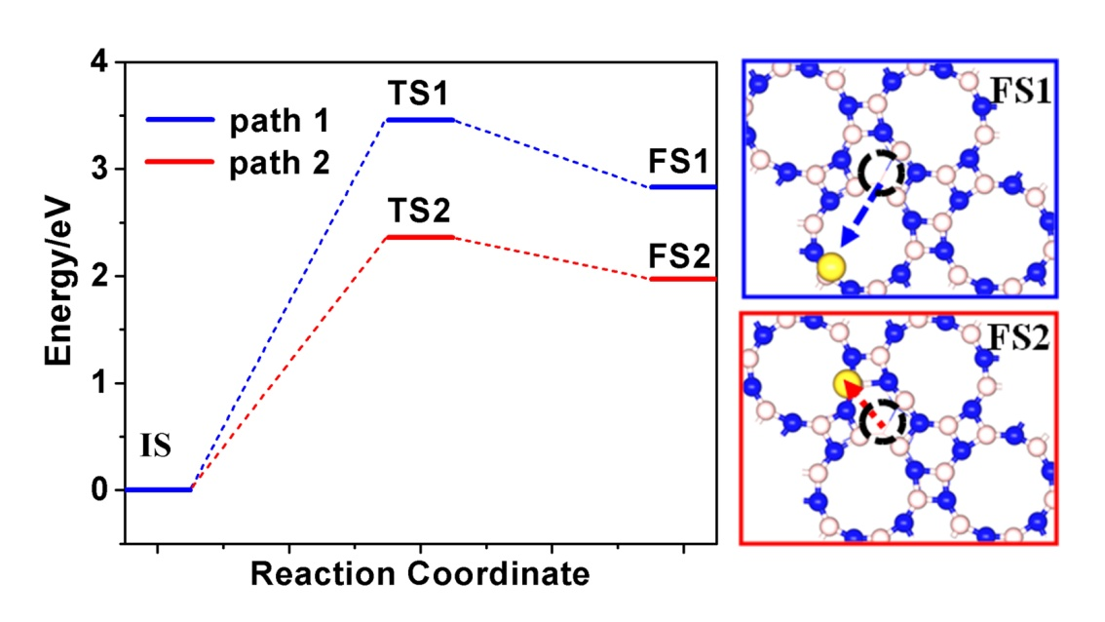
FIGURE S3│Potential energy diagrams for the migration of a single Au atom on V_{N} vacancy.

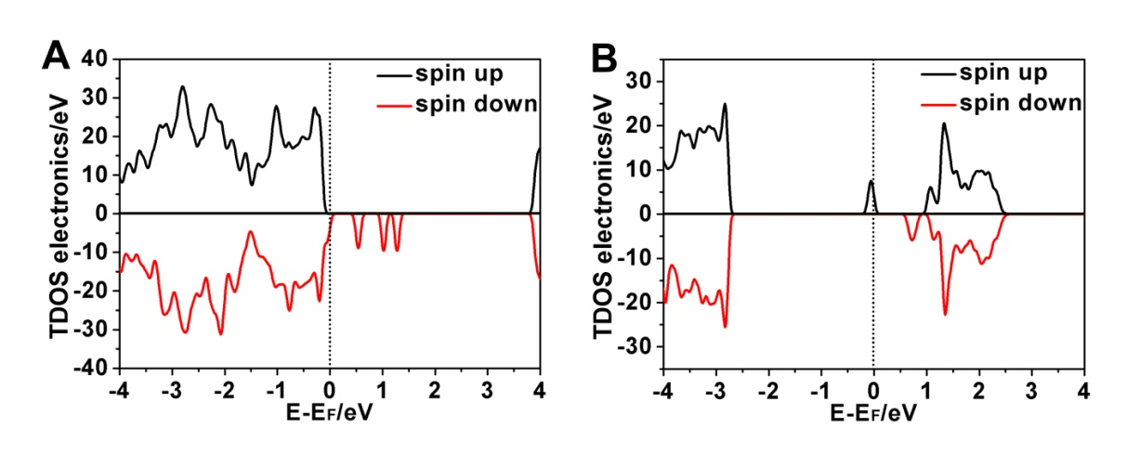
FIGURE S4│Total density of states (TDOS) for p-BN with V_{B} defect (A) and p-BN with V_{N} defect (B).

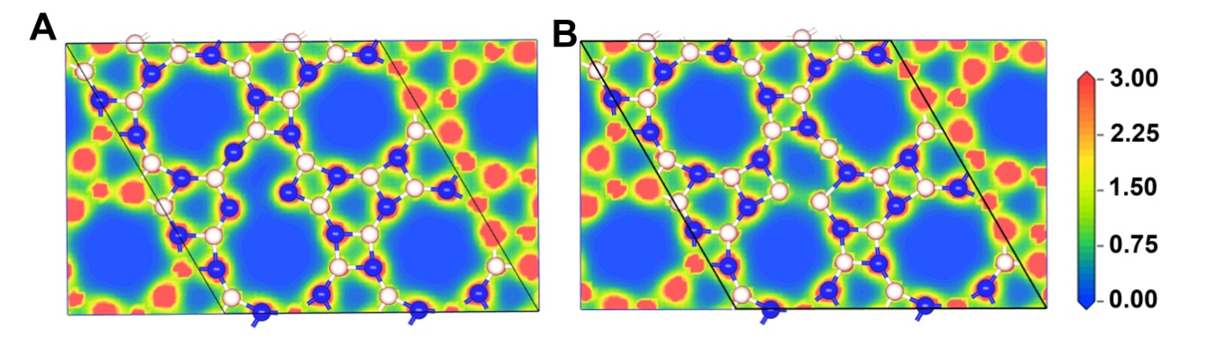
FIGURE S5│The total charge density of p-BN with V_{B} defect (A) and p-BN with V_{N} defect (B).

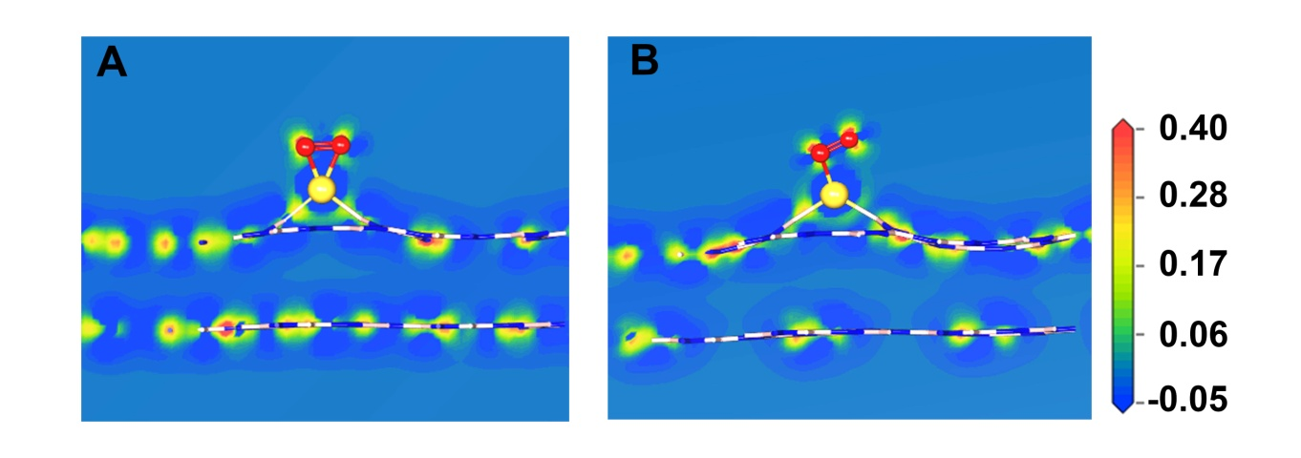
FIGURE S6│ The charge-density difference plots of O₂ adsorbed on Au/p-BN-V_{N}: (A) *O₂-Bridge, (B) *O₂-Pauling.

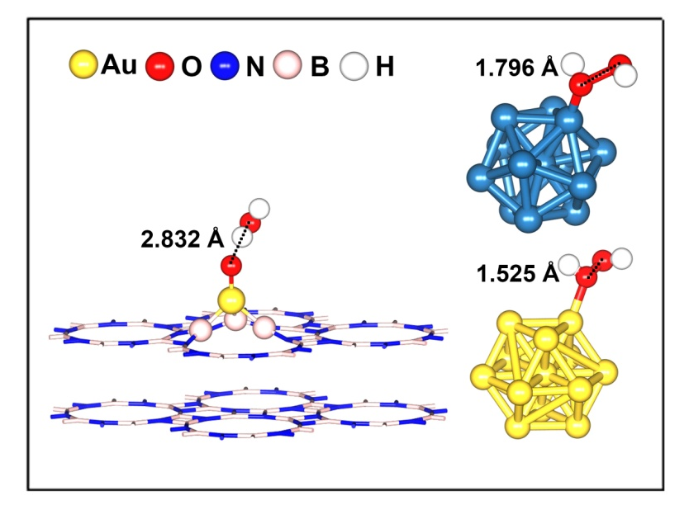
FIGURE S7│The geometry structures of H₂O₂ adsorption on Au/p-BN-V_{N}, Pt₁₃ and Au₁₃ cluster.

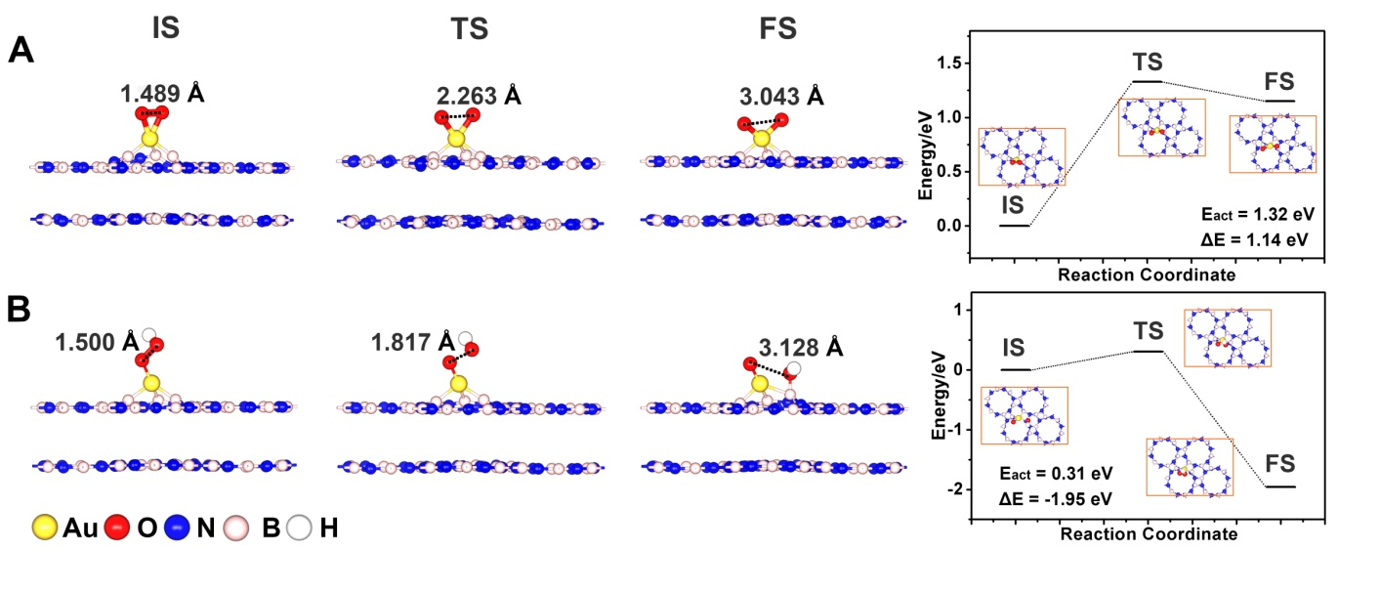
FIGURE S8│The structures for initial state (IS), transition state (TS), final state (FS) and potential energy profile for (A) *O₂→ *O + *O, (B) *OOH → *OH + *O on a Au atom supported p-BN with V_{N}.

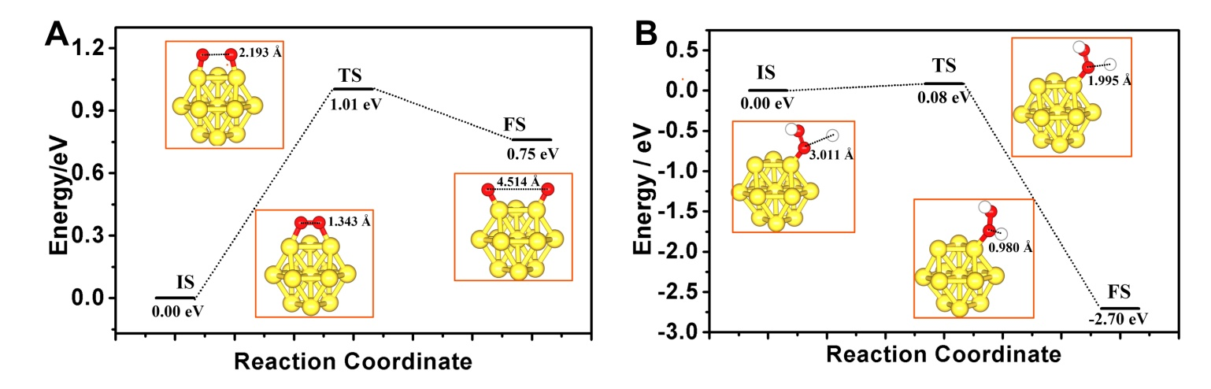
FIGURE S9│The structures for initial state (IS), transition state (TS), final state (FS) and potential energy profile for (A) *O₂→ *O + *O, (B) *OOH + H⁺ + e⁻ → H₂O₂* on Au₁₃ cluster.

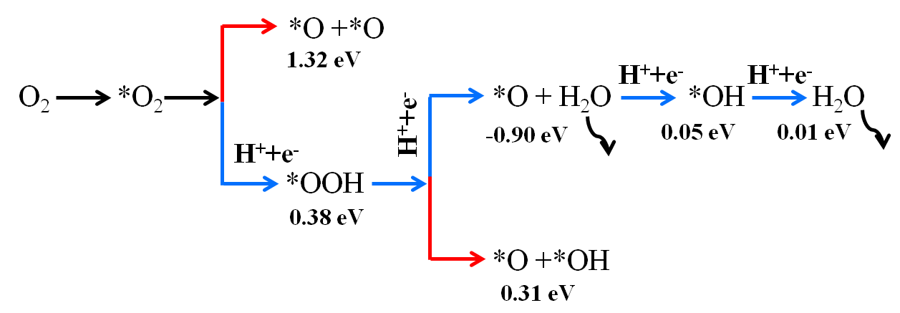
FIGURE S10│The possible reaction pathways for ORR on Au/p-BN-V_{N} surface. The * denotes the adsorption site on the Au/p-BN-V_{N} surface. The values (in units of eV) represent the activation energy. The paths with the blue sign is the most favorable due to their lower activation energies.

2 Supplementary Tables

Table S1│ The adsorption energies (E_{ads}, eV), O-O lengths, and charges transfer amount from catalysts to O₂ obtained by the Hirshfeld Charge analysis of the adsorbed *O₂-Bridge on metal (Pt, Pd, and Au)/p-BN with B and N vacancy defect.
Catalysts | E_{ads} O₂ (eV) | d_{O-O} (Å) | d_{M-O} (Å) | Charge (e)
Pt/p-BN-V_{B} | 1.043 | 1.312 | 2.016 | 0.202
Pt/p-BN-V_{N} | 2.213 | 1.347 | 2.141 | 0.230
Pd/p-BN-V_{B} | 0.611 | 1.302 | 2.070 | 0.205
Pd/p-BN-V_{N} | 1.976 | 1.336 | 2.070 | 0.343
Au/p-BN-V_{B} | 0.522 | 1.280 | 2.008 | 0.128
Au/p-BN-V_{N} | 1.658 | 1.489 | 1.979 | 0.513

Table. S2│ The calculated adsorption energies (E_{ads}/eV) of *O₂, *OOH, *O, *OH and H₂O on Au/p-BN-V_{N}, which obtained in a H₂O solvent environment by COSMO.
 | O₂ (Bridge) | O₂(Pauling) | OOH | OH | O | H₂O
E_{ads}/eV | 1.658 | 0.717 | 1.925 | 3.282 | 5.413 | 0.488
E_{ads}/eV(COSOM) | 2.031 | 1.150 | 1.911 | 3.274 | 5.752 | 0.509

