Supplementary Table S1. Screening analysis for herbicides, pesticides, mycotoxins and metals carried out by Agrifood Technology (Werribee, Australia)
AT3 Chemicals  (LOD <0.010 (mg/kg) |  | AT5 chemicals  (LOD <0.010 (mg/kg)
2-phenylphenol | Fenthion | Azoxystrobin
Abamectin | Fenvalerate | Boscalid
Acephate | Fenvalerate (Total) | Bromacil
Aldrin | Fipronil | Carbendazim / Benomyl
Atrazine | Fludioxonil | Chlorantraniliprole
Azinphos methyl | Flusilazole | Dithianon
Benalaxyl | Fluvalinate | Diuron
BHC alpha | Fluvalinate tau | Fenhexamid
BHC beta | HCB | Fenpyroximate
BHC delta | Heptachlor | Flubendiamide
BHC gamma (Lindane) | Heptachlor epoxide | Imidacloprid
BHC Total | Hexaconazole | Methomyl
Bifenazate | Hexythiazox | Methomyl Oxime
Bifenthrin | Imazalil | Pymetrozine
Bioresmethrin | Indoxacarb | Pyraclostrobin
Bitertanol | Iprodione | Spinetoram
Buprofezin | Kresoxim methyl | Spinosad
Captan | Linuron | Spirotetramat
Carbaryl | Malathion | Tebufenozide
Chlordane | Metalaxyl | Thiabendazole
Chlorfenapyr | Methamidophos | Thiacloprid
Chlorfenvinphos | Methidathion | Thiamethoxam
Chlorothalonil | Metribuzin | Trifloxystrobin
Chlorpyrifos | Mevinphos
Chlorpyrifos methyl | Monocrotophos
Chlorthal dimethyl | Myclobutanil
Clofentezine | Omethoate
Cyfluthrin | Oxyfluorfen | LCMS - MS Mycotoxin Screen  (LOD as shown)
Cyfluthrin beta | Paclobutrazol | Aflatoxin B1 < 1.0 µg/kg
Cyhalothrin lambda | Parathion ethyl | Aflatoxin B2 < 1.0 µg/kg
Cypermethrin | Parathion methyl | Aflatoxin G1 < 1.0 µg/kg
Cypermethrin alpha | Penconazole | Aflatoxin G2 < 1.0 µg/kg
Cyproconazole | Pendimethalin | Deoxynivalenol < 100µg/kg
Cyprodinil | Penthiopyrad | Fumonisin B1 < 20 µg/kg
DDD p,p | Permethrin | Fumonisin B2 < 20 µg/kg
DDE p,p | Phenothrin | HT2 < 20 µg/kg
DDT p,p | Phorate | Nivalenol < 100µg/kg
DDT Total | Phosmet | Ochratoxin A < 1.0 µg/kg
Deltamethrin | Piperonyl butoxide | T2 < 1.0 µg/kg
Diazinon | Pirimicarb | Total Aflatoxin (B1, B2, G1, G2)  < 4.0 µg/kg
Dichlorvos | Pirimiphos methyl | Zearelenoneb < 1.0 µg/kg
Dicloran | Prochloraz
Dicofol | Procymidone
Dieldrin | Profenofos
Difenoconazole | Propargite
Dimethoate | Propiconazole | Mercury
Dimethoate (Total) | Prothiofos | Mercury < 1.0 µg/kg
Dimethomorph | Pyrethrins
Diphenylamine | Pyrimethanil
Disulfoton | Pyriproxyfen
Endosulphan alpha | Quintozene
Endosulphan beta | Sulfoxaflor | Metals
Endosulphan sulphate | Tebuconazole | Aluminium† 58 mg/kg
Endosulphan Total | Tebufenpyrad | Chromium < 0.010 mg/kg
Endrin Total | Terbufos | Copper 5.1 mg/kg
Esfenvalerate | Tetradifon | Lead < 0.030 mg/kg
Ethoprofos | Tolclofos methyl
Etoxazole | Triadimefon
Fenamiphos | Triadimenol | † Not NATA accredited
Fenarimol | Trichlorfon
Fenitrothion | Vinclozolin
Fenoxycarb

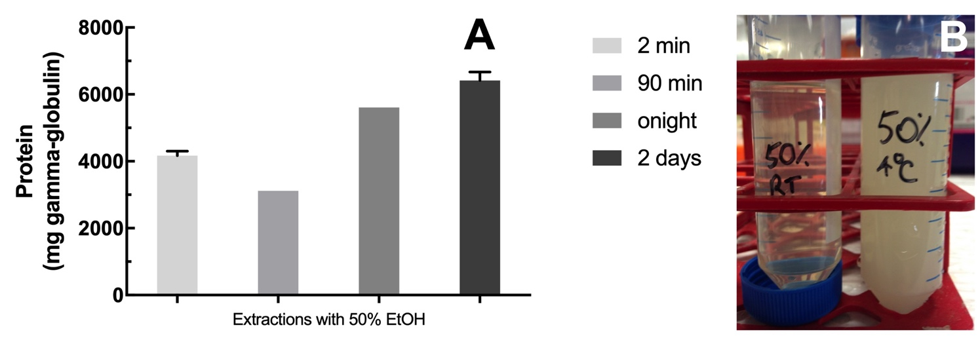
Figure S1. (A) The effect of extraction on avenin yield. Maximum freeze-dried avenin yield was observed after a two-day extraction. Oat flour (500 g) was extracted with 50% EtOH v/v for the indicated time and protein content of the supernatant measured. (B) Avenin precipitation by chilling at 4°C. A precipitate formed as the 50% EtOH extract cooled below 15°C and appeared to be complete at 10°C. This could be reversed 10 times, by warming to 20°C and then cooling again to 4°C.

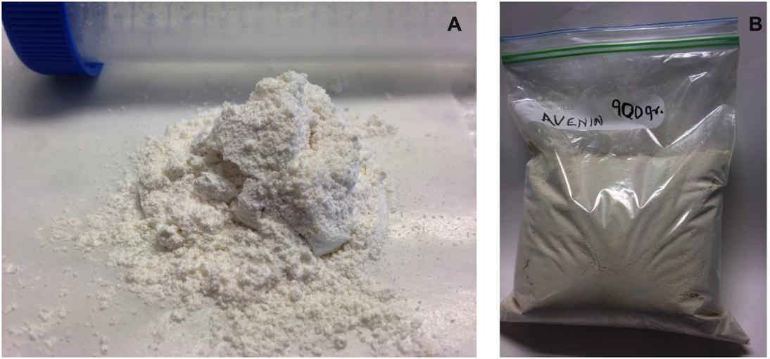
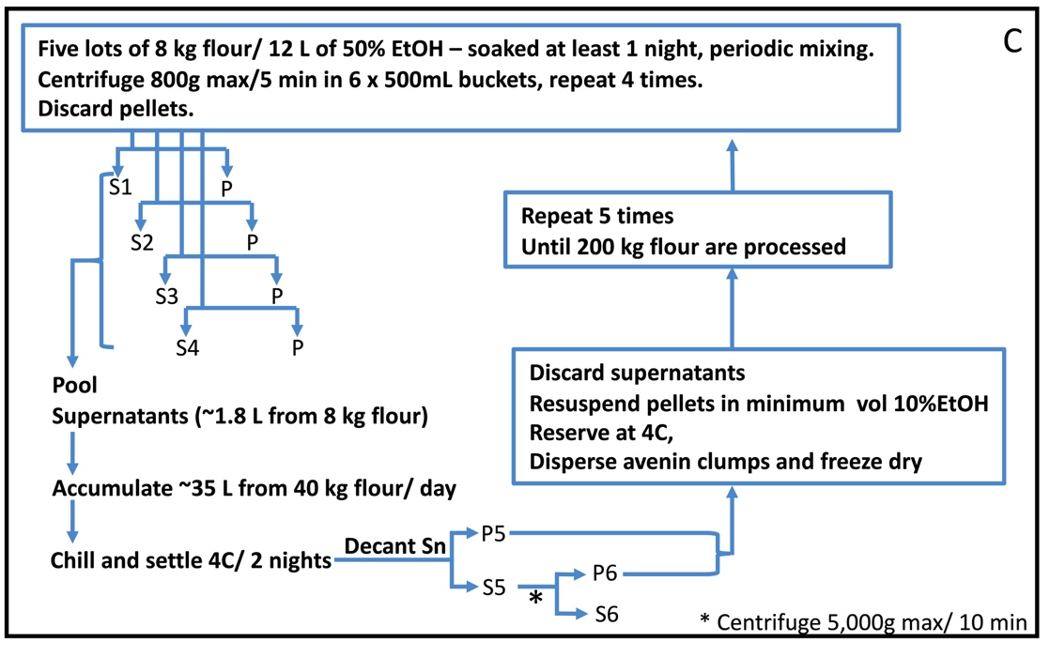
Figure S2. Results of large scale avenin isolation by chill precipitation showing: (A) 10 g fine powder; (B) 900 g of freeze dried purified avenin preparation, and (C) repeated large scale preparation protocol for avenin isolation.

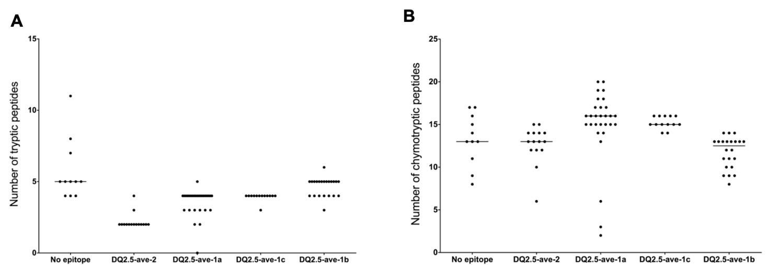

Figure S3. Comparison of detectable avenin peptides obtained using trypsin (A) and chymotrypsin (B) digestion in silico. Number of peptides and the median values are shown for each epitope group individually.

