Supplementary Material

Supplementary Figures
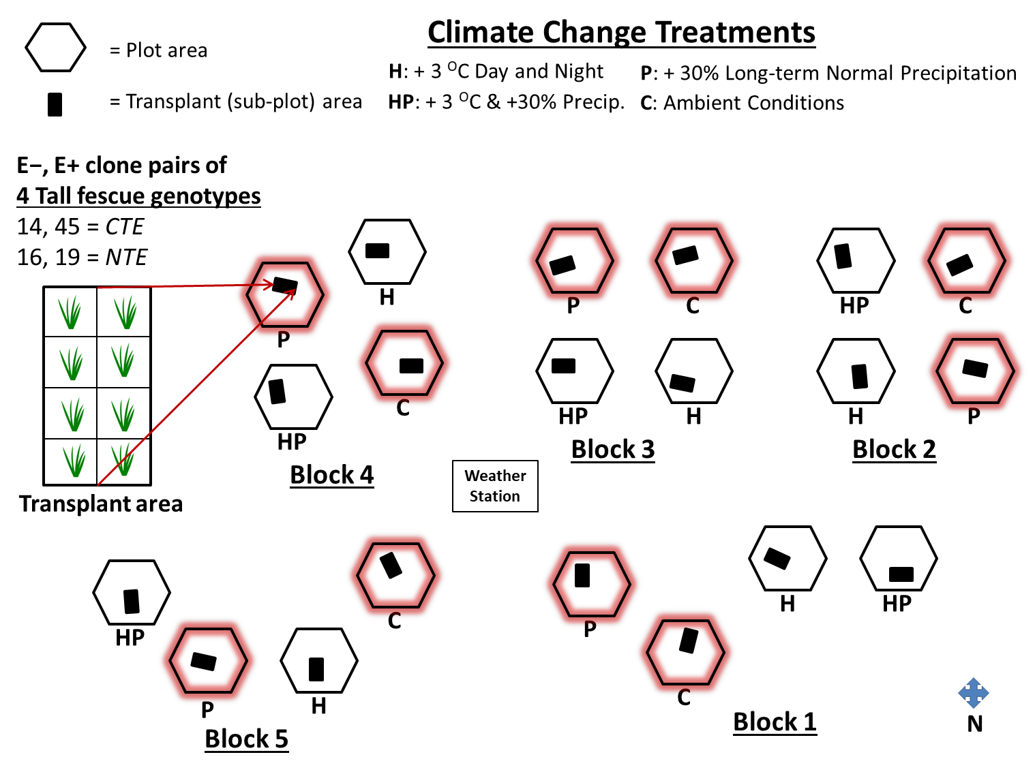
Figure S1: Experimental design of the long-term field climate change project established in 2008 at the UK Spindletop research farm in Lexington, KY. Factorial combinations of added heat (H), and added precipitation (P) were applied to hexagonal, 5.8 m² plots (C = control/ ambient climate conditions). Cloned pairs of four tall fescue genotypes, where one clone was endophyte-infected (E+) and one clone was endophyte-free (E−) were transplanted into each climate treatment plot in 2011 (n = 8 plants per plot). E+ clones of tall fescue genotypes 14 and 45 contained common toxic endophyte (CTE) strains, whereas E+ clones of tall fescue genotypes 16 and 19 contained non-toxic endophyte (NTE) strains. All four grass-endophyte genotypes within the transplant area, but only from the mesic climate treatment plots highlighted in red, were used for analysis in this study. Data collected from two grass-endophyte genotypes (specifically C and P samples of genotypes CTE45 and NTE19; n=32 samples out of the n=68 analyzed here) that were previously published in Slaughter et al. (2018) were used in the analysis presented in this manuscript.

Supplementary Tables

Table S1: Analysis of variance (ANOVA) results for the effects of independent treatment variables on shoot nutrient parameters. Significant p-values (α = 0.05) are denoted with bold type.
 | Shoot P | Shoot N | Shoot C | Shoot N:P | Shoot C:N
Treatment Effect | - % - | - % - | - % - | -- | --
Precip | F_{1,4}† = 0.05  p = 0.8385 | F_{1,4} = 3.88  p = 0.1201 | F_{1,4} = 0.67  p = 0.4575 | F_{1,4} = 3.18  p = 0.1493 | F_{1,4} = 5.79  p = 0.0738
TFtype | F_{3,24} = 1.08  p = 0.3758 | F_{3,24} = 10.93  p = 0.0001 | F_{3,24} = 2.27  p = 0.1063 | F_{3,24} = 5.06  p = 0.0074 | F_{3,24} = 17.32  p <0.0001
TFtype x Precip | F_{3,24} = 1.24  p = 0.3176 | F_{3,24} = 0.15  p = 0.9284 | F_{3,24} = 0.28  p = 0.8386 | F_{3,24} = 0.71  p = 0.5528 | F_{3,24} = 0.23  p = 0.8752
Estatus | F_{1,20} = 14.08  p = 0.0013 | F_{1,20} = 0.80  p = 0.3808 | F_{1,20} = 0.63  p = 0.4357 | F_{1,20} = 11.34  p = 0.0031 | F_{1,20} = 0.02  p = 0.8818
Estatus x Precip | F_{1,20} = 0.10  p = 0.7493 | F_{1,20} = 0.26  p = 0.6180 | F_{1,20} = 0.94  p = 0.3446 | F_{1,20} = 0.90  p = 0.3528 | F_{1,20} = 1.48  p = 0.2383
TFtype x Estatus | F_{3,20} = 1.09  p = 0.3742 | F_{3,20} = 0.68  p = 0.5717 | F_{3,20} = 0.46  p = 0.7133 | F_{3,20} = 0.23  p = 0.8758 | F_{3,20} = 0.88  p = 0.4687
TFtype x Estatus x Precip | F_{3,20} = 1.00  p = 0.4124 | F_{3,20} = 0.42  p = 0.7375 | F_{3,20} = 0.84  p = 0.4877 | F_{3,20} = 0.79  p = 0.5122 | F_{3,20} = 0.96  p = 0.4308
† Numerator, denominator degrees of freedom

Table S2: Analysis of variance (ANOVA) results for the effects of independent treatment variables on root nutrient parameters. Significant p-values (α = 0.05) are denoted with bold type.
 | Root P | Root N | Root C | Root N:P | Root C:N
Treatment Effect | - % - | - % - | - % - | -- | --
Precip | F_{1,4}† = 0.26  p = 0.6373 | F_{1,4} = 0.92  p = 0.3908 | F_{1,4} = 0.59  p = 0.4837 | F_{1,4} = 0.74  p = 0.4389 | F_{1,4} = 0.03  p = 0.8632
TFtype | F_{3,24} = 1.26  p = 0.3092 | F_{3,24} = 1.00  p = 0.4102 | F_{3,24} = 1.36  p = 0.2784 | F_{3,24} = 0.54  p = 0.6576 | F_{3,24} = 9.37  p = 0.0003
TFtype x Precip | F_{3,24} = 0.71  p = 0.5561 | F_{3,24} = 0.61  p = 0.6137 | F_{3,24} = 1.02  p = 0.4014 | F_{3,24} = 0.52  p = 0.6735 | F_{3,24} = 0.45  p = 0.7210
Estatus | F_{1,20} = 3.80  p = 0.0655 | F_{1,20} = 31.64  p = 0.2150 | F_{1,20} = 30.42  p = 0.5237 | F_{1,20} = 35.46  p = 0.0300 | F_{1,20} = 30.18  p = 0.6748
Estatus x Precip | F_{1,20} = 33.30  p = 0.0843 | F_{1,20} = 30.05  p = 0.8234 | F_{1,20} = 30.79  p = 0.3841 | F_{1,20} = 30.71  p = 0.4096 | F_{1,20} = 30.82  p = 0.3748
TFtype x Estatus | F_{3,20} = 2.75  p = 0.0694 | F_{3,20} = 0.01  p = 0.9986 | F_{3,20} = 1.90  p = 0.1617 | F_{3,20} = 1.73  p = 0.1940 | F_{3,20} = 3.64  p = 0.0304
TFtype x Estatus x Precip | F_{3,20} = 0.29  p = 0.8309 | F_{3,20} = 0.53  p = 0.6688 | F_{3,20} = 0.04  p = 0.9869 | F_{3,20} = 0.13  p = 0.9400 | F_{3,20} = 0.73  p = 0.5472
† Numerator, denominator degrees of freedom

Table S3: Analysis of variance (ANOVA) results for the effects of independent treatment variables on tall fescue biomass and on soil C and N concentrations. Green shoot weights and dead shoot weights were determined by separating total aboveground material (total shoot weight) into live (green) and senesced/dead (brown) portions to record weights for statistical analysis, and then recombined to ball-grind for nutrient analyses. Significant p-values (α = 0.05) are denoted with bold type.
 | Root weight | Total shoot weight | Root: Shoot | Green shoot weight | Dead shoot weight | Soil C | Soil N
Treatment Effect | - g - | - g - | -- | - g - | - g - | - % - | - % -
Precip | F_{1,4}† = 0.48  p = 0.5250 | F_{1,4} = 0.10  p = 0.7672 | F_{1,4} = 2.18  p = 0.2141 | F_{1,4} = 0.17  p = 0.7019 | F_{1,4} = 0.01  p = 0.9195 | F_{1,4} = 3.74  p = 0.1254 | F_{1,4} = 2.23  p = 0.2096
TFtype | F_{3,24} = 0.91  p = 0.4525 | F_{3,24} = 1.52  p = 0.2353 | F_{3,24} = 2.94  p = 0.0537 | F_{3,24} = 0.75  p = 0.5321 | F_{3,24} = 2.31  p = 0.1014 | F_{3,24} = 1.50  p = 0.2392 | F_{3,24} = 1.14  p = 0.353
TFtype x Precip | F_{3,24} = 0.95  p = 0.4327 | F_{3,24} = 1.11  p = 0.3643 | F_{3,24} = 1.97  p = 0.1454 | F_{3,24} = 1.41  p = 0.2637 | F_{3,24} = 0.20  p = 0.8941 | F_{3,24} = 0.34  p = 0.7957 | F_{3,24} = 0.73  p = 0.5455
Estatus | F_{1,20} = 7.45  p = 0.0129 | F_{1,20} = 14.03  p = 0.0013 | F_{1,20} = 0.98  p = 0.3333 | F_{1,20} = 15.49  p = 0.0008 | F_{1,20} = 15.51  p = 0.0008 | F_{1,20} = 1.93  p = 0.1796 | F_{1,20} = 3.01  p = 0.0981
Estatus x Precip | F_{1,20} = 0.90  p = 0.3544 | F_{1,20} = 5.63  p = 0.0278 | F_{1,20} = 4.82  p = 0.0401 | F_{1,20} = 5.61  p = 0.0281 | F_{1,20} = 4.99  p = 0.0371 | F_{1,20} = 0.00  p = 0.988 | F_{1,20} = 0.00  p = 0.9593
TFtype x Estatus | F_{3,20} = 1.72  p = 0.1951 | F_{3,20} = 2.27  p = 0.112 | F_{3,20} = 1.28  p = 0.3083 | F_{3,20} = 1.67  p = 0.2046 | F_{3,20} = 5.10  p = 0.0088 | F_{3,20} = 0.71  p = 0.5589 | F_{3,20} = 0.68  p = 0.5745
TFtype x Estatus x Precip | F_{3,20} = 0.81  p = 0.5034 | F_{3,20} = 2.90  p = 0.0606 | F_{3,20} = 2.61  p = 0.0795 | F_{3,20} = 3.25  p = 0.0434 | F_{3,20} = 1.23  p = 0.3239 | F_{3,20} = 1.12  p = 0.3664 | F_{3,20} = 1.35  p = 0.2862
† Numerator, denominator degrees of freedom

