Supplementary Material

Supplementary Figures and Tables
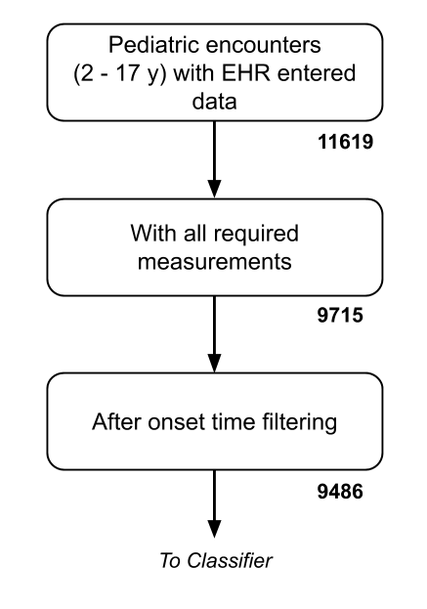
Supplemental Figure 1: Inclusion flowchart. The final data set used in training and testing constitutes 9,486 examples, of which 101 (1.06%) are labeled as severely septic.

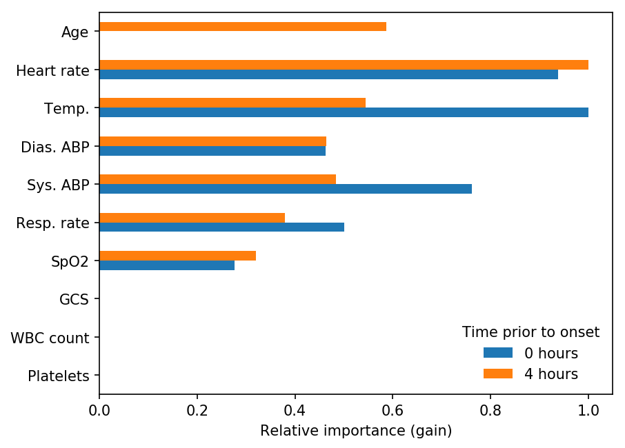
Supplemental Figure 2: Feature importance plot. The importance scores are measures of relative information gain (or equivalently, entropy decrease) and are measured during the training of models and averaged across folds. Values presented in this plot are scaled to the maximum importance score for a given prediction time to enable comparison between prediction times.

Supplemental Table 1: Pediatric SIRS (modified from Goldstein et al., 2005), for patient age ranges examined in this study. The SIRS score is the total of the number of the four measurements below that are out-of-range. In this data set, white counts are reported only as “normal” or “abnormal.”
 | Temperature |  | Heart Rate | Respiration Rate | White Count
Patient age (y) | (C, low) | (C, high) | Tachycardia (beats/min) | Tachypnea (breath/min)
2-5 | < 36 | > 38.5 | > 140 | > 22 | abnormal
6-12 |  |  | > 130 | > 18
13-17 |  |  | > 110 | > 14

Supplemental Table 2: Pediatric Sepsis, Severe Sepsis, and Septic Shock Gold Standard (after Goldstein et al., 2005).
Sepsis | Any ICD-9 code for septicemia, sepsis, severe sepsis, or septic shock, plus a SIRS score of ≥ 2, where at least one of temperature or WBC is abnormal.
Severe sepsis | Sepsis, plus: | Cardiovascular dysfunction, acute respiratory distress syndrome (ARDS), or ≥ 2 other organ dysfunctions (respiratory, neurologic, hematologic, renal, hepatic)
Septic Shock | Severe sepsis, plus: | Cardiovascular organ dysfunction

Supplemental Table 3: Organ dysfunction criteria (modified from Goldstein et al., 2005). *: Substantial modifications required for chart-based implementation. Causal attribution is impossible for fluid-refractory hypotension, and exam components (core-to-peripheral temperature gap and delayed capillary refill) cannot be checked retrospectively. **: Radiological (bilateral infiltrates) and history components (acute onset and no evidence of left heart failure) unavailable. ***: Substantial modifications required for chart-based implementation. Proven need, causal attribution of FiO₂ and SpO₂ relationship, and non-elective nature of mechanical ventilation cannot be assessed retrospectively.
Cardiovascular* | Delivery of 40 ml/kg/hr of IV fluids during an hour-long period, any of: concurrent Systolic BP < 74, 83, 90 mmHg (for patients 2-5, 6-12, or 13-17); IV dopamine of ≥ 5 μg/kg/min; any IV Dobutamine, Epinephrine, or Norepinephrine.
ARDS** | PaO2/FiO₂ < 200 mmHg
Respiratory*** | PaO2/FiO₂ < 300 mmHg, PaCO₂ > 65 mmHg, FiO₂ ≥ 0.50
Neurologic | Glasgow Coma Scale ≤ 11
Hematologic | Platelets “abnormal” or INR “abnormal”
Renal | Serum creatinine “abnormal”
Hepatic | Alanine transaminase “abnormal” or total bilirubin “abnormal”

Supplementary Table 4. ICD-9 codes used for “suspected infection” classification.
ICD-9 code | Name
003.1 | Salmonella septicemia
038.0 | Streptococcal septicemia
038.10 | Staphylococcal septicemia, unspecified(038.10)
038.11 | Methicillin susceptible Staphylococcus aureus septicemia
038.12 | Methicillin resistant Staphylococcus aureus septicemia
038.19 | Other staphylococcal septicemia
038.2 | Pneumococcal septicemia
038.3 | Septicemia due to anaerobes
038.40 | Septicemia due to gram-negative organism, unspecified(038.40)
038.41 | Septicemia due to hemophilus influenzae
038.42 | Septicemia due to escherichia coli
038.43 | Septicemia due to pseudomonas
038.44 | Septicemia due to serratia
038.49 | Other septicemia due to gram-negative organisms
038.8 | Other specified septicemias
038.9 | Unspecified septicemia
054.5 | Herpetic septicemia
415.12 | Septic pulmonary embolism
422.92 | Septic myocarditis
449 | Septic arterial embolism
670.20 | Puerperal sepsis, unspecified as to episode of care or not applicable
670.22 | Puerperal sepsis, delivered, with mention of postpartum complication(670.22)
670.24 | Puerperal sepsis, postpartum condition or complication(670.24)
670.34 | Puerperal septic thrombophlebitis, postpartum condition or complication(670.34)
673.31 | Obstetrical pyemic and septic embolism, delivered, with or without mention of antepartum condition(673.31)
771.81 | Septicemia of newborn
785.52 | Septic shock
995.90 | Systemic inflammatory response syndrome, unspecified(995.90)
995.91 | Sepsis
995.92 | Severe sepsis
995.93 | Systemic inflammatory response syndrome due to noninfectious process without acute organ dysfunction
995.94 | Systemic inflammatory response syndrome due to noninfectious process with acute organ dysfunction
998.02 | Postoperative shock, septic(998.02)

