Supplementary Material

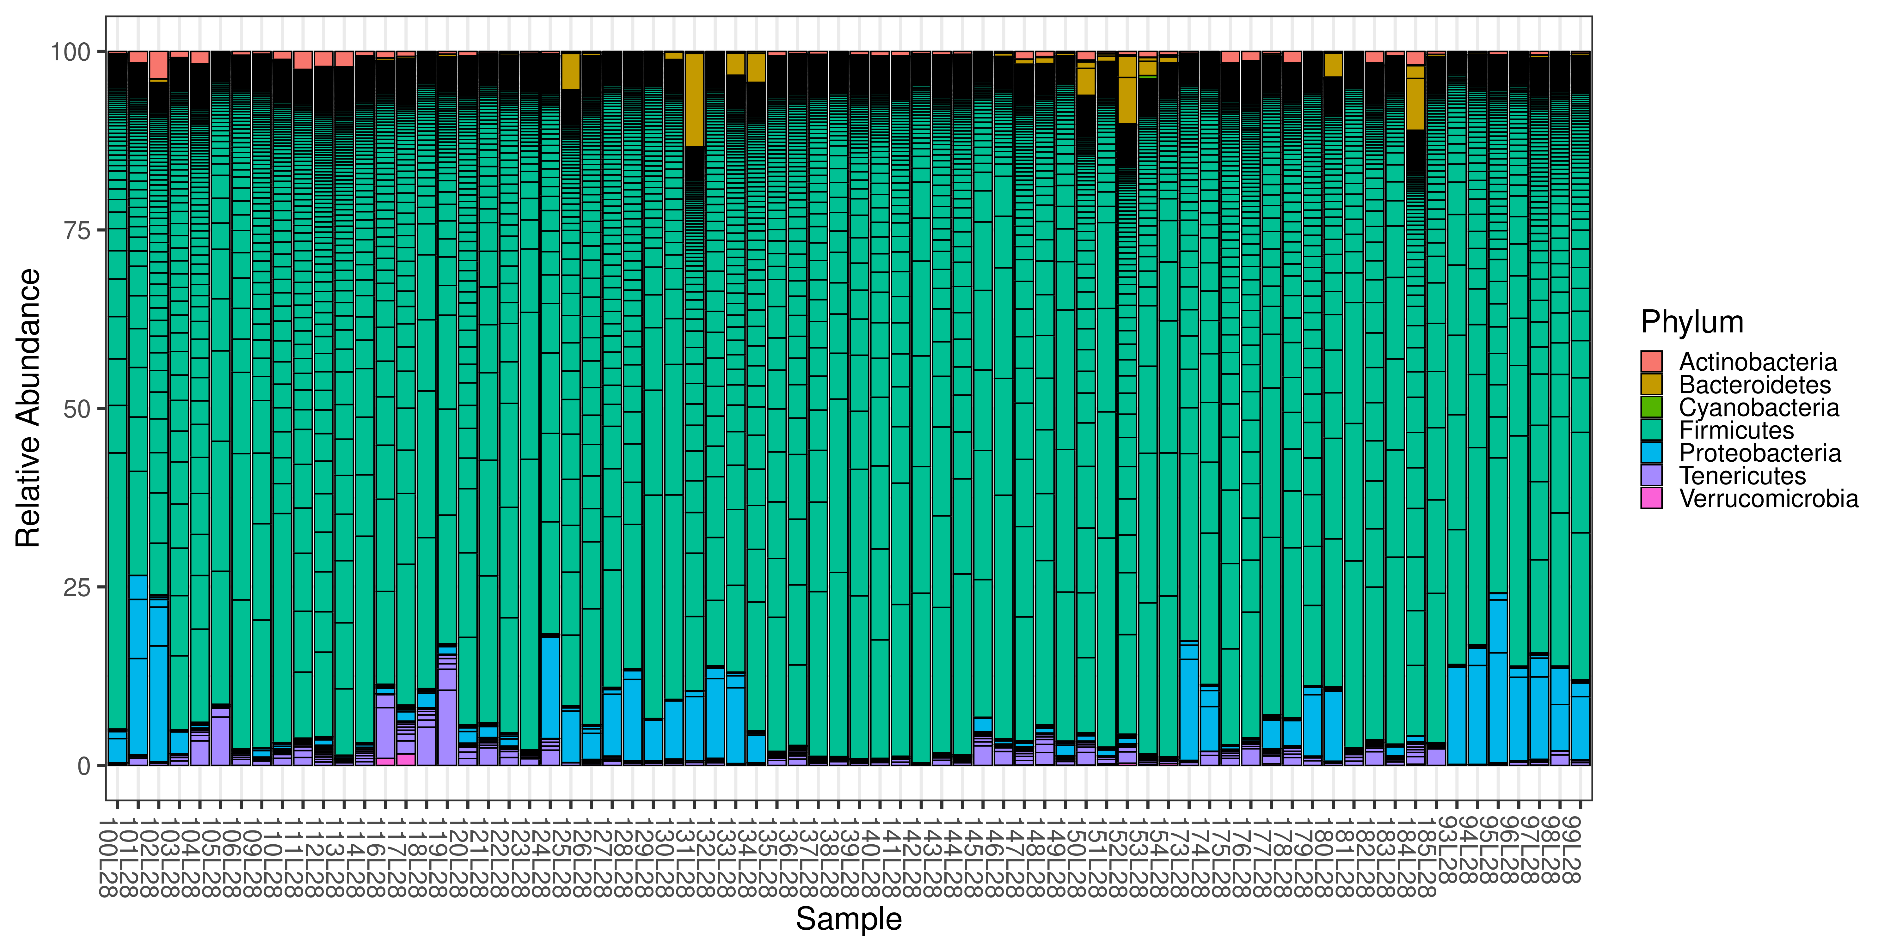
Figure S1 Microbiota composition analysis using 16S rRNA sequencing in caecal contents of chickens. Relative abundance of bacterial phyla within all samples. Samples 93L28, 94L28, 95L28, 96L28, 173L28, 97L28, 98L28, 99L28, 100L28, 101L28, 174L28 and 102L28 belong to LBC-21/22 in experiment 1; Samples 125L28, 126L28, 127L28, 128L28, 129L28, 179L28, 130L28, 131L28, 132L28, 133L28, 134L28 and 180L28 belong to LBC-70/78 in experiment 1; Samples 103L28, 104L28, 105L28, 106L28, 109L28, 175L28, 110L28, 111L28, 112L28, 113L28, 114L28 and 176L28 belong to LBC-21/22 in experiment 2; Samples 135L28, 136L28, 137L28, 138L28, 139L28, 181L28, 185L28, 140L28, 141L28, 142L28, 143L28, 144L28 and 182L28 belong to LBC-70/78 in experiment 2; Samples 116L28, 117L28, 118L28, 119L28, 177L28, 120L28, 121L28, 122L28, 123L28, 124L28 and 178L28 belong to LBC-21/22 in experiment 3; Samples 145L28, 146L28, 147L28, 148L28, 149L28, 183L28, 150L28, 151L28, 152L28, 153L28, 154L28 and 184L28 belong to LBC-70/78 in experiment 3.

Table S1 Comparison of bacterial relative abundance in caecal contents (at the taxonomic level, phylum) between different aged chickens at time of infection.
Phylum | # OTUs | p-value | FDR-adjusted p-value
Firmicutes | 187 | 0.00009999 | 0.00069993
Bacteroidetes | 4 | 0.00029997 | 0.00179982
Tenericutes | 14 | 0.00319968 | 0.01279872
Proteobacteria | 8 | 0.00469953 | 0.01879812
Actinobacteria | 1 | 0.01429857 | 0.04289571
Verrucomicrobia | 1 | 0.46795320 | 0.51994801
Cyanobacteria | 1 | 0.51994801 | 0.51994801
FDR-adjusted p-values < 0.05 are written in bold.
Table S2 Comparison of bacterial relative abundance in caecal contents (at the taxonomic level, family) between different aged chickens at time of infection.
Family | # OTUs | p-value | FDR-adjusted p-value
Campylobacteraceae | 1 | 0.00009999 | 0.00259974
Enterococcaceae | 1 | 0.00009999 | 0.00259974
Erysipelotrichaceae | 8 | 0.00009999 | 0.00259974
Lachnospiraceae | 49 | 0.00009999 | 0.00259974
Lactobacillaceae | 2 | 0.00009999 | 0.00259974
Peptostreptococcaceae | 2 | 0.00009999 | 0.00259974
Ruminococcaceae | 94 | 0.00009999 | 0.00259974
Streptococcaceae | 1 | 0.00019998 | 0.00499950
Bacteroidaceae | 1 | 0.00069993 | 0.01609839
uncultured-bacterium | 6 | 0.00139986 | 0.02939706
Clostridiaceae-1 | 1 | 0.00209979 | 0.04409559
Rikenellaceae | 1 | 0.00209979 | 0.04409559
Coriobacteriaceae | 1 | 0.01199880 | 0.20397960
uncultured-rumen-bacterium | 2 | 0.01689831 | 0.27037296
Aerococcaceae | 1 | 0.02659734 | 0.39896010
Enterobacteriaceae | 1 | 0.03319668 | 0.49795020
Clostridiales-vadinBB60-group | 10 | 0.03629637 | 0.51369863
Ambiguous_taxa | 16 | 0.03659634 | 0.51369863
Family-XIII | 3 | 0.06849315 | 0.75379129
Chitinophagaceae | 2 | 0.16348365 | 0.87687231
Thermoanaerobacteraceae | 1 | 0.17398260 | 0.87687231
Christensenellaceae | 2 | 0.20587941 | 0.91340866
Veillonellaceae | 1 | 0.27607239 | 0.95740426
Sphingomonadaceae | 1 | 0.31786821 | 0.95740426
Defluviitaleaceae | 1 | 0.45415458 | 0.95740426
Verrucomicrobiaceae | 1 | 0.47225277 | 0.95740426
Phyllobacteriaceae | 1 | 0.47665233 | 0.95740426
Alcaligenaceae | 1 | 0.51784822 | 0.95740426
Desulfovibrionaceae | 1 | 0.56534347 | 0.95740426
Peptococcaceae | 1 | 0.66563344 | 0.95740426
Xanthobacteraceae | 1 | 0.73072693 | 0.95740426
Comamonadaceae | 1 | 0.95740426 | 0.95740426
FDR-adjusted p-values < 0.05 are written in bold.

Table S3 28 of 216 OTUs with significant (plus an additional log fold change criterion of +/- 2) different abundance between different aged chickens at time of infection.
log2FoldChange | pvalue | padj | OTU_ID | Phylum | Class | Order | Family | Genus
6.32948466 | 1.33E-55 | 2.85E-53 | OTU_3 | Firmicutes | Erysipelotrichia | Erysipelotrichales | Erysipelotrichaceae | Turicibacter
-3.89862629 | 3.46E-17 | 3.70E-15 | OTU_14 | Proteobacteria | Epsilon-proteobacteria | Campylobacterales | Campylobacteraceae | Campylobacter
-2.45228859 | 7.23E-15 | 5.15E-13 | OTU_12 | Firmicutes | Clostridia | Clostridiales | Ruminococcaceae | [Eubacterium] coprostanoligenes group
8.94321971 | 4.24E-14 | 2.27E-12 | OTU_42 | Bacteroidetes | Bacteroidia | Bacteroidales | Bacteroidaceae | Bacteroides
-5.65288619 | 1.51E-12 | 6.45E-11 | OTU_85 | Firmicutes | Erysipelotrichia | Erysipelotrichales | Erysipelotrichaceae | Erysipelatoclostridium
5.59167262 | 1.89E-11 | 6.73E-10 | OTU_29 | Firmicutes | Clostridia | Clostridiales | Ruminococcaceae | Ruminococcus 1
-4.11016512 | 4.20E-11 | 1.28E-09 | OTU_60 | Firmicutes | Clostridia | Clostridiales | Lachnospiraceae | Ambiguous_taxa
3.62911045 | 9.75E-11 | 2.61E-09 | OTU_13 | Firmicutes | Clostridia | Clostridiales | Ruminococcaceae | Subdoligranulum
-4.37438696 | 1.11E-10 | 2.64E-09 | OTU_54 | Firmicutes | Clostridia | Clostridiales | Ruminococcaceae | Ambiguous_taxa
-3.56440119 | 1.25E-10 | 2.67E-09 | OTU_63 | Firmicutes | Clostridia | Clostridiales | Ruminococcaceae | Anaerotruncus
-2.42026925 | 3.16E-10 | 6.14E-09 | OTU_69 | Firmicutes | Clostridia | Clostridiales | Ruminococcaceae | Ambiguous_taxa
-2.85982582 | 7.52E-07 | 1.07E-05 | OTU_126 | Firmicutes | Bacilli | Lactobacillales | Streptococcaceae | Streptococcus
2.51176478 | 1.36E-05 | 0.00018195 | OTU_162 | Firmicutes | Clostridia | Clostridiales | Lachnospiraceae | Blautia
2.12653731 | 2.07E-05 | 0.00023351 | OTU_297 | Firmicutes | Clostridia | Clostridiales | Lachnospiraceae | Ambiguous_taxa
-2.31443319 | 2.59E-05 | 0.00027756 | OTU_437 | Firmicutes | Clostridia | Clostridiales | Ruminococcaceae | [Eubacterium] coprostanoligenes group
2.41932537 | 4.74E-05 | 0.00046096 | OTU_168 | Firmicutes | Clostridia | Clostridiales | Lachnospiraceae | Ambiguous_taxa
-2.92864417 | 8.12E-05 | 0.00066812 | OTU_17 | Tenericutes | Mollicutes | Mollicutes RF9 | uncultured bacterium | uncultured bacterium
-2.40548313 | 0.00027534 | 0.00196407 | OTU_195 | Firmicutes | Erysipelotrichia | Erysipelotrichales | Erysipelotrichaceae | Erysipelatoclostridium
-3.61069256 | 0.00042458 | 0.00283938 | OTU_200 | Firmicutes | Clostridia | Clostridiales | Peptostreptococcaceae | Romboutsia
-2.68020319 | 0.00056928 | 0.00348075 | OTU_304 | Firmicutes | Clostridia | Clostridiales | Ruminococcaceae | Flavonifractor
-3.46089619 | 0.00119331 | 0.00654788 | OTU_209 | Firmicutes | Clostridia | Clostridiales | Ambiguous_taxa | Ambiguous_taxa
2.17733665 | 0.00244336 | 0.01244948 | OTU_120 | Tenericutes | Mollicutes | Mollicutes RF9 | uncultured rumen bacterium | uncultured rumen bacterium
2.02714231 | 0.0026292 | 0.01308483 | OTU_91 | Firmicutes | Clostridia | Clostridiales | Clostridiales vadinBB60 group | uncultured bacterium
-2.18237298 | 0.00297871 | 0.01392541 | OTU_189 | Firmicutes | Clostridia | Clostridiales | Lachnospiraceae | Tyzzerella 3
2.56266896 | 0.00299331 | 0.01392541 | OTU_93 | Tenericutes | Mollicutes | Mollicutes RF9 | uncultured bacterium | uncultured bacterium
-2.03361244 | 0.01162044 | 0.04434364 | OTU_187 | Firmicutes | Bacilli | Lactobacillales | Enterococcaceae | Enterococcus
-3.94357235 | 0.01181116 | 0.04434364 | OTU_149 | Firmicutes | Clostridia | Clostridiales | Lachnospiraceae | Ambiguous_taxa
2.39813291 | 0.0132418 | 0.04885768 | OTU_219 | Firmicutes | Erysipelotrichia | Erysipelotrichales | Erysipelotrichaceae | Ambiguous_taxa

