Supplementary Text for
Hitting the Target but Missing the Mark: Unintended Environmental Consequences of the Paris Climate Agreement
Joseph Kiesecker¹*, Sharon Baruch-Mordo¹*, Christina M. Kennedy¹, James R. Oakleaf¹, Alessandro Baccini², Bronson W. Griscom³

Procedures to calculate wind development footprint
We adjusted the amount of area converted for cells selected for wind development to represent the footprint from 10 3-MW rated capacity turbines, or 0.1 km². We chose 3-MW rated capacity as it is projected to be the most deployed wind turbine (Wiser et al. 2016), and we assumed 10 turbines can fit in a 1-km² cell based on reported mean nearest neighbor distance of ~340 m for 3-MW turbines (Diffendorfer and Compton 2014). We used half of the distance (170 m) as a radius to calculate the area around each turbine as 0.09 km², which implied a 1-km cell can hold ~10 3-MW turbines. Evans and Kiesecker (2014) estimated that wind turbine footprint with associated infrastructure is 0.77 ha, which for 10 turbines will total 0.077 km². Therefore we assumed the land area footprint for 10 3-MW turbines is roughly 0.1 km², and accordingly assumed only 10 % land conversion for cells allocated to wind energy.

Procedures to calculate differences in life cycle emission factors (lce_{s})

We calculated for each renewable energy sector s, its average difference in life cycle emission factors (Δlce_{s}) with the fossil fuel sectors of coal, gas and oil. While oil represented only 1% of electricity and heat production in 2014 (IEA 2017), and in general it represented a low proportion of countries’ energy portfolios (median across countries with data 1.8 %), for some countries, e.g., Gibraltar (100%), Benin (99%), Malta (97%), Jamaica (90%), etc., oil was the primary source for electricity and heat production. Therefore we included it as a source of emissions and included its differences in Δlce_{s.} The International Panel of Climate Change (IPCC; Moomaw et el. 2011; Schlömer et al. 2014) estimated the median lifecycle emission factors in gCO₂/kWh as 840, 820, and 490 for oil, coal, and gas, respectively. Onshore wind was estimated as 11 gCO₂/kWh, concentrated solar power (CSP) as 27 gCO₂/kWh, and utility-scale solar photovoltaic (PV) as 48 gCO₂/kWh. For each renewable energy sector, we calculated its difference with oil, coal, and gas, and then averaged the results to calculate Δlce_{s}. For example for wind, differences with oil, coal, and gas were 829, 809, 479, which averaged to 706 gCO₂/kWh, or the value we used for Δlce_{wind}. We similarly calculated Δlce_{csp} as 699, Δlce_{utility-scale_pv} as 669, and Δlce_{rooftop_pv} as 676 gCO₂/kWh, and for each cell we then calculated the number of years (yr_{i}) to repay carbon deficits based on the renewable energy sector that was sited in that cell. Finally, we note that for final calculations of yr_{i}, we redefined Δlce_{s} to be its inverse, i.e., from gCO₂/kWh to kWh/gCO₂, which we multiplied by conversion factors of 10¹² g/Mt and 1/1000 MW/kW to obtained final estimates of Δlce_{s} in MtCO₂/MWh.

SUPPLEMENTARY FIGURES
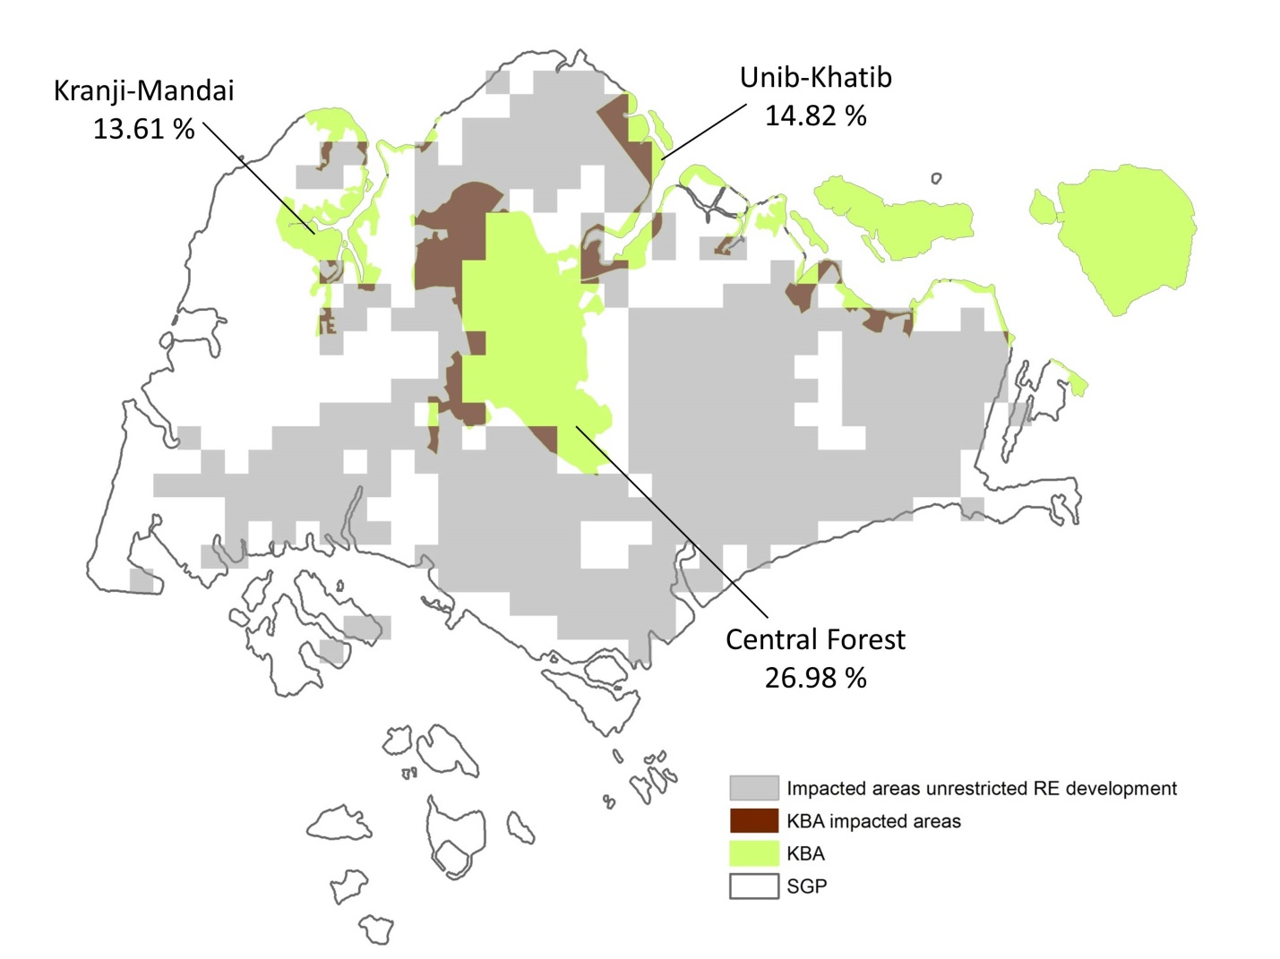
Figure S1. – Example calculation of median percent area potential loss of the three KBAs in Singapore. Each KBA’s area loss (dark brown) was calculated based on the overlap between KBA (green) and the impacted cells under an unrestricted renewable energy development in which development is sited where wind and solar resources are the highest (grey). For the country of Singapore we reported the median loss across all impacted KBAs as the median of 13.61, 14.28, and 26.98%, which was 14.28%.

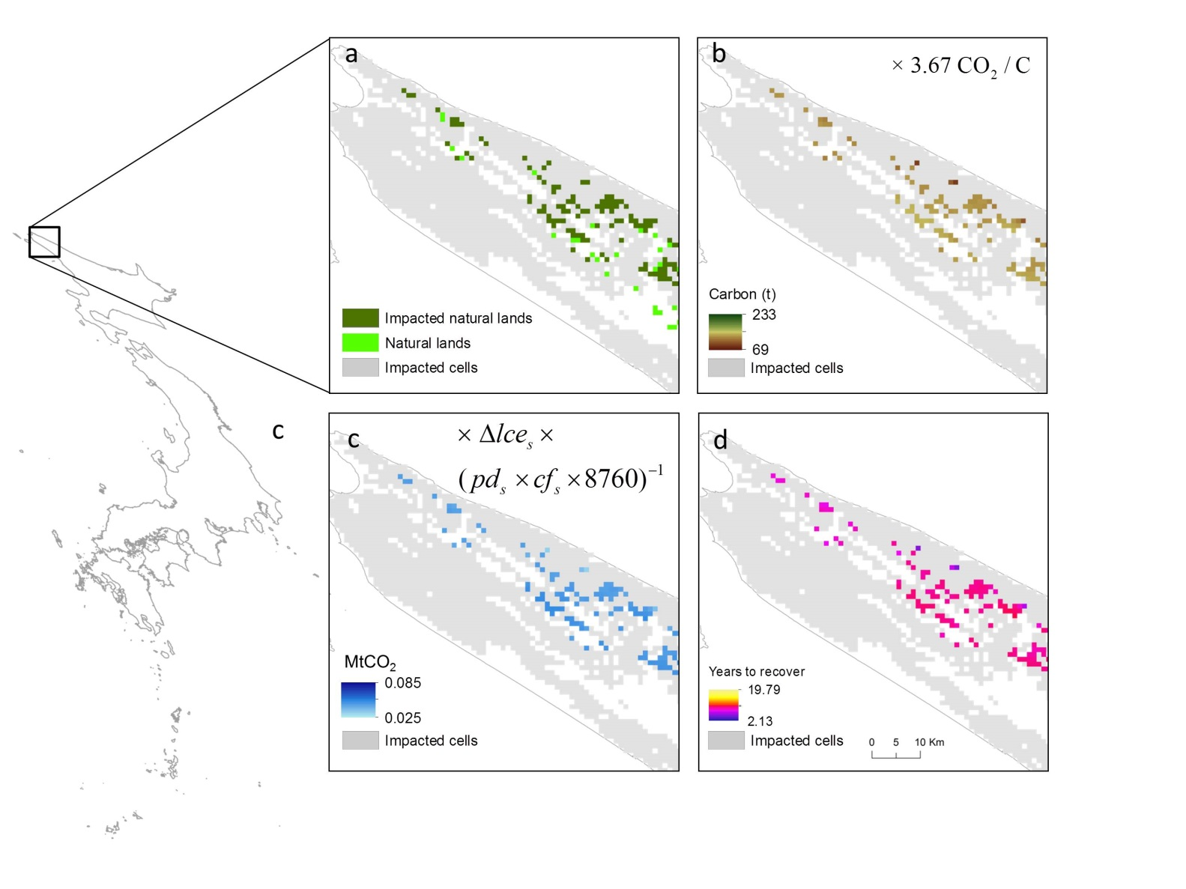Figure S2. – Example calculation of years to recover carbon loss in Japan under a development scenario in which wind and solar renewable energy is sited (resulting in impacted cells) where resources are the highest. a) areas of overlap (darker green) between impacted cells (grey) and natural areas (lighter green), b) tons of carbon loss for each pixel of overlap areas which were multiplied by the insert equation to obtain, c) emissions loss for each pixel which were multiplied by the insert equation to obtain, d) the number of years it would take to recover the carbon loss. Δlce_{s} is the average difference between the inverse IPCC life cycle emission factors (MWh/ MtCO₂; Schlömer et al. 2014) of fossil fuel sectors and the renewable energy sector s that was sited in focal cell i, is the sector-specific power density in MW/km², cf_{s} is the sector-specific unit-less capacity factor, or the observed output over rated capacity, and 8760 is a conversion factor from hours to years.

SUPPLEMENTARY REFERENCES

Diffendorfer, J. E., and Compton, R. W. (2014). Land cover and topography affect the land transformation caused by wind facilities. PLoS ONE, 9(2). https://doi.org/10.1371/journal.pone.0088914

Evans J. S., and Kiesecker J.M. (2014). Shale Gas, Wind and Water: Assessing the Potential Cumulative Impacts of Energy Development on Ecosystem Services within the Marcellus Play. PLoS ONE 9(2): e89210. https://doi.org/10.1371/journal.pone.0089210

International Energy Agency (2017). Statistics (www.iea.org/classicstats/statisticssearch/, Accessed 1st January 2017)

Moomaw, W. et al. (2014). Annex II: Methodology. IPCC Spec. Rep. Renew. Energy Sources Clim. Chang. Mitig. 16, NP.

Schlomer, S. et al. (2014). Annex III: Technology-specific cost and performance parameters.

UNEPLive. Emissions-Impacts-Climate Chagne. (2017). Available at: https://pre-uneplive.unep.org/theme/index/13#indcs. (Accessed: 1st January 2017)

Wiser, R., Jenni, K., Seel, J., Baker, E., Hand, M., Lantz, E. and Smith, A. (2016). Expert elicitation survey on future wind energy costs. Nature Energy 1, 16135.

