Supplementary Material
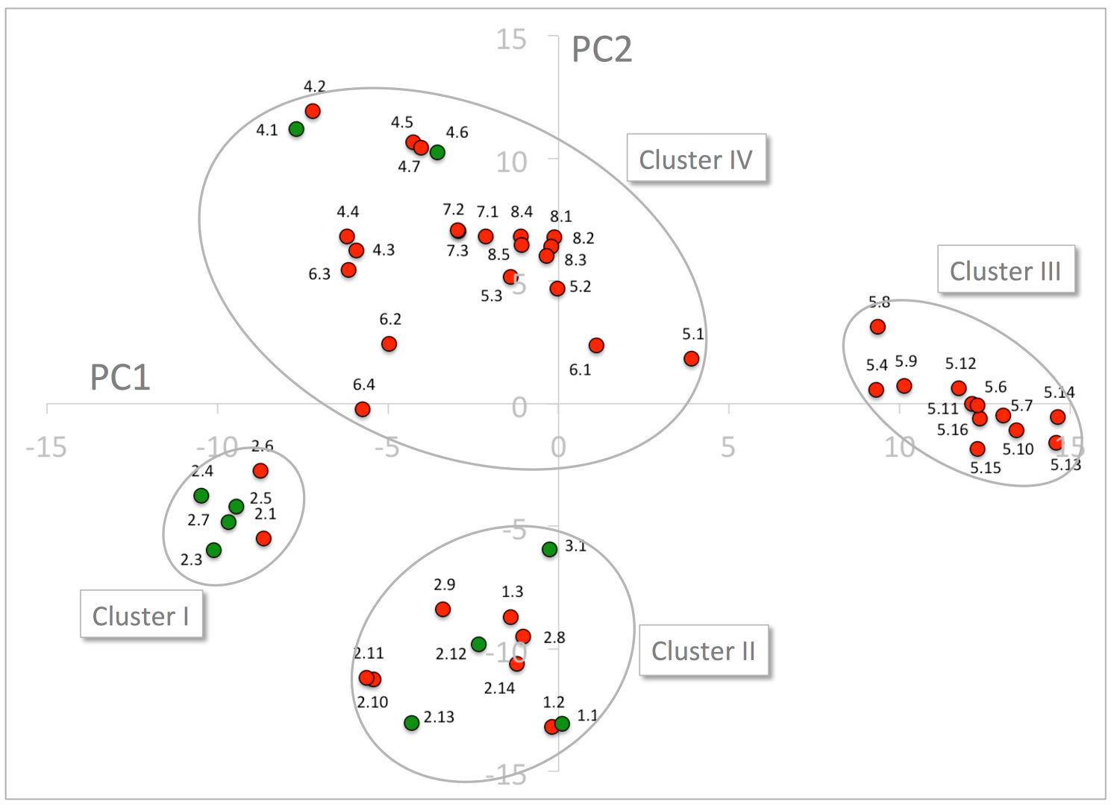

Supplementary Figure 7. Principal Component Analysis of the 51 NPF sequences expressed by z-scales of the 48 cavity residues that excludes the ExxE[K/R] motif. GA transporting and GA non-transporting transporters are shown as green and red dots, respectively. The four clusters are marked by ellipses. PC1 and PC2 refer to the first and second principal components, respectively.

