Fig. suppl. 1 Walewska, Wołodko et al. 2019

Fig. suppl. 1 Equine luteal explants viability assay (A) Viability of mid CL explants after in vitro stimulation with Nodal (concentrations from 0.1 to 10 ng/mL), prostaglandin F2α (PGF2α, 10⁻⁷ M); and luteinizing hormone (LH, 10 ng/mL). (B) Explants viability exposed to 20% and 5% of oxygen. (C) Viability of mid CL explants after in vitro stimulation with SB (10 μM), PGF2α (10⁻⁷ M) and PGF2α (10⁻⁷ M) with SB (10 μM). Results expressed as % of control. (n=6 for A and C; n=4 for B). Values are expressed as means ± SEM.

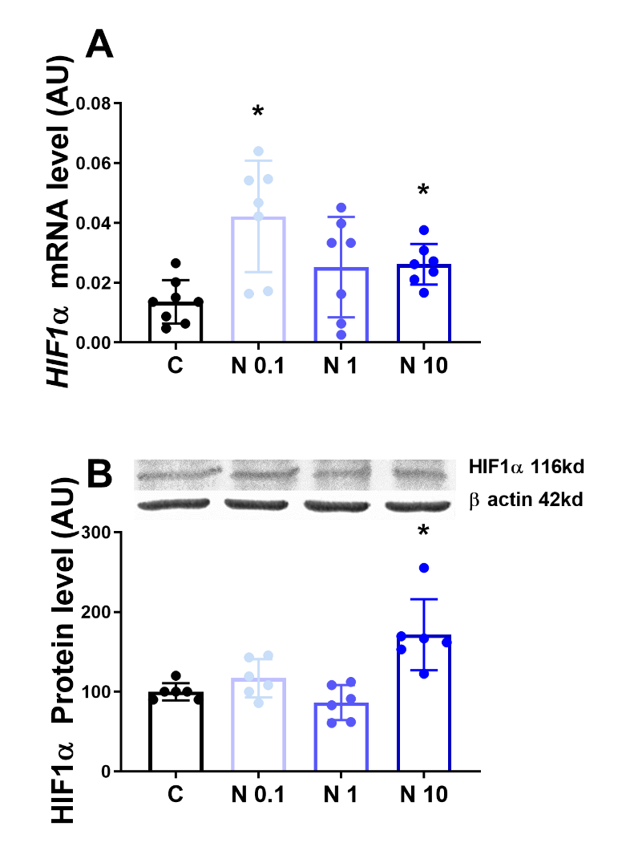
Fig. suppl. 2 Walewska, Wołodko et al. 2019

Fig. suppl. 2 HIF1α mRNA and protein expression after in vitro culture of mid CL explants Expression of (A) hypoxia inducible factor 1 α (HIF1α) mRNA, (B) HIF1α protein after 24h culture: (i) no factor (negative control); (ii) Nodal (0,1 ng/mL); (iii) Nodal (1 ng/mL); (iv) Nodal (10 ng/mL) (n=6). mRNA expression determined by real-time PCR, expression relative to β−2-microglobulin (B2MG) expression. Protein expression determined by western blot, upper panel: representative immunoblot; lower panel: densitometry of protein expression relative to β-actin expression. Values are expressed as means ± SEM in arbitrary units (AU). Statistical differences are marked with asterisks (* p<0.05).

