Supplementary materials

Table S1 Material list per sampler with rough cost estimates.
Item | Distributor | Price (€)
- Tipping bucket inc. logger | Davis Instruments Corp., USA | 250
- 12 x Y-connector | Kartell, Italy | 6
- 3 m silicon tubing | VWR®, Int. | 9
- 12 x air vent tubing | VWR®, Int. | 18
- Honey jar | Bormioli Rocco, Italy | 15
- M3 screws and nuts | - | <5
- Silicon adhesive | Sika, Switzerland | <5
- Cable binders | - | <1
- Plastic sheet | - | 5
- Plastic box | UTZ-Rako | 15
- Funnel (214 cm2  )# | - | 6
Total cost inc. rain gauge |  | 329
Total cost excl. rain gauge Inc. funnel# |  | 85
(Prices might deviate depending on local currency and alternative materials that can be used)

Supplementary material - laboratory experiment
From sampling approximately 50 rainfall events in different field studies over four years (e.g. Fischer et al., (2017a)), the different samplers used in this study to collect rainfall, were no longer functional. Therefore, to assess the mixing of different water samples in experiment I and II it was necessary to build a new sampler. With exception of the bottles (due to availability), almost all materials were identical to the original ZRS-sampler used. The modified sampler consisted of a funnel (Ø 10cm) attached to a silicon tube (1.5 m) to guide water into the sampler (Figure S1). The sampler consists of 3 x 100 ml wide mouth bottles (100 ml; Duran), each representing 5 mm of rainwater. The different bottles were connected serially to each other using silicon tubing (Ø 9 mm OD). To divert rainwater into a bottle, a bifurcation is made using a Y-connector connected to a 100 mm vertical silicon tube (Ø 9mm OD) reaching the bottom of the bottles. Each bottle has a smaller second silicon tube attached in the lid (Ø 3mm OD, 500 mm) acting as an air vent. Once the air vent is reached a headspace with air of 1 cm remains.
Experiment I was used to assess the maximum rainfall intensity before sampling errors occurred. For this, different volumes of water were poured into the funnel of the sampler. The water volumes were 10, 20, 30 and 50 ml of water representing 0.5, 1, 1.5, 2 and 2.5 mm s⁻¹ of rainfall respectively. A correct functioning of the sampler was defined as: the poured volume of water enters in the first empty bottle while no water was transferred to the consecutive bottles. A non-correct functioning of the sampler would occur if the water syphons into not only the first empty bottles, but into multiple bottles. By filling different volumes, the volume or maximum rainfall intensity where non-correct functioning occurred could be determined. The experiment was repeated three times.
Experiment II was used to assess the sampling error from mixing of different water samples. Different tests were performed by pouring (as different combinations) alternately 100 ml deionized water or 100 ml salt-dye solution (1 g L⁻¹ table salt (NaCl) and dye (Rhodamine 20 ppm, used only for visualization due to a broken fluorometer)) into the sequential sampler (100 ml represents 5 mm rainwater Figure S1):

Test 1 to 3: consists of filling the first bottle with 100 ml deionized water, bottle 2 with 100 ml salt-dye solution and bottle 3 with 100 ml deionized water. This gives information on mixing between all three bottles.
Test 4: consists of filling the first bottle with 100 ml salt-dye solution, bottle 2 and bottle 3 with 100 ml deionized water. This will give information if water mixes with water in bottle 1 and if water from bottle 1 is transferred into bottle 2 and 3.
Test 5: consists of filling bottle 1 and 2 with 100 ml deionized water and bottle 3 with 100 ml salt-dye solution. This will give information if water mixes with water of bottle 1 and 2 and if water from the last pour is transferred into bottle 1 and 3.
The electrical conductivity (EC) of the different samples was measured (electric conductivity and pH sensor HI-98129, resolution 1 µS cm⁻¹, Hanna instruments) before it was filled into the sampler (EC 100 ml beaker) and in the bottles after all three bottles were filled. If a sampler was not sampling correctly, i.e. water with different EC was mixing, electric conductivity in the bottle increased with respect to the initial EC. In this case it is likely the stable isotope composition would also be affected when sampling rain events.
The volume of water which was erroneously collected in that bottle (V_{E}) in ml or %, can be determined using a mass balance
$c_{b}V_{b}=c_{i}V_{i}+c_{i2}V_{E}$ (S1)
where c_{i} is the initial EC, V_{i} is the volume of water before pouring, c_{i2} is the water composition of the subsequently poured water, V_{b} and c_{b} are the collected water volume in the bottle and its EC.

Table S2 Laboratory experiment II where the mixing of a sequential sampler was assessed, in six different tests, by filling a sequential sampler (consisting of three bottles) alternately with deionized water or water with dissolved table salt (NaCl) and dye for visualisation (Rhodamine 20 ppm). The electrical conductivity of the water was measured before it was filled into the sampler (EC 100 ml beaker) and after each test the water’s electric conductivity was measured in the sample bottle (EC bottle). The error in ml and % calculated using the mass balance equation S1.
 | Type of water | EC  100 ml beaker  [μS cm⁻¹] | EC  bottle  [μS cm⁻¹] | Δ EC  [μS cm⁻¹] | Error  [ml] | Error  [%]
Test 1
Bottle 1 | deionized H₂O | 1 | 21 | 20 | 1 | 1
Bottle 2 | NaCl & dye | 2145 | 2095 | -50 | -2 | 2
Bottle 3 | deionized H₂O | 1 | 15 | 14 | 1 | 1
Test 2
Bottle 1 | deionized H₂O | 1 | 14 | 13 | 1 | 1
Bottle 2 | NaCl & dye | 2133 | 2083 | -50 | -2 | 2
Bottle 3 | deionized H₂O | 1 | 26 | 25 | 1 | 1
Test 3
Bottle 1 | deionized H₂O | 1 | 5 | 4 | 0 | 0
Bottle 2 | NaCl & dye | 2090 | 2026 | -64 | -3 | 3
Bottle 3 | deionized H₂O | 1 | 96 | 95 | 4 | 4
Test 4
Bottle 1 | NaCl & dye | 2142 | 2101 | -41 | -2 | 2
Bottle 2 | deionized H₂O | 1 | 45 | 44 | 2 | 2
Bottle 3 | deionized H₂O | 1 | 1 | 0 | 0 | 0
Test 5
Bottle 1 | deionized H₂O | 1 | 5 | 4 | 0 | 0
Bottle 2 | deionized H₂O | 1 | 8 | 7 | 0 | 0
Bottle 3 | NaCl & dye | 2092 | 2030 | -62 | -3 | 3
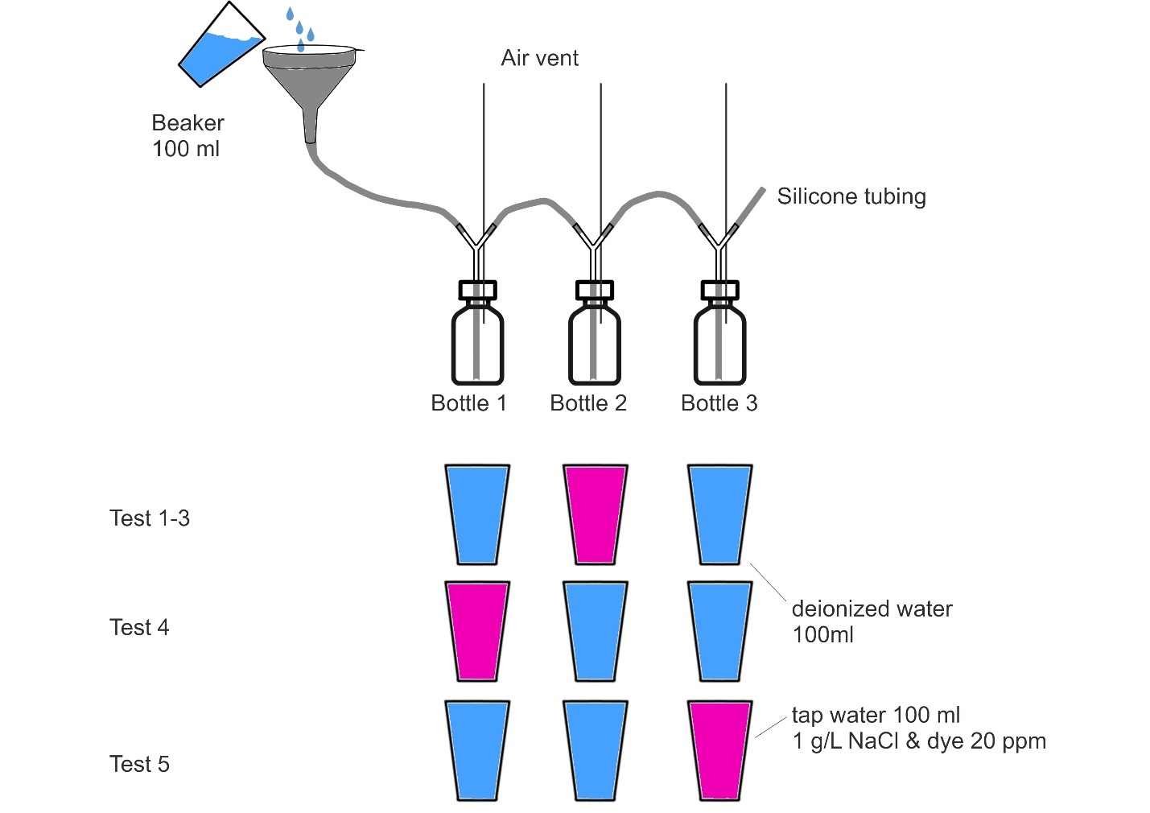

Figure S1 Laboratory experiment II. To assess the sampling error different tests were performed. Test 1 to 3 consists of filling the first bottle with 100 ml deionized water, bottle 2 with 100 ml salt-dye solution and bottle 3 with 100 ml deionized water. This gives information on mixing between all three bottles. Test 4 consists of filling the first bottle with 100 ml salt-dye solution, bottle 2 and bottle 3 with 100 ml deionized water. This gives information on the effect of mixing on bottle 1 and if water from bottle 1 is transferred into bottle 2 and 3. Test 5 consists of filling bottle 1 and 2 with 100 ml deionized water and bottle 3 with 100 ml salt-dye solution. This gives information on the effect of mixing on bottle 1 and 2 and if water from the last pour is transferred into bottle 1 and 3. Before pouring and after all sample bottles were full the electric conductive was measured.

https://youtu.be/3oxZWE8Tqn4

Video S1 Experiment I, assessing the maximum rainfall intensity before sampling errors occur. For this, volumes of water (10, 20, 30 and 50 ml of water representing 0.5, 1, 1.5, 2 and 2.5 mm s-1 of rainfall respectively) were poured into the funnel of the sampler (speed 2x).
https://youtu.be/Cy2qpDdhX2s

Video S2 Experiment II test 1, filling the sampler’s first bottle with 100 ml deionized water, bottle 2 with 100 ml salt-dye solution and bottle 3 with 100 ml deionized water. (speed 2x).
https://youtu.be/NuR05_W7hnw

Video S3 Experiment II test 2, filling the sampler’s first bottle with 100 ml deionized water, bottle 2 with 100 ml salt-dye solution and bottle 3 with 100 ml deionized water. (speed 2x).
https://youtu.be/8IasK-2XXgY

Video S4 Experiment II test 3, filling the sampler’s first bottle with 100 ml deionized water, bottle 2 with 100 ml salt-dye solution and bottle 3 with 100 ml deionized water. (speed 2x).
https://youtu.be/ckb8uo6kKqY

Video S5 Experiment II test 4, filling the sampler’s first bottle with 100 ml salt-dye solution, bottle 2 and bottle 3 with 100 ml deionized water. This gives information on the effect of mixing on bottle 1 and if water from bottle 1 is transferred into bottle 2 and 3 (speed 2x).
https://youtu.be/gRfTNAUe6yU

Video S6 Experiment II test 5, filling the sampler’s bottle 1 and 2 with 100 ml deionized water and bottle 3 with 100 ml salt-dye solution. This gives information on the effect of mixing on bottle 1 and 2 and if water from the last pour is transferred into bottle 1 and 3 (speed 2x).

Supplementary material - rainwater collected in rainfall events
The ZRS-samplers were compared on the rooftop of the CHN building of ETH Zurich, Switzerland (ETH CHN-building, 43 m above ground level, Figure S2). The well-protected location and good accessibility allowed simplified logistics, e.g. collection of samples after rain events. The comparison consisted of two rainwater-sampling periods: A) with three ZRS-samplers with a tipping bucket (S-1 to 3) in May and June 2011, and B) with three ZRS-samplers (S-1, 2 and 3) with a tipping bucket and two ZRS-samplers attached to a funnel (S-4 and 5) from October 2015 until June 2016).
All rainwater samples were collected within 1-2 days after an event and filtered (25mm 0.45-μm PTFE Syringe Filter, Simplepure USA) before analysing their isotopic composition using a Cavity Ring-Down Spectroscope-Picarro (L1102-i (samples were taken in 2011) and L2130-I (samples collected after 2011). The analysis scheme of Penna et al.(2010) was used. The precision for both analysers was for δ²H <0.6‰ and for δ¹⁸O <0.16‰. The isotope composition of water samples is denoted as δ‐notation, which expresses the relative deviation of the isotopic mixing ratios R from the internationally accepted primary water isotope standard the Vienna standard mean ocean water (VSMOW2;(Coplen, 2011)) δ=(R-R_{VSMOW2})/R_{VSMOW2} (with R^{2H}_{VSMOW2}= 155.76 •10⁻⁶ and R^{18O}_{VSMOW2}= 2005.2 •10⁻⁶ , and δ expressed in ‰).
The different ZRS-samplers are compared in this study with respect to rainfall amount and the isotopic composition δ¹⁸O and δ²H of the samples. For each rainfall event, the ZRS-sampler’s total rainfall amount (P_{tot} ) and the standard deviation (S_{D Ptot}) among the P_{tot} of the different ZRS-samplers is calculated. In addition, the standard deviation (S_{D}) for δ¹⁸O or δ²H among the temporally matching samples, i.e., different ZRS-samplers bottles filled at the same time are calculated as
$S_{D I b}=\sqrt{\frac{\sum_{i=1}^{Sn}{\left(I_{b}-\overline{δI_{b}}\right)}}{Sn-1}}$ (S2)
where δI indicate δ¹⁸O or δ²H, Sn indicates samplers S1 to Sn and subscripts b indicate bottles filled at the same time (Table S3). The rounded precision of liquid water isotope spectroscopes (generally δ¹⁸O <0.16‰ and δ²H <0.6 ‰) was used as a measure for consistent sampling or mixing (δ¹⁸O <0.1‰ and δ²H <1‰).

Table S3 For the sampled 11 rainfall events the total rainfall amount, mean temperature, and per event for the different ZRS-samplers indicated as S-1 to S-5 the δ¹⁸O and δ²H. The sample numbers are indicated as 1 to n. Isotope compositions followed by letters L indicate that the bottle leaked and was not fully filled. Mean and S_{D} all were calculated using the δ¹⁸O orδ²H of sampler 1-5. Mean and S_{D} sel were calculated using the δ¹⁸O orδ²H excluding malfunctioning rain samplers indicated by the letter L. Bold numbers indicate were S_{D 18O} >0.3‰ and S_{D 2H} > 3‰.
 |  |  |  | δ¹⁸O [‰] of ZRS-sampler
Date  [dd-mm-yy] | P _{tot} [mm] | T  [°C] | sample | S-1 | S-2 | S-3 | S-4 | S-5 | Mean  all  [‰] |  | S_{D} all  [-] |  | Mean  sel  [‰] |  | S_{D} sel  [-]
1. 26-05-11 | 8.3(0.3) | 16 | 1 | -0.93 | -0.94 | -1.6L |  |  | -1.17 |  | 0.41 |  | -0.93 |  | 0.01
 |  |  | 2 | -3.78 | -3.64 | -3.93L |  |  | -3.78 |  | 0.15 |  | -3.71 |  | 0.10
2. 31-05-11 | 27.4(2.6) | 18 | 1 | -4.07 | -4.12 | -7.91L |  |  | -5.36 |  | 2.20 |  | -4.09 |  | 0.03
 |  |  | 2 | -7.06 |  | -6.05L |  |  | -6.55
 |  |  | 3 | -7.41 | -7.03 | -9.04L |  |  | -7.83 |  | 1.07 |  | -7.22 |  | 0.27
 |  |  | 4 | -8.71 | -8.94 | -8.76L |  |  | -8.80 |  | 0.12 |  | -8.83 |  | 0.17
 |  |  | 5 | -8.58 | -8.59 |  |  |  | -8.58 |  | 0.01 |  | -8.58 |  | 0.01
 |  |  | 6
3. 15-10-15 |  | 18 | 1 | -11.45 | -11.62 | -11.65 | -11.03 | -11.19 | -11.39 |  | 0.27 |  | -11.39 |  | 0.27
 |  |  | 2 |  |  |  | -12.35
4- 16-10-15 | 1.3 (0.2) | 6 | 1 | -11.54 | -11.65 | -11.73 | -11.56 | -11.69 | -11.63 |  | 0.08 |  | -11.63 |  | 0.08
5. 17-10-15 | 11.5(0.5) | 6 | 1 | -12.09 | -11.89 | -12.12 |  | -12.01 | -12.03 |  | 0.10 |  | -12.03 |  | 0.10
 |  |  | 2 | -13.04 | -12.88 | -13.01 |  | -13.02 | -12.99 |  | 0.07 |  | -12.99 |  | 0.07
 |  |  | 3 | -13.57 | -13.56 | -13.68 |  | -13.64 | -13.61 |  | 0.06 |  | -13.61 |  | 0.06
6. 26-10-15 | 8.3(0.5) | 11 | 1 | -15.98 | -16.78L | -15.98 | -15.97 | -17.47L | -16.44 |  | 0.67 |  | -15.98 |  | 0.01
 |  |  | 2 | -18.65 | -17.40L | -18.54 | -18.79 |  | -18.34 |  | 0.64 |  | -18.66 |  | 0.12
7. 19-11-15 | 30.7(1.1) | 8 | 1 | -5.22 | -14.95L | -5.23 | -5.54 | -16.81L | -9.55 |  | 5.82 |  | -5.33 |  | 0.18
 |  |  | 2 | -5.37 | -9.45 L | -5.78 | -6.24 | -16.71L | -8.71 |  | 4.75 |  | -5.80 |  | 0.43
 |  |  | 3 | -11.02 | -13.78L | -11.66 | -11.97 | -15.96L | -12.88 |  | 2.00 |  | -11.55 |  | 0.48
 |  |  | 4 | -14.09 | -19.24L | -14.51 | -14.73 |  | -15.64 |  | 2.41 |  | -14.44 |  | 0.16
 |  |  | 5 | -17.46L | -19.07L | -18.61 | -18.36 |  | -18.38 |  | 0.68 |  | -18.14 |  | 0.36
 |  |  | 6 | -22.11L |  | -22.14 | -22.67 |  | -22.31 |  | 0.32 |  | -22.31 |  | 0.38
 |  |  | 7 | -18.40L |  | -16.99 | -17.43 |  | -17.61 |  | 0.72 |  | -17.61 |  | 0.32
8. 23-11-15 | 8.9(0.4) | 2 | 1 | -12.73 | -12.79 | -12.77 |  | -11.94L | -12.56 |  | 0.41 |  | -12.76 |  | 0.03
 |  |  | 2 | -13.95 | -13.20 | -14.71 | -13.21L | -15.95L | -14.21 |  | 1.16 |  | -13.95 |  | 0.75
 |  |  | 3 | -15.56 | -15.55 |  | -15.63L | -17.18L | -15.98 |  | 0.80 |  | -15.58 |  | 0.04
9. 28-11-15 | 6.5(0.6) | 6 | 1 | -7.32 L | -9.53 L | -6.76 | -5.76 | -8.50L | -7.57 |  | 1.47 |  | -6.27 |  | 0.71
 |  |  | 2 | -7.38 L | -7.09 L | -7.46 | -7.87 | -6.14L | -7.19 |  | 0.65 |  | -7.67 |  | 0.29
10. 15-12-15 | 4.5(0.3) | 7 | 1 | -12.63 | -12.71 | -12.62 | -12.63 | -10.67L | -12.25 |  | 0.88 |  | -12.64 |  | 0.04
 |  |  | 2 | -9.88 | -8.38L | -10.05 | -10.04 |  | -9.58 |  | 0.81 |  | -9.99 |  | 0.10
 |  |  | 3 |  | -11.74L
11. 28-02-16 | 22.6(1.6) | 3 | 1 | -9.14 | -9.09 | -9.09 | -9.36 | -9.85 | -9.30 |  | 0.32 |  | -9.30 |  | 0.32
 |  |  | 2 | -9.67 | -10.14 | -9.58 | -9.80 | -10.46 | -9.93 |  | 0.37 |  | -9.93 |  | 0.37
 |  |  | 3 | -12.63L | -11.08 | -11.25 | -11.41 | -12.09 | -11.69 |  | 0.65 |  | -11.46 |  | 0.44
 |  |  | 4 | -11.16L | -13.28 | -12.61 |  | -13.39 | -12.61 |  | 1.03 |  | -13.09 |  | 0.42
 |  |  | 5 |  | -12.88

Table 1 (continue)
 |  |  |  | δ²H [‰] of ZRS-sampler
Date  [dd-mm-yy] | P _{tot} [mm] | T  [°C] | sample | S-1 | S-2 | S-3 | S-4 | S-5 | Mean  all  [‰] |  | S_{D} all  [-] |  | Mean  sel  [‰] |  | S_{D} sel  [-]
1. 26-05-11 | 8.3(0.3) | 16 | 1 | -1.9 | -2.0 | -6.5L |  |  | -3.5 |  | 2.6 |  | -1.9 |  | 0.08
 |  |  | 2 | -20.1 | -20.1 | -20.9L |  |  | -20.4 |  | 0.5 |  | -20.0 |  | 0.004
2. 31-05-11 | 27.4(2.6) | 18 | 1 | -22.13 | -22.08 | -52.3L |  |  | -32.18 |  | 17.46 |  | -22.10 |  | 0.04
 |  |  | 2 | -46.66 |  | -35.6L |  |  | -41.13
 |  |  | 3 | -49.65 | -46.10 | -59.3L |  |  | -51.69 |  | 6.85 |  | -47.9 |  | 2.5
 |  |  | 4 | -60.92 | -61.89 | -58.1 |  |  | -60.29 |  | 2.00 |  | -60.3 |  | 0.6
 |  |  | 5 | -59.27 | -59.30 |  |  |  | -59.28 |  | 0.02 |  | -59.3 |  | 0.02
 |  |  | 6
3. 15-10-15 |  | 18 | 1 | -81.6 | -82.5 | -82.4 | -78.6 | -80.4 | -81.1 |  | 1.6 |  | -81.1 |  | 1.6
 |  |  | 2 |  |  |  | -87.6
4- 16-10-15 | 1.3 (0.2) | 6 | 1 | -79.1 | -80.5 | -80.4 | -79.9 | -80.2 | -80.0 |  | 0.6 |  | -80.0 |  | 0.6
5. 17-10-15 | 11.5(0.5) | 6 | 1 | -79.5 | -79.5 | -79.7 |  | -78.9 | -79.4 |  | 0.4 |  | -79.4 |  | 0.4
 |  |  | 2 | -84.5 | -83.7 | -84.3 |  | -84.6 | -84.3 |  | 0.4 |  | -84.3 |  | 0.4
 |  |  | 3 | -90.1 | -89.9 | -90.8 |  | -90.9 | -90.4 |  | 0.5 |  | -90.4 |  | 0.5
6. 26-10-15 | 8.3(0.5) | 11 | 1 | -116.8 | -124.0L | -117.1 | -116.4 | -128.8 | -120.7 |  | 5.5 |  | -116.8 |  | 0.3
 |  |  | 2 | -138.4 | -128.3L | -137.2 | -139.2 |  | -135.7 |  | 5.1 |  | -138.2 |  | 1.0
7. 19-11-15 | 30.7(1.1) | 8 | 1 | -38.7 | -114.8L | -39.0 | -41.1 | -128.0L | -72.3 |  | 45.1 |  | -39.6 |  | 1.3
 |  |  | 2 | -40.4 | -70.8L | -44.0 | -47.5 | -126.4L | -65.8 |  | 35.9 |  | -44.0 |  | 3.5
 |  |  | 3 | -81.7 | -103.2L | -86.3 | -87.9 | -115.8L | -95.0 |  | 14.2 |  | -85.3 |  | 3.2
 |  |  | 4 | -105.4 | -149.2L | -109.0 | -111.0 |  | -118.6 |  | 20.5 |  | -108.5 |  | 1.4
 |  |  | 5 | -135.5L | -148.2L | -145.6 | -143.3 |  | -143.1 |  | 5.5 |  | -141.4 |  | 2.5
 |  |  | 6 | -174.0L |  | -173.7 | -178.7 |  | -175.5 |  | 2.8 |  | -175.5 |  | 3.5
 |  |  | 7 | -137.7L |  | -124.4 | -126.5 |  | -129.5 |  | 7.1 |  | -129.5 |  | 1.55
8. 23-11-15 | 8.9(0.4) | 2 | 1 | -89.6 | -89.9 | -89.4 |  | -122.5L | -97.9 |  | 16.4 |  | -89.6 |  | 0.2
 |  |  | 2 | -95.7 | -94.3 | -95.3 | -111.0L | -115.6L | -102.4 |  | 10.1 |  | -95.1 |  | 0.7
 |  |  | 3 | -115.1 | -115.4 |  | -92.5L | -82.0L | -101.3 |  | 16.7 |  | -107.7 |  | 0.2
9. 28-11-15 | 6.5(0.6) | 6 | 1 | -46.7 | -64.8L | -43.6 | -49.2 | -54.6L | -51.8 |  | 8.3 |  | -46.4 |  | 4.0
 |  |  | 2 | -48.8 | -45.3L | -47.1 | -48.1 | -38.0L | -45.4 |  | 4.4 |  | -47.6 |  | 0.7
10. 15-12-15 | 4.5(0.3) | 7 | 1 | -89.7 | -89.9 | -89.5 | -89.3 | -75.1L | -86.7 |  | 6.5 |  | -89.6 |  | 0.2
 |  |  | 2 | -71.4 | -90.4L | -73.4 | -72.3 |  | -76.9 |  | 9.1 |  | -72.4 |  | 1.0
 |  |  | 3 |  | -86.1L
11. 28-02-16 | 22.6(1.6) | 3 | 1 | -60.5 | -60.7 | -60.5 | -61.8 | -68.4 | -62.4 |  | 3.4 |  | -62.4 |  | 3.4
 |  |  | 2 | -65.3 | -71.6 | -62.7 | -64.2 | -71.5 | -67.1 |  | 4.2 |  | -67.1 |  | 4.2
 |  |  | 3 | -95.4L | -84.6 | -85.9 | -87.8 | -90.5 | -88.9 |  | 4.3 |  | -87.2 |  | 2.5
 |  |  | 4 | -86.8L | -100.4 | -95.4 |  | -98.9 | -95.4 |  | 6.1 |  | -98.2 |  | 2.6
 |  |  | 5 |  | -95.3

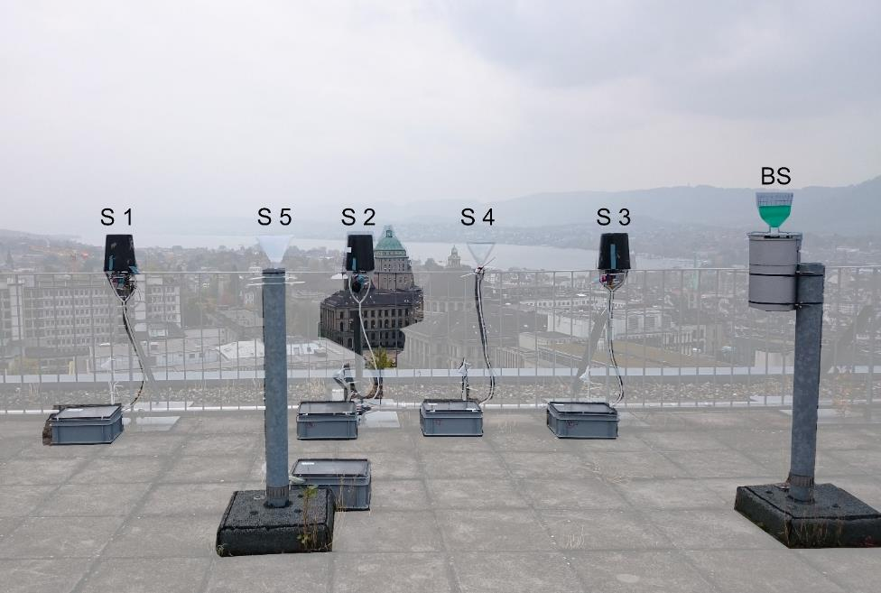

Figure S2 Experimental setup the rooftop of the ETH Zurich University (ETH CHN-building, 43 m above ground level) with three ZRS-samplers (S-1, 2 and 3) with tipping bucket, two ZRS-samplers without a tipping bucket (S-4 and 5) and bulk sampler (BS, not used in this manuscript).

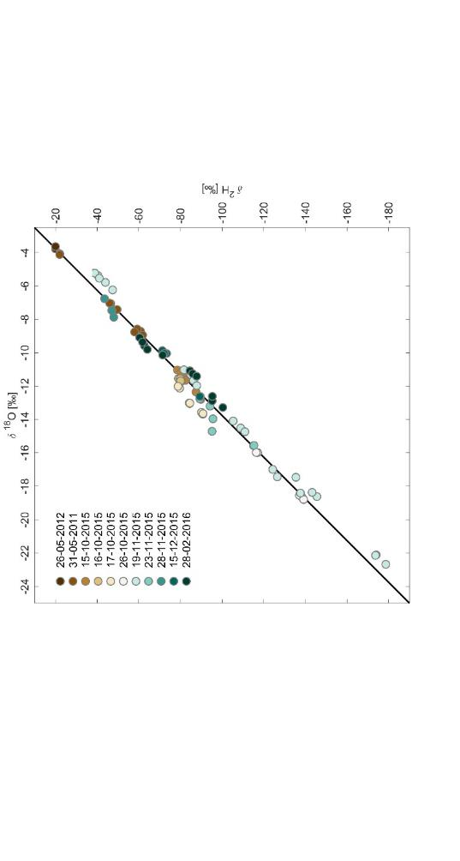

Figure S3 The global meteoric water line (black line) with all collected rainfall samples of the different events (colours, date dd-mm-yyyy). All collected samples lie on the GWML.

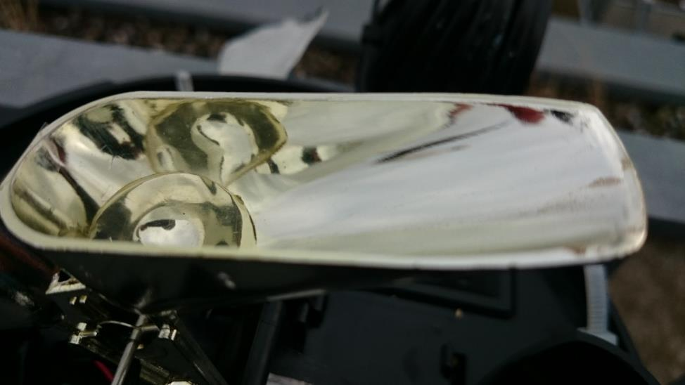

Figure S4 After the rain stopped a last rain droplet remained in one of the buckets of the tipping bucket rain gauge. If this water is not removed it could cause contamination in the isotopic composition of the rain of the next event. This highlights the need for maintenance and cleaning when samples are collected.

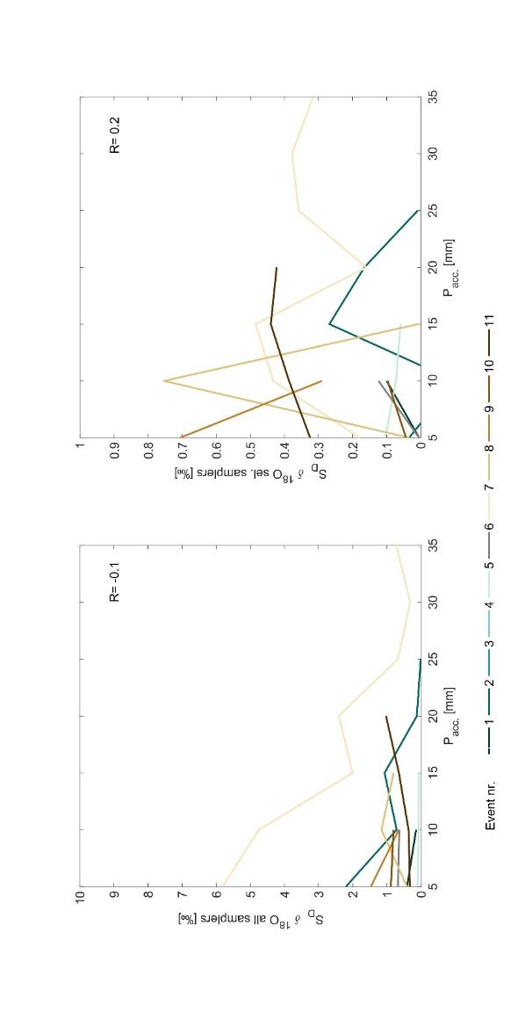

Figure S5 To assess whether the rainfall amount could affect the S_{D} the rainfall amount is represented as S_{D} for all rain samplers (left panel) and rain samplers excluding malfunctioning rain samplers (right panel). Different rainfall events are indicated as coloured lines.

