Supplementary tables
Table S1. Main compounds of ZXC
Name | Chemical structure
Gallic acid | 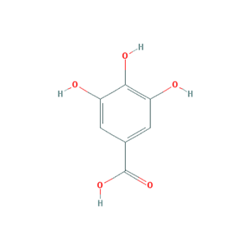
Crocin I | 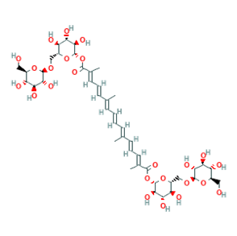
Crocin II | 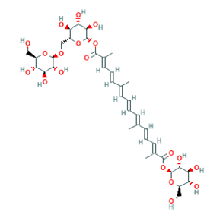
Liquiritin | 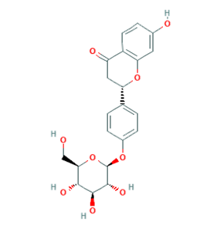
Cinnamic acid | 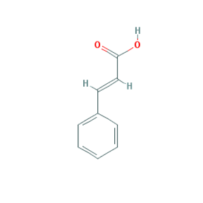
Cinnamaldehyde | 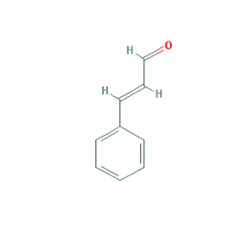
Eugenol | 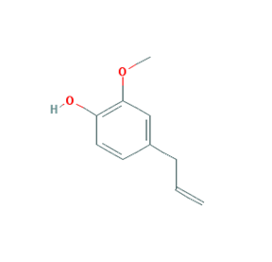
Glycyrrhetinic acid | 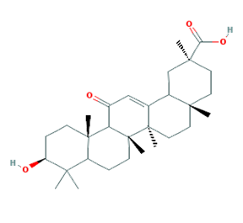
Muscone | 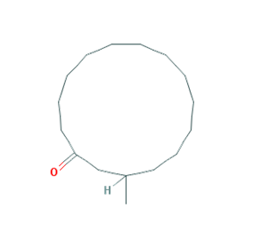
ZXC: Zhenlong Xingnao Capsule

Table S2. Real-time polymerase chain reaction primers
Primer ID | Sequence
P-P38-F | 5’-AGA CGA ATG GAA GAG CCT GA-3’
P-P38-R | 5’-GGG ATG GAC AGA ACA GAA GC-3’
NF-кB-F | 5’-TGG GAC GAC ACC TCT ACA CA-3’
NF-кB-R | 5’-GGC TCA AAG TTC TCC ACC AG-3’
BCL2-F | 5’-GGT GGA CAA CAT CGC TCT G-3’
BCL2-R | 5’-CAG CCA GGA GAA ATC AAA CA-3’
BAX-F | 5’-ACG CAT CCA CCA AGA AGC-3’
BAX-R | 5’-GCC ACA CGG AAG AAG ACC T-3’
CASPASE3-F | 5’-ACG GGA CTT GGA AAG CAT C-3’
CASPASE3-R | 5’-TAA GGA AGC CTG GAG CAC AG-3’
ACTIN-F | 5’-CCC ATC TAT GAG GGT TAC GC-3’
ACTIN-R | 5’-TTT AAT GTC ACG CAC GAT TTC-3’

Table S3. Antioxidant index results for the left-brain tissue (mean ± standard deviation, n = 10)
Antioxidant index | MDA  (nmol/mg protein) | GSH-Px  (mg/g protein) | T-AOC  (U/mg protein) | T-SOD  (U/mg protein)
Sham | 2.02±0.86 | 5.68±1.84 | 1.82±0.41 | 4.57±1.73
MCAO model | 2.47±0.94 | 5.98±2.71 | 1.61±0.47 | 3.84±1.43
Low ZXC | 3.23±1.62 | 5.04±1.50 | 1.54±0.56 | 3.98±1.67
High ZXC | 1.35±0.64 | 6.92±2.42 | 1.63±0.55 | 4.02±1.36
Nimodipine | 2.32±0.62 | 5.25±2.06 | 1.65±0.46 | 3.47±1.57
MDA: Malondialdehyde; GSH-Px: glutathione peroxidase; T-AOC: total antioxidant capacity; T-SOD: total superoxide dismutase; MCAO: middle cerebral artery occlusion; ZXC: Zhenlong Xingnao Capsule

Table S4. Antioxidant index results for the right-brain tissue (mean ± standard deviation, n = 10)
Antioxidant index | MDA  (nmol/mg protein) | GSH-Px  (mg/g protein) | T-AOC  (U/mg protein) | T-SOD  (U/mg protein)
Sham | 1.73±0.62 | 6.31±2.71 | 2.03±0.65 | 5.17±1.83
MCAO model | 2.60±0.82* | 3.83±1.30** | 1.33±0.34* | 3.78±0.88*
Low ZXC | 2.23±1.67 | 3.42±1.16 | 1.34±0.40 | 5.50±2.13
High ZXC | 2.23±0.73 | 4.89±1.94 | 1.84±0.50# | 5.58±1.71#
Nimodipine | 2.33±1.36 | 4.58±2.18 | 1.38±0.53 | 4.53±1.48
*: P < 0.05 vs. sham group; **: P < 0.01 vs. sham group; #: P < 0.05 vs. model group.
MDA: Malondialdehyde; GSH-Px: glutathione peroxidase; T-AOC: total antioxidant capacity; T-SOD: total superoxide dismutase; MCAO: middle cerebral artery occlusion; ZXC: Zhenlong Xingnao Capsule

