**Supplemental Information**

Exploring silica stoichiometry on a large floodplain riverscape

**Authors**: Joanna C. Carey1,2*, KathiJo Jankowski3, Paul Julian4, Lienne Sethna5, Patrick Thomas6, Jason Rohweder3

**Supplemental Methods**

*Study system*

The mainstem impounded reaches we study range from 38-71 km long. The most southern reach - Open River - is a free-flowing 82 km mile stretch of river downstream of the last navigation dam near Cape Girodeau, MO. The median residence times for the impounded reaches ranges from 1 to 2 days, except for Reach 1, which has an estimated median residence time of 9 days (Wasely, 2000). The run-of-river impounded areas of the UMRS navigation pools have lower potential for retention and processing than typical reservoirs associated with hydropower dams. The UMRS has a series of 26 low-head lock and dams that impound the flow of the river. While these impoundments have fundamentally altered the river’s hydrological character, they do not affect water residence time and associated nutrient processing to the same degree as hydroelectric dams.

Aquatic areas were defined in a geographic information system (GIS) based on their major geomorphic and physical features (Wilcox 1993). The extent of each of these aquatic areas types as a proportion of total reach area varies substantially among river reaches of the UMRS (De Jager et al. 2018).

For the mainstem stratified random sampling design, the population of possible sampling sites in each study reach was defined as the intersections of a north–south, east–west grid laid over each aquatic area type. The resolution of the sampling grid varies by aquatic area type; in main and side channel areas the distance between grid lines was 200m while in backwater lakes the distance was 50m. During each sampling event, SRS sites were randomly selected from this population and the number of sites varied among study reaches.

*Data Handling*

Any datum associated with a fatal analytical qualifier indicating a potential data quality problem was removed prior to analysis. If a constituent (i.e. SRP or DIN) was greater than the total (i.e. TP or TN) within a given sample by a factor of 1.3, it was deemed a reversal and excluded from the analysis. For purposes of data analysis and summary statistics, data reported as less than the method detection limit (MDL) were assigned a value of one-half the MDL, unless otherwise noted. Total and dissolved fractions were screened for reversals (i.e. dissolved > total) and remove prior to analysis.

*Chlorophyll a concentrations*

CHL concentrations measured on spectrophotometer are more accurate, but much more laborious to obtain compared to fluorometric methods. Therefore, the program used season-year specific regressions between CHL and CHLF to estimate CHL concentrations for all sites. Calibration equations were determined for each year and season separately (R2 generally > 0.85). CHL was determined spectrophotometrically in the presence of pheophyton using standard methods (American Public Health Association, 2005). Briefly, river water was filtered through a 47-mm glass fiber (A/E) filter, the filter was ground, and chlorophyll was extracted in 90% buffered acetone solution. Following centrifugation, sample absorption was read at 750 and 664 nm before and after acidification with 0.1 N HCL. CHLF was determined fluorometrically by filtering river water through a 25-mm glass fiber (A/E) filter, extracting using a 1:1 mixture of acetone and DMSO (dimethyl sulfoxide), and reading the fluorescence on a Turner Designs 10 AU digital fluorometer. Further details concerning sampling design and analytical methods can be found in Soballe & Fischer (2004).

*Basin characteristics*

The land use predictors included in the original models included categories of land cover that accounted for at least 5% of basin coverage. Categories with <5% basin coverage were excluded from the model predictors, including shrub/scrub, grassland/herbatious, and open water land cover categories. After excluding these non-dominant land cover types, all basins had between 94.5 and 99.5% of basin land cover represented in the models. We combined several similar land use categories in order to reduce the number of predictors in multiple linear regression models. Specifically, we combined all categories of developed land (i.e. combined all density types), forest lands (deciduous + mixed + evergreen), and wetland types (emergent + woody). Similar to land use, we also excluded primary lithology types that represented less than 5% of the basins, and created one new category of combined lithology type (denoted as ‘other’ in the model) that were non-dominant but present at levels >5% in several basins (this ‘other’ category included schist, gneiss, granite, mafic metavolcanic, basalt, and clay/mud)..

**Supplemental Results**

Si concentration responded differently to river hydrogeomorphology than Si:TP or Si:TN.

Si:TP ratios varied across reaches in certain aquatic areas. Swan Lake in reach 4 and Lake Pepin in reach 1. Lake Pepin had similar Si:TP to the main channel, whereas Swan Lake had lower Si:TP than the main channel. Si:TP differed between channels and off-channel areas: main and side channel Si:TP not differ significantly from one another, but Si:TP in channels was lower than in contiguous and isolated backwaters. Impounded Si:TP was most similar to channels. Among reaches, we found some different patterns among ratios.

In addition to downstream changes, pairwise comparisons among reaches showed different patterns among Si, Si:TN and Si:TP. Si concentrations were similar among reaches 3, 4, and the Open River, but differed from the upper reaches (1 and 2), as well as the IL River. Si:TP varied significantly among all reaches except reach 4 and the Open River. Si:TN was similar between reaches 1 and 2, and reaches 3 and 4, but these all differed from the Open River and the IL River.

The role of phytoplankton dynamics in altering Si stoichiometry in the watershed is also apparent in our seasonal analysis. In the UMRS, phytoplankton exhibit compositional and seasonal succession throughout the year, with diatoms typically dominating during the spring and fall and blue-green algae dominating in the summer [(Baker and Baker, 1981)](https://www.zotero.org/google-docs/?D3t1SN). This shift in species composition corresponds to seasonal differences in Si concentrations within the UMRS (Fig S1).

*Land use vs. lithological predictor separately*

Examining ratios using land use coverage alone, we found that Si:TP ratios were best explained by developed and pasture coverage (adj. R2=0.18, df=20, p=0.05), whereas Si:TN ratios were best described by forest and developed coverage (adj. R2=0.72, df=20, p<0.0001). Examining concentrations using land use alone, both forests and wetlands were important predictors in multiple linear regression of TN and TP, as well as wetland coverage in the case of TP (TP: adj. R2=0.23, df=19, p=0.05; TN: adj. R2=0.79, df=20, p=<0.0001). Using lithology alone to predict ratios, we found that Si:TP ratios were best explained by limestone and shale coverage (adj. R2=0.3, df=20, p=0.01), whereas Si:TN ratios were best described by limestone and sandstone coverage (adj. R2=0.35, df=20, p=0.005). TP concentrations were explained by sandstone and shale (adj. R2=0.23, df=20, p=0.03), whereas TN concentrations were explained by sandstone and limestone (adj. R2=0.37, df=20, p=0.003). As mentioned above, no land use predictors were considered viable for multiple linear regression of Si alone, in contrast to lithology, which explained 20% of observed Si concentrations (adj. R2=0.20).

Cultivated crops land was not a good predictor of nutrient ratios partially due to the extremely high covariation between cultivated cropland and other basin land cover types, which resulted in exclusion of cultivated crops from Stepwise AIC regressions. However, even replacing forest coverage with cultivated crops as a predictor in our multiple linear regression models still does not identify cultivated crops as important predictors of tributary stoichiometry. Cultivated cropland may be less of an important driver of tributary stoichiometry due to the high variability in basin land use in the UMR (Table S3), or the common practice of farmers leaving siliceous plant parts (e.g. husks, straw) on fields, which might prevent soil amorphous Si depletion and altered nutrient exports from agricultural landscapes.

**Supplemental Discussion**

*Suspended material composition in the UMRS*

The input and distribution of suspended solids play a critical role in river ecosystem structure and function [(Vannote et al., 1980)](https://www.zotero.org/google-docs/?dThmIq). The quantity and composition of suspended solids is determined by it source (i.e. allochthonous versus autochthonous) and thus, its biogeochemical composition [(Bukaveckas et al., 2011)](https://www.zotero.org/google-docs/?wch5mb). In the UMRS, suspended material on average is composed of approximately a third of algal-derived C, although there are notable declines in the organic matter content of suspended solids (i.e. VSS) along the UMR. This is consistent with organic matter processes hypothesized in the river continuum concept (RCC) [( Vannote et al., 1980)](https://www.zotero.org/google-docs/?sxmvKt). Suspended material can also play a role in P-cycling and transport, with particulate P potentially accounting for a proportion of the total P pool.

**References**

American Public Health Association (2005). Standard methods for the examination of water and wastewater. 21st ed. American Public Health Association.

Baker, K. K., and Baker, A. L. (1981). Seasonal succession of the phytoplankton in the upper Mississippi River. Hydrobiologia 83, 295–301. doi:10.1007/BF00008280.

Bukaveckas, P. A., MacDonald, A., Aufdenkampe, A., Chick, J. H., Havel, J. E., Schultz, R., et al. (2011). Phytoplankton abundance and contributions to suspended particulate matter in the Ohio, Upper Mississippi and Missouri Rivers. Aquat Sci 73, 419–436. doi:10.1007/s00027-011-0190-y.

De Jager, N. R., Rogala, J. T., Rohweder, J. J., Van Appledorn, M., Bouska, K. L., Houser, J. N., et al. (2018). Indicators of Ecosystem Structure and Function for the Upper Mississippi River System. U.S. Geological Survey.

Soballe, D. M., and Fischer, J. R. (2004). Long term resource monitoring program procedures: Water quality monitoring. U.S. Geological Survey.

Vannote, R. L., Minshall, G. W., Cummins, K. W., Sedell, J. R., and Cushing, C. E. (1980). The River Continuum Concept. Can. J. Fish. Aquat. Sci. 37, 130–137. doi:10.1139/f80-017.

Wasely, D. (2000). Concentration and movement of nitrogen and other materials in selected reaches and tributaries of the Upper Mississippi River System.

Wilcox, D. B. (1993). An Aquatic Habitat Classification System for the Upper Mississippi River System. U.S. Fish and Wildlife Service.

**Supplemental Figures**

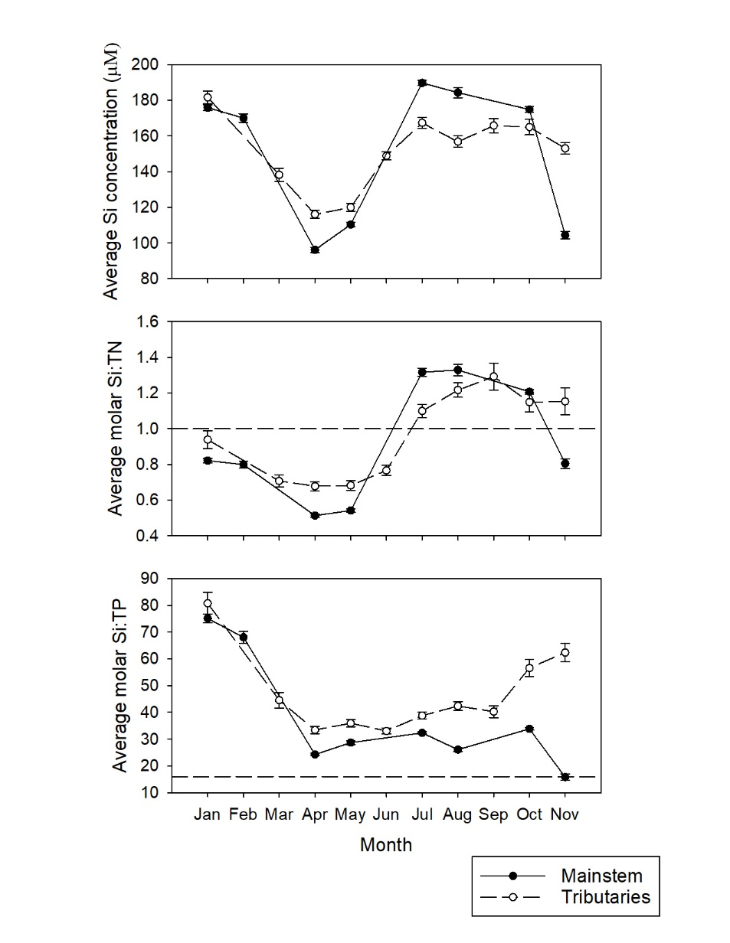

Figure S1: Seasonal trends of Si, Si:TN, and Si:TP in mainstem and tributaries

**Supplemental Tables**

Table S1: Mean ± standard error of total phosphorus (TP), soluble reactive phosphorus (SRP), total nitrogen (TN), and dissolved inorganic nitrogen (DIN) concentrations, as well as the percent SRP and percent DIN for the period of record (2010-2018) for tributary and mainstem (including all aquatic areas) sites.

|  |  |  |  |  |  |  |  |
| --- | --- | --- | --- | --- | --- | --- | --- |
| Dataset | Type/Aquatic Area | Total Phosphorus (µM) | Soluble Reactive Phosphorus (µM) | Percent Soluble Reactive Phosphorus | Total Nitrogen (µM) | Dissolved Inorganic Nitrogen (µM) | Percent Dissolved Inorganic Nitrogen |
| Tributaries | Tributaries | 6.2 ± 0.2 | 1.7 ± 0.2 | 24 ± 1.0 | 263 ± 11 | 225 ± 11 | 77 ± 1.4 |
| Mainstem | Main Channel | 6.4 ± 0.5 | 2.0 ± 0.2 | 30 ± 1.4 | 218 ± 8 | 172 ± 8 | 77 ± 1.3 |
|  | Side Channel | 6.5 ± 0.5 | 2.0 ± 0.2 | 29 ± 1.3 | 219 ± 8 | 171 ± 8 | 77 ± 1.2 |
|  | Connected Backwater | 6.4 ± 0.4 | 1.8 ± 0.2 | 28 ± 1.3 | 164 ± 6 | 130 ± 7 | 77 ± 2.3 |
|  | Impoundment | 4.5 ± 0.3 | 1.2 ± 0.1 | 27 ± 2.1 | 188 ± 8 | 138 ± 8 | 73 ± 1.7 |
|  | Riverine Lake | 6.9 ± 1.1 | 2.3 ± 0.5 | 31 ± 3.8 | 177 ± 16 | 149 ± 19 | 76 ± 8.1 |
|  | Isolated Backwater | 5.1 ± 0.4 | 0.8 ± 0.1 | 16 ± 3.3 | 79 ± 8 | 31 ± 13 | 32 ± 10.0 |

Table S2: The coefficient of variation (CV) across space of each nutrient concentration/ratio. The CV represents a unitless and standardized metric of the magnitude of spatial variation. ‘SRS’ indicates stratified random sampling, the sampling method used in the mainstem.



Table S3. Summary statistics of ratio of dissolved silicon (DSi) and total phosphorus (TP), ratio of DSi and total nitrogen (TN) DSi, percent land cover and percent lithology coverage for the 23 tributaries of the Upper Mississippi River System.

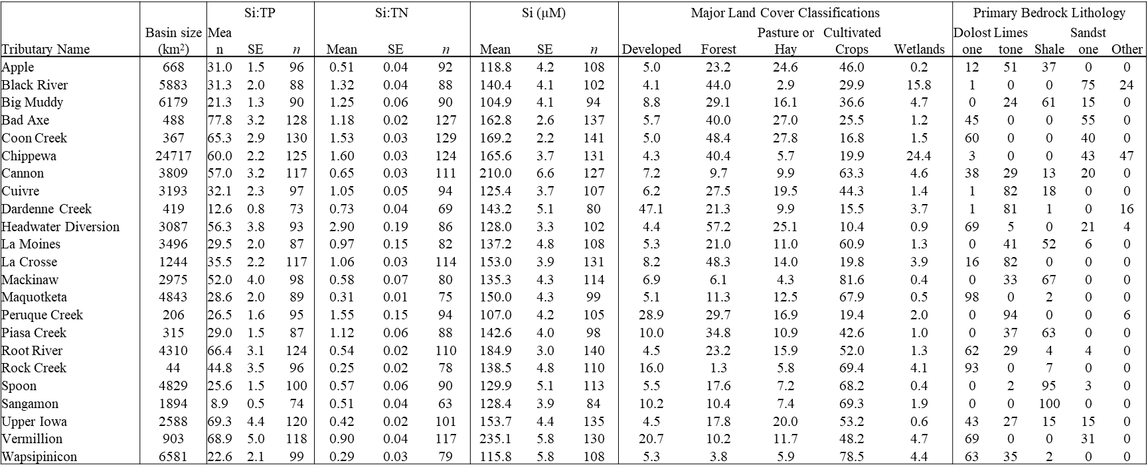

Table S4. Correlation of individual variables with axes of the PCA. PC1 = principal component 1, PC2 = principal component 2.

|  |  |  |
| --- | --- | --- |
| **Variable** | **PC1** | **PC2** |
| Turbidity | 0.95 |  |
| VSS | 0.93 |  |
| Chl *a* | 0.48 | 0.71 |
| Depth |  | -0.86 |
| Temp | 0.93 |  |
| Si | -0.78 | -0.46 |
| Si:TN | -0.82 |  |
| Si:TP | -0.95 |  |
| TN | 0.61 | -0.58 |
| TP | 0.93 |  |
| Vel |  | -0.85 |

Table S5: Comparison of models using site-specific factors to explain patterns in DSi concentration (a), Si:TN (b) and Si:TP (c) in each aquatic area type. Chl = chlorophyll, VSS = volatile suspended solids, TURB = turbidity, and TEMP = water temperature. R2m = marginal R2 (fixed effects) and R2c = conditional R2 (full model).

A)

|  |  |  |  |  |  |  |
| --- | --- | --- | --- | --- | --- | --- |
| **DSi** | **n** | **k** | **AICc** | **DAICc** | **R2m** | **R2c** |
| **MAIN CHANNEL** | | | | | | |
| Chl+VSS+TEMP | 2494 | 7 | 4529.3 | 0.0 | 0.20 | 0.53 |
| Chl+VSS+TURB+TEMP | 2492 | 8 | 4533.8 | 4.5 | 0.20 | 0.53 |
| Chl+Temp | 2495 | 6 | 4595.6 | 66.3 | 0.18 | 0.5 |
| Chl+TURB | 2494 | 6 | 4673.1 | 143.8 | 0.17 | 0.5 |
| Chl+VSS | 2495 | 6 | 4677.2 | 147.9 | 0.17 | 0.5 |
| Chl | 2496 | 5 | 4710.3 | 181.0 | 0.15 | 0.43 |
| VSS | 2500 | 5 | 5242.5 | 713.2 | 0.02 | 0.43 |
| Turb | 2499 | 5 | 5272.8 | 743.5 | 0.00 | 0.43 |
| Temp | 2500 | 5 | 5290.6 | 761.3 | 0.00 | 0.43 |
| **SIDE CHANNEL** | | | | | | |
| Chl+VSS+TEMP | 2567 | 7 | 5179.2 | 0.0 | 0.16 | 0.46 |
| Chl+VSS+TURB+TEMP | 2567 | 8 | 5184.2 | 5.0 | 0.16 | 0.46 |
| Chl+Temp | 2567 | 6 | 5231.0 | 51.8 | 0.14 | 0.47 |
| Chl+TURB | 2567 | 6 | 5284.8 | 105.6 | 0.13 | 0.44 |
| Chl+VSS | 2567 | 6 | 5286.2 | 107.0 | 0.13 | 0.43 |
| Chl | 2572 | 5 | 5315.8 | 136.6 | 0.12 | 0.44 |
| VSS | 2571 | 5 | 5714.6 | 535.4 | 0.02 | 0.38 |
| Turb | 2573 | 5 | 5744.9 | 565.7 | 0.008 | 0.38 |
| Temp | 2574 | 5 | 5760.4 | 581.2 | 0.002 | 0.39 |
| **BACKWATERS** | | | | | | |
| Chl+VSS+TURB+TEMP | 3337 | 8 | 9439.8 | 0.0 | 0.04 | 0.28 |
| Chl+VSS+TEMP | 3337 | 7 | 9454.2 | 14.4 | 0.04 | 0.27 |
| Chl+Temp | 3337 | 6 | 9466.0 | 26.2 | 0.02 | 0.25 |
| Chl+TURB | 3337 | 6 | 9537.6 | 97.8 | 0.02 | 0.26 |
| Chl+VSS | 3337 | 6 | 9552.2 | 112.4 | 0.01 | 0.25 |
| Chl | 3337 | 5 | 9579.8 | 140.0 | 0.007 | 0.21 |
| Temp | 3346 | 5 | 9549.3 | 109.5 | 0.02 | 0.25 |
| Turb | 3345 | 5 | 9598.1 | 158.3 | 0.008 | 0.26 |
| VSS | 3345 | 5 | 9624.2 | 184.4 | 0 | 0.23 |
| **ISOLATED BACKWATERS** | | | | | | |
| Turb | 108 | 5 | 299.7 | 0.0 | 0.12 | 0.19 |
| Chl+TURB | 108 | 6 | 305.7 | 6.0 | 0.12 | 0.19 |
| Chl+VSS+TURB+TEMP | 108 | 8 | 308.7 | 9.0 | 0.16 | 0.22 |
| VSS | 108 | 5 | 313.9 | 14.2 | 0.02 | 0.10 |
| Temp | 108 | 5 | 317.4 | 17.7 | 0 | 0.08 |
| Chl | 108 | 5 | 318.0 | 18.3 | 0.002 | 0.09 |
| Chl+VSS | 108 | 6 | 318.8 | 19.1 | 0.02 | 0.10 |
| Chl+Temp | 108 | 6 | 323.0 | 23.3 | 0.002 | 0.09 |
| Chl+VSS+TEMP | 108 | 7 | 323.8 | 24.1 | 0.02 | 0.10 |
| **IMPOUNDED** | | | | | | |
| Chl+VSS+TEMP | 817 | 7 | 2078.4 | 0.0 | 0.15 | 0.29 |
| Chl+VSS+TURB+TEMP | 817 | 8 | 2081.6 | 3.2 | 0.15 | 0.29 |
| Chl+Temp | 819 | 6 | 2083.7 | 5.3 | 0.14 | 0.29 |
| Chl+VSS | 817 | 6 | 2104.1 | 25.7 | 0.12 | 0.27 |
| Chl | 819 | 5 | 2105.0 | 26.6 | 0.12 | 0.26 |
| Chl+TURB | 819 | 6 | 2107.4 | 29.0 | 0.12 | 0.27 |
| VSS | 818 | 5 | 2146.0 | 67.6 | 0.07 | 0.26 |
| Turb | 820 | 5 | 2201.6 | 123.2 | 0.02 | 0.22 |
| Temp | 820 | 5 | 2219.7 | 141.3 | 0.002 | 0.19 |

B)

|  |  |  |  |  |  |  |
| --- | --- | --- | --- | --- | --- | --- |
| **Si:TN** | **n** | **k** | **AICc** | **AICc** | **R2m** | **R2c** |
| **MAIN CHANNEL** | | | | | | |
| Chl+VSS+TEMP | 2489 | 7 | 2865.5 | 0.0 | 0.13 | 0.56 |
| Chl+VSS+TURB+TEMP | 2487 | 8 | 2870.9 | 5.4 | 0.13 | 0.56 |
| Chl+Temp | 2490 | 6 | 2974.2 | 108.7 | 0.10 | 0.57 |
| Temp | 2495 | 5 | 3186.0 | 320.5 | 0.05 | 0.52 |
| Chl+TURB | 2489 | 6 | 3342.2 | 476.7 | 0.03 | 0.45 |
| VSS | 2495 | 5 | 3394.9 | 529.4 | 0.01 | 0.43 |
| Turb | 2494 | 5 | 3400.9 | 535.4 | 0.01 | 0.44 |
| Chl+VSS | no convergence |  |  |  |  |  |
| Chl | no convergence |  |  |  |  |  |
| **SIDE CHANNELS** | | | | | | |
| Chl+VSS+TEMP | 2565 | 7 | 3889.2 | 0.0 | 0.15 | 0.49 |
| Chl+VSS+TURB+TEMP | 2565 | 8 | 3892.6 | 3.4 | 0.15 | 0.49 |
| Chl+Temp | 2565 | 6 | 3972.7 | 83.5 | 0.13 | 0.51 |
| Temp | 2571 | 5 | 4212.8 | 323.6 | 0.07 | 0.45 |
| Chl+TURB | 2565 | 6 | 4378.2 | 489.0 | 0.04 | 0.36 |
| Chl+VSS | 2565 | 6 | 4386.7 | 497.5 | 0.04 | 0.36 |
| Chl | 2565 | 5 | 4411.0 | 521.8 | 0.03 | 0.37 |
| VSS | 2569 | 5 | 4464.7 | 575.5 | 0.02 | 0.34 |
| Turb | no convergence |  |  |  |  |  |
| **BACKWATERS** | | | | | | |
| Chl+Temp | 3333 | 6 | 10904.0 | 0.0 | 0.08 | 0.18 |
| Chl+VSS+TEMP | 3333 | 7 | 10910.0 | 6.0 | 0.08 | 0.18 |
| Chl+VSS+TURB+TEMP | 3333 | 8 | 10912.0 | 8.0 | 0.08 | 0.18 |
| Temp | 3341 | 5 | 10950.0 | 46.0 | 0 | 0.19 |
| Chl | 3333 | 5 | 11204.0 | 300.0 | 0 | 0.09 |
| Chl+VSS | 3333 | 6 | 11205.0 | 301.0 | 0 | 0.1 |
| Chl+TURB | 3333 | 6 | 11210.0 | 306.0 | 0 | 0.09 |
| Turb | 3341 | 5 | 11227.0 | 323.0 | 0 | 0.09 |
| VSS | 3341 | 5 | 11227.0 | 323.0 | 0 | 0.1 |
| **ISOLATED BACKWATERS** | | | | | | |
| VSS | 108 | 5 | 462.3 | 0.0 | 0.02 | 0.10 |
| Turb | 108 | 5 | 462.4 | 0.1 | 0.002 | 0.10 |
| Chl+TURB | 108 | 6 | 463.6 | 1.3 | 0.03 | 0.11 |
| Chl | 108 | 5 | 464.2 | 1.9 | 0.02 | 0.11 |
| Chl+VSS | 108 | 6 | 465.5 | 3.2 | 0.03 | 0.12 |
| Temp | 108 | 5 | 465.9 | 3.6 | 0.0002 | 0.09 |
| Chl+VSS+TURB+TEMP | 108 | 8 | 467.1 | 4.8 | 0.04 | 0.12 |
| Chl+Temp | 108 | 6 | 467.5 | 5.2 | 0.03 | 0.11 |
| Chl+VSS+TEMP | 108 | 7 | 468.8 | 6.5 | 0.03 | 0.11 |
| **IMPOUNDED** | | | | | | |
| Chl+VSS+TEMP | 816 | 7 | 1412.7 | 0.0 | 0.34 | 0.38 |
| Chl+VSS+TURB+TEMP | 816 | 8 | 1415.0 | 2.3 | 0.34 | 0.38 |
| Chl+Temp | 818 | 6 | 1444.4 | 31.7 | 0.31 | 0.36 |
| Temp | 819 | 5 | 1631.7 | 219.0 | 0.13 | 0.17 |
| Chl+VSS | 816 | 6 | 1671.2 | 258.5 | 0.09 | 0.12 |
| Chl+TURB | 818 | 6 | 1672.2 | 259.5 | 0.09 | 0.12 |
| Chl | 818 | 5 | 1674.0 | 261.3 | 0.09 | 0.11 |
| VSS | 817 | 5 | 1689.0 | 276.3 | 0.07 | 0.1 |
| Turb | 819 | 5 | 1725.2 | 312.5 | 0.03 | 0.06 |

C)

|  |  |  |  |  |  |  |
| --- | --- | --- | --- | --- | --- | --- |
| **Si:TP** | **n** | **k** | **AICc** | **AICc** | **R2m** | **R2c** |
| **MC** | | | | | | |
| Chl+VSS+TEMP | 2490 | 7 | 4274.0 | 0.0 | 0.17 | 0.63 |
| Chl+VSS+TURB+TEMP | 2488 | 8 | 4278.0 | 4.0 | 0.05 | 0.63 |
| Chl+Temp | 2491 | 6 | 4374.0 | 100.0 | 0.16 | 0.64 |
| Chl+VSS | 2490 | 5 | 4507.0 | 233.0 | 0.11 | 0.6 |
| Chl+TURB | 2490 | 6 | 4551.0 | 277.0 | 0.13 | 0.6 |
| Temp | 2496 | 5 | 4590.0 | 316.0 | 0.09 | 0.61 |
| VSS | 2496 | 5 | 4920.0 | 646.0 | 0.05 | 0.54 |
| Turb | 2495 | 5 | 5013.0 | 739.0 | 0.02 | 0.54 |
| Chl | no convergence |  |  |  |  |  |
| **SC** | | | | | | |
| Chl+VSS+TURB+TEMP | 2565 | 8 | 4757.0 | 0.0 | 0.18 | 0.59 |
| Chl+VSS+TEMP | 2565 | 7 | 4760.0 | 3.0 | 0.18 | 0.59 |
| Chl+Temp | 2565 | 6 | 4862.0 | 105.0 | 0.14 | 0.59 |
| Temp | 2571 | 5 | 5052.0 | 295.0 | 0.1 | 0.57 |
| Chl+VSS | 2565 | 6 | 5092.0 | 335.0 | 0.11 | 0.54 |
| Chl+TURB | 2565 | 6 | 5147.0 | 390.0 | 0.1 | 0.54 |
| Chl | 2565 | 5 | 5238.0 | 481.0 | 0.07 | 0.56 |
| VSS | 2569 | 5 | 5407.0 | 650.0 | 0.05 | 0.49 |
| Turb | 2571 |  | 5503.0 | 746.0 | 0.02 | 0.5 |
| **BW** | | | | | | |
| Chl+VSS+TEMP | 3333 | 7 | 7875.0 | 0.0 | 0.15 | 0.4 |
| Chl+VSS+TURB+TEMP | 3333 | 8 | 7878.0 | 3.0 | 0.15 | 0.4 |
| Chl+Temp | 3333 | 6 | 7894.0 | 19.0 | 0.13 | 0.41 |
| Temp | 3341 | 5 | 7965.0 | 90.0 | 0.11 | 0.42 |
| Chl+VSS | 3333 | 6 | 8271.0 | 396.0 | 0.08 | 0.31 |
| Chl+TURB | 3333 | 6 | 8309.0 | 434.0 | 0.06 | 0.31 |
| Chl | 3333 | 5 | 8327.0 | 452.0 | 0.05 | 0.33 |
| VSS | 3341 | 5 | 8342.0 | 467.0 | 0.06 | 0.3 |
| Turb | 3341 | 5 | 8471.0 | 596.0 | 0.02 | 0.29 |
| **IMP** | | | | | | |
| Chl+VSS+TEMP | 816 | 7 | 1868.1 | 0.0 | 0.39 | 0.41 |
| Chl+VSS+TURB+TEMP | 816 | 8 | 1871.1 | 3.0 | 0.39 | 0.41 |
| Chl+Temp | 818 | 6 | 1927.1 | 59.0 | 0.34 | 0.38 |
| Chl+VSS | 816 | 6 | 1988.1 | 120.0 | 0.29 | 0.31 |
| VSS | 817 | 5 | 2006.0 | 137.9 | 0.27 | 0.29 |
| Chl+TURB | 818 | 6 | 2013.1 | 145.0 | 0.27 | 0.29 |
| Temp | 819 | 5 | 2049.0 | 180.9 | 0.23 | 0.27 |
| Chl | 818 | 5 | 2073.0 | 204.9 | 0.21 | 0.25 |
| Turb | 819 | 5 | 2156.0 | 287.9 | 0.13 | 0.15 |

Table S6. Pairwise differences among aquatic areas. Aquatic areas that share a letter are not significantly different from one another (p>0.05). Post-hoc pairwise differences were calculated based on the results of the reach*aquatic area mixed model using the emmeans package in R.

|  |  |  |  |  |  |
| --- | --- | --- | --- | --- | --- |
| **Aquatic Area** | **DSi** | **TN** | **TP** | **Si:TN** | **Si:TP** |
| Main channel | cd | d | b | a | c |
| Side channel | d | d | b | a | cd |
| Contiguous backwater | b | b | bc | b | b |
| Riverine lake | bc | c | cd | a | b |
| Impounded area | cd | c | a | a | d |
| Isolated backwater | a | a | d | b | a |