Supplementary Material

Analysis of the phylogenic origin of key genes for citrus fruit quality using C. maxima and C. reticulata diagnostic SNPs
Milena do Amaral Santos¹, Marcia Fabiana Barbosa de Paula¹, Frederique Ollitrault², Ronan Rivillan³, Edson Mario de Andrade Silva¹, Abelmon da Silva Gesteira⁴, François Luro⁵, Dominique Garcia³, Patrick Ollitrault^{2,*}, Fabienne Micheli^{1,3,*}
* Correspondence: Patrick Ollitrault: patrick.ollitrault@cirad.fr; Fabienne Micheli: fabienne.micheli@cirad.fr

Supplementary Data

Supplementary Data 1. Examples of haplotype networks of carotenoid biosynthesis pathway established from resequencing data
For each gene, the two haplotypes of clementine were directly obtained from the reference sequence of an haploid Clementine (Phytozome) and the re-sequencing data of the diploid Nules clementine. Willow leaf mandarin and Ridge Pineaple sweet orange haplotypes were obtained from their re-sequencing data according to their parental relationship with clementine. Duncan grapefruit haplotypes were then deduced from its resequencing data tacking advantage of its parentalship with sweet orange. Haplotypes from Nadorcott, Ponkan and Cleopatra Mandarin as well as Chandler and acidless Pummelo and Sour orange were inferred from their re-sequencing data by statistical approach using GEVALT software (Ofir Davidovich, Gad Kimmel and Ron Shamir. GEVALT: An integrated software tool for genotype analysis. BMC Bioinformatics 2007, 8:36) integrated in SNiPlay (http://sniplay.southgreen.fr/cgi-bin/home.cgi). The haplotype networks were established with Haplophyle software integrated in SNiPlay.
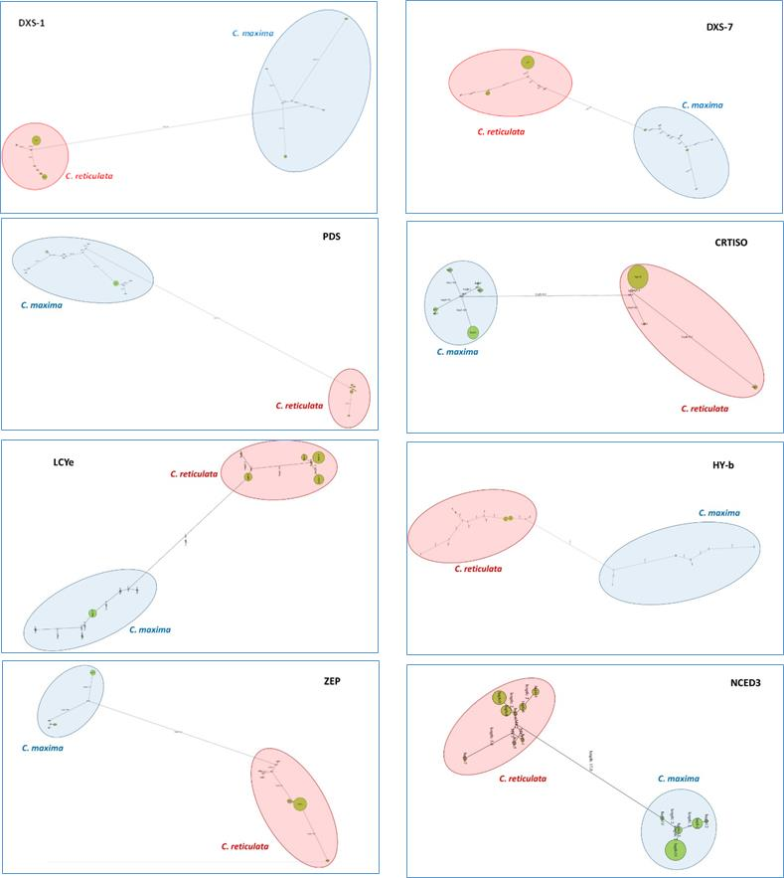

Supplementary Tables
Supplementary Table 1. List of the 92 varieties used in this study. Variety name was according to Tanaka (1957). Pedigree from Ollitrault et al. (2012), Wu et al. (2014, 2018), Curk et al. (2016) and Oueslati et al., 2017).
Varieties used for the in silico analysis are indicated in bold. R: C. reticulata; M: C. maxima; C: citron C. medica; Mic.: C. micrantha; F1: hybrid.
Horticultural group | Tanaka classification | Commun name | pedigree | Total of varieties
Mandarins | Citrus reticulata | Citrus depressa mandarin | R/? | 22
 |  | Nan feng mi chu mandarin | R/M
 |  | San Hu Hong Chu mandarin | R/M
 |  | Szibat mandarin | R/M
 |  | Cleopatra mandarin | R
 |  | Dancy mandarin | R/M
 |  | King mandarin | R/M
 |  | Ladu mandarin | R/M
 |  | Ponkan mandarin | R/M
 |  | Satsuma Owari mandarin | R/M
 |  | Sunki mandarin | R
 |  | Willowleaf mandarin | R/M
 |  | Kara mandarin | R/M
 |  | Carvalhal mandarin | R/M
 |  | Fairchild mandarin | R/M
 |  | Fortune mandarin | R/M
 |  | Fremont mandarin | R/M
 |  | Wilking mandarin | R/M
 |  | Fallglo mandarin | R/M
 |  | Se Hui Gan mandarin | R/M
 |  | Daoxianensis mandarin | R/M
 |  | Fuzhu mandarin | R/M
Pummelos | Citrus maxima | Chandler pummelo | M/R | 10
 |  | Timor pummelo | M
 |  | Deep red pummelo | M
 |  | Kao Pan pummelo | M
 |  | Nam Roy pummelo | M
 |  | Pink pummelo | M
 |  | Tahiti pummelo | M
 |  | Azimboa pummelo | M
 |  | Da Xanh pummelo | M
 |  | Gil pummelo | M
Citrons | Citrus medica | Corsican citron | C | 5
 |  | Etrog Citron | C
 |  | Mac Veu de montagne citron | C
 |  | Buddha’s hand citron | C
 |  | Hupang citron | C
Papeda | C. micrantha | Micrantha | Mic. | 1
Clementina | C. clementina | Haploide Clementine | R/M | 2
 |  | Clementine Nules | R/M
Sour orange | C. aurantium | BigaradierMaroc | F1: RxM | 2
 |  | Bouquetier de Nice | F1: RxM
Sweet Orange | Citrus sinensis | Valencia late | R/M | 2
 |  | Washington navel | R/M
Grapefruit | Citrus paradisi | Duncan grapefruit | R/M | 3
 |  | Marsh grapefruit | R/M
 |  | Star Ruby grapefruit | R/M
Tangelo | C. reticulata × C. paradisi | Nova tangelo | R/M | 17
 |  | Osceola tangelo | R/M
 |  | Page tangelo | R/M
 |  | Robinson tangelo | R/M
 |  | Allspice tangelo | R/M
 |  | Mapo tangelo | R/M
 |  | Minneola tangelo | R/M
 |  | Orlando tangelo | R/M
 |  | Pearl tangelo | R/M
 |  | Sampson tangelo | R/M
 |  | San Jacinto tangelo | R/M
 |  | Seminole tangelo | R/M
 |  | Sunrise tangelo | R/M
 |  | Sunshine tangelo | R/M
 |  | UGLI® tangelo | R/M
 |  | Webber tangelo | R/M
 |  | Wekiwa tangelo | R/M
Tangor | C. reticulata × C. sinensis | Temple tangor | R/M | 7
 |  | Ambersweet tangor | R/M
 |  | Dweet tangor | R/M
 |  | Ellendale tangor | R/M
 |  | Kiyomi tangor | R/M
 |  | Murcott tangor | R/M
 |  | Ortanique tangor | R/M
Orangelo | C. paradisi × C. sinensis | Jackson orangelo | R/M | 2
 |  | Triumph orangelo | R/M
Lemons and limes | Citrus limon | Lisbon lemon | (RxM)xC | 10
 | Citrus limon | Eureka lemon | (RxM)xC
 | Citrus meyeri | Meyer lemon | (R/M)xC
 | Citrus jambhiri | Rough lemon | F1: RxC
 | Citrus limonia | Volkamer lemon | F1: RxC
 | Citrus limonia | Rangpur lime | F1: RxC
 | Citrus limettioides | Palestinian sweet lime | (RxM)xC
 | Citrus limetta | Marrakech limonette | (RxM)xC
 | Citrus aurantiifolia | Mexican lime | MicxC
 | C. bergamia | Bergamotte | R/M/C
Nasnaran | C. amblycarpa | Nasnaran | F1: MxMic. | 1
Out-group | Citrus hystrix | Combava | - | 1
 | Poncirus trifoliata | Pomeroy trifoliate | - | 2
 |  | Rubidoux trifoliate | -
 | Clymenia polyandra | Clymenia polyandra | - | 1
 | Eremocitrus glauca | Desert lime | - | 1
 | Microcitrus australasica | Australian finger lime | - | 1
 | Citrus japonica | Marumi kumquat | - | 1
 | Severinia buxifolia | Chinese box orange | - | 1
Total |  |  |  | 92

Supplementary Table 2. Complete list of the genes used in this study. ID: identification in phytozome annotation of clementine reference genome (Wu et al., 2014).
Metabolic pathway | Gene name | Gene code | ID
Carotenoid genes | Phytoene syntase | PSY_6 | Ciclev10011841m
 | Phytoene desaturase | PDS_9a | Ciclev10005632m
 |  | PDS_9b | Ciclev10007114m
 | Beta-carotene 3-hydroxylase | HYB_9 | Ciclev10005481m
 | Carotene cis-transisomerase | CRTISO_6 | Ciclev10011230m
 | Lycopene beta-cyclase | LCYb_9 | Ciclev10004730m
 | Capsanthin/capsorubin synthase | CCS_8 | Ciclev10028245m
 | Lycopene epsilon-cyclase | LCYe_1 | Ciclev10008410m
 | Zeaxanthin epoxidase | ZEP_7 | Ciclev10025089m
 | Zeta-carotene isomerase | Z-ISO_3 | Ciclev10020648m
 | Epoxycarotenoid dioxygenase | NCED_2 | Ciclev10014639m
 |  | NCED_9 | Ciclev10006710m
 |  | NCED_3 | Ciclev10019364m
 | 1-deoxy-D-xylulose-5-phosphate synthase | DXS_7 | Ciclev10024949m
 |  | DXS_9 | Ciclev10004432m
 |  | DXS_1 | Ciclev10007595m
Sugar genes | Fructan exohydrolase | FEH_1 | Ciclev10007827m
 | Invertase_beta-frutofuranosidase | INV_6 | Ciclev10013701m
 |  | INV_7a | Ciclev10025243m
 |  | INV_7b | Ciclev10025259m
 |  | INV_9 | Ciclev10004465m
 | Sucrose-phosphate phosphatase | SPP_2 | Ciclev10015425m
 |  | SPP_6 | Ciclev10011822m
 | SucrosePhosphateSynthase | SPS_1a | Ciclev10007312m
 |  | SPS_3 | Ciclev10018655m
 | Glycosyl transferase | GT_9 | Ciclev10004221m
 | Sucrose Synthase | SUSY_1a | Ciclev10010343m
 |  | SUSY_1b | Ciclev10007483m
 |  | SUSY_3 | Ciclev10018889m
 |  | SUSY_6 | Ciclev10011062m
 |  | SUSY_9 | Ciclev10004341m
 | Sucrose Transporter | SUT2_4 | Ciclev10030996m
 |  | SUT4_5 | Ciclev10000941m
 |  | SUT1_5 | Ciclev10000828m
Chlorophyll genes | Pheophorbide a oxygenase | PAO_8 | Ciclev10028147m
 | Geranylgeranyl diphosphate reductase | GDR_3 | Ciclev10020061m
 | Geranylgeranyl diphosphate reductase | GDR_2 | Ciclev10015206m

Supplementary Table 3. Distribution of SNPs in PCA analysis. The same color indicated markers with the same segregation pattern.
Marker code | Principal axis |  |  | Chrm.
 | F1 | F2 | F3 | Number | Position
DXS_1_004 | -0.742 | 0.651 | -0.008 | 1 | 2201769
DXS_1_005 | 0.898 | 0.314 | -0.030 | 1 | 2204655
LCYe_1_016 | 0.756 | 0.334 | -0.117 | 1 | 10946683
LCYe_1_018 | 0.247 | -0.015 | -0.243 | 1 | 10947735
LCYe_1_017 | -0.756 | -0.334 | 0.117 | 1 | 10949337
SPS_1b_118 | 0.925 | 0.326 | -0.003 | 1 | 20335430
SUSY_1a_076 | 0.620 | 0.221 | -0.038 | 1 | 24769884
SUSY_1a_074 | -0.925 | -0.321 | 0.033 | 1 | 24769925
SUSY_1a_075 | -0.848 | -0.214 | -0.086 | 1 | 24770550
SUSY_1b_077 | 0.764 | -0.125 | -0.124 | 1 | 24815532
SUSY_1b_078 | -0.764 | 0.585 | 0.007 | 1 | 24815911
SUSY_1b_079 | -0.810 | -0.299 | -0.102 | 1 | 24817862
SPS_1b _065 | 0.924 | 0.349 | -0.005 | 1 | 25882871
SPS_1b _117 | -0.673 | 0.658 | -0.135 | 1 | 25882940
SPS_1b _119 | 0.742 | -0.651 | 0.008 | 1 | 25883715
SPP_2_060 | 0.716 | -0.414 | 0.129 | 2 | 647558
SPP_2_059 | 0.862 | 0.256 | -0.034 | 2 | 648813
SPP_2_112 | 0.622 | -0.402 | 0.103 | 2 | 649874
SPP_2_058 | 0.902 | 0.357 | 0.091 | 2 | 649938
GDR_2_142 | -0.566 | 0.369 | -0.371 | 2 | 10232512
GDR_2_141 | 0.473 | -0.138 | -0.037 | 2 | 10233106
NCED_2_002 | -0.590 | 0.742 | 0.259 | 2 | 35236903
NCED_2_100 | -0.553 | 0.707 | 0.134 | 2 | 35237027
GDR_3_139 | -0.533 | 0.551 | -0.150 | 3 | 7269388
GDR_3_137 | -0.710 | 0.174 | -0.314 | 3 | 7269418
GDR_3_138 | -0.640 | 0.678 | -0.144 | 3 | 7269966
SPS_3_070 | -0.815 | -0.441 | -0.066 | 3 | 23004267
SPS_3_120 | -0.820 | -0.243 | -0.234 | 3 | 23007967
SPS_3_121 | 0.874 | 0.238 | 0.106 | 3 | 23008019
SPS_3_069 | -0.795 | 0.022 | 0.124 | 3 | 23008371
NCED_3_028 | 0.714 | -0.672 | 0.037 | 3 | 29352238
NCED_3_029 | -0.712 | 0.596 | -0.033 | 3 | 29353038
NCED_3_030 | 0.549 | 0.204 | -0.370 | 3 | 29353389
Z-ISO_3_041 | 0.897 | 0.336 | -0.051 | 3 | 39692943
Z-ISO_3_105 | 0.722 | 0.077 | -0.165 | 3 | 39693203
Z-ISO_3_042 | -0.907 | -0.344 | -0.022 | 3 | 39694029
SUSY_3_080 | 0.728 | 0.239 | 0.270 | 3 | 46011973
SUSY_3_125 | -0.754 | -0.168 | -0.423 | 3 | 46015516
SUSY_3_082 | -0.718 | -0.308 | -0.233 | 3 | 46015618
SUT2_4_090 | -0.854 | -0.162 | 0.131 | 4 | 23706202
SUT2_4_089 | 0.765 | -0.205 | -0.174 | 4 | 23707455
SUT2_4_091 | 0.607 | -0.676 | 0.077 | 4 | 23708831
SUT2_4_129 | -0.632 | -0.086 | -0.277 | 4 | 23710311
SUT4_5_093 | -0.655 | -0.280 | -0.589 | 5 | 35066730
SUT4_5_092 | -0.704 | 0.499 | -0.050 | 5 | 35067373
SUT4_5_094 | 0.655 | 0.280 | 0.589 | 5 | 35070565
SUT1_5_096 | -0.917 | -0.337 | -0.021 | 5 | 39527580
SUT1_5_095 | 0.894 | 0.281 | 0.024 | 5 | 39528405
CRTISO_6_003 | 0.887 | 0.307 | -0.213 | 6 | 19580111
CRITSO_6_001 | 0.653 | 0.227 | -0.495 | 6 | 19580386
CRITSO_6_002 | 0.596 | -0.746 | -0.200 | 6 | 19581034
SPP_6_063 | 0.249 | -0.524 | -0.293 | 6 | 19587634
SPP_6_061 | -0.887 | -0.307 | 0.213 | 6 | 19587935
SPP_6_115 | -0.637 | -0.224 | 0.396 | 6 | 19588948
SPP_6_116 | -0.853 | -0.248 | 0.074 | 6 | 19589174
INV_6_048 | 0.560 | 0.010 | -0.448 | 6 | 20334510
INV_6_107 | -0.211 | -0.580 | 0.014 | 6 | 20334875
INV_6_108 | -0.861 | -0.287 | 0.083 | 6 | 20335430
INV_6_047 | 0.886 | 0.306 | -0.017 | 6 | 20336709
PSY_6_143 | 0.793 | 0.106 | -0.365 | 6 | 21391650
PSY_6_144 | 0.793 | 0.106 | -0.365 | 6 | 21393272
PSY_6_145 | 0.523 | -0.354 | 0.018 | 6 | 21393302
SUSY_6_085 | 0.006 | 0.458 | 0.416 | 6 | 21405852
SUSY_6_083 | -0.881 | -0.316 | 0.219 | 6 | 21406297
SUSY_6_084 | -0.596 | 0.746 | 0.200 | 6 | 21407171
ZEP_7_104 | -0.401 | 0.396 | -0.196 | 7 | 3222750
ZEP_7_38 | -0.635 | 0.655 | -0.033 | 7 | 3223699
ZEP_7_102 | 0.656 | -0.710 | -0.024 | 7 | 3223842
ZEP_7_039 | -0.707 | 0.619 | -0.010 | 7 | 3228529
DXS_7_097 | 0.710 | 0.083 | -0.085 | 7 | 5043747
DXS_7_007 | -0.791 | 0.065 | 0.119 | 7 | 5044084
DXS_7_008 | -0.683 | 0.684 | -0.082 | 7 | 5044407
INV_7a _050 | -0.917 | -0.324 | -0.009 | 7 | 6557846
INV_7a _049 | 0.848 | 0.148 | -0.107 | 7 | 6558776
INV_7a _051 | -0.620 | -0.263 | 0.407 | 7 | 6559831
INV_7b_052 | 0.757 | -0.169 | 0.187 | 7 | 6562070
INV_7b _054 | 0.526 | 0.228 | -0.381 | 7 | 6562309
INV_7b _053 | 0.706 | -0.593 | 0.013 | 7 | 6562761
CCS_8_019 | -0.678 | 0.349 | -0.091 | 8 | 19259940
CCS_8_021 | 0.665 | -0.488 | 0.194 | 8 | 19260511
CCS_8_020 | 0.712 | 0.202 | 0.015 | 8 | 19260867
PAO_8_133 | 0.835 | 0.183 | -0.119 | 8 | 21113191
PAO_8_134 | -0.842 | -0.223 | 0.117 | 8 | 21116731
PAO_8_135 | -0.019 | -0.482 | -0.194 | 8 | 21116878
SUSY_9_086 | 0.817 | 0.264 | -0.156 | 9 | 1499940
SUSY_9_087 | 0.923 | 0.336 | -0.018 | 9 | 1502120
SUSY_9_088 | 0.795 | 0.290 | -0.216 | 9 | 1502352
DXS_9_011 | -0.913 | -0.355 | 0.004 | 9 | 2354611
INV_9_110 | -0.280 | 0.308 | -0.036 | 9 | 2355144
DXS_9_010 | 0.890 | 0.347 | 0.075 | 9 | 2355144
DXS_9_012 | 0.742 | -0.651 | 0.008 | 9 | 2355446
GT_9_073 | -0.916 | -0.327 | 0.005 | 9 | 15985569
GT_9_124 | 0.622 | 0.149 | -0.047 | 9 | 15987011
GT_9_123 | 0.912 | 0.279 | -0.080 | 9 | 15987291
PDS_9b _035 | -0.916 | -0.327 | 0.005 | 9 | 17778673
PDS_9b _036 | -0.830 | -0.116 | 0.094 | 9 | 17779170
PDS_9b _037 | -0.246 | -0.156 | 0.000 | 9 | 17779554
PDS_9a _032 | -0.916 | -0.327 | 0.005 | 9 | 17790595
PDS_9a _033 | 0.916 | 0.327 | -0.005 | 9 | 17791304
PDS_9a _034 | 0.626 | -0.561 | -0.007 | 9 | 17792958
LCYb_9_022 | -0.916 | -0.327 | 0.005 | 9 | 22728581
LCYb_9_023 | 0.916 | 0.327 | -0.005 | 9 | 22728720
LCYb_9_024 | -0.576 | 0.517 | 0.005 | 9 | 22729397
INV_9_111 | -0.279 | 0.303 | -0.029 | 9 | 27283782
INV_9_055 | 0.621 | -0.306 | 0.338 | 9 | 27286067
INV_9_056 | -0.811 | -0.105 | -0.021 | 9 | 27287227
HYB_9_099 | 0.742 | -0.651 | 0.008 | 9 | 29488796
HYB_9_013 | -0.742 | 0.651 | -0.008 | 9 | 29488937
HYB_9_014 | 0.353 | -0.315 | -0.012 | 9 | 29489930
HYB_9_015 | -0.689 | -0.285 | -0.539 | 9 | 29490755

Supplementary Table 4. Diagnostic set of 115 SNPs related to fruit quality and their impact on the protein sequence. aa: amino acid; R: C. reticulata; M: C. maxima. See Excel File.

Supplementary Table 5. Phylogenetic origin of 29 genes of the carotenoid, sugar and chlorophyll biosynthesis pathways for 75 citrus varieties. See Excel File.

