Supplementary Legends of Method and Figure

Supplementary Method 1 Detailed search strategy.
Supplementary Method 2 Reason from exclusion of literature.

Supplementary Figure 1 Risk of bias assessment.
Supplementary Figure 2 Meta-regression of the interaction of long course of low-dose corticosteroids in 28-day mortality and APACHE II score (A), mortality rate of baseline (B), the published year (C) and sample size (D).
Note: Size of the data markers indicates weight of the study; APACHE, Acute Physiology and Chronic Health Evaluation.
Supplementary Figure 3 Trial sequential analysis of long course of low-dose corticosteroids for 28-day mortality.
Note: A diversity-adjusted information size of 12,082 patients was calculated based on an anticipated relative risk reduction (RRR) of 10% (event proportion of 28.9% in the control arm, α=0.05 (two-sided), β=0.10 (Power 90%)). The blue cumulative Z-curve was constructed using a fixed-effects model and crossed the conventional boundaries and trial sequential monitoring boundaries when trials were included.
Supplementary Figure 4 Trial sequential analysis of long course of low-dose corticosteroids for 28-day mortality as sensitive analysis.
Note: A diversity-adjusted information size of 7,067 patients was calculated based on an anticipated relative risk reduction (RRR) of 13% (event proportion of 28.9% in the control arm, α=0.05 (two-sided), β=0.10 (Power 90%)). The blue cumulative Z-curve was constructed using a fixed-effects model and crossed the conventional boundaries and trial sequential monitoring boundaries when trials were included.
Supplementary Figure 5 Trial sequential analysis of long course of low-dose corticosteroids for 28-day mortality as sensitive analysis.
Note: A diversity-adjusted information size of 9,025 patients was calculated based on an anticipated relative risk reduction (RRR) of 10% (event proportion of 28.9% in the control arm, α=0.05 (two-sided), β=0.10 (Power 80%)). The blue cumulative Z-curve was constructed using a fixed-effects model and crossed the conventional boundaries but not trial sequential monitoring boundaries. However, the blue cumulative z-curve crossed the required information size (RIS) line when trials were included.
Supplementary Figure 6 Trial sequential analysis of long course of low-dose corticosteroids for 90-day mortality.
Note: A diversity-adjusted information size of 90,499 patients was calculated based on an anticipated relative risk reduction (RRR) of 10% (event proportion of 32.9% in the control arm, α=0.05 (two-sided), β=0.10 (Power 90%)). The blue cumulative Z-curve was constructed using a fixed-effects model and did not cross any boundaries when trials were included.
Supplementary Figure 7 Trial sequential analysis of long course of low-dose corticosteroids for 90-day mortality as sensitive analysis.
Note: A diversity-adjusted information size of 21,951 patients was calculated based on an anticipated relative risk reduction (RRR) of 20% (event proportion of 32.9% in the control arm, α=0.05 (two-sided), β=0.10 (Power 90%)). The blue cumulative Z-curve was constructed using a fixed-effects model and did not cross any boundaries when trials were included.
Supplementary Figure 8 Trial sequential analysis of long course of low-dose corticosteroids for 90-day mortality as sensitive analysis.
Note: A diversity-adjusted information size of 74,553 patients was calculated based on an anticipated relative risk reduction (RRR) of 10% (event proportion of 32.9% in the control arm, α=0.05 (two-sided), β=0.10 (Power 80%)). The blue cumulative Z-curve was constructed using a fixed-effects model and did not cross any boundaries when trials were included.
Supplementary Figure 9 Forest plot of the benefits of long course of low-dose corticosteroids for ICU mortality.
Supplementary Figure 10 Trial sequential analysis of long course of low-dose corticosteroids for ICU mortality.
Note: A diversity-adjusted information size of 5,333 patients was calculated based on an anticipated relative risk reduction (RRR) of 18% (event proportion of 37.1% in the control arm, α=0.05 (two-sided), β=0.10 (Power 90%)). The blue cumulative Z-curve was constructed using a fixed-effects model and crossed the conventional boundaries and trial sequential monitoring boundaries when trials were included.
Supplementary Figure 11 Trial sequential analysis of long course of low-dose corticosteroids for ICU mortality as sensitive analysis.
Note: A diversity-adjusted information size of 3,984 patients was calculated based on an anticipated relative risk reduction (RRR) of 18% (event proportion of 37.1% in the control arm, α=0.05 (two-sided), β=0.10 (Power 80%)). The blue cumulative Z-curve was constructed using a fixed-effects model and crossed the conventional boundaries and trial sequential monitoring boundaries when trials were included.
Supplementary Figure 12 Forest plot of the benefits of short course of high-dose and long course of low-dose corticosteroids for in-hospital mortality.
Supplementary Figure 13 Trial sequential analysis of long course of low-dose corticosteroids for in-hospital mortality.
Note: A diversity-adjusted information size of 12,846 patients was calculated based on an anticipated relative risk reduction (RRR) of 9% (event proportion of 39.2% in the control arm, α=0.05 (two-sided), β=0.10 (Power 90%)). The blue cumulative Z-curve was constructed using a fixed-effects model and crossed the conventional boundaries and trial sequential monitoring boundaries when trials were included.
Supplementary Figure 14 Trial sequential analysis of long course of low-dose corticosteroids for in-hospital mortality as sensitive analysis.
Note: A diversity-adjusted information size of 9,596 patients was calculated based on an anticipated relative risk reduction (RRR) of 9% (event proportion of 39.2% in the control arm, α=0.05 (two-sided), β=0.10 (Power 80%)). The blue cumulative Z-curve was constructed using a fixed-effects model and crossed the conventional boundaries and trial sequential monitoring boundaries when trials were included.
Supplementary Figure 15 Forest plot of the benefits of short course of high-dose and long course of low-dose corticosteroids for shock reversal by day 7.
Supplementary Figure 16 Forest plot of the benefits of long course of low-dose corticosteroids for shock reversal by day 28.
Supplementary Figure 17 Forest plot of the benefits of long course of low-dose corticosteroids for length of ICU stay.
Supplementary Figure 18 Forest plot of the benefits of long course of low-dose corticosteroids for length of hospital stay.
Supplementary Figure 19 Forest plot of the benefits of long course of low-dose corticosteroids for SOFA score at day 7.
Supplementary Figure 20 Forest plot of harms of short course of high-dose and long course of low-dose corticosteroids for gastroduodenal bleeding.
Supplementary Figure 21 Forest plot of harms of short course of high-dose and long course of low-dose corticosteroids for superinfection.
Supplementary Figure 22 Forest plot of harms of long course of low-dose corticosteroids for neuromuscular weakness.
Supplementary Figure 23 Forest plot of harms of short course of high-dose and long course of low-dose corticosteroids for hyperglycaemia.
Supplementary Figure 24 Forest plot of harms of long course of low-dose corticosteroids for hypernatraemia.
Supplementary Figure 25 The L’Abbe plot and Egger’s regression of corticosteroids of long course of low-dose for 28-day mortality (A), 90-day mortality (B), ICU mortality (C) and hospital mortality (D).
Supplement Method 1 Detailed search strategy.
1. Search strategy for Ovid MEDLINE(R) Epub Ahead of Print, In-Process & Other Non-Indexed Citations, Ovid MEDLINE(R) Daily, Ovid MEDLINE and Versions(R) <1946 to 2019 March 22>
#1 exp Sepsis /(115377)
#2 exp Shock, Septic /(21342)
#3 (sepsis or septic shock).mp. /(126560)
#4 #1 or #2 or #3 /(173622)
#5 exp Adrenal Cortex Hormones /(383450)
#6 (corticosteroid* or steroid*).mp. /(395245)
#7 #6 or #5 /(669900)
#8 #4 and #7 /(7265)
#9 ((randomized controlled trial or controlled clinical trial).pt. or randomized.ab. or placebo.ab. or clinical trials as topic.sh. or randomly.ab. or trial.ti.) not (animals not (humans and animals)).sh. /(1108431)
#10 #8 and #9 /(613)

2. Search strategy for Ovid EMbase Classic + EMbase <1947 to 2019 March 22>
#1 exp Sepsis /(252555)
#2 exp Shock, Septic /(48565)
#3 (sepsis or septic shock).mp. /(233303)
#4 #1 or #2 or #3 /(289456)
#5 exp Adrenal Cortex Hormones /(966500)
#6 (corticosteroid* or steroid*).mp. /(703270)
#7 #6 or #5 /(1280809)
#8 #4 and #7 /(29783)
#9 ((randomized controlled trial or controlled clinical trial).pt. or randomized.ab. or placebo.ab. or clinical trials as topic.sh. or randomly.ab. or trial.ti.) not (animals not (humans and animals)).sh. /(1229328)
#10 #8 and #9 /(2181)

3. Search strategy for Cochrane Central Register of Controlled Trials <Issue 3 of 12, March 2019>
#1 MeSH descriptor [sepsis] explode all trees /(3970)
#2 MeSH descriptor [shock, septic] explode all trees /(763)
#3 steroid* in All Text /(25347)
#4 (sepsis in All Text or (septic in All Text and shock in All Text)) /(10284)
#5 #1 or #2 or #3 or #4 /(36517)
#6 MeSH descriptor [Adrenal Cortex Hormones] explode all trees /(13631)
#7 corticosteroid* in All Text /(16194)
#8 #6 or #7 /(26225)
#9 #5 and #8 in Trials /(5932)

4. Search strategy for Latin American & Caribbean Health Sciences Literature, http://www.bireme.br <March 22, 2019>
Search on: (sepsis or (septic shock)) and (glucocorticoid or corticosteroid or steroid) /(46)

Supplement Method 2 Reason from exclusion of literature.
Author | Year | Reasons
Marik | 2019 | This is retrospective before-after study.
Kyriazopoulou | 2019 | This is a review.
Tilouche | 2019 | This is comparing between continuous and intermittent administration of hydrocortisone.
Hyvernat | 2018 | This is to study the difference in the benefits of different doses of hydrocortisone.
Kido | 2018 | This is a retrospective and observational study.
Marik | 2018 | This is a review.
Ngaosuwan | 2018 | This is to study the difference in the benefits of different doses of hydrocortisone.
Tongyoo | 2018 | This is a retrospective study from the previously reported randomized controlled trial..
Antcliffe | 2018 | This is a retrospective study from the previously reported VANISH trial in 2014 and 2016.
Menon | 2017 | The participants were pediatric septic shock.
Ngaosuwan | 2017 | The intervention and control were 100 mg or 200 mg per day of hydrocortisone.
Billot | 2017 | This is a statistical analysis plan and did not meet the study design of this meta-analysis.
Gordon | 2016 | This was a factorial study exploring the early use of vasopressin versus noradrenalin and therefore the data are somewhat complex, and the population randomization was complex and likely to be mixed.
Maiden | 2016 | The intervention was Triiodothyronine.
Hyvernat | 2016 | The interventions were both low-dose hydrocortisone.
Annane | 2016 | This is a review.
Meduri | 2016 | This is a review.
O’Hearn | 2016 | This is a study protocol.
Chen | 2015 | The drugs of experimental and control group were same
Raghunathan | 2015 | The interventions were enteral fluid therapy.
Donnino | 2015 | The interventions were enteral ubiquinol.
Hung | 2015 | The participants were severely burned patients.
Póvoa | 2015 | The interventions were steroids, whether it's specifically cortisol or not is unclear.
Carmean | 2015 | This is a questionnaire survey.
Lipcsey | 2015 | This is a review.
Cho | 2015 | This is a review.
Venet | 2015 | This study mainly focused on severely burned patients.
Gordon | 2014 | The reason is that not all patients in the trial received hydrocortisone or placebo (50 of the 61 patients reported), and qualified data was not available.
Fink | 2014 | This is a review.
Marshall | 2014 | This is a review.
Sharma | 2014 | This is a study protocol.
Annane | 2013 | The intervention was drotrecogin alfa (activated).
Laviolle | 2013 | The participants were healthy volunteer.
Vincent | 2013 | This is a review.
Venkatesh | 2013 | This is a study protocol.
Hicks | 2012 | The subjects of this study were beagles.
Cherfan | 2011 | The intervention mainly focused on etomidate.
Huh | 2011 | The interventions of experimental and control group were same.
Deng | 2011 | The reported outcomes did not meet our outcomes.
Annane | 2010 | The intervention were intensive insulin infusion and conventional insulin therapy for patients treated with corticosteroids.
Salluh | 2010 | This was a review.
Valoor | 2009 | The participants were pediatric septic shock.
Cuthbertson | 2009 | The intervention mainly focused on etomidate.
Dellinger | 2009 | The intervention was phospholipid emulsion
Russell | 2009 | The intervention was vasopressin or norepinephrine.
Yeager | 2009 | The reported outcomes did not meet our outcomes.
Kaufman | 2008 | The effects of corticosteroids were assessed at baseline and after 24 h, and the reported outcomes mainly focused on neutrophil functions
Rinaldi | 2008 | The interventions were Vasopressin versus Norepinephrine.
Loisa | 2007 | The interventions were both low-dose hydrocortisone but with different adminstration of way.
Mikami | 2007 | The participants were diagnosed with community-acquired pneumonia without sepsis and septic shock
Cicarelli | 2006 | The participants were diagnosed with SIRS with or without sepsis, and the data of sepsis or septic shock was not available.
Levy | 2005 | The intervention was drotrecogin alfa.
Markovitz | 2005 | This was a retrospective cohort study.
Memis | 2004 | The intervention was lornoxicam.
Keh | 2003 | This study mainly focused on immunologic and hemodynamic results and did not provide data for outcomes in this meta-analysis.
Meduri | 1998 | The participants were diagnosed with ARDS and the data of sepsis or septic shock was not available.
Weiget | 1985 | The participants were mixed population and the data of sepsis or septic shock was not available.
Lucas | 1984 | This was a quasi-randomized controlled trial
Mckee | 1983 | The participants were mixed population and the data of sepsis or septic shock was not available.
Thompson | 1976 | The reported outcomes did not meet our outcomes.
Klastersky | 1971 | This was a quasi-randomized controlled trial
Wagner | 1955 | This was a quasi-randomized controlled trial
Hahn | 1951 | The reported outcomes did not meet our outcomes.

Supplementary Figure 1 Risk of bias assessment.

Supplementary Figure 2 Meta-regression of the interaction of long course of low-dose corticosteroids in 28-day mortality and APACHE II score (A), mortality rate of baseline (B), the published year (C) and sample size (D).
Note: Size of the data markers indicates weight of the study; APACHE, Acute Physiology and Chronic Health Evaluation.

Supplementary Figure 3 Trial sequential analysis of long course of low-dose corticosteroids for 28-day mortality.
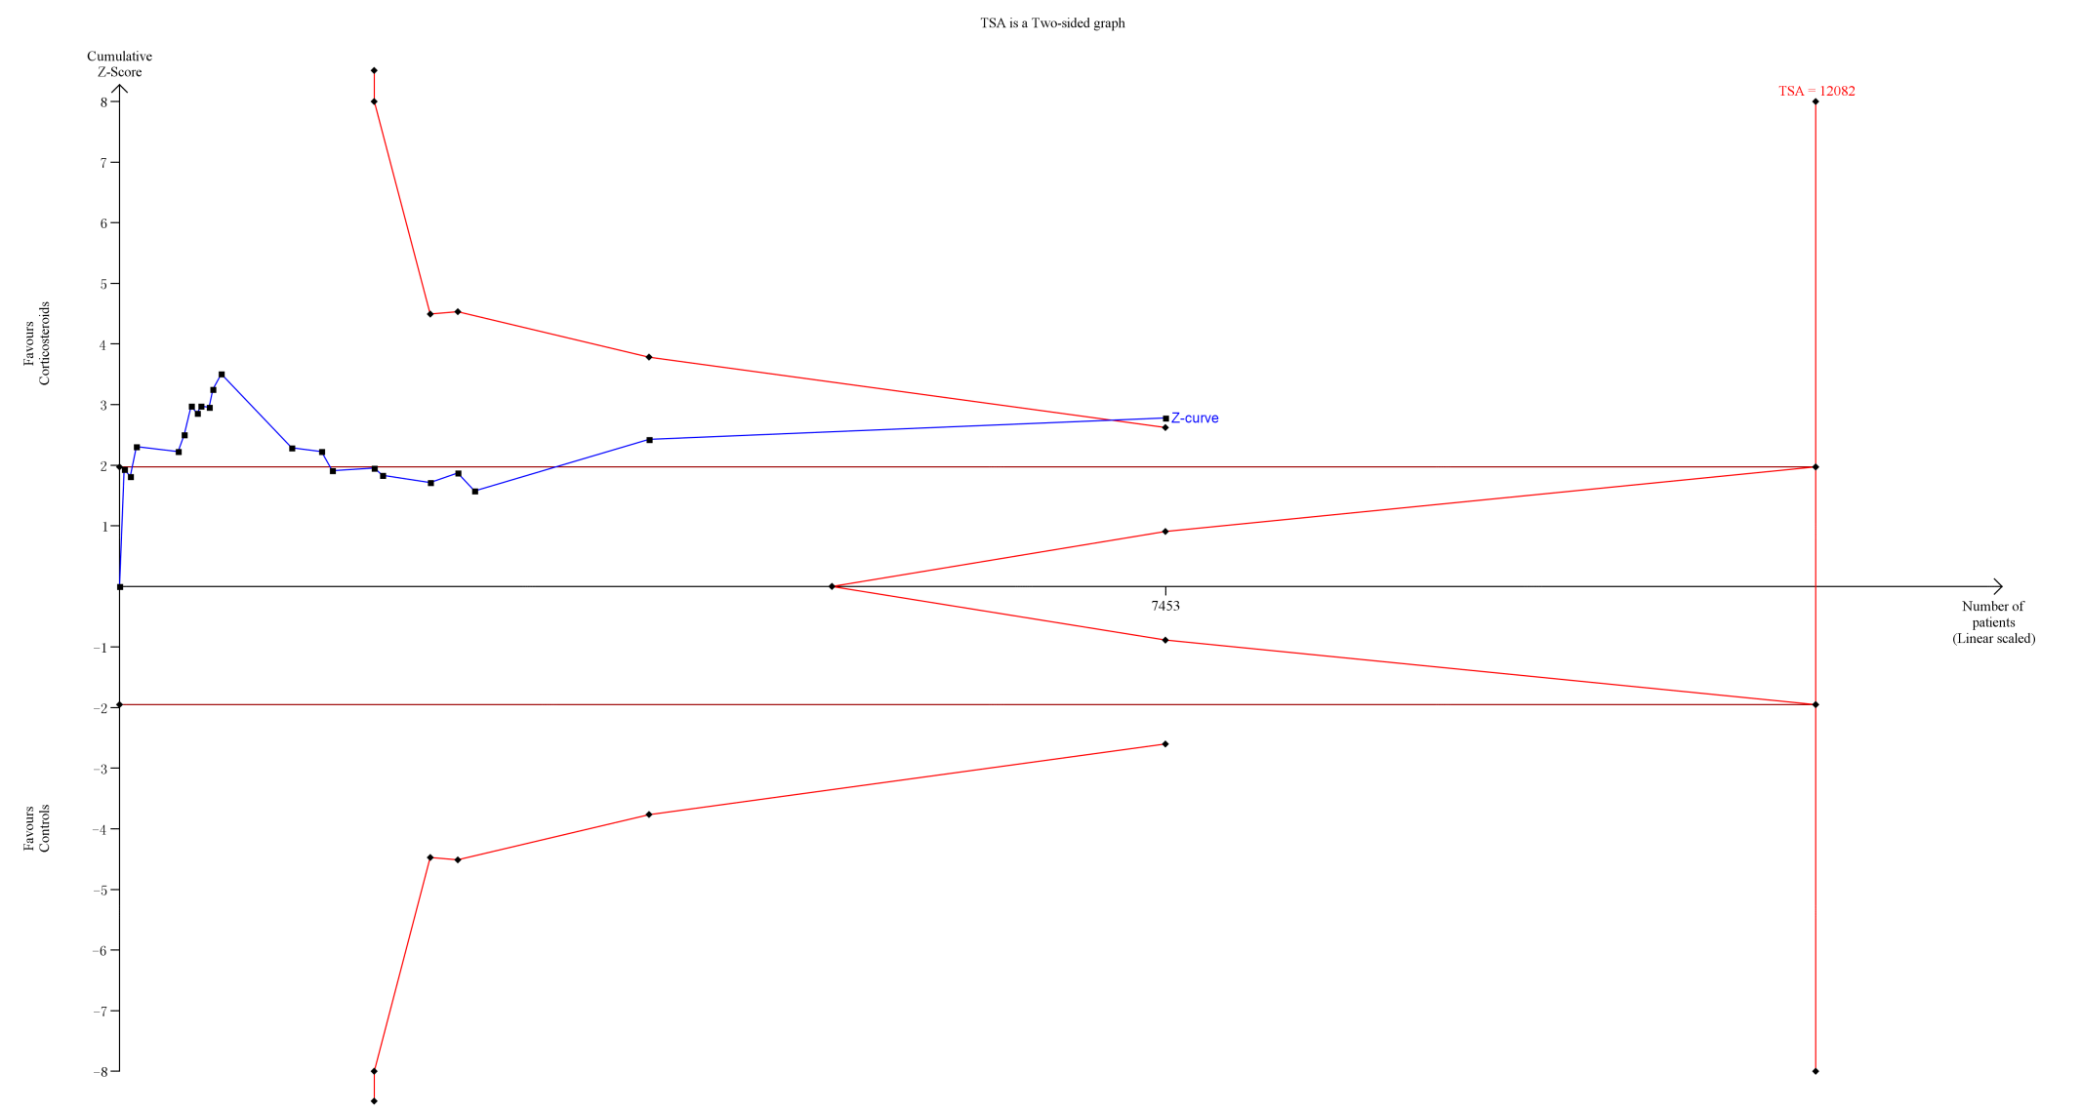
Note: A diversity-adjusted information size of 12,082 patients was calculated based on an anticipated relative risk reduction (RRR) of 10% (event proportion of 28.9% in the control arm, α=0.05 (two-sided), β=0.10 (Power 90%)). The blue cumulative Z-curve was constructed using a fixed-effects model and crossed the conventional boundaries and trial sequential monitoring boundaries when trials were included.

Supplementary Figure 4 Trial sequential analysis of long course of low-dose corticosteroids for 28-day mortality as sensitive analysis.
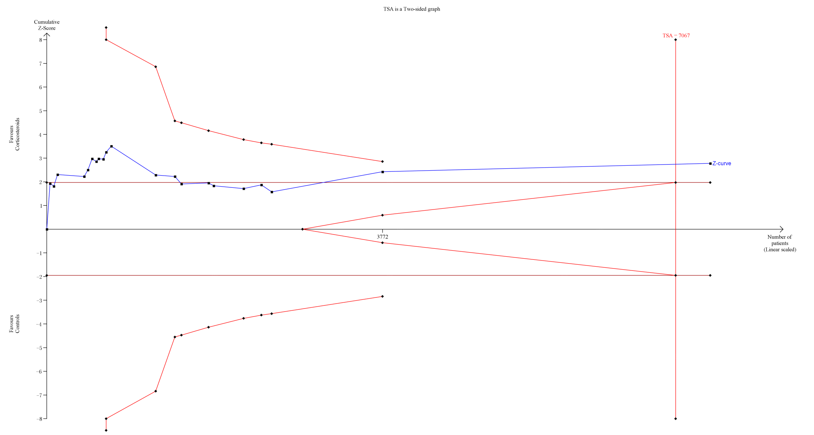
Note: A diversity-adjusted information size of 7,067 patients was calculated based on an anticipated relative risk reduction (RRR) of 13% (event proportion of 28.9% in the control arm, α=0.05 (two-sided), β=0.10 (Power 90%)). The blue cumulative Z-curve was constructed using a fixed-effects model and crossed the conventional boundaries and trial sequential monitoring boundaries when trials were included.

Supplementary Figure 5 Trial sequential analysis of long course of low-dose corticosteroids for 28-day mortality as sensitive analysis.
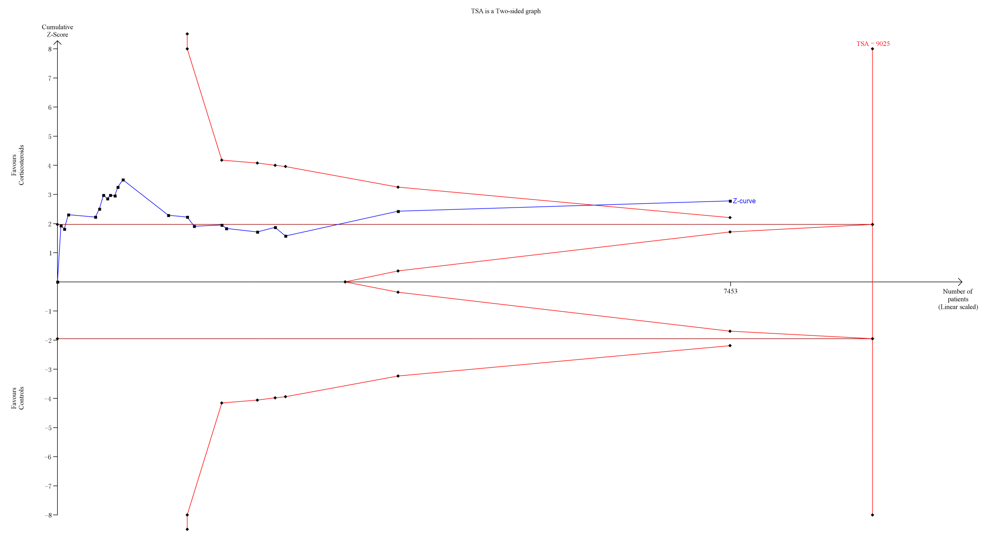
Note: A diversity-adjusted information size of 9,025 patients was calculated based on an anticipated relative risk reduction (RRR) of 10% (event proportion of 28.9% in the control arm, α=0.05 (two-sided), β=0.10 (Power 80%)). The blue cumulative Z-curve was constructed using a fixed-effects model and crossed the conventional boundaries but not trial sequential monitoring boundaries. However, the blue cumulative z-curve crossed the required information size (RIS) line when trials were included.

Supplementary Figure 6 Trial sequential analysis of long course of low-dose corticosteroids for 90-day mortality.
Note: A diversity-adjusted information size of 90,499 patients was calculated based on an anticipated relative risk reduction (RRR) of 10% (event proportion of 32.9% in the control arm, α=0.05 (two-sided), β=0.10 (Power 90%)). The blue cumulative Z-curve was constructed using a fixed-effects model and did not cross any boundaries when trials were included.

Supplementary Figure 7 Trial sequential analysis of long course of low-dose corticosteroids for 90-day mortality as sensitive analysis.
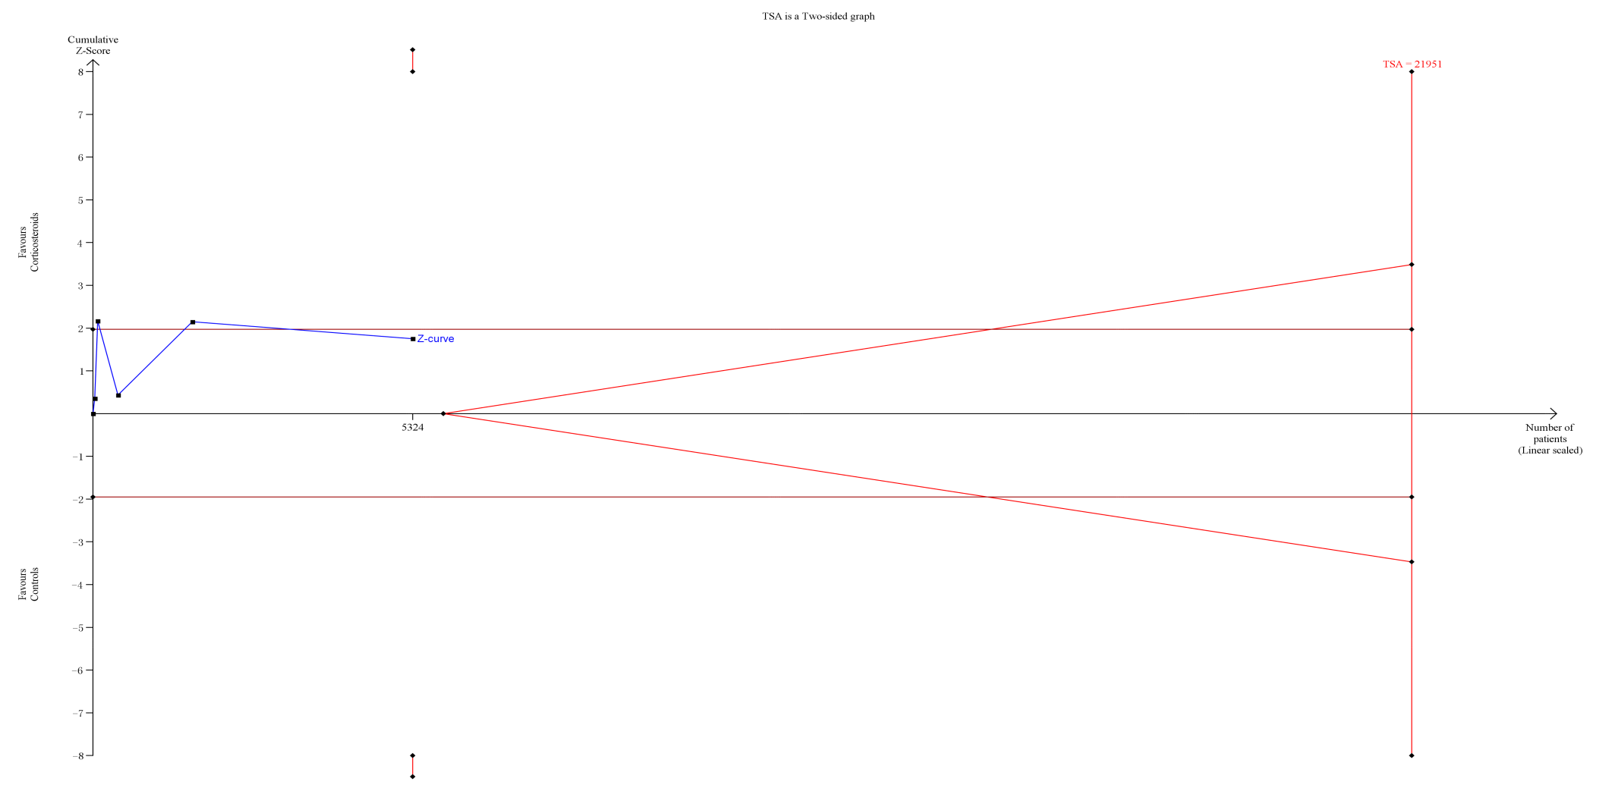
Note: A diversity-adjusted information size of 21,951 patients was calculated based on an anticipated relative risk reduction (RRR) of 20% (event proportion of 32.9% in the control arm, α=0.05 (two-sided), β=0.10 (Power 90%)). The blue cumulative Z-curve was constructed using a fixed-effects model and did not cross any boundaries when trials were included.

Supplementary Figure 8 Trial sequential analysis of long course of low-dose corticosteroids for 90-day mortality as sensitive analysis.
Note: A diversity-adjusted information size of 74,553 patients was calculated based on an anticipated relative risk reduction (RRR) of 10% (event proportion of 32.9% in the control arm, α=0.05 (two-sided), β=0.10 (Power 80%)). The blue cumulative Z-curve was constructed using a fixed-effects model and did not cross any boundaries when trials were included.

Supplementary Figure 9 Forest plot of the benefits of long course of low-dose corticosteroids for ICU mortality.

Supplementary Figure 10 Trial sequential analysis of long course of low-dose corticosteroids for ICU mortality.
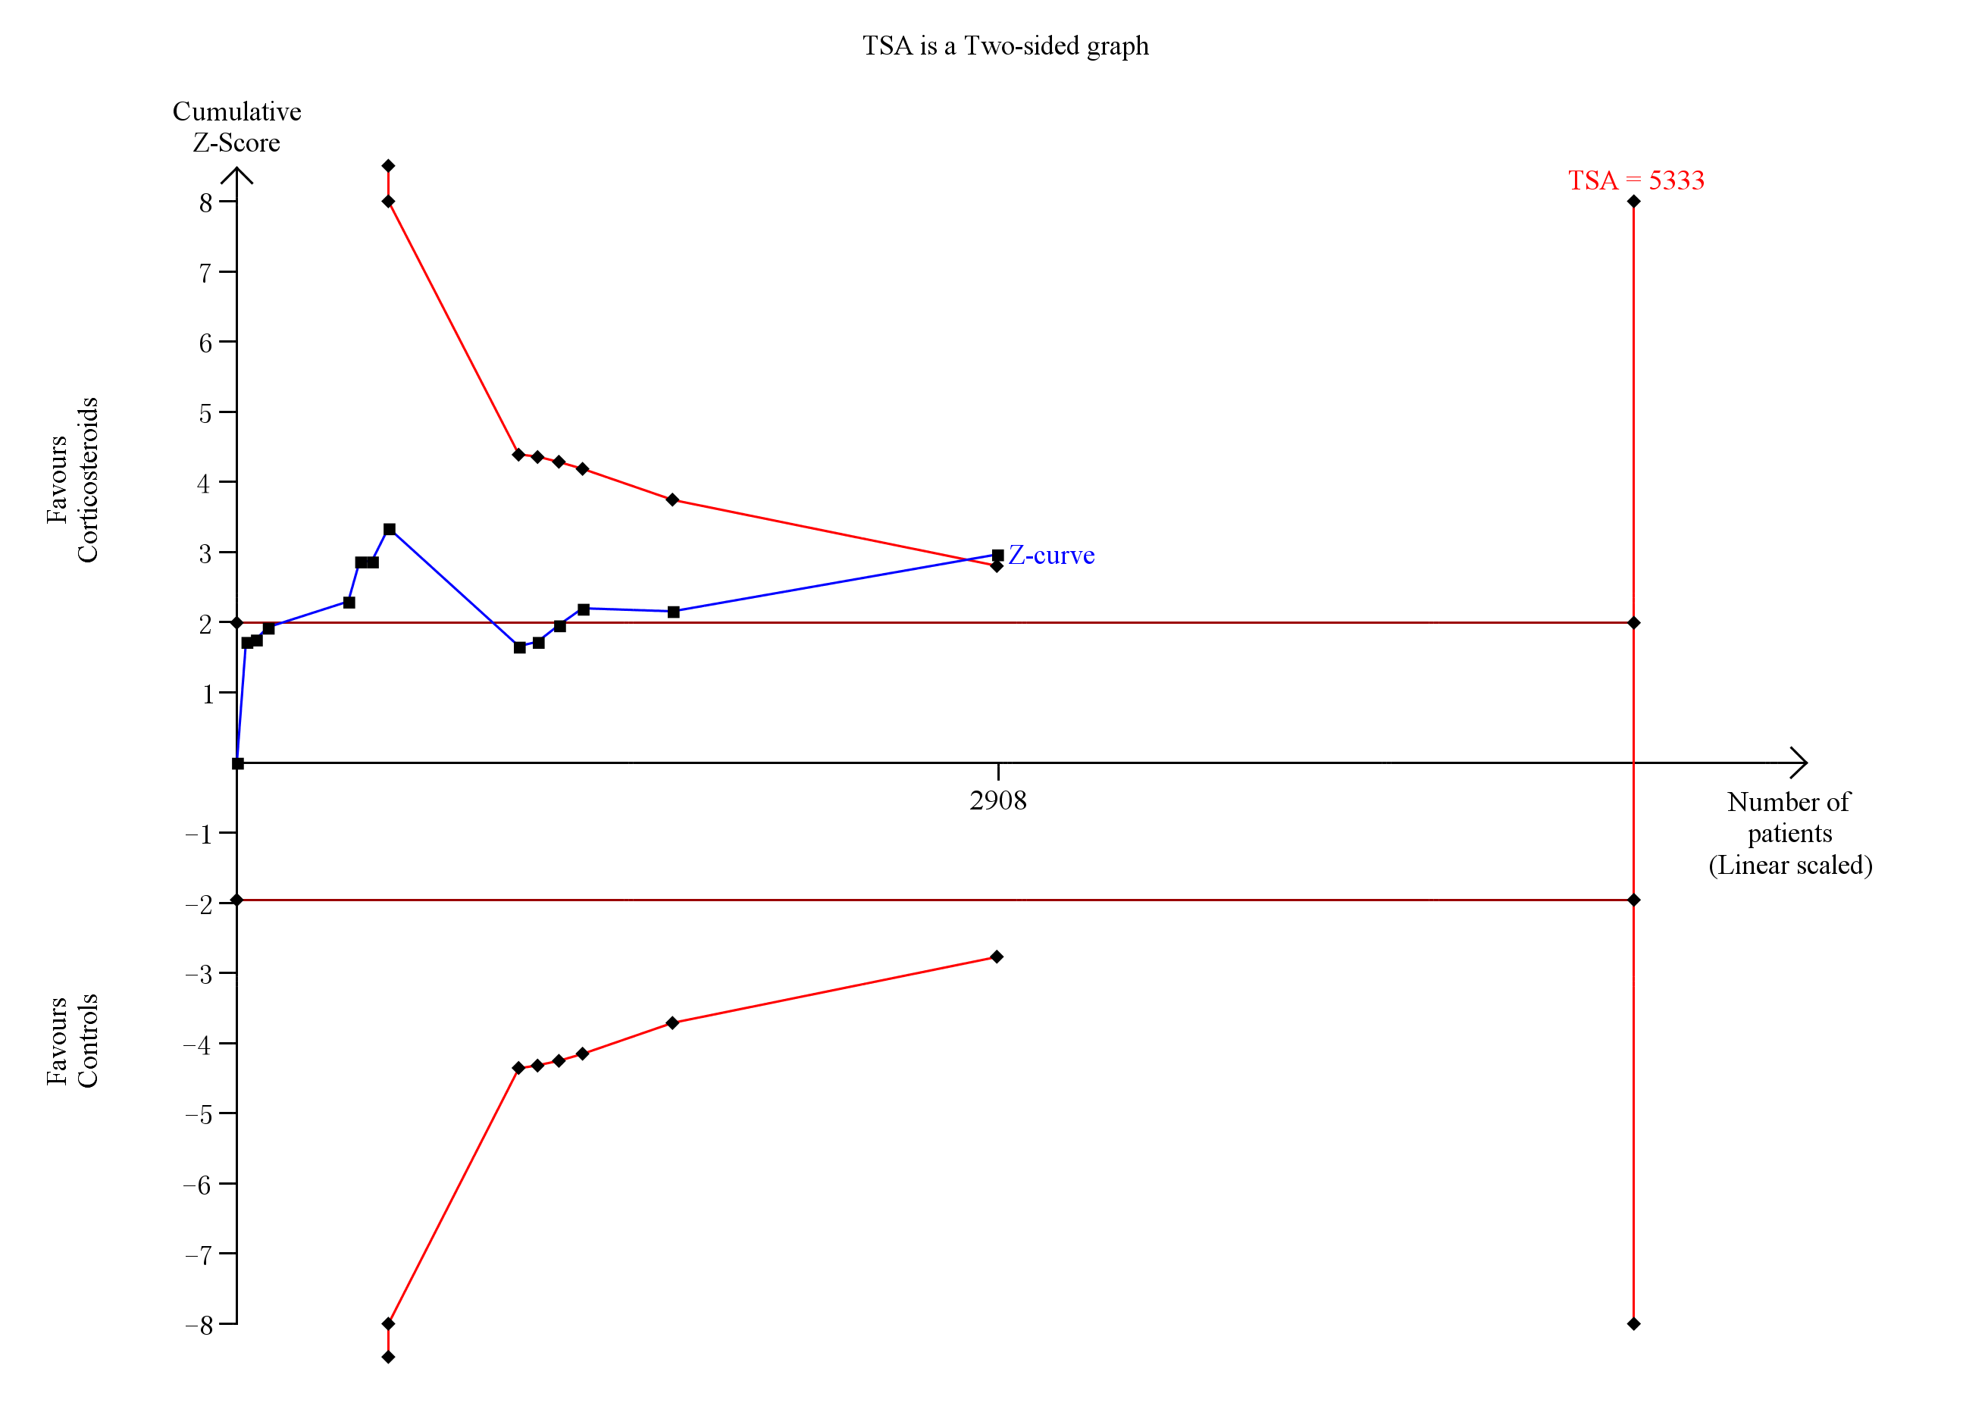
Note: A diversity-adjusted information size of 5,333 patients was calculated based on an anticipated relative risk reduction (RRR) of 18% (event proportion of 37.8% in the control arm, α=0.05 (two-sided), β=0.10 (Power 90%)). The blue cumulative Z-curve was constructed using a fixed-effects model and crossed the conventional boundaries and trial sequential monitoring boundaries when trials were included.
Supplementary Figure 11 Trial sequential analysis of long course of low-dose corticosteroids for ICU mortality as sensitive analysis.
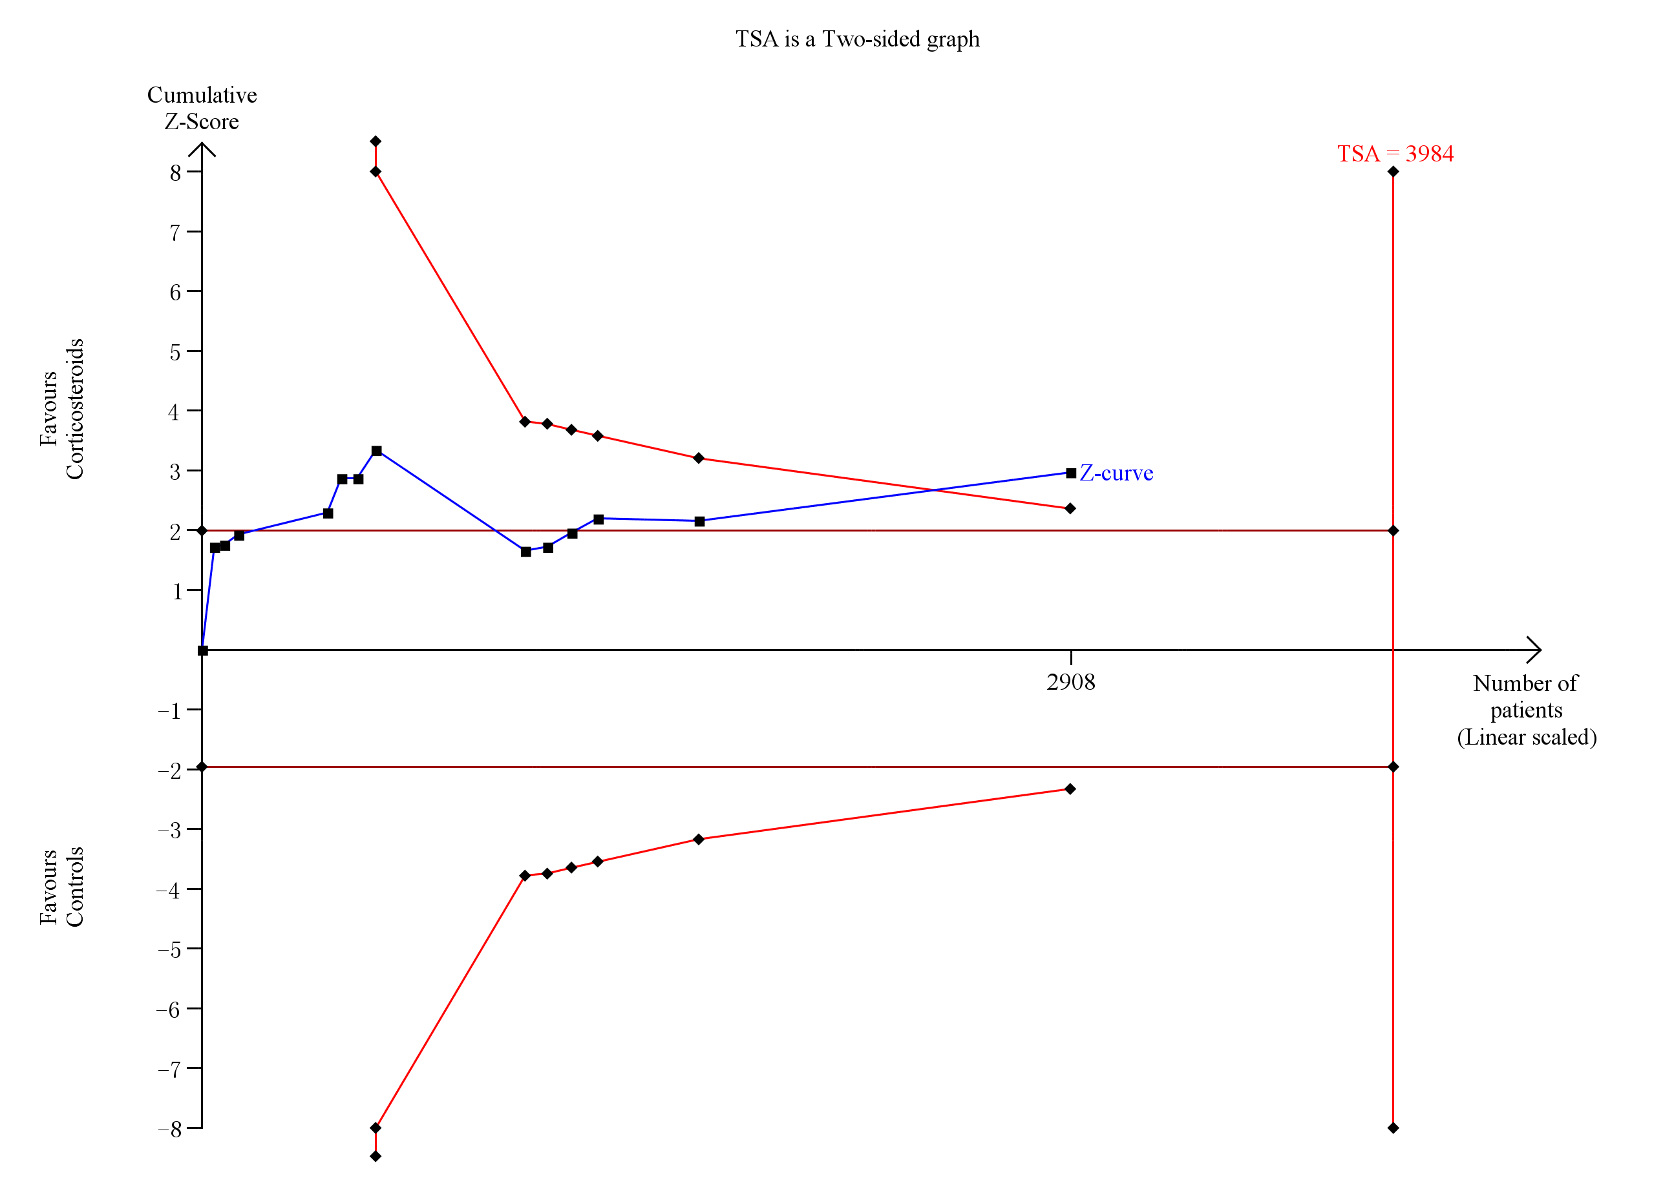
Note: A diversity-adjusted information size of 3,984 patients was calculated based on an anticipated relative risk reduction (RRR) of 18% (event proportion of 37.8% in the control arm, α=0.05 (two-sided), β=0.10 (Power 80%)). The blue cumulative Z-curve was constructed using a fixed-effects model and crossed the conventional boundaries and trial sequential monitoring boundaries when trials were included.

Supplementary Figure 12 Forest plot of the benefits of short course of high-dose and long course of low-dose corticosteroids for in-hospital mortality.

Supplementary Figure 13 Trial sequential analysis of long course of low-dose corticosteroids for in-hospital mortality.
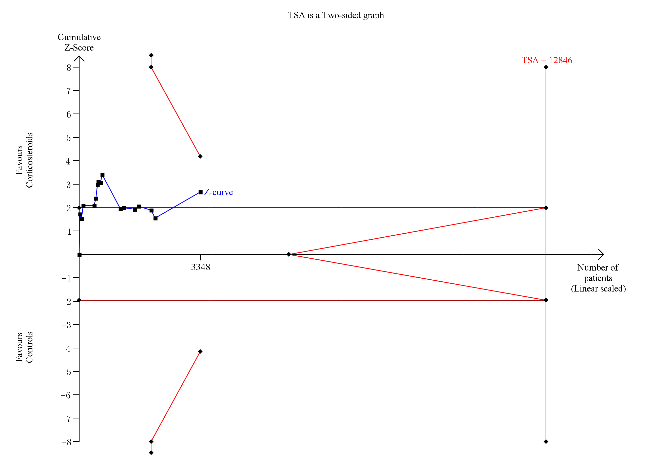
Note: A diversity-adjusted information size of 12,846 patients was calculated based on an anticipated relative risk reduction (RRR) of 9% (event proportion of 38.7% in the control arm, α=0.05 (two-sided), β=0.10 (Power 90%)). The blue cumulative Z-curve was constructed using a fixed-effects model and crossed the conventional boundaries and trial sequential monitoring boundaries when trials were included.
Supplementary Figure 14 Trial sequential analysis of long course of low-dose corticosteroids for in-hospital mortality as sensitive analysis.
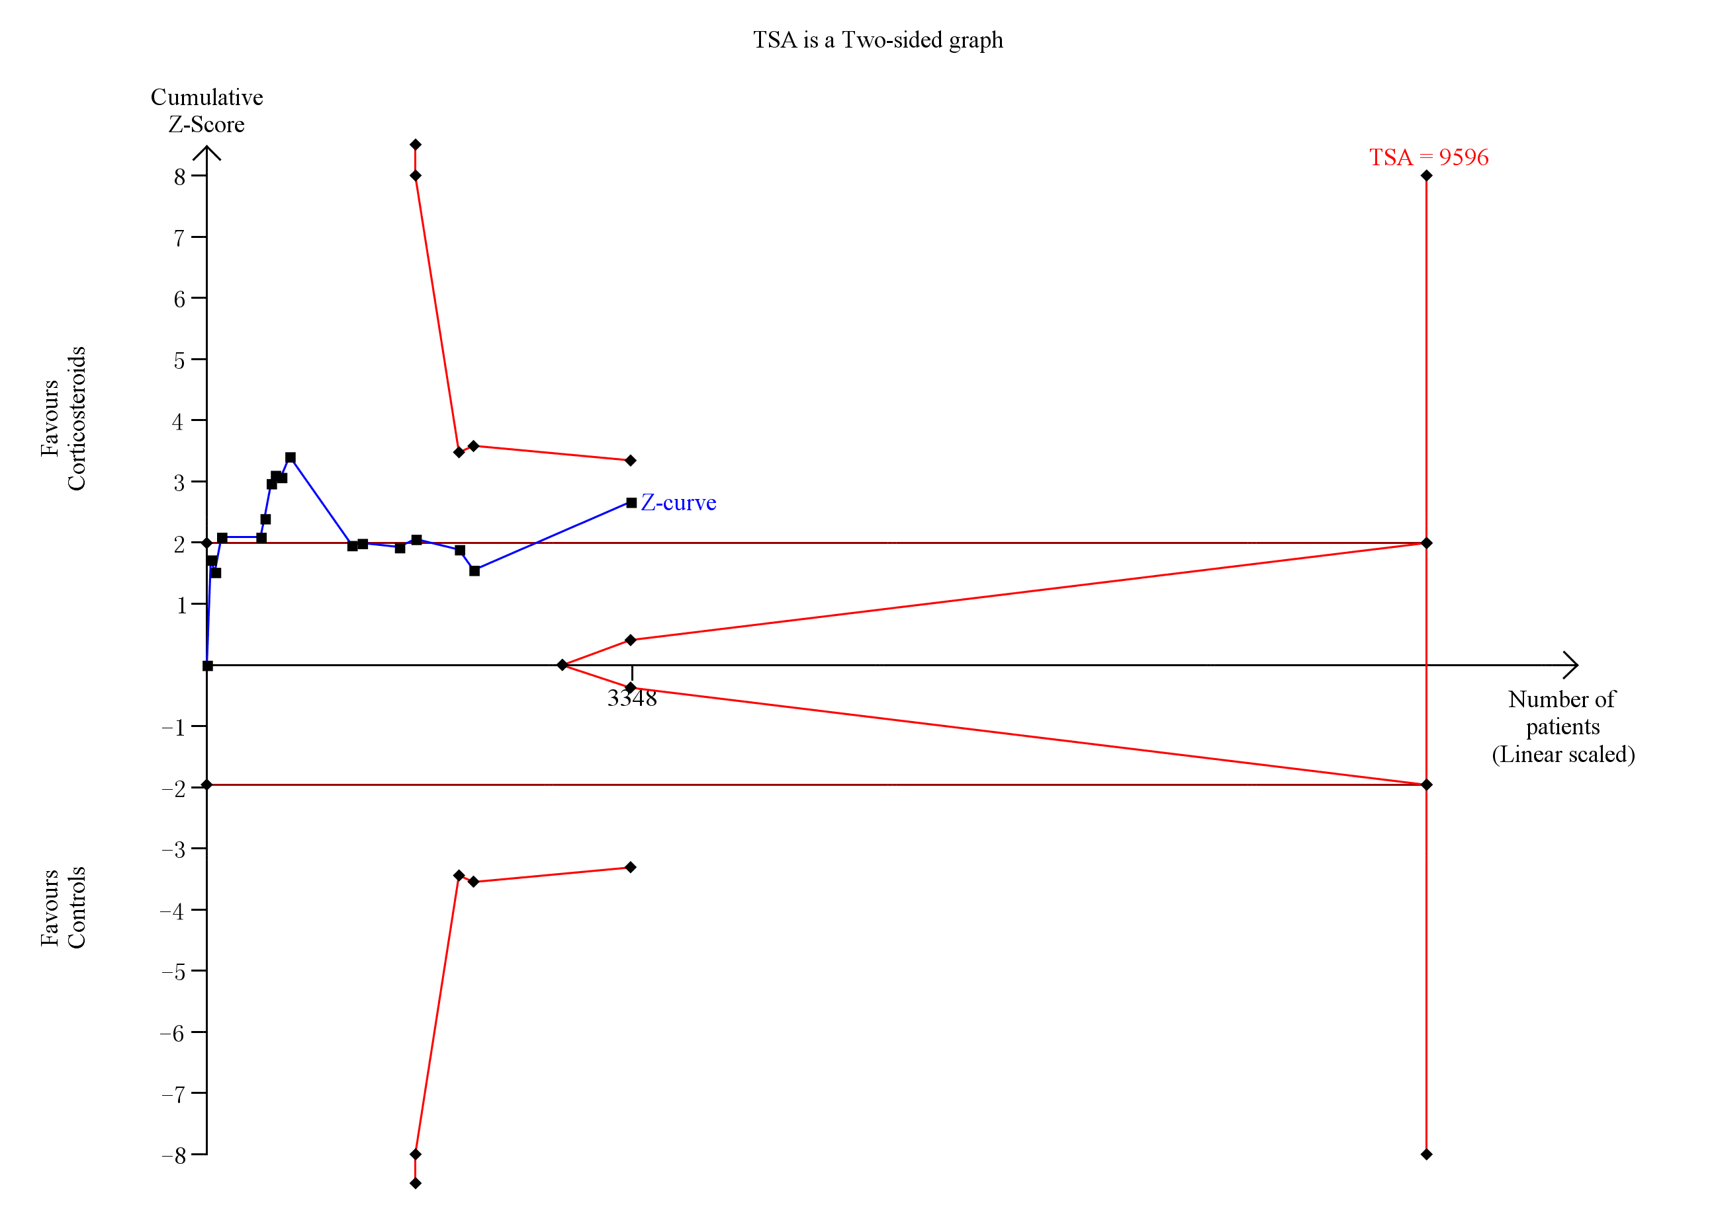
Note: A diversity-adjusted information size of 9,596 patients was calculated based on an anticipated relative risk reduction (RRR) of 9% (event proportion of 38.7% in the control arm, α=0.05 (two-sided), β=0.10 (Power 80%)). The blue cumulative Z-curve was constructed using a fixed-effects model and crossed the conventional boundaries and trial sequential monitoring boundaries when trials were included.

Supplementary Figure 15 Forest plot of the benefits of short course of high-dose and long course of low-dose corticosteroids for shock reversal by day 7.

Supplementary Figure 16 Forest plot of the benefits of long course of low-dose corticosteroids for shock reversal by day 28.

Supplementary Figure 17 Forest plot of the benefits of long course of low-dose corticosteroids for length of ICU stay.
Supplementary Figure 18 Forest plot of the benefits of long course of low-dose corticosteroids for length of hospital stay.
Supplementary Figure 19 Forest plot of the benefits of long course of low-dose corticosteroids for SOFA score at day 7.

Supplementary Figure 20 Forest plot of harms of short course of high-dose and long course of low-dose corticosteroids for gastroduodenal bleeding.

Supplementary Figure 21 Forest plot of harms of short course of high-dose and long course of low-dose corticosteroids for superinfection.

Supplementary Figure 22 Forest plot of harms of long course of low-dose corticosteroids for neuromuscular weakness.
Supplementary Figure 23 Forest plot of harms of short course of high-dose and long course of low-dose corticosteroids for hyperglycaemia.

Supplementary Figure 24 Forest plot of harms of long course of low-dose corticosteroids for hypernatraemia.
Supplementary Figure 25 The L’Abbe plot and Egger’s regression of corticosteroids of long course of low-dose for 28-day mortality (A), 90-day mortality (B), ICU mortality (C) and hospital mortality (D).

