Supporting information for
Microplastic intake, its biotic drivers, and hydrophobic organic contaminant levels in the Baltic herring
*Ogonowski M.^{1,2,3}, Wenman V.¹, Barth A.⁴, Hamacher-Barth E. ⁴, Danielsson S.⁵ and *Gorokhova E.¹

¹ Stockholm University, Department of Environmental Science and Analytical Chemistry, Svante Arrhenius väg 8, SE-106 91, Stockholm, Sweden
² Swedish University of Agricultural Sciences, Department of Aquatic Resources, Institute of Freshwater Research, Stångholmsvägen 2, SE-178 93, Drottningholm, Sweden
³ AquaBiotaWater Research, Löjtnantsgatan 25, SE-11550 Stockholm, Sweden
⁴ Stockholm University, Department of Biochemistry and Biophysics, Svante Arrhenius väg 16C, SE-106 91, Stockholm, Sweden
⁵ Swedish Museum of Natural History, Department of Environmental Science and Monitoring, P. O. Box 50 007, SE-104 05, Stockholm Sweden

*corresponding authors:
martin.ogonowski@aces.su.se
elena.gorokhova@aces.su.se

1.1 Data handling of FTIR spectra
FTIR spectra were corrected for atmospheric CO₂ absorption by subtraction of a CO₂ spectrum and baseline corrected according to Primpke et al. (2018). To reduce noise and enhance the spectrum quality without losing subtle spectral information, each spectrum passed through a baseline correction and denoising procedure using a second order derivative Savitzky-Golay filter (Renner et al. 2019) as implemented in Unscrambler® X (version 10.5.1; Camo Software, 2018). Both pre-processed and original spectra were then compared to the spectral libraries assembled by Primpke and co-workers (Primpke et al. 2018) using BioRad KnowItAll® Informatics System software. The Correlation algorithm implemented in the software was used to evaluate each query spectrum to the spectra of the databases. The most appropriate match (Hit Quality Index; HQI) was selected based on matching peak wavenumber positions. The scale 0 – 100% was used, with 100 being the best possible match, and a minimum 70% HQI between unknown and matched spectra was accepted as a threshold. Moreover, in a ranked list of the database hits, the difference, or gap in the HQI between two successive hits was used as an indicator of the match quality. When several hits were followed by a 10% gap, all these hits were treated as equally plausible matches. In all spectra, we focused on the 3799 to 850 wavenumber (cm⁻¹) region, excluding the interval 2690 to 1900 wavenumber (cm⁻¹) which corresponds to the absorption range of the diamond ATR crystal.
    - Microparticle classification
The putative microplastic particles found in the gastrointestinal tract of herring by visual identification were classified as either microplastic, semi-synthetic or natural based on the combination of visual information and FTIR spectra (Figure S1, Table S1). When all FTIR spectra showed a closest match with synthethic materials, the particle was classified as synthethic. If some spectra matched natural material but the particle color was of unnatural (bright red or blue) the particle was classified as semi-synthethic. Particles with natural color and at least one match with a natural material were classified as natural.

2.1 Model parameterization
2.1.1 Clearance rate (CR)
Clearance rates (CR) for Baltic herring were calculated based on intake rates of Calanus finmarchicus in the North Sea (Fig. 5 in Varpe and Fiksen 2010), which is the main prey for herring in this area. These copepods are also of similar size (2-3 mm prosome length) as the microplastic particles considered in this study (Pasternak et al. 2004). We used the reported values on C. finmarchicus consumption by herring expressed as (J copepod [J herring]⁻¹ day⁻¹) and ambient C. finmarchicus abundance to obtain the CR.

The average CR of the Baltic herring population examined in this study (L h⁻¹) was calculated assuming an energy content of 3.5 kJ and 10 kJ g wet weight⁻¹ for C. finmarchicus and herring, respectively (Varpe et al. 2005). The average weight of the sampled Baltic herring (35 g) was used to derive the consumption rate on an individual basis using a first-order exponential decay function fitted to data on the CR and prey abundance for the North Sea herring feeding on C. finmarchicus (Figure S3). The asymptote value (1.04 × 10³ L ind.⁻¹ h⁻¹) was assumed to represent CR of the Baltic herring, because mesozooplankton abundance in the Baltic Sea normally supersede the maximum reported abundance for C. finmarchicus in the North Sea (Varpe and Fiksen 2010, Gorokhova et al. 2016).

2.1.2 Ambient MP concentrations in the Baltic Sea (CMP)
We used the average microplastic concentrations reported by Gewert et al. (2017) in the outer Stockholm archipelago (0.58 MP m⁻³) estimated by surface manta trawls (335 µm mesh). These values were used, because the size range (median MP size and inter quartile range, IQR: fragment diameter = 1 mm (IQR 0.6-1.5 mm), fiber length = 1 mm (IQR 1-3 mm)) fits well the size of MP recovered from the fish guts. Also, the polymer materials have been rigorously identified by FTIR in this selection of the field-collected MP, thus ensuring that the fragments collected were indeed microplastics.

2.1.3. Gut evacuation rates (GER)
We were not able to find data on gut evacuation rates for adult herring; therefore, a lower and an upper limit reported for two clupeid species of similar size and feeding ecology as the herring analyzed here (Collard et al. 2015) were chosen. The lower limit (0.05 h⁻¹) was adopted from the experimental and field data collected for adult South American pilchard (Sardinops sagax) (van der Lingen 1998). The upper limit (0.26 h⁻¹) was experimentally derived for adult European pilchard (Sardina pilchardus) (Costalago and Palomera 2014).

2.2 Monte Carlo simulation of MP burden in the Baltic herring
To estimate MP burden (MP ind⁻¹) dynamics at a given MP abundance from time 0 to the point when it is stabilized (48 h), we performed Monte Carlo simulation with 1000 permutations using STELLA® ver. 9.4.1 software (iSee systems, Inc. Lebanon, NH, U.S.A.), with the equations (Eqs. 1 to 3) integrated as shown in Figure S4. Ambient MP concentrations (CMP) were allowed to vary randomly following a Poisson distribution as were the data presented in Gewert et al. (2017), whereas the CR values were normally distributed with a mean and SD of 1041 L h⁻¹ and 27 h⁻¹, respectively, and GER values varied randomly between 0.05 and 0.26 h⁻¹ without any assumption regarding the distribution (Table S2). The final value of each run was used to represent an individual in the population.
SI Tables and Figures
Table S1. FTIR classification results based on the comparison with a reference database (Primpke et al. 2018). A match to one or more equally plausible compounds was accepted at HQI ≥ 70%. Spectra with HQI-scores below this threshold were classified as unknown.
Sample | Sample type | FTIR Classification | Group
1 | transparent fiber | fur | natural
2 | transparent fiber | polyvinyl | synthetic
3 | blue fiber | plant fiber, cellulose, hydroxypropyl methyl cellulose, polyvinyl alcohol | semi-synthetic
4 | transparent fiber | algae | natural
5 | transparent fiber | fur | natural
6 | transparent fiber | algae | natural
7 | red fiber | fur | natural
8 | black fiber | plant fiber | natural
9 | black fiber | plant fiber, cellulose | natural
10 | blue fiber | plant fiber, viscose | semi-synthetic
11 | blue fiber | viscose, polyvinyl | semi-synthetic
12 | transparent fiber | chitin | natural
13 | blue fiber | unknown | unknown
14 | blue fiber | unknown | unknown
15 | blue fiber | plant fiber, cellulose, hydroxypropyl methyl cellulose, polyvinyl alcohol | semi-synthetic
16 | red fiber | plant fiber, cellulose, hydroxypropyl methyl cellulose, rubber | semi-synthetic
17 | black fiber | unknown | unknown
18 | white fragment | acrylonitrile butadiene styrene, alkyd varnish | synthetic
19 | blue fiber | unknown | unknown
20 | black fiber | unknown | unknown
21 | red fiber | rubber, ethylene propylene, poly 1-butene isotactic | synthetic
22 | brown fragment | polyamide, fur | synthetic
23 | black fiber | rubber, poly 1-butene isotactic | synthetic
24 | black fiber | rubber, polyethylene | synthetic
25 | blue fiber | fur | natural

Table S1 continued
Sample | Sample type | FTIR Classification | Group
26 | red fiber | unknown | unknown
27 | red fiber | fur, zein | natural
28 | red fiber | fur, zein | natural
29 | red fiber | fur, zein | natural
30 | red fiber | fur, zein | natural
31 | red fiber | fur, zein | natural
32 | red fiber | fur, zein | natural
33 | red fiber | plant fiber, wood, hydroxyethyl cellulose | semi-synthetic
34 | blue fiber | plant fiber, viscose, cellulose, wood, hydroxyethyl cellulose | semi-synthetic
35 | black fiber | unknown | unknown
36 | blue fiber | unknown | unknown
37 | white fiber | fur, animal fiber, zein | natural
38 | black fiber | hydroxypropyl methyl cellulose, ethyl cellulose, hydroxypropyl cellulose | synthetic
39 | white fragment | fur, chitin | natural
40 | black fiber | plant fiber, hydroxypropyl methyl cellulose, viscose | semi-synthetic
41 | black fiber | cellulose, plant fiber, viscose, wood | natural
42 | black fiber | plant fiber, cellulose, hydroxyethyl cellulose | natural
43 | black fiber | hydroxyethyl cellulose, wood, plant fiber, cellulose | natural
44 | black fiber | cellulose, plant fiber, wood, hydroxyethyl cellulose | natural
45 | black fragment | algae, plant fiber, viscose, wood, cellulose | natural
46 | black fragment | polyurethane acrylic resin, alkyd varnish | synthetic
47 | brown fiber | plant fiber, methyl cellulose | natural
48 | brown fragment | polyethylene, ethylene propylene, rubber | synthetic
49 | brown fragment | honeycomb, plant fiber, algae | natural
50 | black fiber | polyester, polyethylene terephthalate | synthetic
51 | brown fiber | unknown | unknown
52 | black fiber | viscose, plant fiber | natural
53 | black fragment | algae, plant fiber | natural
54 | red fiber | algae | natural
55 | black fiber | unknown | unknown
56 | red fiber | chitin, fur | natural

Table S1 continued
Sample | Sample type | FTIR Classification | Group
57 | black fiber | plant fiber, wood, viscose | semi-synthetic
58 | blue fiber | fur, animal fiber | natural
59 | black fiber | plant fiber, wood, viscose | semi-synthetic
60 | black fiber | unknown | unknown
61 | black fiber | unknown | unknown

Table S2. Variables and simulation settings used to model microplastic ingestion in Baltic Sea herring. Details regarding derivation of the values are provided in the Supporting Information 2.1.
Parameter | Unit | Average | Min | Max | S.D | Distribution | Species | Meaning | Reference
CMP | MP L⁻¹ | 5.8 × 10⁻⁴ |  |  |  | Poisson |  | MP concentration in the water column | Gewert et al. 2017
CR | L ind.⁻¹ h⁻¹ | 1.04 × 10³ |  |  | 2.6 × 10² | Normal | Clupea harengus | Clearance rate | Varpe & Fiksen 2010
GER¹ | h⁻¹ |  | 5 × 10⁻² | 2.6 × 10⁻¹ |  |  | Sardinops sagax, Sardina pilchardus | Gut evacuation rate | Van der Lingen 1998, Costalago & Palomera 2014
IR | MP h⁻¹ |  |  |  |  |  |  | Number of MP ingested at time t
MP | MP |  |  |  |  |  |  | Number of MP in fish stomach at time t
ER | MP h⁻¹ |  |  |  |  |  |  | Number of MP egested at time t
- The lower value for GER is based on data for Sardinops sagax (Van der Lingen 1998) while the higher is derived from Sardina pilchardus (Costalago & Palomera 2014).

Table S3. Descriptive statistics for the predicted (modelled) and observed distributions of the MP burden in the Baltic herring. The data are presented as either “Total”, i.e., where individuals without MP in the GIT are included, or “Zeros excluded” that shows only the fish with positive MP burden.
 | Total |  | Zeros excluded
 | Mod | Obs | Mod | Obs
n | 1000 | 130 | 806 | 29
Mean | 4.7 | 0.9 | 5.9 | 3.9
SD | 4.7 | 2.6 | 4.5 | 4.4
Median | 3.6 | 0 | 4.4 | 2
Min | 0 | 0 | 1.3 | 1
Max | 33.3 | 17 | 33.3 | 17
Range | 33.3 | 17 | 32 | 16
Skew | 1.8 | 4.2 | 2 | 1.6
Kurtosis | 5 | 18.2 | 5.7 | 1.4
SE | 0.1 | 0.2 | 0.2 | 0.8

Table S4. Summary statistics for the generalized additive model showing the degrees of freedom for the smoothing parameter (edf), χ²-statistic, model estimate (Est.), standard error (S.E.), z-statistic and p-value.
Variable | edf | χ² | Est. | S.E. | z | p
s(Weight) | 1.44 | 16.8 |  |  |  | 0.0002
s(Reproductive phase) | 3.26 | 11.1 |  |  |  | 0.02
s(Gut fullness) | 2.86 | 41.3 |  |  |  | <0.0001
s(Age) | 1.00 | 18.8 |  |  |  | <0.0001
(Intercept) |  |  | -8.9 | 3.0 | -3.0 | 0.003
Western Gotland Basin |  |  | 7.3 | 2.9 | 2.6 | 0.01
Northern Baltic proper |  |  | 9.9 | 3.4 | 2.9 | 0.003
Bothnian Sea |  |  | 6.8 | 3.3 | 2.1 | 0.04
Bothnian Bay |  |  | 7.3 | 3.3 | 2.2 | 0.03
Deviance explained |  |  |  |  |  | 64.7%

Table S5. Summary statistics and factor loadings for the variables used in the factor analysis. WS MP burden = weight specific MP burden. Factor loadings > 0.7 are considered statistically significant.
 | Factor 1 | Factor 2
WS MP burden | -0.135 | 0.578
BDE sum | 0.921 | 0.243
HBCD | 0.997 | -0.042
DD sum | 0.953 | 0.083
HCB | 0.941 | -0.099
PCB sum | 0.562 | 0.824
SS | 3.969 | 1.091
Proportion var | 0.662 | 0.182
Cumulative var | 0.662 | 0.843

Table S6. Summary statistics for the confirmatory generalized additive models showing the degrees of freedom for the smoothing or fixed parameter (edf, df), F-statistic, p-value and deviance explained (dev. (%)) per modeled HOC-group. The initial model included all terms while the final model included only significant terms after backward variable selection (sequential removal of insignificant terms). Residual plots for the initial model are provided in Figure S6.
 |  |  |  | Initial model |  |  |  | Final model
Model | Dependent  variable | Explanatory  variable | (e)df |  | F | p | dev. (%) | (e)df | F | p | dev. (%)
1 | PCBs | s(Weight) | 1.91 |  | 0.81 | 0.41 | 67.4 |  |  |  | 47.9
 |  | s(Reproductive phase) | 1.00 |  | 0.001 | 0.98
 |  | s(Age) | 1.16 |  | 0.40 | 0.53
 |  | s(Weighted MP burden) | 1.65 |  | 1.59 | 0.23
 |  | s(Gut fullness) | 2.06 |  | 1.26 | 0.24
 |  | Basin | 4.00 |  | 3.18 | 0.03 |  | 4.00 | 6.90 | <0.001
2 | BDEs | s(Weight) | 1.78 |  | 0.62 | 0.51 | 76.5 |  |  |  | 53.6
 |  | s(Reproductive phase) | 1.00 |  | 4.03 | 0.06 |  | 1.00 | 24.30 | <0.001
 |  | s(Age) | 2.59 |  | 2.00 | 0.14
 |  | s(Weighted MP burden) | 1.00 |  | 1.51 | 0.23
 |  | s(Gut fullness) | 2.39 |  | 2.88 | 0.05 |  | 2.33 | 3.57 | 0.04
 |  | Basin | 4.00 |  | 2.81 | 0.05
3 | DDs | s(Weight) | 3.24 |  | 9.93 | <0.001 | 96.0 | 3.28 | 14.54 | <0.001 | 95.6
 |  | s(Reproductive phase) | 1.00 |  | 0.99 | 0.33
 |  | s(Age) | 1.00 |  | 8.43 | 0.01 |  | 1.00 | 14.10 | <0.001
 |  | s(Weighted MP burden) | 1.00 |  | 0.16 | 0.69
 |  | s(Gut fullness) | 1.90 |  | 3.47 | 0.05 |  | 1.63 | 4.64 | 0.02
 |  | Basin | 4.00 |  | 18.80 | <0.001 |  | 4.00 | 33.42 | <0.001
4 | HBCD | s(Weight) | 1.52 |  | 0.23 | 0.73 | 82.8 |  |  |  | 77.4
 |  | s(Reproductive phase) | 1.00 |  | 8.49 | 0.01 |  | 1.00 | 10.20 | <0.01
 |  | s(Age) | 1.00 |  | 6.14 | 0.02 |  | 1.00 | 7.57 | 0.01
 |  | s(Weighted MP burden) | 1.00 |  | 0.10 | 0.76
 |  | s(Gut fullness) | 1.93 |  | 2.07 | 0.16
 |  | Basin | 4.00 |  | 1.79 | 0.17 |  | 4.00 | 2.58 | 0.06
5 | HCB | s(Weight) | 1.00 |  | 0.02 | 0.88 | 76.2 |  |  |  | 73.0
 |  | s(Reproductive phase) | 1.00 |  | 5.64 | 0.03 |  | 1.00 | 5.86 | 0.02
 |  | s(Age) | 1.20 |  | 4.29 | 0.06 |  | 1.38 | 5.54 | 0.03
 |  | s(Weighted MP burden) | 1.00 |  | 0.10 | 0.75
 |  | s(Gut fullness) | 2.08 |  | 0.78 | 0.65
 |  | Basin | 4.00 |  | 1.01 | 0.42 |  | 4.00 | 3.16 | 0.03

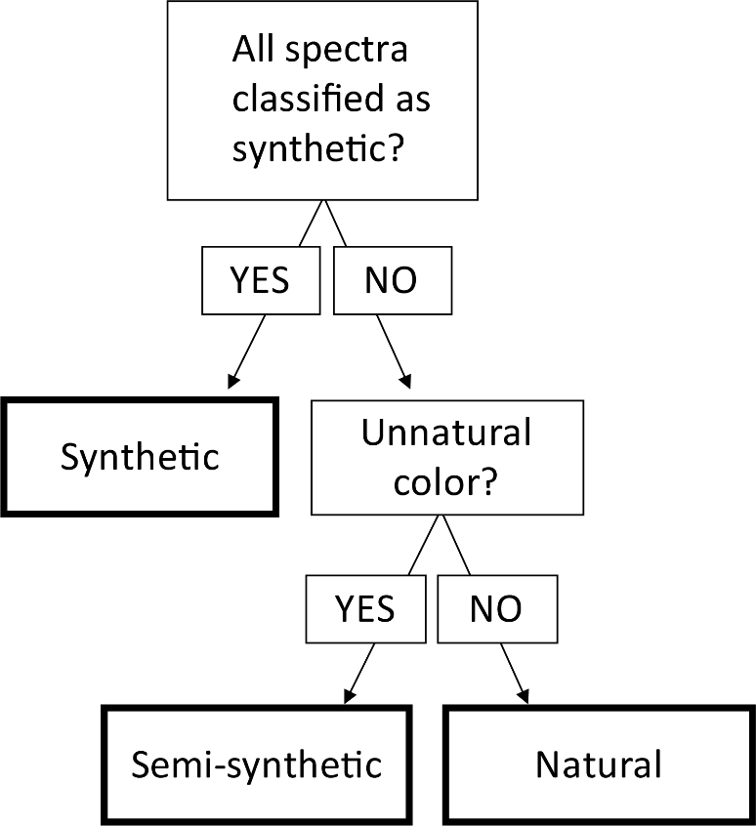
Figure S1. Decision tree describing the classification process of microparticles found in the gastro-intestinal tract of herring using both quantitative FTIR-data and qualitative visual information.
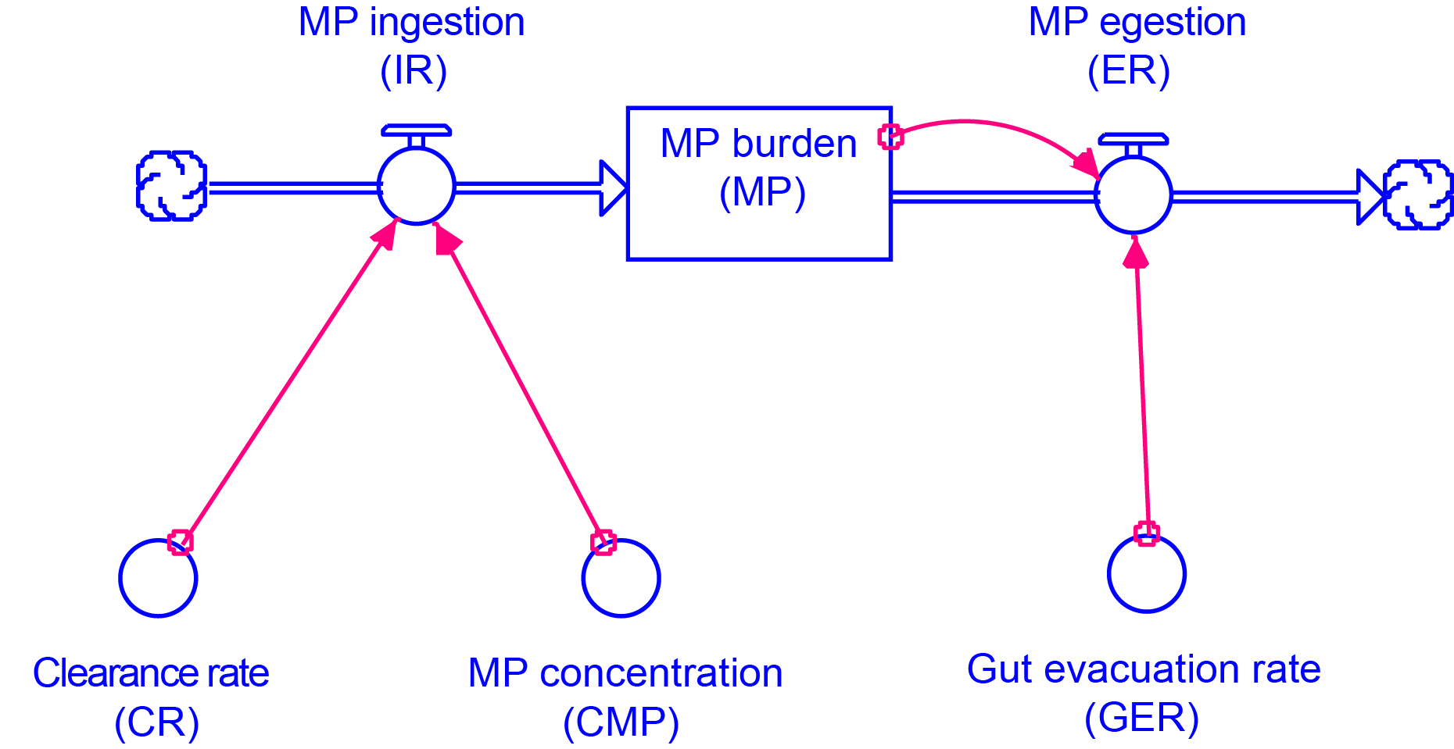
Figure S2. Schematic representation of the model used to predict microplastic ingestion in Baltic herring.
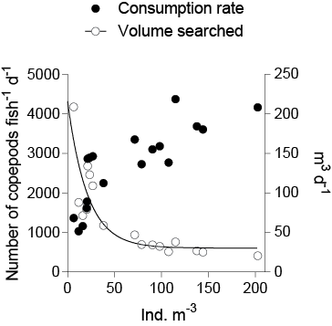
Figure S3. Consumption rates (left axis) and clearance rates (right axis) as a function of Calanus finmarchicus abundance. The values are based on the data presented in Fig. 5, Varpe and Fiksen (2010) and adjusted for fish with average body weight of 35 g.
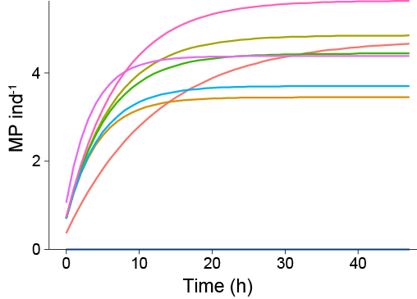
Figure S4. Modeled MP burden (MP ind⁻¹) in the first ten simulation runs for 48 h. Observe that values are stabilized at the end of the simulation; these values are used to represent intrapopulation variability. Three out of ten individuals contain no MP.

Figure S5. Diagnostic plot for the zero inflated poisson GAM model. The quantile-quantile plot shows the distribution of the deviance residuals as a function of residual quantiles from a theoretical distribution. Black points represent observations. Grey lines are simulated residuals from randomly generated zero inflated data. Observations that distribute close to the theoretical distribution (red line) and are within the bounds of the simulated data indicate appropriate model specification.
Figure S6. Diagnostic quantile-quantile plots for the confirmatory GAM-analysis (Table S6). The quantile-quantile plot shows the distribution of the deviance residuals as a function of residual quantiles from a theoretical distribution. Black points represent observations. Grey lines are simulated residuals from randomly generated data. Grey bands are 95% confidence intervals. Observations that distribute close to the theoretical distribution (red line) and are within the bounds of the simulated data indicate appropriate model specification. Each panel refers to a specific model with one of the HOC-groups as the dependent variable: PCBs (A), BDEs (B), DDs (C), HBCD (D) and HCB (E).
References
Collard, F., B. Gilbert, G. Eppe, E. Parmentier, and K. Das. 2015. Detection of Anthropogenic Particles in Fish Stomachs: An Isolation Method Adapted to Identification by Raman Spectroscopy. Archives of Environmental Contamination and Toxicology 69:331–339.
Costalago, D., and I. Palomera. 2014. Feeding of European pilchard (Sardina pilchardus) in the northwestern Mediterranean: from late larvae to adults. Scientia Marina 78:41–54.
Gorokhova E, Lehtiniemi M, Postel L, Rubene G, Amid C, Lesutiene J, Uusitalo L, Strake S, Demereckiene 2016. Indicator properties of Baltic zooplankton for classification of environmental status within Marine Strategy Framework Directive. PLoS ONE 11(7): e0158326.doi:10.1371/journal.pone.0158326
van der Lingen, C. D. 1998. Gastric evacuation, feeding periodicity and daily ration of sardine Sardinops sagax in the southern Benguela upwelling ecosystem. South African Journal of Marine Science 19:305–316.
Ojaveer, H., A. Lankov, T. Raid, A. Põllumäe, and R. Klais. 2018. Selecting for three copepods—feeding of sprat and herring in the Baltic Sea. ICES Journal of Marine Science.
Pasternak, A., K. S. Tande, E. Arashkevich, and W. Melle. 2004. Reproductive patterns of Calanus finmarchicus at the Norwegian midshelf in 1997. Journal of Plankton Research 26:839–849.
Primpke, S., M. Wirth, C. Lorenz, and G. Gerdts. 2018. Reference database design for the automated analysis of microplastic samples based on Fourier transform infrared (FTIR) spectroscopy. Analytical and Bioanalytical Chemistry 410:5131–5141.
Renner, G., A. Nellessen, A. Schwiers, M. Wenzel, T. C. Schmidt, and J. Schram. 2019. Data preprocessing & evaluation used in the microplastics identification process: A critical review & practical guide. TrAC Trends in Analytical Chemistry 111:229–238.
Varpe, Ø., and Ø. Fiksen. 2010. Seasonal plankton–fish interactions: light regime, prey phenology, and herring foraging. Ecology 91:311–318.
Varpe, Ø., Ø. Fiksen, and A. Slotte. 2005. Meta-ecosystems and biological energy transport from ocean to coast: the ecological importance of herring migration. Oecologia 146:443.

http://www.spectroscopyonline.com/ft-ir-search-algorithm-assessing-quality-match?id=&sk=&date=&pageID=3

