Supplemental files
Supplementary figure 1 Image processing by software.
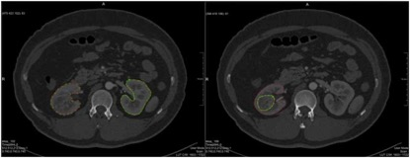
The left image shows the renal parenchymal area after surrounding structures including blood vessels and collecting system were excluded in axial image. The right shows space-occupying lesions were semi-automatically excluded from renal parenchymal area.

Supplementary figure 2 Bland-Altman test shows the results of CT-GFR measurement by the homemade software from the of 2 experienced radiologists.

Supplementary figure 3 A 47-year-old man suffered from right sided renal tumor.
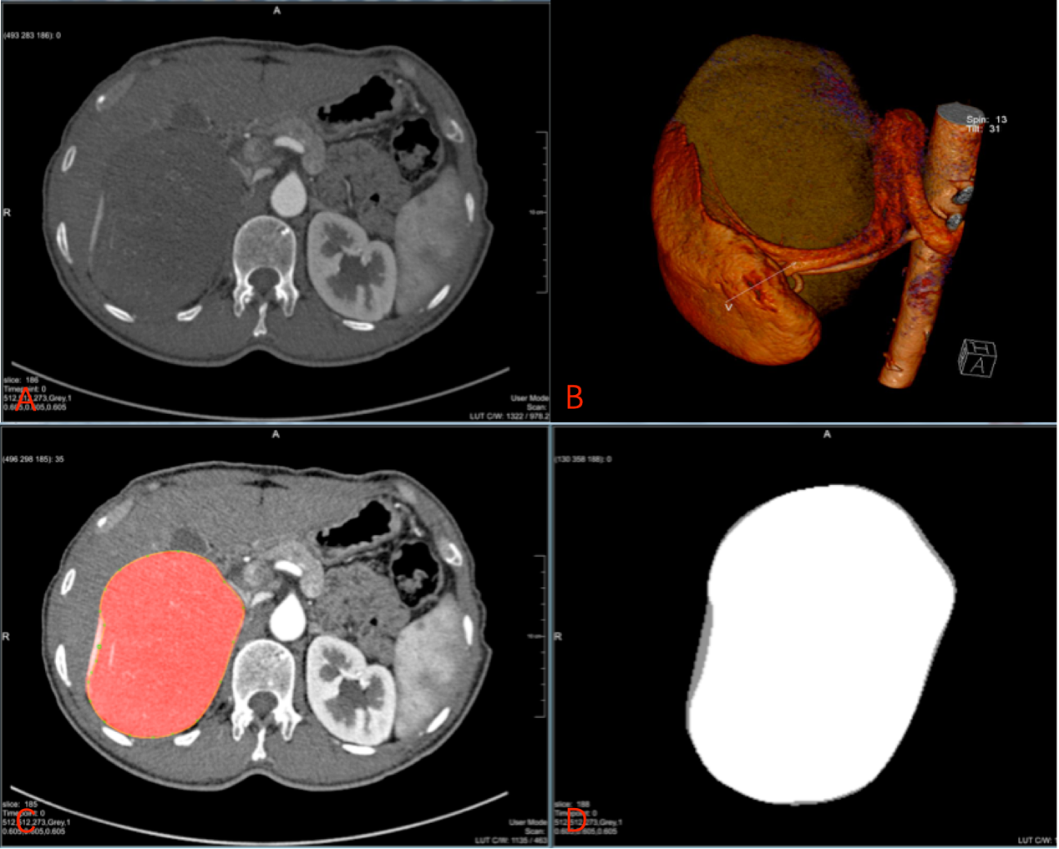
A showed the axial images of CT angiography. B showed volume rendering (VR) image of right kidney. C and D showed tumor was semi-automatically excluded from renal parenchymal area by homemade software.

Supplementary figure 4 CT images of region of interest in abdomen aorta at multiple time points
A showed the region of interest of the abdominal aorta in the phase of Bolus triggering.
B showed the region of interest of the abdominal aorta in the arterial phase.
C showed the region of interest of the abdominal aorta in the phase of Dynamic scans.
D showed the region of interest of the abdominal aorta in the Early parenchymal phase.
E showed the region of interest of the abdominal aorta in the Late parenchymal phase.

Supplementary table 1 Results of Statistical Comparison between Split CT-GFR of with Tumors and without Tumors
Phase of renal parenchymal | GFR Measurement of tumor-bearing kidney | Paired t Test Difference
 |  | ‾x *(n=91)  (ml·min⁻¹·1.73m⁻²) |  | t value | p value
Early | CT-GFR(w) | 3.00±2.30 | 5.06 |  | 0.000
 | CT-GFR(wo)
Late | CT-GFR(w) | 3.14±3.13 | 3.89 |  | 0.002
 | CT-GFR(wo)
CT-GFR(w)：Quantitative glomerular filtration rate with tumor based on the method of two point of Patlak plot；CT-GFR(wo)：Quantitative glomerular filtration rate without tumor based on the method of two point of Patlak plot

Supplementary table 2 Results of Statistical Comparison between Relative CT-GFR and Relative R-GFR of Split Kidney
Relative GFR of split kidney |  | Paired t Test Difference |  |  | Correlation Analysis
 |  | ‾x *(n=15)  (ml·min⁻¹·1.73m⁻²) | t value | p value | r value | p value
Non-tumor-bearing kidney | rR-GFR | … | … | … | … | …
 | Early rCT-GFR | -0.05±1.53 | -0.14^{γ} | 0.89^{γ} | 0.88^{γ} | <0.001^{γ}
 | Late rCT-GFR | 0.56±2.0 | 1.08^{γγ} | 0.30^{γγ} | 0.69^{γγ} | 0.004^{γγ}
Tumor-bearing kidney | rR-GFR | … | … | … | … | …
 | Early rCT-GFR | 0.05±1.53 | 0.14^{λ} | 0.89^{λ} | 0.88^{λ} | <0.001^{λ}
 | Late rCT-GFR | -0.56±2.0 | -1.08^{λλ} | 0.30^{λλ} | 0.69^{λλ} | 0.004^{λλ}
*Data are‾x ± standard deviation
^{γ}Data represent results of the comparison between rR-GFR and rCT-GFR in early renal parenchymal phase of non-tumor-bearing kidney.
^{γγ}Data represent results of the comparison between rR-GFR and rCT-GFR in late renal parenchymal phase of non-tumor-bearing kidney.
^{λ}Data represent results of the comparison between rR-GFR and rCT-GFR in early renal parenchymal phase of tumor-bearing kidney.
^{λλ}Data represent results of the comparison between rR-GFR and rCT-GFR in late renal parenchymal phase of tumor-bearing kidney.
rCT-GFR：Quantitative relative glomerular filtration rate based on the method of two point of Patlak plot； rR-GFR：Quantitative relative glomerular filtration rate based on the method of radionuclide examination.

Supplementary table 3 Baseline clinical characteristics of patients.
Characteristics | All patients (N=91)
Age (years) mean±SD | 58±12
Male gender, n (%) | 58(64%)
Height(m) mean±SD | 1.66±0.07
Weight(kg) mean±SD | 70±10.8
Hypertension, n (%) | 33(36%)
Diabetes mellitus, n (%) | 10(11%)
Coronary artery disease, n (%) | 7(8%)
Arrhythmia, n (%) | 2(2%)
Hepatitis, n (%) | 3(3%)
Congenital heart disease, n (%) | 1(1%)
Chronic obstructive pulmonary disease, n (%) | 1(1%)
Tuberculosis | 2(2%)

