Supplementary Table 1| Detailed information of the crude drugs composed in SMYAD.

No. | Drug Name | Authentication | Voucher specimen
SMYAD-A | Lonicerae Japonicae Flos | Flower bud of Lonicera japonica Thunb. | 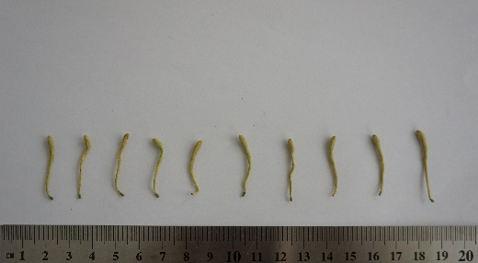
SMYAD-B | Scrophulariae Radix | Root of Scrophularia ningpoensis Hemsl | 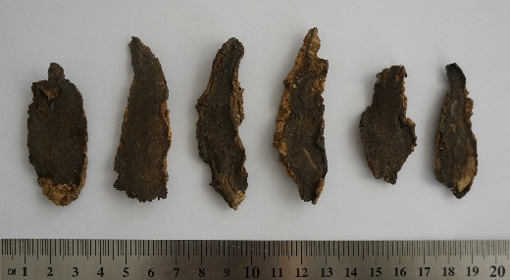
SMYAD-C | Angelicae Sinensis Radix | Root of. Angelica sinensis ( Oliv. ) Diels | 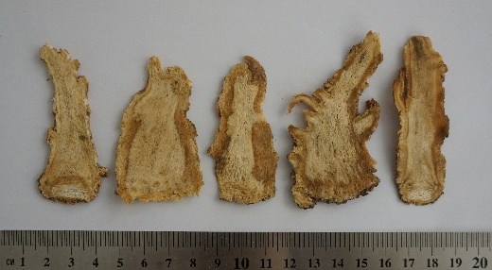
SMYAD-D | Glycyrrhizae Radix Et Rhizoma | Stem of Glycyrrhiza uralensis Fisch | 