Figure S1. Representative images of hematoxylin and eosin (HE) staining of mouse colon tissue at the 10th weekend. Original magnification, 100× and 200×. CK: control treatment; COS: COS control treatment; CACM: AOM/DSS-induced colitis-associated CRC model mice; CMCOS, COS-treated CACM mice (300 mg/kg/d COS); CACMe, exchanged CACM treatment; CMCOSe: exchanged CMCOS treatment.

Figure S2. The abundances of fecal total bacteria at the 0th, 1st, 3rd, 6th, 9th and 10th weekends. The results were presented as the mean ± standard deviation (SD); n = 8 for each treatment. Analysis of variance (ANOVA) was used, significant differences (P < 0.05) between treatments are indicated by the letters a, b, or c. CK: control treatment; COS: COS control treatment; CACM: AOM/DSS-induced colitis-associated CRC model mice; CMCOS, COS-treated CACM mice (300 mg/kg/d COS); CACMe, exchanged CACM treatment; CMCOSe: exchanged CMCOS treatment.
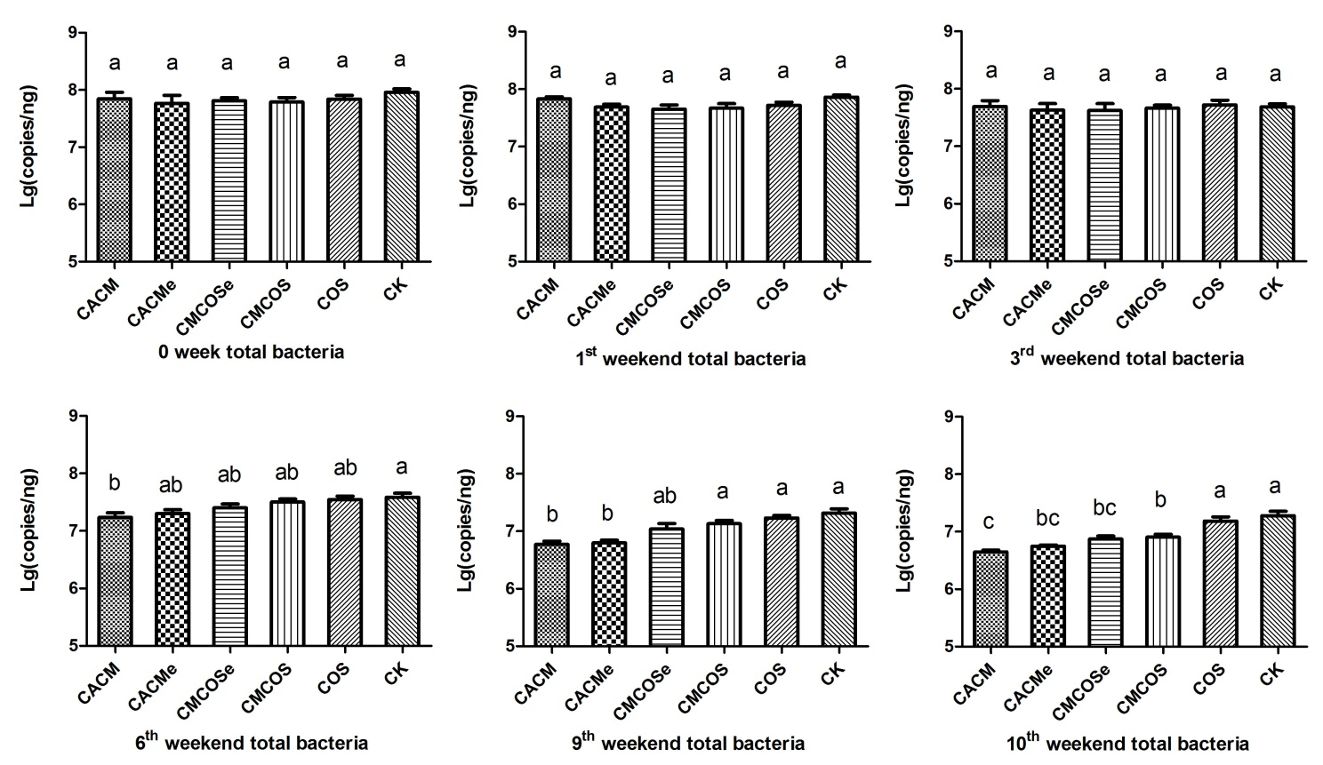

Figure S3. The abundances of fecal Fusobacterium nucleatum at the 0th, 1st, 3rd, 6th, 9th and 10th weekends. The results were presented as the mean ± standard deviation (SD); n = 8 for each treatment. Analysis of variance (ANOVA) was used, significant differences (P < 0.05) between treatments are indicated by the letters a, b, or c. CK: control treatment; COS: COS control treatment; CACM: AOM/DSS-induced colitis-associated CRC model mice; CMCOS, COS-treated CACM mice (300 mg/kg/d COS); CACMe, exchanged CACM treatment; CMCOSe: exchanged CMCOS treatment.
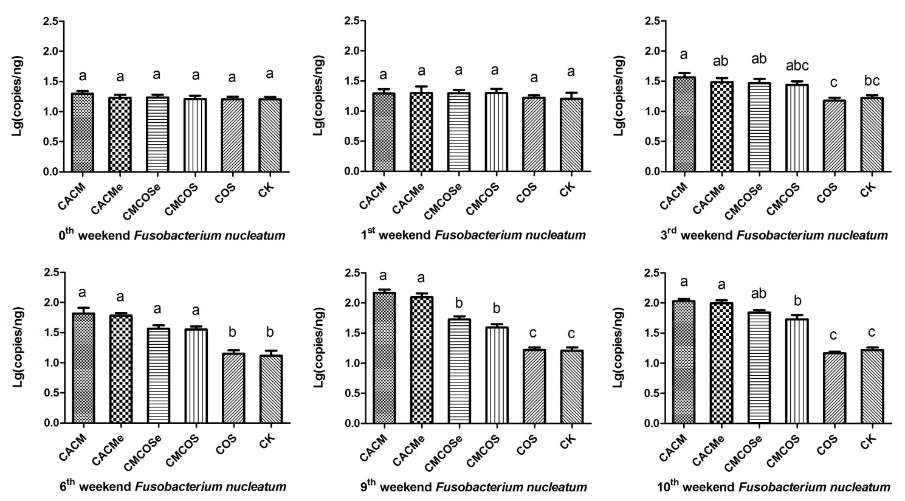

Figure S4. The abundances of fecal Enterococcus at the 0th, 1st, 3rd, 6th, 9th and 10th weekends. The results were presented as the mean ± standard deviation (SD); n = 8 for each treatment. Analysis of variance (ANOVA) was used, significant differences (P < 0.05) between treatments are indicated by the letters a, b, c, or d. CK: control treatment; COS: COS control treatment; CACM: AOM/DSS-induced colitis-associated CRC model mice; CMCOS, COS-treated CACM mice (300 mg/kg/d COS); CACMe, exchanged CACM treatment; CMCOSe: exchanged CMCOS treatment.
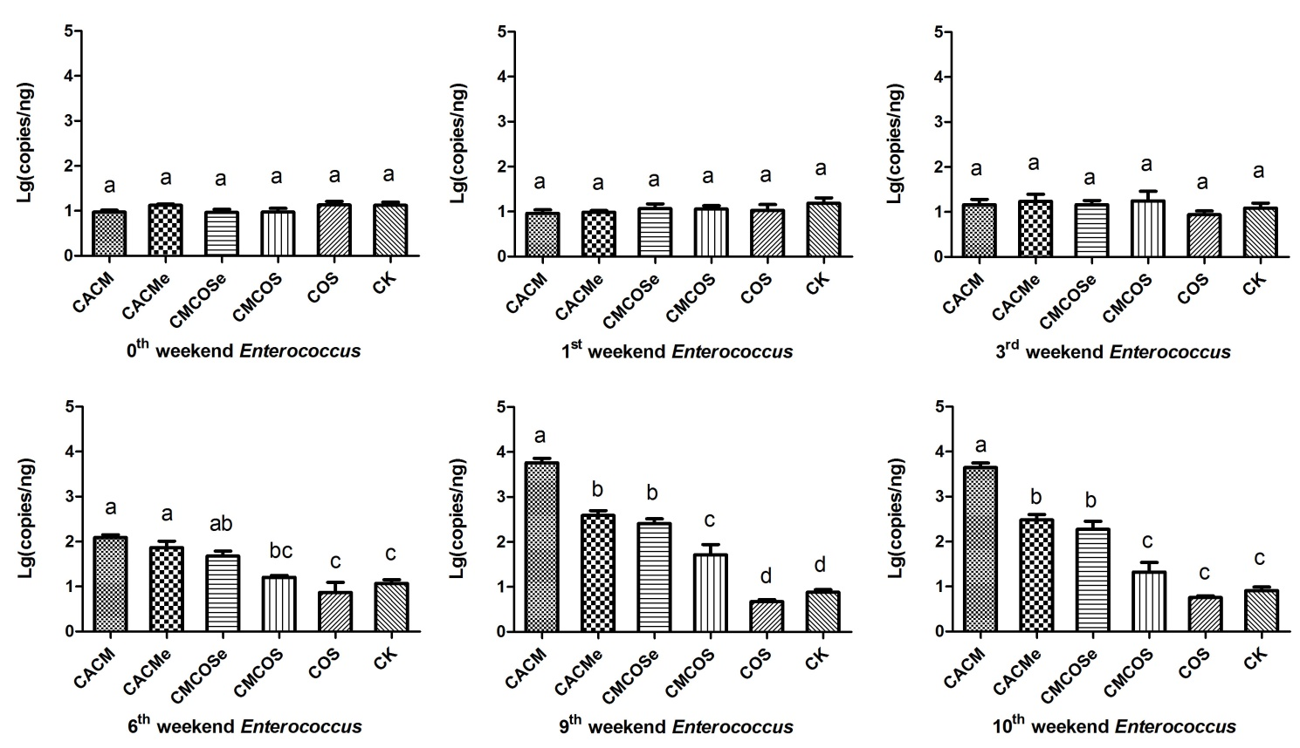

Figure S5. The abundances of fecal Lactobacillus at the 0th, 1st, 3rd, 6th, 9th and 10th weekends. The results were presented as the mean ± standard deviation (SD); n = 8 for each treatment. Analysis of variance (ANOVA) was used, significant differences (P < 0.05) between treatments are indicated by the letters a, b, or c. CK: control treatment; COS: COS control treatment; CACM: AOM/DSS-induced colitis-associated CRC model mice; CMCOS, COS-treated CACM mice (300 mg/kg/d COS); CACMe, exchanged CACM treatment; CMCOSe: exchanged CMCOS treatment.
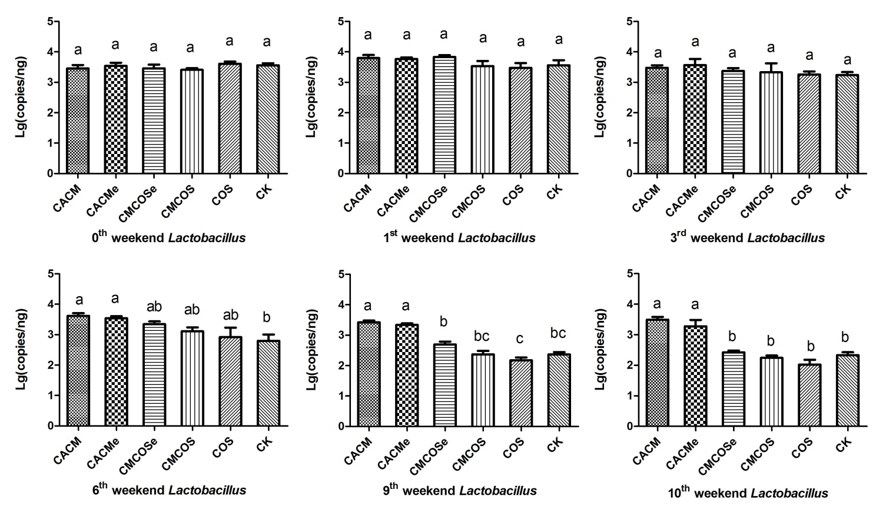

Figure S6. The abundances of fecal butyrate-producing bacteria at the 0th, 1st, 3rd, 6th, 9th and 10th weekends. The results were presented as the mean ± standard deviation (SD); n = 8 for each treatment. Analysis of variance (ANOVA) was used, significant differences (P < 0.05) between treatments were indicated by the letters a, b, c, or d. CK: control treatment; COS: COS control treatment; CACM: AOM/DSS-induced colitis-associated CRC model mice; CMCOS, COS-treated CACM mice (300 mg/kg/d COS); CACMe, exchanged CACM treatment; CMCOSe: exchanged CMCOS treatment.
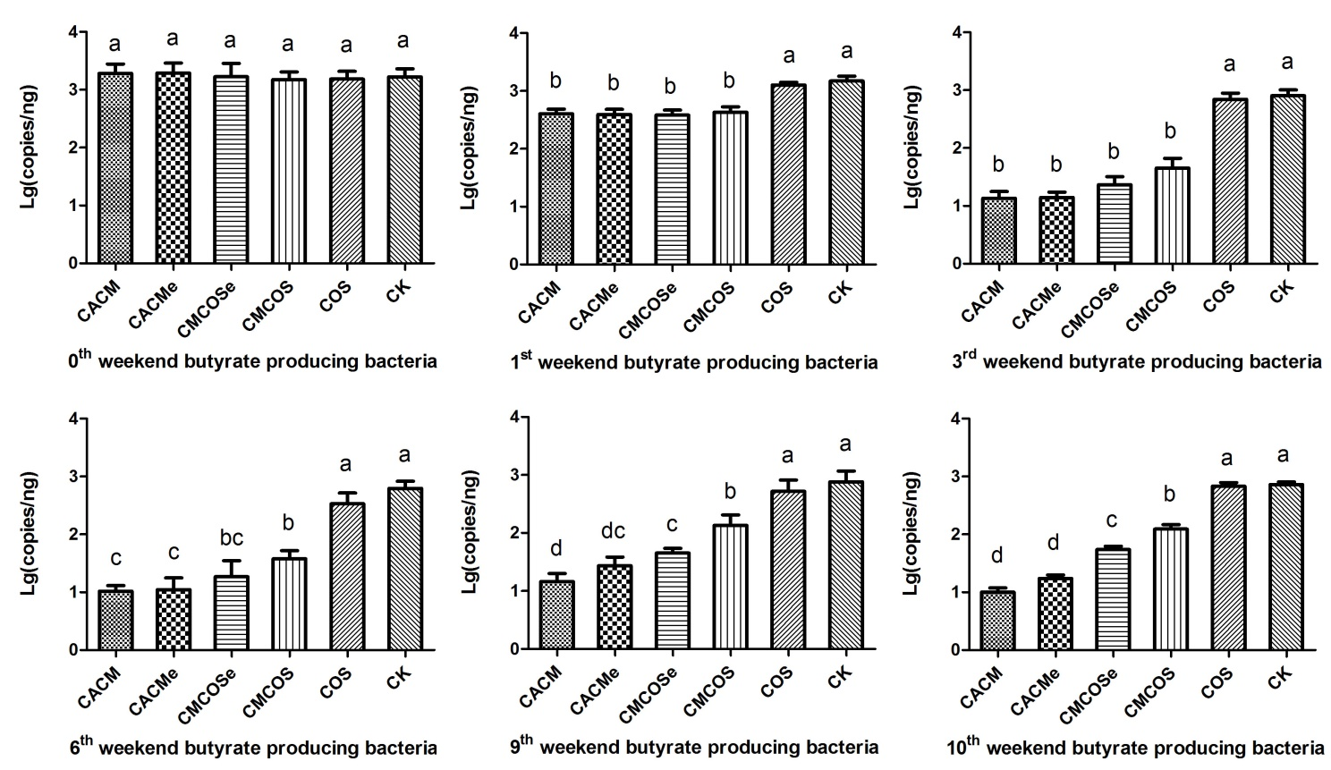

Figure S7. Analysis of bacterial similarities at different categorical levels. The statistics were performed based on bray-curtis distance, n = 4. CK: control treatment; COS: COS control treatment; CACM: AOM/DSS-induced colitis-associated CRC model mice; CMCOS, COS-treated CACM mice (300 mg/kg/d COS); CACMe, exchanged CACM treatment; CMCOSe: exchanged CMCOS treatment.
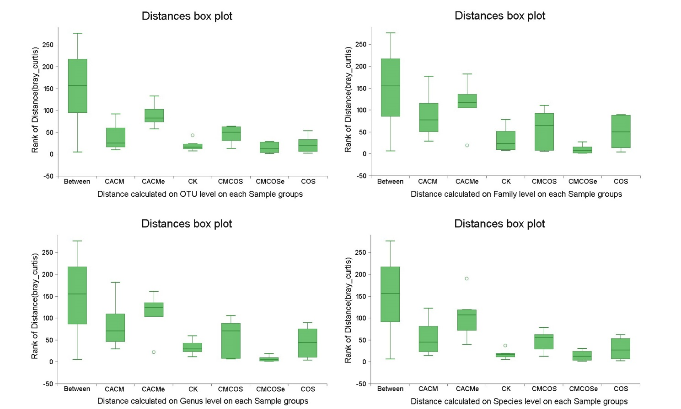

Figure S8. Pincipal components analysis (PCA) of 18S rRNA gene-sequencing. PC1, PC2 and PC3 explained 39.06, 17.48 and 15.62% of variation, respectively. The statistics were performed based on bray-curtis distance, n = 4. CK: control treatment; COS: COS control treatment; CACM: AOM/DSS-induced colitis-associated CRC model mice; CMCOS, COS-treated CACM mice (300 mg/kg/d COS); CACMe, exchanged CACM treatment; CMCOSe: exchanged CMCOS treatment.
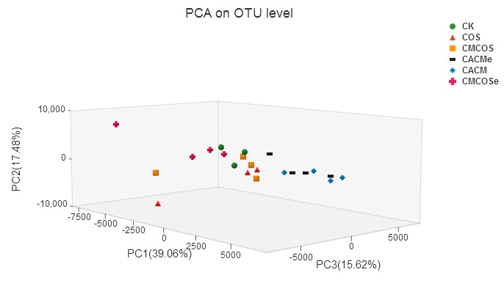

Figure S9. Relative abundances at the phylum, family and genus levels for fungi that exceeded 1% of the total. The results are presented as the mean ± standard deviation (SD); n = 3 for CK and COS, n = 4 for CACM, CMCOS, CACMe and CMCOSe. * Analysis of variance (ANOVA) was used, significant differences between CK and treatments were indicated (P < 0.05). CK: control treatment; COS: COS control treatment; CACM: AOM/DSS-induced colitis-associated CRC model mice; CMCOS, COS-treated CACM mice (300 mg/kg/d COS); CACMe, exchanged CACM treatment; CMCOSe: exchanged CMCOS treatment.
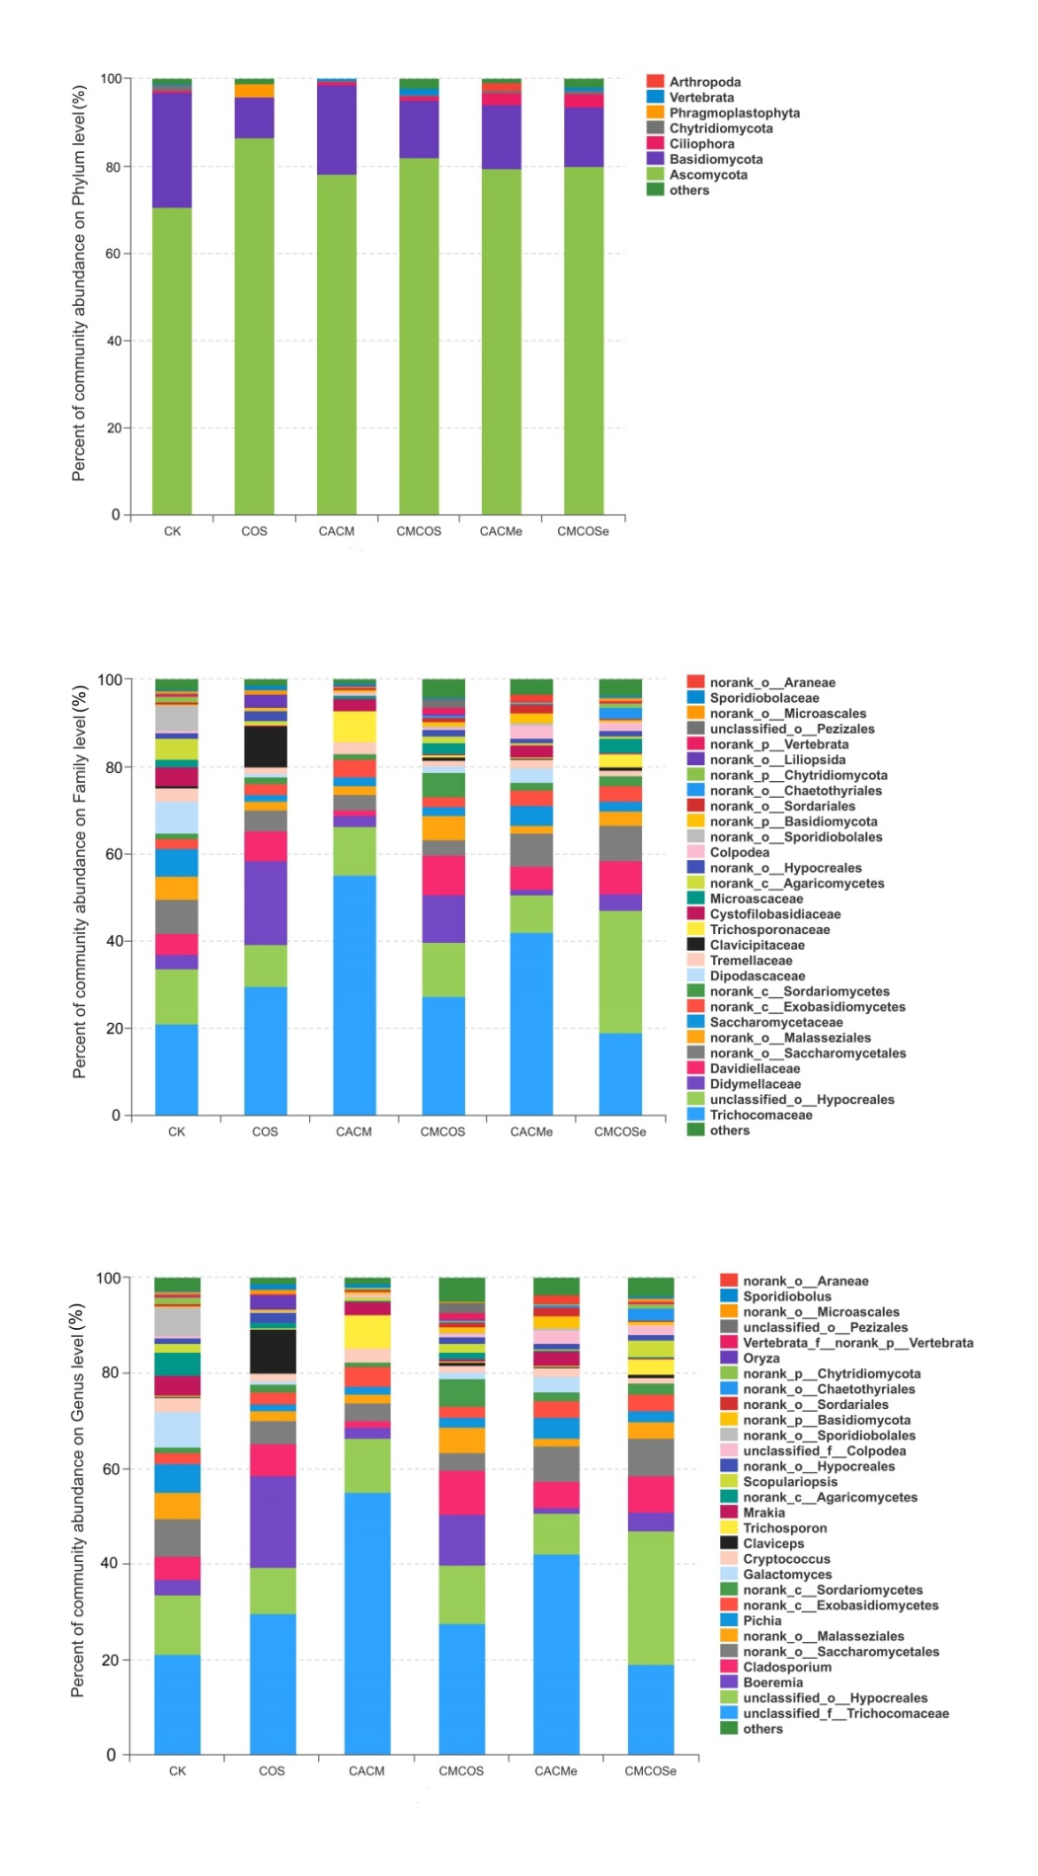

Figure S10. The correlation between microbiota at species level and environmental factors (DAI, tumor multiplicity and cytokines). The most abundant 50 species in each sample were used to perform the hierarchical clustering and heatmap analyses based on Spearman correlation coefficient. n = 4. TUM: tumor multiplicity; DAI: disease activity index.

Figure S11. The correlation between mycobiota at species level and environmental factors (DAI, tumor multiplicity and cytokines). The most abundant 50 species in each sample were used to perform the hierarchical clustering and heatmap analyses based on Spearman correlation coefficient. n = 4. TUM: tumor multiplicity; DAI: disease activity index.

Table S1. The primer sequences for specific bacteria by real-time PCR
Traget bacterial group | Primer name | Primer sequences | R² | Amplification efficiency (%)
Total bacteria ^{[1]} | 341F | CCTACGGGAGGCAGCAG | 0.998 | 105.8
 | 518R | ATTACCGCGGCTGCTGG
Lactobacillus ^{[2]} | Lac-F | AGCAGTAGGGAATCTTCCA | 0.993 | 99.3
 | Lac-R | CACCGCTACACATGGAG
Enterococcus ^{[3]} | Ent-F | CCCTTATTGTTAGTTGCCATCATT | 0.996 | 103.6
 | Ent-R | ACTCGTTGTACTTCCCATTGT
Fusobacterium nucleatum ^{[4]} | Fus-F | CAACCATTACTTTAACTCTACCATGTTCA | 0.993 | 92.9
 | Fus-R | GTTGACTTTACAGAAGGAGATTATGTAAAAATC
Butyrate producing bacteria ^{[5]} | Bco-F | GCIGAICATTTCACITGGAAYWSITGGCAYATG | 0.994 | 95.2
 | Bco-R | CCTGCCTTTGCAATRTCIACRAANGC
Note: The PCR amplification procedures were: 95°C 30 s; 40 cycles of denaturing at 95°C for 5 s, and annealing/extension at 60°C for 30 s. After all cycles, dissociation curves were performed as 95°C for 15s, 60°C for 1 min, and 95°C for 15 s. The references were present as follows.
[1] Muyzer, G, De Waal EC, Uitterlinden AG. Profiling of complex microbial populations by denaturing gradient gel electrophoresis analysis of polymerase chain reaction-amplified gene coding for 16S rRNA. Appl Environ Microbiol 1993; 59: 695-700.
[2] Collado MC, Isolauri E, Laitinen K, et al. Distinct composition of gut microbiota during pregnancy in overweight and normal-weight women. Am J Clini Nutri 2008; 88: 894-899.
[3] Rinttilä T, Kassinen A, Malinen E, et al. Development of an extensive set of 16S rDNA-targeted primers for quantification of pathogenic and indigenous bacteria in faecal samples by real-time PCR. J Appl Microbiol 2004; 97(6): 1166-1177.
[4] Castellarin, M., Warren, R., Freeman, J., Dreolini, L., Krzywinski, M., Strauss, J. et al. Fusobacterium nucleatum infection is prevalent in human colorectal carcinoma. Genome Res 2012; 22: 299–306.
[5] Louis P, Flint HJ. Development of a semiquantitative degenerate real-time pcr-based assay for estimation of numbers of butyryl-coenzyme A (CoA) CoA transferase genes in complex bacterial samples. Appli Environ Microbiol, 2007; 73(6): 2009-2012.

Table S2. The dynamic changes of body weights in the experimental period.
Time (week) | CK | COS | CACM | CMCOS | CACMe | CMCOSe
0 | 23.76±1.62 | 23.59±1.28 | 23.92±1.06 | 23.41±0.51 | 23.76±0.95 | 23.59±1.01
1 | 23.85±1.11 | 24.70±1.12 | 23.18±1.27 | 22.73±1.08 | 22.72±0.82 | 22.73±0.67
2 | 24.13±0.91ª | 24.79±1.57ª | 21.01±1.01^{b} | 20.94±0.61^{b} | 20.76±0.52^{b} | 20.84±0.418^{b}
3 | 24.72±1.46ª | 24.63±1.29ª | 22.03±1.50^{b} | 21.80±1.23^{b} | 21.73±0.26^{b} | 21.99±0.69^{b}
4 | 23.58±1.11^{ab} | 24.26±1.53ª | 22.93±1.74^{ab} | 23.13±0.81^{ab} | 22.52±0.58^{ab} | 23.41±0.78^{b}
5 | 24.13±1.23ª | 24.94±1.59ª | 20.13±1.39^{b} | 21.85±1.01^{b} | 21.41±1.42^{b} | 21.18±1.16^{b}
6 | 24.80±1.15^{ab} | 25.50±1.17ª | 22.32±1.72^{c} | 23.51±1.06^{abc} | 22.68±1.19^{bc} | 22.66±2.28^{bc}
7 | 25.40±1.29^{ab} | 26.21±1.28ª | 23.44±1.48^{b} | 24.81±1.20^{ab} | 24.15±1.02^{ab} | 23.83±2.01^{b}
8 | 26.42±0.76ª | 27.11±1.56ª | 19.34±1.01^{c} | 21.70±1.30^{b} | 19.96±1.27^{bc} | 21.02±1.61^{bc}
9 | 26.85±0.87ª | 27.51±1.57ª | 21.29±0.37^{d} | 23.93±0.58^{b} | 21.75±1.11^{cd} | 23.30±0.91^{bc}
10 | 27.14±1.19ª | 27.68±1.86ª | 22.01±0.41^{d} | 25.34±1.03^{b} | 22.95±0.57^{cd} | 24.43±0.81bc
Note: The results were presented as the mean ± standard deviation (SD); n = 8 for each treatment. Analysis of variance (ANOVA) was used, significant differences (P < 0.05) between treatments are indicated by the letters a, b, or c. CK, control group; COS, COS treated group; CACM, AOM/DSS induced colitis-associated CRC model mice; CMCOS, COS treated CACM mice (300 mg/kg COS), CACMe, exchanged CACM group; CMCOSe: exchanged CMCOS group.

Table S3. The dynamic changes of disease activity index in the experimental period.
Time (week) | CK | COS | CACM | CMCOS | CACMe | CMCOSe
0 | 0.00±0.00 | 0.00±0.00 | 0.00±0.00 | 0.00±0.00 | 0.00±0.00 | 0.00±0.00
1 | 0.00±0.00^{b} | 0.00±0.00^{b} | 0.45±0.25ª | 0.25±0.30^{ab} | 0.54±0.25ª | 0.29±0.21^{ab}
2 | 0.00±0.00^{b} | 0.00±0.00^{b} | 1.83±0.31ª | 1.59±0.16ª | 1.75±0.15ª | 1.71±0.21ª
3 | 0.00±0.00^{b} | 0.00±0.00^{b} | 1.46±0.25ª | 1.21±0.25ª | 1.37±0.28ª | 1.25±0.30ª
4 | 0.00±0.00^{b} | 0.00±0.00^{b} | 0.92±0.46ª | 0.50±0.18ª | 0.62±0.45ª | 0.58±0.23ª
5 | 0.00±0.00^{d} | 0.00±0.00^{d} | 2.79±0.25ª | 2.00±0.40^{c} | 2.50±0.31^{ab} | 2.08±0.46^{bc}
6 | 0.00±0.00^{d} | 0.00±0.00^{d} | 2.19±0.26ª | 1.08±0.30^{c} | 2.04±0.37^{ab} | 1.29±0.70^{c}
7 | 0.00±0.00^{d} | 0.00±0.00^{d} | 1.52±0.26ª | 0.67±0.18^{c} | 1.33±0.44^{ab} | 0.96±0.41^{bc}
8 | 0.00±0.00^{d} | 0.00±0.00^{d} | 3.95±0.12ª | 2.75±0.35^{c} | 3.58±0.46^{ab} | 3.13±0.25^{c}
9 | 0.00±0.00^{d} | 0.00±0.00^{d} | 3.22±0.27ª | 2.19±0.18^{c} | 2.72±0.25^{b} | 2.33±0.27^{c}
10 | 0.00±0.00^{d} | 0.00±0.00^{d} | 2.80±0.38ª | 1.57±0.25^{c} | 2.45±0.27^{ab} | 1.76±0.42^{c}
Note: The results were presented as the mean ± standard deviation (SD); n = 8 for each treatment. Analysis of variance (ANOVA) was used, significant differences (P < 0.05) between treatments are indicated by the letters a, b, or c. CK, control group; COS, COS treated group; CACM, AOM/DSS-induced colitis-associated CRC model mice; CMCOS, COS-treated CACM mice (300 mg/kg COS), CACMe, exchanged CACM group; CMCOSe: exchanged CMCOS group.

Table S4. The histological assessment of each mouse in each group
 | CACM | CACMe | CMCOSe | CMCOS | COS | CK
Normal tissue  Colitis  Low-grade intraepithelial neoplasia  High-grade intraepithelial neoplasia  Adenocarcinoma | 0  0  0  6  2 | 0  0  1  6  1 | 0  1  4  3  0 | 0  2  5  1  0 | 8  0  0  0  0 | 8  0  0  0  0
n = 8 for each group.
The histological assessment was based on dysplasia and intestinal cancer classification as previously reported ^{[1-2]}.
- Riddell RH, Goldman H, Ransohoff DF, et al. Dysplasia in inflammatory bowel disease: standardized classification with provisional clinical applications. Hum Pathol 1983;14(11):931-68.
- Boivin GP 1, Washington K, Yang K, et al. Pathology of Mouse Models of Intestinal Cancer: Consensus Report and Recommendations. Gastroenterology. 2003;124(3):762-77.

