Supplementary material

Table S1 – Specifications of the input data used for this study
Types | Feature | Values
Area of Study | GSAs | 12, 13, 14, 15, 16, 19 (portion) and 21 (portion)
 | Latitude Range | 33 - 39
 | Longitude Range | 8.5 – 16.75
 | N. of Cells | 500
 | Surface Area | 303536 Km^2
VMS | Time Frame | 2012 - 2016
 | N. of Vessels | 377 (average) 588 (uniques)
 | N. of Pings | 31470316 (total) 6294063 (average)
Fleet Register | N. of Vessels | 587
 | Average LOA | 22 m
 | Average Power | 290 kW
 | Average Tonnage | 79 GT
Landings | Time Frame | 2012 - 2016
 | N. of Vessels | 89 (average * year), 231 (uniques)
 | N. of Species | 4 (ARS, DPS, HKE, MUT)
 | Avg. N. of Observations by Year | 30339
 | Avg. N. of Observation by Vessel | 77
 | Avg. N. of Observation by Species | 7585
Survey | Time Frame | 2012 - 2016
 | N. of Species | 4 (ARS, DPS, HKE, MUT)
 | N. of Observations | 19699
 | Avg. N. of Observation by Year | 3940
 | Avg. N. of Observation by Species | 4925
 | N. of Measured Specimens | 162063
 | Avg. N. of Measured Specimens by Year | 32413
 | Avg. N. of Measured Specimens by Species | 40516
Fishery | Time Frame | 2012 - 2016
 | N. of Species | 4 (ARS, DPS, HKE, MUT)
 | N. of Observations | 51559
 | Avg. N. of Observation by Year | 4687
 | Avg. N. of Observation by Species | 12890
 | N. of Measured Specimens | 493611
 | Avg. N. of Measured Specimens by Year | 44874
 | Avg. N. of Measured Specimens by Species | 123403
Costs | Time Frame | 2014
 | N. of Vessels | 385
 | N. of Observations | 587
 | Avg. N. of Observation by Vessel | 1.5
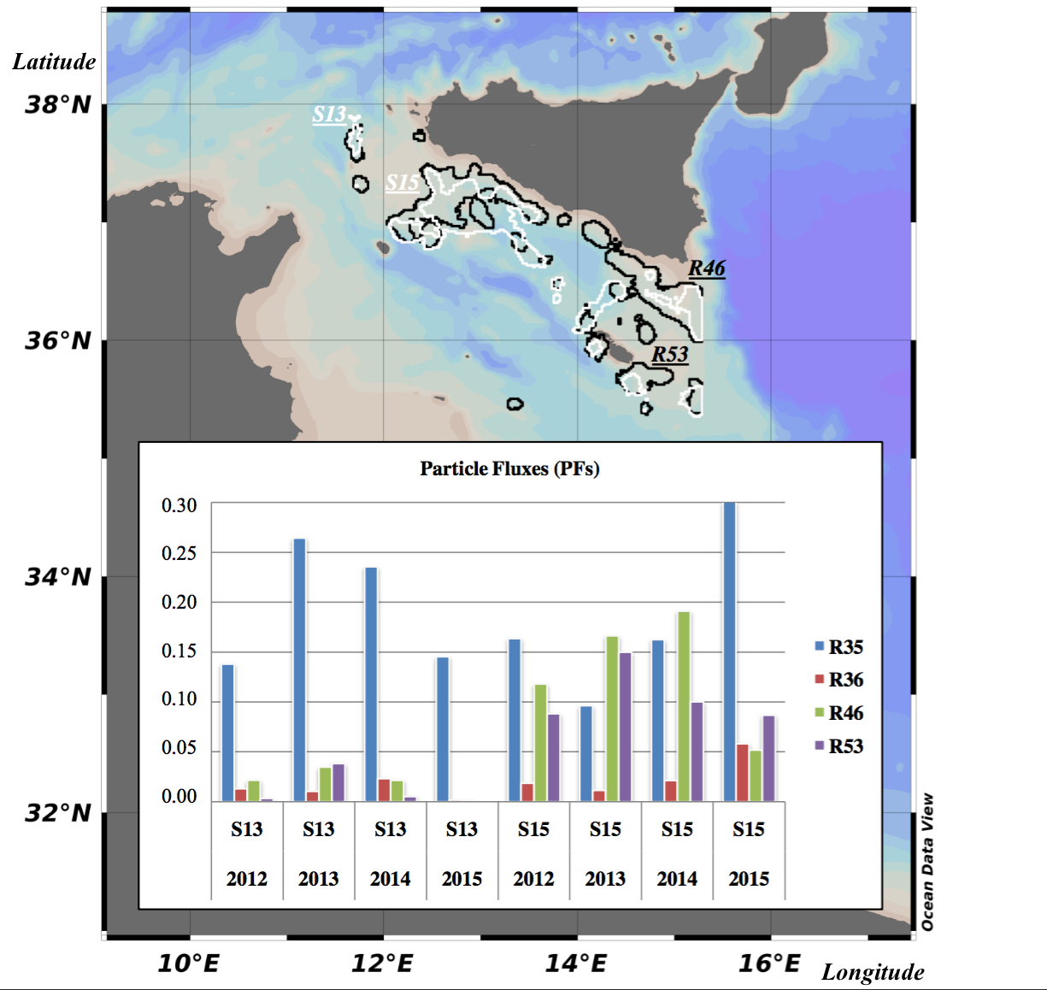

Figure S1 – The map displays the shape and geographical distribution of known spawning (white polygons) and nursery (black polygons) areas of Parapenaeus longirostris in the SoS. For sake of clarity the authors labeled spawning areas S13 and S15 and nursery areas R46 and R53. Yearly connectivity between such areas is provided by particle fluxes (PFs) and displayed by means of a bar plot. There, PFs (y-axis), between spawning (x-axis) and nursery (colored bars) areas, are provided for all computed years (from 2012 to 2015) and they consider a time window for larvae settlement ranging 10 and 30 days after eggs release.

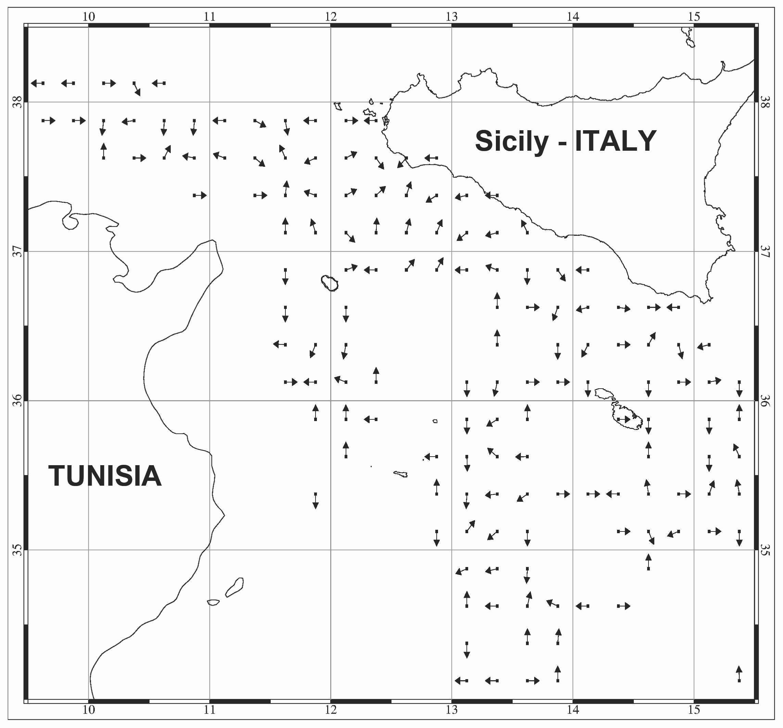

Figure S2 – Potential migration map of Parapenaeus longirostris between juvenile and adult stage in the Strait of Sicily. The computation of the migration pattern was carried out considering the distribution of the age class 0 for the juvenile stage (A^{t} in eq. 4 and 5) and the sum of the distribution of the higher age classes for the adult stages (A^{(t+1)} in eq. 4 and 5). The normalized dataset was used as model inputs and the obtained results provide information only on the direction of the migration.

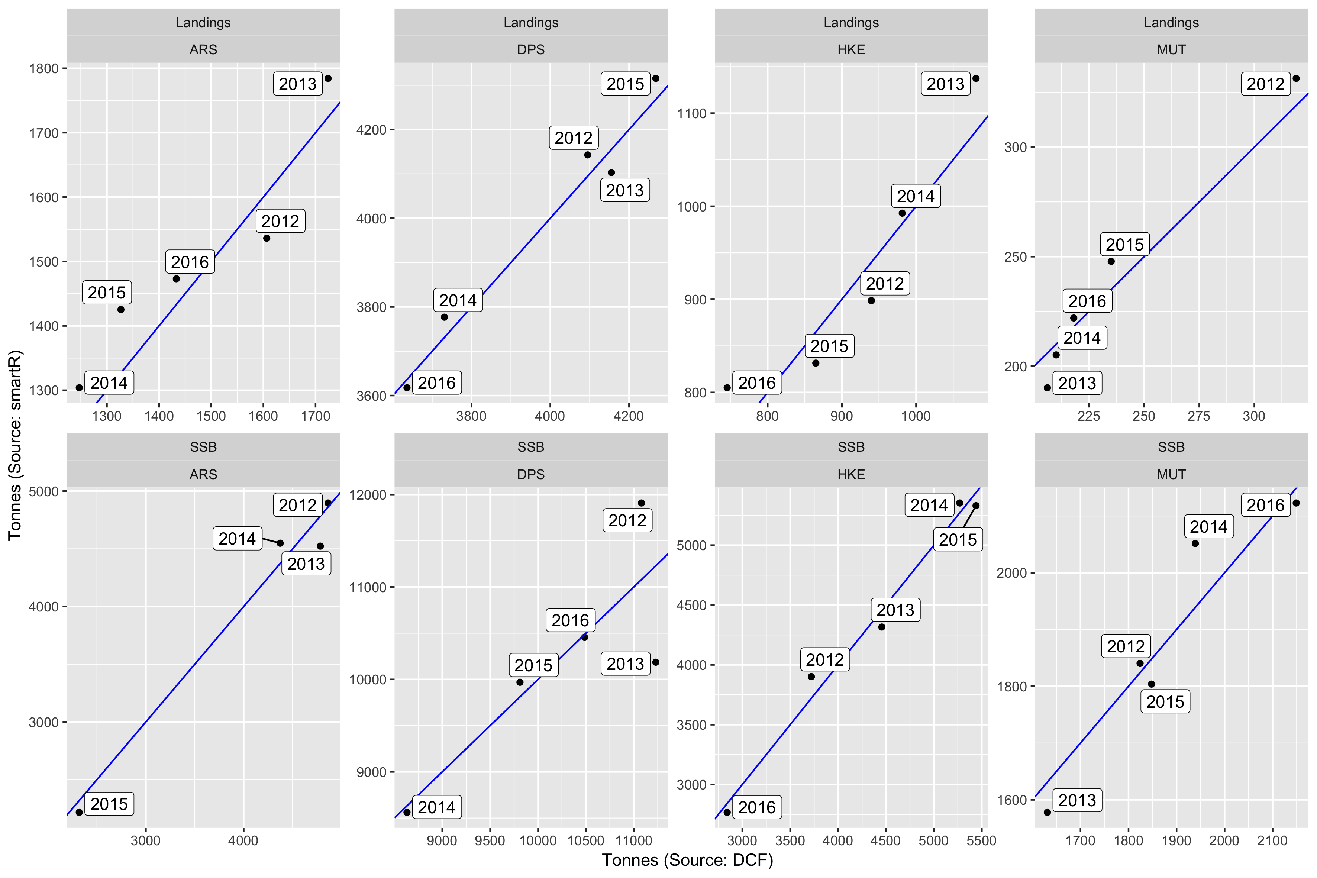

Figure S3 – Comparison between the total annual landing and SSB, for the four species, estimated by smartR (x-axis) and the corresponding estimates of DCF for landing and SAC_GFCM for SSB (y-axis). The blue line represents the bisector (y=x).

Table S2 - variation of $\overline{F}$ in the different scenarios expressed as % of the status quo. Age ranges for the computation of $\overline{F}$were: 1-3 years (ARS), 0-2 years (DPS), 1-5 years (HKE) and 1-3 years (MUT).
Scenario | % variation of $F$ by species, with respect to status quo
 | ARS | DPS | HKE | MUT
Effort Regime | -19.2 | -23.5 | -10.4 | -18.5
GFCM FRA | 3.3 | -28.7 | -0.8 | -26.2
FRA Network | 10.8 | -29.0 | -10.5 | -44.6
Summer stop | -42.4 | -62.0 | -26.6 | -49.6
Winter stop | -14.2 | -13.2 | -18.9 | -23.4

Table S3 - variation of $\overline{{SSB}_{2017-2022}}$in the different scenarios expressed as %with respect to $\overline{{SSB}_{2017-2022}^{status quo}}$ the status quo. Age ranges for the computation of $\overline{F}$ were: 1-3 years (ARS), 0-2 years (DPS), 1-5 years (HKE) and 1-3 years (MUT).
Scenario | % variation of the $\overline{{SSB}_{2017-2022}}$by species, with respect to $\overline{{SSB}_{2017-2022}^{status quo}}$
 | ARS | DPS | HKE | MUT
Effort Regime | 24.7 | 136.9 | 26.8 | 23.7
GFCM FRA | -3.9 | 848.3 | 1.4 | 34.0
FRA Network | -9.1 | 884.0 | -0.4 | 80.1
Summer stop | 79.5 | 1653.1 | 58.6 | 87.3
Winter stop | 18.7 | 47.9 | 0.7 | 31.2

