Supporting tables
Table S1 Profiles for Paratrechina longicornis specimens in this study.
ID | mt Clade | Haplotype | Infection type | Latitude | Longitude | Region | Country | nDNA
plJP01 | I | Hap15 | A | 26.21891 | 127.68644 | Northeast Asia | Japan | Y
plJP02-2 | II-3 | Hap11 | F | 26.1784797 | 127.7994308 | Northeast Asia | Japan | Y
plJP03 | II-3 | Hap23 | F | 24.35555 | 124.24238 | Northeast Asia | Japan | Y
plJP04 | I | Hap15 | AF | 24.39036333 | 124.2460911 | Northeast Asia | Japan | Y
plJP05 | I | Hap33 | A | 24.31386 | 123.90633 | Northeast Asia | Japan | Y
plJP06 | I | Hap8 | N | 24.33107972 | 123.9090897 | Northeast Asia | Japan | Y
plJP07 | II-3 | Hap23 | F | 26.398756 | 127.758078 | Northeast Asia | Japan | Y
plJP08 | I | Hap8 | N | 26.333547 | 127.787008 | Northeast Asia | Japan | Y
plJP09 | II-3 | Hap11 | F | 26.167364 | 127.828897 | Northeast Asia | Japan | Y
plJP10 | I | Hap15 | AF | 26.14476 | 127.66473 | Northeast Asia | Japan | Y
plJP11 | I | Hap15 | A | 26.0957 | 127.6828 | Northeast Asia | Japan | Y
plJP12 | I | Hap21 | AF | 26.096 | 127.7218 | Northeast Asia | Japan | Y
plJP13 | I | Hap8 | N | 26.14186 | 127.74891 | Northeast Asia | Japan | Y
plJP14 | I | Hap8 | N | 26.13774 | 127.72902 | Northeast Asia | Japan | Y
plJP15 | II-3 | Hap11 | F | 26.6777 | 127.8912 | Northeast Asia | Japan | Y
plJP16 | II-3 | Hap11 | F | 26.33846 | 127.84567 | Northeast Asia | Japan | Y
plJP17 | I | Hap9 | AF | 26.36461 | 127.85358 | Northeast Asia | Japan | Y
plJP18 | I | Hap15 | AF | 26.23266 | 127.68115 | Northeast Asia | Japan | Y
plJP19 | II-2 | Hap19 | N | 26.23752 | 127.67418 | Northeast Asia | Japan | Y
plJP20 | II-2 | Hap19 | N | 26.24146 | 127.6792 | Northeast Asia | Japan | Y
plJP21 | I | Hap8 | N | 26.43612 | 127.79304 | Northeast Asia | Japan | Y
plJP22 | I | Hap8 | N | 26.20983 | 127.65172 | Northeast Asia | Japan | Y
pl01-4 | I | Hap8 | N | 25.157405 | 121.401672 | East Asia | Taiwan | Y
pl02-2 | I | Hap15 | AF | 25.056328 | 121.224689 | East Asia | Taiwan | Y
pl03-2 | II-1 | Hap2 | F | 24.828056 | 121.071289 | East Asia | Taiwan | Y
pl04 | I | Hap8 | N | 24.81848 | 121.12813 | East Asia | Taiwan | Y
pl05 | I | Hap8 | A | 24.81684 | 121.11055 | East Asia | Taiwan | Y
pl06 | II-2 | Hap1 | N | 24.49518 | 120.82783 | East Asia | Taiwan | Y
pl07 | I | Hap21 | AF | 24.06126 | 120.43017 | East Asia | Taiwan | Y
pl08 | II-1 | Hap2 | F | 24.98925 | 121.46495 | East Asia | Taiwan | Y
pl09 | II-3 | Hap25 | F | 25.05575 | 121.1943 | East Asia | Taiwan
pl10 | I | Hap8 | A | 23.96461 | 120.57375 | East Asia | Taiwan
pl11 | I | Hap9 | A | 24.08009 | 120.55845 | East Asia | Taiwan
pl114 | I | Hap9 | AF | 22.66592 | 120.31297 | East Asia | Taiwan
pl115 | II-1 | Hap10 | N | 22.62255 | 120.28884 | East Asia | Taiwan
pl12 | I | Hap9 | A | 24.08269 | 120.55847 | East Asia | Taiwan
pl13 | I | Hap9 | A | 24.0808 | 120.5587 | East Asia | Taiwan
pl14 | II-2 | Hap1 | N | 23.97484 | 120.68483 | East Asia | Taiwan
pl15 | I | Hap15 | A | 24.07217 | 120.87296 | East Asia | Taiwan | Y
pl17 | I | Hap8 | A | 23.75804 | 120.6715 | East Asia | Taiwan
pl171 | I | Hap8 | A | 22.6258 | 120.341 | East Asia | Taiwan | Y
pl172 | II-1 | Hap2 | F | 22.62573 | 120.36373 | East Asia | Taiwan | Y
pl18 | I | Hap15 | AF | 23.80967 | 120.72036 | East Asia | Taiwan
pl180 | I | Hap16 | AF | 22.75782 | 121.10272 | East Asia | Taiwan
pl182 | II-1 | Hap2 | F | 22.77547 | 121.1477 | East Asia | Taiwan
pl183 | I | Hap8 | A | 22.53192 | 120.96728 | East Asia | Taiwan | Y
pl185 | II-2 | Hap17 | N | 23.56713 | 119.56514 | East Asia | Taiwan
pl186 | I | Hap8 | N | 23.5676 | 119.5621 | East Asia | Taiwan
pl187 | I | Hap9 | A | 23.55607 | 119.6021 | East Asia | Taiwan
pl189 | II-3 | Hap11 | F | 23.66052 | 119.56007 | East Asia | Taiwan | Y
pl19 | I | Hap8 | AF | 23.91944 | 120.67461 | East Asia | Taiwan
pl195 | I | Hap18 | AF | 22.06374 | 121.56617 | East Asia | Taiwan | Y
pl200 | I | Hap9 | A | 23.56369 | 119.48947 | East Asia | Taiwan | Y
pl208 | I | Hap8 | AF | 24.22642 | 120.8794 | East Asia | Taiwan | Y
pl21 | I | Hap8 | N | 23.76022 | 120.61775 | East Asia | Taiwan | Y
pl22 | II-1 | Hap2 | F | 23.48456 | 120.468 | East Asia | Taiwan
pl225 | II-1 | Hap2 | F | 22.91977 | 121.13971 | East Asia | Taiwan | Y
pl23 | II-2 | Hap19 | N | 23.11964 | 120.36213 | East Asia | Taiwan | Y
pl230 | I | Hap9 | AF | 21.93197 | 120.82416 | East Asia | Taiwan | Y
pl233 | I | Hap20 | AF | 22.0025 | 120.7456 | East Asia | Taiwan | Y
pl24 | I | Hap9 | A | 23.14064 | 120.32557 | East Asia | Taiwan
pl26 | I | Hap21 | A | 23.13657 | 120.30029 | East Asia | Taiwan | Y
pl27 | II-1 | Hap2 | F | 23.29165 | 120.39574 | East Asia | Taiwan
pl29 | II-1 | Hap10 | N | 22.65576 | 120.29132 | East Asia | Taiwan
pl30 | II-1 | Hap2 | N | 22.67611 | 120.3119 | East Asia | Taiwan
pl31 | II-2 | Hap1 | N | 22.64306 | 120.6106 | East Asia | Taiwan
pl32 | I | Hap21 | A | 22.59472 | 120.61087 | East Asia | Taiwan
pl33 | I | Hap8 | AF | 24.9022 | 121.8621 | East Asia | Taiwan | Y
pl35 | I | Hap21 | A | 23.78891 | 120.47762 | East Asia | Taiwan
pl36 | I | Hap22 | AF | 23.8253 | 120.4559 | East Asia | Taiwan
pl37 | II-1 | Hap2 | F | 23.79779 | 120.46528 | East Asia | Taiwan | Y
pl38 | II-1 | Hap2 | F | 23.79232 | 120.44801 | East Asia | Taiwan
pl39 | I | Hap8 | AF | 23.77125 | 120.41276 | East Asia | Taiwan
pl40 | II-1 | Hap2 | N | 23.76207 | 120.38989 | East Asia | Taiwan
pl41 | I | Hap8 | N | 23.76186 | 120.359 | East Asia | Taiwan
pl42 | I | Hap8 | AF | 23.65795 | 120.31242 | East Asia | Taiwan
pl43 | I | Hap8 | N | 23.61172 | 120.30735 | East Asia | Taiwan
pl44 | II-1 | Hap2 | F | 23.552 | 120.3471 | East Asia | Taiwan
pl45 | I | Hap9 | A | 23.45888 | 120.3325 | East Asia | Taiwan | Y
pl46 | I | Hap21 | AF | 23.46512 | 120.24691 | East Asia | Taiwan | Y
pl47 | II-2 | Hap19 | N | 23.41133 | 120.30818 | East Asia | Taiwan
pl48 | I | Hap8 | AF | 23.4287 | 120.3979 | East Asia | Taiwan
pl49 | I | Hap8 | AF | 22.99459 | 120.23331 | East Asia | Taiwan
pl50 | II-2 | Hap1 | N | 22.99847 | 120.19744 | East Asia | Taiwan
pl51 | II-2 | Hap1 | N | 22.99391 | 120.20748 | East Asia | Taiwan
pl58 | II-3 | Hap11 | F | 22.52346 | 120.46428 | East Asia | Taiwan
pl69 | II-3 | Hap23 | F | 23.899 | 121.5503 | East Asia | Taiwan | Y
pl74 | II-2 | Hap1 | N | 23.96713 | 121.60876 | East Asia | Taiwan
pl76 | I | Hap24 | A | 24.02891 | 121.62731 | East Asia | Taiwan
plCN01 | I | Hap26 | A | 21.39219 | 101.31512 | East Asia | China | Y
plCN02 | I | Hap21 | AF | 22.29695007 | 114.1742821 | East Asia | China | Y
plCN04.2 | I | Hap8 | AF | 22.25664636 | 113.9027274 | East Asia | China | Y
plCN07 | II-1 | Hap27 | N | 22.27944 | 114.1579 | East Asia | China | Y
plCN09 | I | Hap28 | A | 22.26393 | 114.23711 | East Asia | China | Y
plCN10 | II-3 | Hap11 | N | 22.29715 | 114.27222 | East Asia | China | Y
plCN11 | II-2 | Hap19 | N | 22.19617 | 113.54118 | East Asia | China | Y
plCN12 | I | Hap8 | N | 22.50213 | 114.12656 | East Asia | China | Y
plCN13 | I | Hap8 | AF | 22.41307 | 114.21012 | East Asia | China | Y
plCN14 | II-1 | Hap2 | F | 22.31048 | 114.1581 | East Asia | China | Y
plCN15 | II-2 | Hap3 | N | 22.28171 | 114.18877 | East Asia | China | Y
plCN16 | II-3 | Hap29 | F | 22.53706 | 114.05406 | East Asia | China | Y
plCN17 | II-3 | Hap4 | F | 22.54667 | 114.12677 | East Asia | China | Y
plCN18 | II-3 | Hap29 | F | 22.54469 | 114.08518 | East Asia | China | Y
pl12.348 | II-3 | Hap11 | F | 21.683 | 102.1 | South Asia | Laos | Y
plID01 | II-1 | Hap2 | F | -0.828076 | 100.53021 | South Asia | Indonesia | Y
plID02 | II-2 | Hap19 | N | -8.50957 | 115.261704 | South Asia | Indonesia | Y
plKH02 | II-1 | Hap2 | F | 13.412693 | 103.867024 | South Asia | Cambodia | Y
plKH03 | II-2 | Hap1 | N | 13.369017 | 103.864459 | South Asia | Cambodia | Y
plMY01 | I | Hap8 | AF | 3.21726 | 101.72442 | South Asia | Malaysia | Y
plMY02 | I | Hap34 | AF | 5.661726 | 100.508539 | South Asia | Malaysia | Y
plMY03 | I | Hap8 | AF | 5.612921 | 100.486052 | South Asia | Malaysia | Y
plMY04 | I | Hap34 | AF | 5.41792 | 100.337 | South Asia | Malaysia | Y
plMY05 | II-2 | Hap19 | N | 5.325918 | 100.287427 | South Asia | Malaysia | Y
plMY07 | II-2 | Hap19 | N | 5.277888 | 100.27023 | South Asia | Malaysia | Y
plMY08 | I | Hap21 | AF | 5.372663 | 100.237777 | South Asia | Malaysia | Y
plMY09 | II-1 | Hap27 | N | 5.406769 | 100.280058 | South Asia | Malaysia | Y
plMY10 | II-1 | Hap2 | F | 5.440082 | 100.287224 | South Asia | Malaysia | Y
plMY101 | I | Hap21 | AF | 3.42173 | 115.152667 | South Asia | Malaysia | Y
plMY11 | I | Hap21 | AF | 5.354718 | 100.300785 | South Asia | Malaysia | Y
plMY13 | I | Hap8 | AF | 1.863265 | 102.966965 | South Asia | Malaysia | Y
plMY14 | II-1 | Hap10 | N | 1.841309 | 102.955261 | South Asia | Malaysia | Y
plMY15 | I | Hap21 | A | 1.842982 | 102.93743 | South Asia | Malaysia | Y
plMY16 | II-2 | Hap19 | N | 1.858027 | 102.940938 | South Asia | Malaysia | Y
plMY17 | II-2 | Hap19 | N | 5.661996 | 100.502915 | South Asia | Malaysia | Y
plMY18 | II-1 | Hap27 | N | 5.674444 | 100.508889 | South Asia | Malaysia | Y
plMY19 | II-2 | Hap3 | N | 5.62605 | 100.46523 | South Asia | Malaysia | Y
plMY20 | I | Hap8 | A | 1.486775 | 103.930877 | South Asia | Malaysia | Y
plMY21 | I | Hap15 | A | 1.487547 | 103.929632 | South Asia | Malaysia | Y
plMY22 | II-1 | Hap10 | N | 1.492245 | 103.927948 | South Asia | Malaysia | Y
plMY23 | I | Hap8 | AF | 1.494658 | 103.922013 | South Asia | Malaysia | Y
plMY24 | I | Hap21 | AF | 2.137032 | 102.505825 | South Asia | Malaysia | Y
plMY25 | II-1 | Hap10 | N | 1.871323 | 102.996996 | South Asia | Malaysia | Y
plMY26 | II-2 | Hap19 | N | 5.601889 | 100.480544 | South Asia | Malaysia | Y
plMY27 | I | Hap21 | A | 5.369258 | 100.248221 | South Asia | Malaysia | Y
plMY28 | I | Hap15 | F | 1.411972 | 103.845186 | South Asia | Singapore | Y
plMY29 | II-1 | Hap35 | N | 1.275823 | 103.624204 | South Asia | Singapore | Y
plMY30 | II-3 | Hap36 | N | 1.312363 | 103.939681 | South Asia | Singapore | Y
plMY31 | II-1 | Hap10 | N | 1.335399 | 103.745502 | South Asia | Singapore | Y
plMY32 | I | Hap21 | AF | 1.294067 | 103.85398 | South Asia | Singapore | Y
plMY34 | II-2 | Hap3 | N | 1.338513 | 103.743131 | South Asia | Singapore | Y
plPH03 | I | Hap15 | AF | 6.692472 | 125.350278 | South Asia | Philippines | Y
plPH04-1 | II-1 | Hap2 | F | 14.156441 | 121.233857 | South Asia | Philippines | Y
plPH04-2 | II-1 | Hap2 | F | 14.156441 | 121.233857 | South Asia | Philippines | Y
plTH01 | II-2 | Hap19 | N | 13.8421 | 100.573 | South Asia | Thailand | Y
plTH02 | I | Hap38 | AF | 13.84194 | 100.57374 | South Asia | Thailand | Y
plTH03 | I | Hap39 | AF | 13.72999 | 100.53828 | South Asia | Thailand | Y
plTH11 | II-1 | Hap27 | N | 13.80283 | 100.55336 | South Asia | Thailand | Y
plTH12 | I | Hap15 | AF | 13.80625 | 100.55512 | South Asia | Thailand | Y
plTH16 | II-1 | Hap27 | N | 13.77629 | 100.45629 | South Asia | Thailand | Y
plTH17 | II-2 | Hap3 | N | 13.80057 | 100.18766 | South Asia | Thailand | Y
plTH18 | II-2 | Hap19 | N | 13.80889 | 100.16084 | South Asia | Thailand | Y
plTH19 | II-1 | Hap40 | N | 13.96531 | 100.08373 | South Asia | Thailand | Y
plTH20 | II-2 | Hap19 | N | 14.45797 | 100.53773 | South Asia | Thailand | Y
plTH21 | I | Hap15 | F | 14.593 | 100.3782 | South Asia | Thailand | Y
plTH23 | II-2 | Hap1 | N | 14.59216 | 100.37907 | South Asia | Thailand | Y
plTH24 | I | Hap8 | F | 14.54583 | 100.50112 | South Asia | Thailand | Y
plTH25 | I | Hap8 | AF | 14.34815 | 100.5806 | South Asia | Thailand | Y
plTH26 | I | Hap15 | F | 14.34539 | 100.59335 | South Asia | Thailand | Y
plTH27 | I | Hap15 | AF | 14.35998 | 100.59255 | South Asia | Thailand | Y
plTH28 | I | Hap15 | F | 14.3501 | 100.5424 | South Asia | Thailand | Y
plTH29 | I | Hap9 | A | 14.35295 | 100.53183 | South Asia | Thailand | Y
plTH30 | I | Hap15 | AF | 13.68233 | 100.65976 | South Asia | Thailand | Y
plTH31 | II-2 | Hap1 | N | 13.68005 | 100.66018 | South Asia | Thailand | Y
plTH32 | II-1 | Hap27 | N | 14.22814 | 100.70685 | South Asia | Thailand | Y
plTH33 | I | Hap9 | F | 14.58983 | 101.02333 | South Asia | Thailand | Y
plTH34 | I | Hap41 | AF | 14.83454 | 101.54985 | South Asia | Thailand | Y
plTH35 | II-2 | Hap3 | N | 14.8746 | 101.7244 | South Asia | Thailand | Y
plTH36 | I | Hap15 | AF | 15.21134 | 101.76631 | South Asia | Thailand | Y
plTH37 | I | Hap8 | AF | 15.29943 | 101.73737 | South Asia | Thailand | Y
plTH38 | I | Hap8 | AF | 14.56549 | 101.97845 | South Asia | Thailand | Y
plTH39 | II-2 | Hap3 | N | 14.51466 | 101.95918 | South Asia | Thailand | Y
plTH40 | I | Hap15 | AF | 14.46594 | 101.90431 | South Asia | Thailand | Y
plVN01 | I | Hap15 | F | 20.99266 | 105.49518 | South Asia | Vietnam | Y
plVN02-1 | II-2 | Hap43 | N | 20.99266 | 105.49518 | South Asia | Vietnam | Y
pl12.101 | I | Hap8 | N | 25.327 | 55.391 | Arabia | Arabia
pl12.99 | I | Hap8 | N | 25.276 | 55.3 | Arabia | Arabia
pl05.246 | II-2 | Hap3 | N | 18.357 | -65.027 | Caribbean | USA-Virgin Islands
pl05.324 | II-2 | Hap1 | F | 18.338 | -64.666 | Caribbean | USA-Virgin Islands
pl06.134 | II-2 | Hap1 | F | 18.011 | -63.043 | Caribbean | France-St Martin
pl06.264 | II-3 | Hap4 | F | 18.083 | -67.939 | Caribbean | USA-Puerto Rico
pl06.647 | II-3 | Hap5 | F | 13.364 | -61.136 | Caribbean | St. Vincent & The Grenadines
pl06.816 | II-2 | Hap1 | N | 13.761 | -60.932 | Caribbean | Saint Lucia
pl07.163 | II-3 | Hap4 | F | 17.128 | -62.612 | Caribbean | St Kitts & Nevis
pl07.382 | II-3 | Hap4 | F | 18.043 | -63.117 | Caribbean | France-St Martin
pl07.561 | II-3 | Hap6 | F | 16.79 | -62.211 | Caribbean | UK-Montserrat
pl07.681 | I | Hap7 | A | 16.772 | -62.219 | Caribbean | UK-Montserrat
pl10.62 | II-3 | Hap5 | F | 24.981 | -77.46 | Caribbean | Bahamas
pl11.24 | II-2 | Hap3 | N | 16.225 | -61.531 | Caribbean | France-Guadeloupe
pl13.382 | II-2 | Hap3 | N | 17.702 | -64.785 | Caribbean | USA-Virgin Islands
pl14.136 | II-3 | Hap14 | F | 13.117 | -59.6 | Caribbean | Barbados
plHug087 | II-2 | Hap1 | N | 14.75777 | -60.922011 | Caribbean | France-Martinique
plHug101 | II-2 | Hap3 | N | 14.683965 | -60.940304 | Caribbean | France-Martinique
plHug88 | II-3 | Hap5 | F | 14.75547 | -60.910702 | Caribbean | France-Martinique
plJM02-3 | I | Hap32 | AF | 18.32025 | -78.09965 | Caribbean | Jamaica
plJM03-3 | I | Hap8 | AF | 18.237484 | -77.050172 | Caribbean | Jamaica
plIN01-1 | II-3 | Hap11 | F | 29.386128 | 79.110206 | Indian Subcontinent | India
plIN01-2 | II-3 | Hap11 | F | 29.386128 | 79.110206 | Indian Subcontinent | India
plIN02-1 | I | Hap8 | A | 28.5411067 | 77.2107594 | Indian Subcontinent | India
plIN02-2 | I | Hap8 | A | 28.5411067 | 77.2107594 | Indian Subcontinent | India
plIN04-1 | II-2 | Hap1 | N | 27.174121 | 78.041145 | Indian Subcontinent | India
plIN04-2 | II-2 | Hap1 | N | 27.174121 | 78.041145 | Indian Subcontinent | India
plIN05-1 | I | Hap31 | N | 29.384286 | 79.106085 | Indian Subcontinent | India
plIN05-2 | I | Hap31 | N | 29.384286 | 79.106085 | Indian Subcontinent | India
plNP01 | I | Hap37 | F | 28.201085 | 83.945061 | Indian Subcontinent | Nepal
pl12.349 | II-3 | Hap5 | F | 26.529 | -80.056 | North America | USA-Florida
pl12.357 | I | Hap12 | A | 25.7454 | -80.1763 | North America | USA-Florida
plUS08 | II-3 | Hap5 | F | 29.6524 | -82.312 | North America | USA-Florida
plUS09 | II-3 | Hap5 | F | 29.6455 | -82.308 | North America | USA-Florida
plUS10 | II-3 | Hap5 | N | 29.6453 | -82.31 | North America | USA-Florida
plUS11 | II-3 | Hap5 | N | 29.6417 | -82.3106 | North America | USA-Florida
plUS12 | I | Hap9 | A | 29.6511 | -82.3737 | North America | USA-Florida
plUS13 | II-3 | Hap5 | F | 29.65072 | -82.3741 | North America | USA-Florida
plUS19 | I | Hap9 | AF | 32.81001 | -116.94625 | North America | USA-CA
plAU01 | I | Hap8 | AF | -16.87701 | 145.75383 | Oceania | Australia
plAU02 | II-2 | Hap1 | N | -12.170968 | 136.76458 | Oceania | Australia
plAU03 | II-2 | Hap1 | N | -11.385879 | 130.426509 | Oceania | Australia
plAU04 | II-2 | Hap1 | N | -11.385879 | 130.426509 | Oceania | Australia
plAU12 | I | Hap8 | AF | -16.9301307 | 145.7720749 | Oceania | Australia
plAU17 | I | Hap8 | N | -16.9133044 | 145.7700533 | Oceania | Australia
plAU19 | II-2 | Hap1 | N | -16.8733555 | 145.7563153 | Oceania | Australia
plFJ01 | I | Hap8 | AF | -17.772803 | 177.367195 | Oceania | Fiji
plFJ02 | I | Hap21 | A | -18.105823 | 178.39531 | Oceania | Fiji
plFJ03 | I | Hap21 | A | -18.113325 | 178.473873 | Oceania | Fiji
plFJ04 | I | Hap21 | A | -18.145858 | 178.447527 | Oceania | Fiji
plFJ05-1 | I | Hap8 | AF | -17.441404 | 177.861391 | Oceania | Fiji
plFJ05-2 | I | Hap8 | AF | -17.441404 | 177.861391 | Oceania | Fiji
plFJ06 | I | Hap9 | A | -17.449162 | 177.983061 | Oceania | Fiji
plFJ07 | II-2 | Hap3 | N | -17.79612 | 177.398636 | Oceania | Fiji
plFJ08 | I | Hap21 | A | -18.21001 | 177.711677 | Oceania | Fiji
plFJ09 | I | Hap21 | A | -18.08804 | 177.552228 | Oceania | Fiji
plUS01 | I | Hap8 | A | 21.307922 | -157.816293 | Polynesia | USA-Hawaii
plUS02 | II-2 | Hap3 | N | 21.270779 | -157.697124 | Polynesia | USA-Hawaii
plUS03 | II-1 | Hap2 | N | 19.410158 | -155.893298 | Polynesia | USA-Hawaii
plUS04 | I | Hap8 | A | 19.724453 | -155.084908 | Polynesia | USA-Hawaii
plUS05-2 | I | Hap8 | N | 19.662305 | -155.006883 | Polynesia | USA-Hawaii
plUS14 | I | Hap42 | N | 19.64074 | -155.99731 | Polynesia | USA-Hawaii
plUS15 | II-1 | Hap2 | F | 19.71444 | -155.03995 | Polynesia | USA-Hawaii
plUS16 | II-2 | Hap3 | N | 21.27906 | -157.82815 | Polynesia | USA-Hawaii
plUS17 | II-2 | Hap3 | N | 21.27898 | -157.83346 | Polynesia | USA-Hawaii
pl12.67 | II-1 | Hap13 | N | -16.534 | 28.803 | South Africa | Zimbabwe
pl10.201 | II-2 | Hap3 | N | 10.597 | -67.007 | South America | Venezuela
pl10.289 | I | Hap7 | N | 10.998 | -63.867 | South America | Venezuela
plGR01 | I | Hap30 | A | 36.44634 | 28.2257 | Southeastern Europe | Greece
plGR03 | I | Hap30 | A | 36.091819 | 28.088709 | Southeastern Europe | Greece
plST01-1 | II-1 | Hap27 | N | 0.367658 | 6.712249 | West Africa | São Tomé and Príncipe
plST01-2 | II-1 | Hap27 | N | 0.367658 | 6.712249 | West Africa | São Tomé and Príncipe
plST01-3 | II-1 | Hap27 | N | 0.367658 | 6.712249 | West Africa | São Tomé and Príncipe
plST01-4 | II-1 | Hap27 | N | 0.367658 | 6.712249 | West Africa | São Tomé and Príncipe

Table S2 Sequences of polymerase chain reaction (PCR) primers used for amplification of mtDNA gene.
Name | Primer sequences (5’ – 3’) | Primer position | Ta (°C) | Reference
C1-J-1745M-F† | CCTCGAATAAATAATATAAGATTTTGAC | COI | 52 | Modified from (Degnan et al., 2004)
PLCOII-R2 | TTAGATTGCAGGAATTTCGTTATATCT | COI | 52 | This study
PLCOII-F1† | ACCACGTCGTTATTCTGACTATC | COI | 52 | This study
C2-N-3661R | CCACAAATTTCTGAACATTGACCA | COII | 52 | (Degnan et al., 2004)

†Primer pair C1-J-1745M-F/PLCOII-R2 amplified partial COI region (approximately 1151 bp), and PLCOII-F1/ C2-N-3661R amplified partial COI-tRNA-COII (approximately 917-928 bp) region

Table S3 Sequences of polymerase chain reaction (PCR) primers used for detection of the reproductive parasites in this study.

Species | Name | Primer sequences (5’ – 3’) | Ta (°C) | Size (bp) | Reference
Wolbachia sp. | 81F | TGGTCCAATAAGTGATGAAGAAAC | 50 | 610 | (Zhou et al., 1998)
 | 691R | AAAAATTAAACGCTACTCCA
 | 16SwolF† | TTGTAGCCTGCTATGGTATAACT | 54 | 896 | (O’Neill et al., 1992)
 | 16SwolR† | GAATAGGTATGATTTTCATGT
 | fts-F† | GTATGCCGATTGCAGAGCTTG | 55 | 769 | (Kondo et al., 1999)
 | fts-R† | GCCATGAGTATTCACTTGGCT
† Primers were used to double-check the infection status of Wolbachia when the result of Wolbachia detection by using primer 81F and 691R was negative.

Table S4 Specific primers used for detection and amplification of Wolbachia in this study.

DNA target | Name | Primer sequences (5’ – 3’) | Ta (°C) | Size (bp) | Reference
Wolbachia A supergroup | 136F | TGAAATTTTACCTCTTTTC | 50 | 556 | (Zhou et al., 1998)
 | 691R | AAAAATTAAACGCTACTCCA
Wolbachia B supergroup | 81F | TGGTCCAATAAGTGATGAAGAAAC | 50 | 442 | (Zhou et al., 1998)
 | 522R | ACCAGCTTTTGCTTGATA
Wolbachia wLonA | WspSpePlA-F | GTTCGTTTGCAATACAACGGTG | 54 | 430 | This study
 | WspSpePlA-R | TGTCATAGCTGACACCAGCTCTTGC
Wolbachia wLonF | WspSpePlF-F | AAGGTGATAAAGATCAAGATCCTT | 54 | 439 | This study
 | WspSpePlF-R | TACCATCACCCTTAGTTGTTGCAT

Table S5 Sequences of polymerase chain reaction (PCR) primers used for amplification of microsatellite loci.

Name | Repeat motif |  | Primer sequences (5’ – 3’) | Ta (°C) | Reference
Prl102 | (CT)^12 | F: | TCCAACTGACCCGGAAGAC | 58 | (Tseng et al., 2019)
 |  | R: | CGTACGGAATCGTGCGAAG
Prl104 | (AG)^15 | F: | GAGAGGGAACCCTGCTTCG | 58 | (Tseng et al., 2019)
 |  | R: | TCTGCCTGGTTTAGCCCTC
Prl106 | (AT)^17 | F: | CTCATCGACCCTTTGACGG | 58 | (Tseng et al., 2019)
 |  | R: | ACTGGTAAGTCCACTCCGC
Prl107 | (AT)^10 | F: | TCTCTGCAGCTGTGTCAGG | 58 | (Tseng et al., 2019)
 |  | R: | CGCAATTAGCGTCTCCGC
Prl109 | (CT)^12 | F: | CAGTCGCAACAATGGCGG | 58 | (Tseng et al., 2019)
 |  | R: | TGACGAAAGCACCCGTAGG
Prl110 | (CT)^15 | F: | CGTTATCCGTTCGTCACCG | 58 | (Tseng et al., 2019)
 |  | R: | GTGTCCGATGCAAATCCCG
Prl111 | (AG)^13 | F: | AGCTGTCTGATTTCGTCGC | 58 | (Tseng et al., 2019)
 |  | R: | AACGCCTTTAATCCGTCGC
Prl113 | (AT)^10 | F: | ATACACATTAGTGCATCCAACC | 58 | (Tseng et al., 2019)
 |  | R: | TTCGGCGTTCGTGAACAAG
Prl118 | (AG)^16 | F: | ACAGGAAGTCGCGGAGATG | 58 | (Tseng et al., 2019)
 |  | R: | AATGCGGTGGTCAAAGTGC
Prl119 | (AT)^13 | F: | ACAACTAATCGCCCGTAGC | 58 | (Tseng et al., 2019)
 |  | R: | TGGATCGTGAGATTTCCGTTTAG
Prl120 | (AG)^17 | F: | CGCATGTGAATGTAAACGATGG | 58 | (Tseng et al., 2019)
 |  | R: | CAGCTTGCGGTTCAAGGTC
Prl121 | (CT)^10 | F: | TAGTGCTGGATGCAGGGTG | 58 | (Tseng et al., 2019)
 |  | R: | ACGGCGTAGTACCTTCTGC
Prl123 | (AG)^12 | F: | ACCGCAGCGTTAATTGC | 58 | (Tseng et al., 2019)
 |  | R: | GTCTCCGGACCCATTCTCG
Prl125 | (CT)^10 | F: | AACACGGATGATTGCATGTC | 58 | (Tseng et al., 2019)
 |  | R: | GCCGTGATACGAACTTCCAC
Prl126 | (AT)^11 | F: | AAGAACTGCAAGAGTGCGG | 58 | (Tseng et al., 2019)
 |  | R: | GCACGTCCCGAGAAACATC
Prl127 | (AG)^12 | F: | AGCTTCCCGTACTTACACG | 58 | (Tseng et al., 2019)
 |  | R: | TGCAGAAAGTATGTCGCGATG
Prl128 | (AT)^15 | F: | AAATTCGTCATGTTCCAGATCC | 58 | (Tseng et al., 2019)
 |  | R: | CAGCTGGCAAGGCATGAAC
Prl130 | (CT)^11 | F: | GCACGCGGAAGCAATTAAC | 58 | (Tseng et al., 2019)
 |  | R: | GGACGCGTTGGAAAGTTCG
Prl132 | (CT)^14 | F: | GATGGCGGAAATACCGGAG | 58 | (Tseng et al., 2019)
 |  | R: | TCGTTGACTTTACGTGTCGC
Prl136 | (AT)^14 | F: | TTGACACAGAAGGCATTTCG | 58 | (Tseng et al., 2019)
 |  | R: | AGACGGGAGGAAATATCACGG

Table S6 Regional genetic diversity of Paratrechina longicornis. Number of individuals sampled (N), number of segregating sites (S), number of haplotypes (h), haplotype diversity (Hd), and nucleotide diversity (π/bp). wLonA+, wLonA-, wLonF+, and wLonF- denote wLonA-infected, wLonA-uninfected, wLonF-infected, and wLonF-uninfected ants in a given region, respectively. Note that the wLonA+ group includes wLonA and F co-infected ants and wLonA single infected ants, and wLonA- group includes uninfected ants and wLonF single infected ants.
Geographic regions † | N | S | h | Hd | π/bp
All | 248 | 172 | 43 | 0.922 | 0.034
wLonA+ | 98 | 21 | 20 | 0.818 | 0.001
wLonA- | 150 | 164 | 27 | 0.922 | 0.026
wLonF+ | 111 | 146 | 24 | 0.898 | 0.032
wLonF- | 137 | 161 | 27 | 0.909 | 0.034
Northeast Asia | 22 | 125 | 8 | 0.857 | 0.031
wLonA+ | 8 | 4 | 4 | 0.643 | 0.001
wLonA- | 14 | 122 | 4 | 0.747 | 0.035
wLonF+ | 11 | 117 | 4 | 0.691 | 0.022
wLonF- | 11 | 110 | 5 | 0.818 | 0.034
East Asia | 81 | 137 | 23 | 0.887 | 0.033
wLonA+ | 39 | 12 | 11 | 0.804 | 0.001
wLonA- | 42 | 130 | 13 | 0.858 | 0.025
wLonF+ | 38 | 124 | 14 | 0.861 | 0.033
wLonF- | 43 | 133 | 15 | 0.878 | 0.032
South Asia | 71 | 136 | 19 | 0.920 | 0.034
wLonA+ | 28 | 7 | 8 | 0.812 | 0.001
wLonA- | 43 | 135 | 14 | 0.906 | 0.024
wLonF+ | 36 | 121 | 10 | 0.835 | 0.018
wLonF- | 35 | 133 | 13 | 0.889 | 0.022
Indian Subcontinent | 9 | 145 | 5 | 0.889 | 0.041
wLonA+ | 2 | 0 | 1 | 0.000 | 0.000
wLonA- | 7 | 137 | 4 | 0.857 | 0.041
wLonF+ | 3 | 106 | 2 | 0.667 | 0.040
wLonF- | 6 | 131 | 3 | 0.800 | 0.041
Oceania | 17 | 115 | 5 | 0.772 | 0.028
wLonA+ | 11 | 2 | 3 | 0.636 | 0.000
wLonA- | 6 | 114 | 3 | 0.600 | 0.022
wLonF+ | 5 | 0 | 1 | 0.000 | 0.000
wLonF- | 12 | 115 | 5 | 0.758 | 0.034
Polynesia | 9 | 124 | 4 | 0.806 | 0.038
wLonA+ | 2 | 0 | 1 | 0.000 | 0.000
wLonA- | 7 | 124 | 4 | 0.810 | 0.035
wLonF- | 8 | 124 | 4 | 0.786 | 0.039
North America | 9 | 110 | 3 | 0.556 | 0.031
wLonA+ | 3 | 4 | 2 | 0.667 | 0.002
wLonA- | 6 | 0 | 1 | 0.000 | 0.000
wLonF+ | 5 | 108 | 2 | 0.400 | 0.025
wLonF- | 4 | 110 | 3 | 0.833 | 0.042
Caribbean | 19 | 128 | 9 | 0.895 | 0.023
wLonA+ | 3 | 3 | 3 | 1.000 | 0.001
wLonA- | 16 | 28 | 6 | 0.850 | 0.008
wLonF+ | 12 | 125 | 7 | 0.894 | 0.023
wLonF- | 7 | 115 | 3 | 0.667 | 0.019
Arabia | 2 | 0 | 1 | 0.000 | 0.000
Southeastern Europe | 2 | 0 | 1 | 0.000 | 0.000
West Africa | 4 | 0 | 1 | 0.000 | 0.000
South America | 2 | 115 | 2 | 1.000 | 0.066
† South Africa excluded from analysis due to sample size of one.

Table S7 Allelic profiles, sequence types (ST), and wsp allele numbers of the two Wolbachia strains in Paratrechina longicornis. The most similar allelic profiles in PubMLST database are also displayed
Host | Strain | ID | Supergroup | ST | gatB | coxA | hcpA | ftsZ | fbpA | wsp
Ephestia kuehniella | Ekue_A | 13 | A | 19 | 7 | 6 | 7 | 3 | 8 | 18
Technomyrmex albipes | Talb_A | 111 | A | 19 | 7 | 6 | 7 | 3 | 8 | 18
Leptomyrmex sp. | Lept_A | 115 | A | 19 | 7 | 6 | 7 | 3 | 8 | 18
Ornipholidotos peucetia | Opeu_A | 123 | A | 19 | 7 | 6 | 7 | 3 | 8 | 18
Pheidole plagiara | Ppla_A_20-05 | 124 | A | 19 | 7 | 6 | 7 | 3 | 8 | 18
Pheidole sauberi | Psau_A | 125 | A | 19 | 7 | 6 | 7 | 3 | 8 | 18
Leptogenys sp. | Lepg_A_06-03 | 146 | A | 19 | 7 | 6 | 7 | 3 | 8 | 18
Aricia artaxerxes | Aart_A | 451 | A | 19 | 7 | 6 | 7 | 3 | 8 | 18
P. longicornis | wLonA | 1827 | A | 19 | 7 | 6 | 7 | 3 | 8 | 18
Brachythemis contaminata | Bcon_F_Odo3 | 360 | F | 239 | 168 | 147 | 173 | 132 | 226 | NA
Orthetrum sabina | Osab_F_Odo6 | 363 | F | 242 | 168 | 147 | 175 | 132 | 226 | NA
Orthetrum sabina | Osab_F_Odo7 | 366 | F | 243 | 168 | 147 | 177 | 132 | 226 | NA
P. longicornis | wLonF | 1828 | F | 471 | 168 | 147 | 262 | 132 | 226 | 708
NA, Not applicable
Table S8 Tests for departure from neutrality for mtDNA sequence variation in Paratrechina longicornis. Tajima’s D, Fu and Li's D*, Fu and Li's F*, normalized Fay and Wu's Hn, DHEW test P-value, and Neutrality index from McDonald–Kreitman test (M-K test). wLonA+, wLonA-, wLonF+, and wLonF- denote wLonA-infected, wLonA-uninfected, wLonF-infected, and wLonF-uninfected ants in a given region, respectively.

Geographic regions | N | Tajima's D | Fu and Li's D* | Fu and Li's F* | Fay and Wu's Hn | DHEW test P-value | Neutrality index
All | 248 | 2.991 | 0.839 | 2.328** | NA | NA | 1.612
wLonA+ | 98 | -1.927* | -3.377** | -3.252** | -2.689* | <0.001 | 12.888***
wLonA- | 150 | 1.445 | 1.135 | 1.550 | -3.465** | 0.863 | 1.014
wLonF+ | 111 | 3.037** | 1.087 | 2.337** | -1.137 | 0.999 | 1.317
wLonF- | 137 | 3.006** | 1.615* | 2.715** | -1.771* | 0.997 | 1.481
Northeast Asia | 22 | 2.249* | 1.766** | 2.111** | 0.78 | 0.709 | 0.947
wLonA+ | 8 | -0.222 | -0.176 | -0.189 | 0.780 | 0.709 | 12.737*
wLonA- | 14 | 2.437** | 1.699** | 2.033** | -0.587 | 0.353 | 0.746
wLonF+ | 11 | -0.234 | 1.589** | 1.155 | -2.115* | 0.037* | 0.945
wLonF- | 11 | 2.798*** | 1.623** | 1.987** | -0.168 | 0.193 | 0.883
East Asia | 81 | 3.380*** | 1.751** | 2.875** | -0.801 | 1.000 | 1.131
wLonA+ | 39 | -1.629 | -3.082* | -2.877* | -1.920* | 0.024* | 9.603**
wLonA- | 42 | 1.302 | 1.925** | 1.915** | -2.82* | 0.823 | 0.775
wLonF+ | 38 | 3.342*** | 1.742** | 2.630** | -0.294 | 0.998 | 0.947
wLonF- | 43 | 2.759** | 1.451 | 2.257** | -0.948 | 0.998 | 1.061
South Asia | 71 | 3.454*** | 1.791** | 2.943** | -0.894 | 1.000 | 1.105
wLonA+ | 28 | -0.998 | -1.462 | -1.428 | -1.828 | 0.021* | 5.074
wLonA- | 43 | 0.98 | 1.591* | 1.574 | -3.100** | 0.707 | 1.013
wLonF+ | 36 | 0.16 | 1.163 | 0.954 | -3.035** | 0.293 | 0.971
wLonF- | 35 | 0.481 | 1.348 | 1.195 | -3.374** | 0.460 | 0.933
Indian Subcontinent | 9 | 1.483 | 1.488* | 1.574* | -0.335 | 1.000 | 0.683
wLonA- | 7 | 1.33 | 1.347 | 1.404 | -0.386 | 1.000 | 0.518
wLonF- | 6 | 1.294 | 1.759** | 1.691** | -0.323 | 1.000 | 0.687
Oceania | 17 | 1.984 | 1.597** | 1.810** | -0.888 | 0.544 | 0.839
wLonA+ | 11 | 0.199 | -0.330 | -0.205 | 0.362 | 0.323 | 12.789
wLonA- | 6 | -1.546** | -1.587** | -1.584** | -3.454*** | 0.001** | 0.719
wLonF- | 12 | 2.648** | 1.553** | 1.910** | -0.143 | 0.245 | 0.839
Polynesia | 9 | 2.209* | 1.627** | 1.833** | -0.248 | 0.089 | 0.849
wLonA- | 7 | 1.062 | 1.667** | 1.561* | -1.119 | 0.028* | 0.849
wLonF- | 8 | 2.051* | 1.357 | 1.574* | -0.275 | 0.059 | 0.849
North America | 9 | 1.756 | 1.585** | 1.660** | -1.051 | 0.095 | 0.947
wLonF+ | 5 | -1.267 | -1.267** | -1.267** | -3.005*** | 0.006** | 0.768
Caribbean | 19 | 0.365 | 1.540** | 1.264 | -3.107** | 0.267 | 1.241
wLonA- | 16 | 2.439* | 1.255 | 1.673** | 0.053 | 0.947 | 1.640
wLonF+ | 12 | -0.313 | 1.523** | 1.084 | -3.133** | 0.112 | 1.153
wLonF- | 7 | -1.683* | -1.804** | -1.793** | -3.703*** | 0.019* | 0.839
*P < 0.05; **P < 0.01; ***P < 0.0001; statistics significantly deviated from expectations under neutrality
Groups with samples size smaller than 5 were excluded from the analyses
NA; Not applicable

Table S9 Genetic diversity of Paratrechina longicornis in Asia regions based on 20 microsatellite markers. Sample size (N), average number of alleles (Na), average number of effective alleles (Ne), average of observed heterozygosity (Ho), average of expected heterozygosity (He), and average of Shannon’s information index (I). wLonA+, wLonA-, wLonF+, and wLonF- denote wLonA-infected, wLonA-uninfected, wLonF-infected, and wLonF-uninfected ants in a given region, respectively.

Geographic regions | N | Na | Ne | Ho | He | I
Asia | 134 | 9.55 | 3.80 | 0.91 | 0.68 | 1.49
wLonA+ | 56 | 7.80 | 3.53 | 0.90 | 0.66 | 1.41
wLonA- | 78 | 8.55 | 3.87 | 0.91 | 0.69 | 1.49
wLonF+ | 69 | 8.25 | 3.60 | 0.90 | 0.66 | 1.42
wLonF- | 65 | 8.50 | 3.87 | 0.91 | 0.69 | 1.49
Northeast Asia | 22 | 4.85 | 3.08 | 0.90 | 0.63 | 1.21
wLonA+ | 8 | 4.30 | 3.09 | 0.89 | 0.62 | 1.18
wLonA- | 14 | 4.00 | 2.91 | 0.91 | 0.62 | 1.13
wLonF+ | 11 | 4.35 | 2.96 | 0.91 | 0.62 | 1.16
wLonF- | 11 | 4.50 | 2.95 | 0.89 | 0.63 | 1.17
East Asia | 41 | 7.90 | 3.76 | 0.91 | 0.68 | 1.47
wLonA+ | 20 | 6.40 | 3.67 | 0.92 | 0.68 | 1.41
wLonA- | 21 | 6.65 | 3.63 | 0.90 | 0.68 | 1.43
wLonF+ | 22 | 6.75 | 3.74 | 0.90 | 0.68 | 1.44
wLonF- | 19 | 6.25 | 3.55 | 0.92 | 0.67 | 1.38
South Asia | 71 | 8.10 | 3.73 | 0.90 | 0.68 | 1.45
wLonA+ | 28 | 6.25 | 3.16 | 0.90 | 0.64 | 1.29
wLonA- | 43 | 7.45 | 3.91 | 0.91 | 0.69 | 1.48
wLonF+ | 36 | 6.55 | 3.29 | 0.90 | 0.64 | 1.32
wLonF- | 35 | 6.95 | 3.87 | 0.91 | 0.69 | 1.46

Table S10 The estimated mean log probability of the data LnP(K), standard deviation of LnP(K) and ΔK for Paratrechina longicornis inferred by STRUCTURE

K | Reps | Mean LnP(K) |  | Stdev LnP(K) |  | Ln'(K) |  | |Ln''(K)| |  | ΔΚ
1 | 5 | -7987.60 | 0.54 |  | -- |  | -- |  | --
2 | 5 | -7454.86 | 69.40 |  | 532.74 |  | 136.50 |  | 1.97
3 | 5 | -7058.62 | 11.19 |  | 396.24 |  | 96.40 |  | 8.62
4 | 5 | -6758.78 | 39.63 |  | 299.84 |  | 88.36 |  | 2.23
5 | 5 | -6547.30 | 43.26 |  | 211.48 |  | 95.02 |  | 2.20
6 | 5 | -6430.84 | 30.03 |  | 116.46 |  | 17.94 |  | 0.60
7 | 5 | -6332.32 | 90.78 |  | 98.52 |  | 103.60 |  | 1.14
8 | 5 | -6337.40 | 263.17 |  | -5.08 |  | 96.60 |  | 0.37
9 | 5 | -6245.88 | 243.52 |  | 91.52 |  | 1956.90 |  | 8.04
10 | 5 | -8111.26 | 3376.97 |  | -1865.38 |  | -- |  | --

Table S11 Genetic diversity of Paratrechina longicornis for ants belonging to Clade II among various geographic regions. Number of individuals sampled (N), number of segregating sites (S), number of haplotypes (h), haplotype diversity (Hd), nucleotide diversity (π/bp)

Geographic regions | N | S | h | Hd | π/bp
Northeast Asia | 8 | 27 | 3 | 0.714 | 0.007
East Asia | 35 | 44 | 12 | 0.830 | 0.010
South Asia | 36 | 49 | 11 | 0.881 | 0.009
Indian Subcontinent | 4 | 23 | 2 | 0.667 | 0.009
West Africa | 4 | 0 | 1 | 0.000 | 0.000
Oceania | 5 | 2 | 2 | 0.400 | 0.001
Polynesia | 5 | 28 | 2 | 0.600 | 0.010
North America | 6 | 0 | 1 | 0.000 | 0.000
Caribbean | 16 | 28 | 6 | 0.850 | 0.008

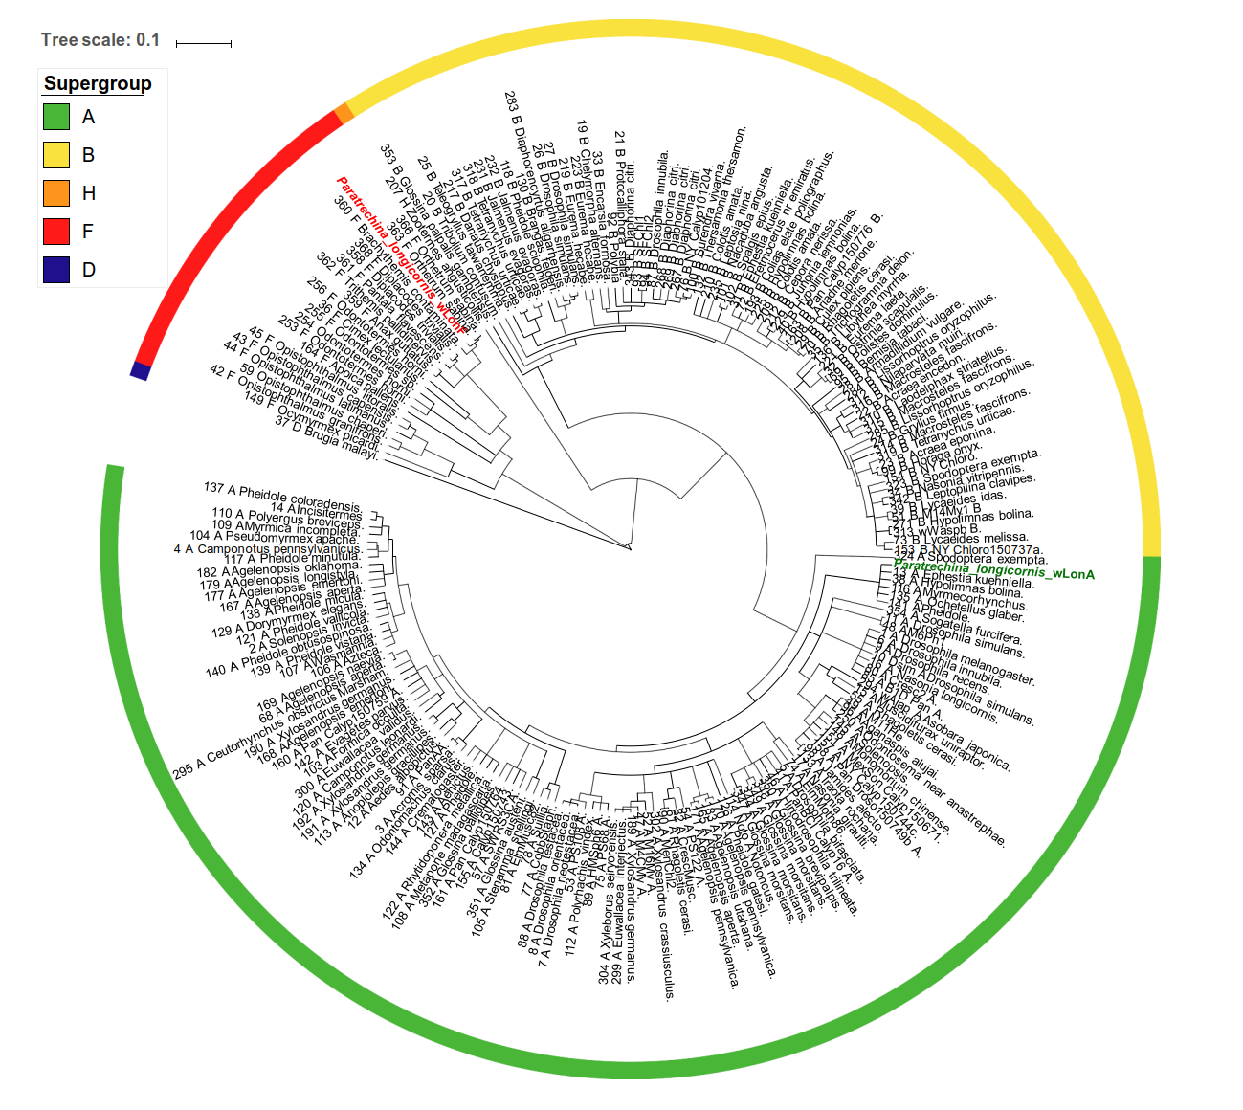
Figure S1 CLonAlFrame genealogy of 5-locus MLST data in Genbank for Wolbachia. The two Wolbachia strains detected in this study are marked in green (wLonA) and red (wLonF). Information regarding host and Wolbachia supergroup is obtained from PubMLST database.
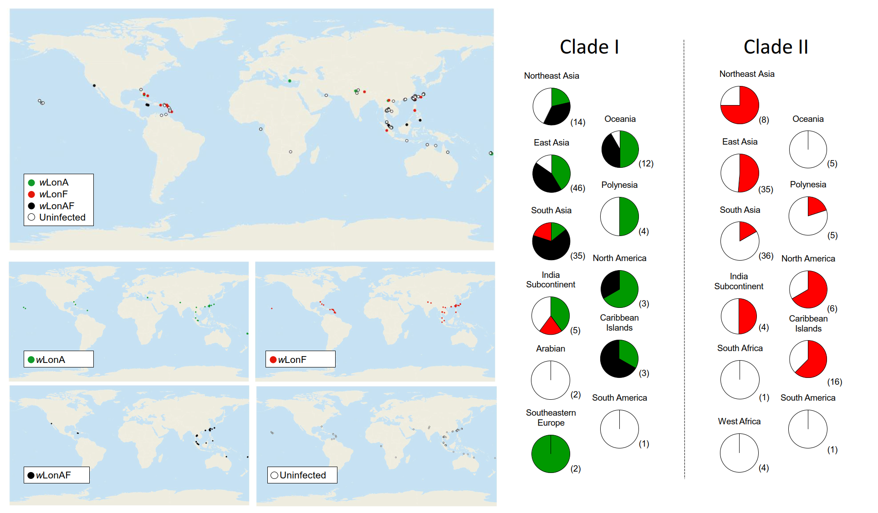
Figure S2 Geographic distribution of Wolbachia infection of Paratrechina longicornis in the study regions. Different colors represent different infection status: wLonA infected (green), wLonF infected (red), wLonA and wLonF co-infection (black), and uninfection (white) individuals. Pie charts show the prevelance of each Wolbachia strain in each geographic region. Sample sizes are shown in parentheses
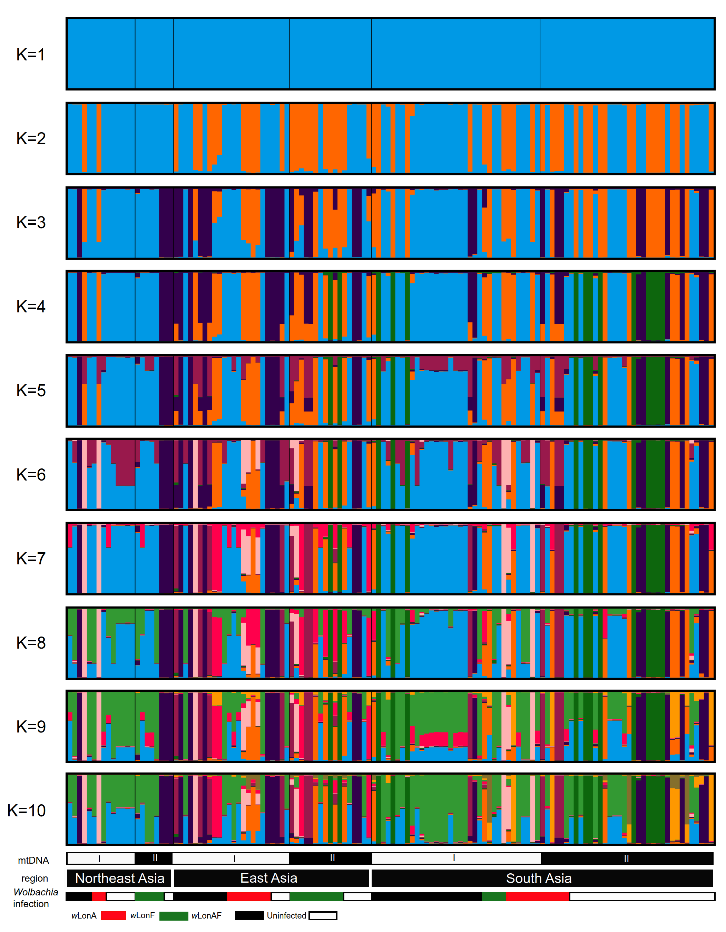
Figure S3 Paratrechina longicornis population clustering analyses from Structure based on 20 microsatellite loci. Results from K=1 to K=10 are shown with the major mode generated by CLUMPAK with the highest mean posterior probability. Samples are organized by mtDNA clade, geographic regions and Wolbachia infection status.

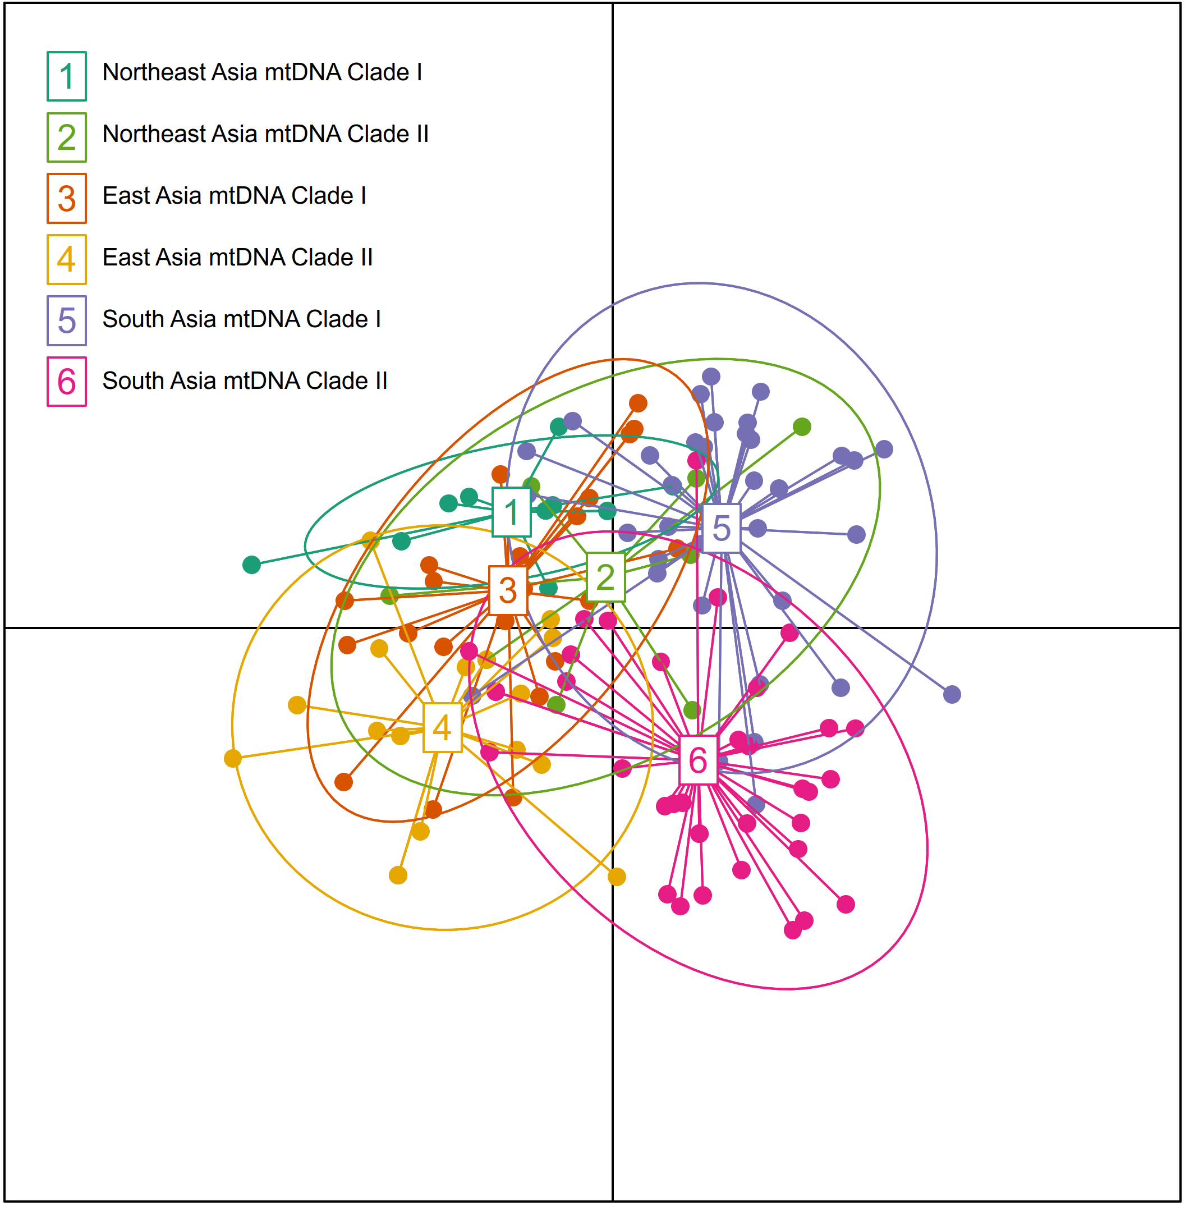
Figure S4 Discriminant analysis of principal components (DAPC) of nuclear DNA variation for Paratrechina longicornis populations from selected Asia regions. Area identities are labelled in the center of the dispersion, while the large open circle indicates the 90% inertia ellipses for each group.

Reference
Degnan, P. H., Lazarus, A. B., Brock, C. D., and Wernegreen, J. J. (2004). Host–symbiont stability and fast evolutionary rates in an ant–bacterium association: cospeciation of Camponotus species and their endosymbionts, Candidatus Blochmannia. Syst. Biol. 53, 95-110.
Kondo, N., Shimada, M., and Fukatsu, T. (1999). High prevalence of Wolbachia in the Azuki Bean Beetle Callosobruchus chinensis (Coleoptera, Bruchidae). Zool. Sci. 16, 955-962.
Molecular Ecology Resources Primer Development C (2011). Permanent Genetic Resources added to Molecular Ecology Resources Database 1 August 2010 – 30 September 2010. Mol. Ecol. Resour. 11, 219-222.
O’Neill, S. L., Giordano, R., Colbert, A. M. E., Karr, T. L., and Robertson, H.M. (1992). 16S rRNA phylogenetic analysis of the bacterial endosymbionts associated with cytoplasmic incompatibility in insects. Proc. Natl. Acad. Sci. U.S.A. 89, 2699-2702.
Tseng, S. P., Darras, H., Lee, C. Y., Yoshimura, T., Keller, L., and Yang, C. C. S. (2019). Isolation and characterization of novel microsatellite markers for a globally distributed invasive ant Paratrechina longicornis (Hymenoptera: Formicidae). Eur. J. Entomol. 116, 253-257. DOI: 10.14411/eje.2019.029
Zhou, W., Rousset, F., and O'Neill, S. (1998). Phylogeny and PCR-based classification of Wolbachia strains using wsp gene sequences. Proc. R. Soc. Lond., B, Biol. Sci. 265, 509–515.

