Supplementary Material
Table S1. Plant species list for each habitat monitored at EAFB for this study, ordered alphabetically. These species are mostly long-lived, perennial species with underground storage being common throughout all taxa. Dispersal ranges a few short meters in some species, anemochory as with some graminoids and asters, to several kilometers, as with legume fruits utilizing zoochory. Clump forming grasses burn primarily above ground all have significant underground storage from which they can resprout following disturbance. Likewise, forbs primarily in the Asteraceae and Fabaceae have large taproots or bulbs that can resprout. All of the pyrophilic hardwoods are capable of resprouting post fire.
Flatwoods | Sandhills
Ageratina aromatica | Andropogon virginicus
Andropogon virginicus | Aristida mohrii
Aristida mohrii | Aristida purpurascens
Aristida purpurAscens | Balduina angustifolia
Aristida stricta | Bulbostylis ciliatifolia
Arundinaria gigantea | Chrysopsis gossypina
Bigelowia nudata | Cnidoscolus stimulosus
Bulbostylis ciliatifolia | Commelina erecta
Carphephorus odoratissimus | Crataegus michauxii
Chamaechrista fasciculata | Croton argyranthemus
Chamaechrista nictitans | Cyperus filiculmis
Chrysopsis gossypina | Cyperus retrorsus
Cnidoscolus stimulosus | Dichanthelium aciculare
Commelina erecta | Dichanthelium acuminatum
Croton argyranthemus | Dichanthelium ovale
Crotalaria purshii | Dichanthelium portoricens
Ctenium aromaticum | Dichanthelium sphaerocarpon
Cyperus filiculmis | Dichanthelium strigosum
Dichanthelium aciculare | Diodia virginiana
Dichanthelium ovale | Eriogonum tomentosum
Dichanthelium portoricens | Euphorbia floridana
Dichanthelium ravenelii | Euthamia caroliniana
Dichanthelium sphaerocarpon | Galactia erecta
Dichanthelium strigosum | Galactia regularis
Diodia teres | Gaylussacia dumosa
Elephantopus elatus | Helianthemum carolinianum
Eriogonum tomentosum | Hieracium gronovii
Euphorbia discoidalis | Houstonia procumbens
Euphorbia floridana | Hypericum gentianoides
Galactia regularis | Hypoxis juncea
Flatwoods (continued) | Sandhills (continued)
Gaylussacia dumosa | Ionactis linariifolia
Gaylussacia frondosa | Lechea sessiliflora
Gelsemium sempervirens | Liatris graminifolia
Helianthus radula | Liatris secunda
Hypericum gentianoides | Liatris tenuifolia
Hypoxis juncea | Licania michauxii
Ilex cassine | Lupinus diffusus
Ilex decidua | Mimosa quadrivalvis
Ilex glabra | Opuntia humifusa
Ilex vomitoria | Paronychia patula
Ionactis linariifolia | Paspalum praecox
Juncus dichotomus | Physalis arenicola
Kalmia hirsuta | Pinus clausa
Lachnocaulon beyrichianum | Pinus palustris
Lechea sessiliflora | Pityopsis aspera
Lespedeza repens | Pityopsis graminifolia
Liatris elegans | Polygonella gracilis
Liatris graminifolia | Polygala polygama
Liatris tenuifolia | Polygala polygama
Licania michauxii | Pteridium aquilinum
Mimosa quadrivalvis | Quercus geminata
Myrica cerifera | Quercus incana
Opuntia humifusa | Quercus laevis
Paspalum praecox | Rhexia mariana
Pinus elliottii | Rhus copallinum
Pinus palustris | Rhynchosia cytisoides
Pityopsis aspera | Rhynchospora grayi
Pityopsis graminifolia | Rubus cuneifolius
Pityopsis oligantha | Schizachyrium scoparium
Polygonella gracilis | Schizachyrium tenerum
Polygala nana | Scleria ciliata
Polygala polygama | Scleria triglomerata
Polypremum procumbens | Serenoa repens
Quercus incana | Smilax auriculata
Quercus minima | Smilax bona-nox
Rhexia alifanus | Solidago odora
Rhexia lutea | Sorghastrum secundum
Rhynchospora baldwinii | Sporobolus junceus
Rhynchosia cytisoides | Stylosanthes biflora
Rhynchospora grayi | Stylisma patens
Flatwoods (continued) | Sandhills (continued)
Rubus cuneifolius | Tephrosia chrysophylla
Schizachyrium scoparium | Tephrosia virginiana
Schizachyrium tenerum | Tradescantia hirsutiflora
Scleria ciliata | Tragia smallii
Scleria triglomerata | Tragia urens
Serenoa repens | Vaccinium arboreum
Seymeria cassioides | Vaccinium darrowii
Smilax auriculata
Smilax laurifolia
Smilax smallii
Solidago odora
Sorghastrum secundum
Stylosanthes biflora
Stylisma patens
Symphyotrichum dumosum
Tephrosia chrysophylla
Tephrosia florida
Tephrosia hispidula
Tephrosia virginiana
Tragia smallii
Tragia urens
Vaccinium corymbosum
Vaccinium darrowii
Vernonia angustifolia
Viola palmata
Xyris brevifolia
Xyris caroliniana
Xyris elliottii

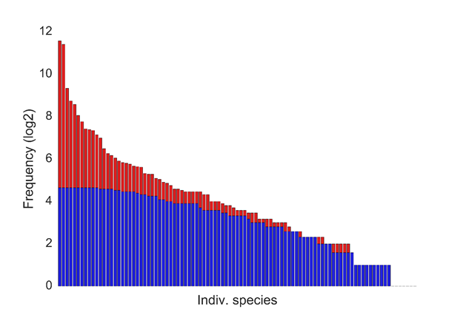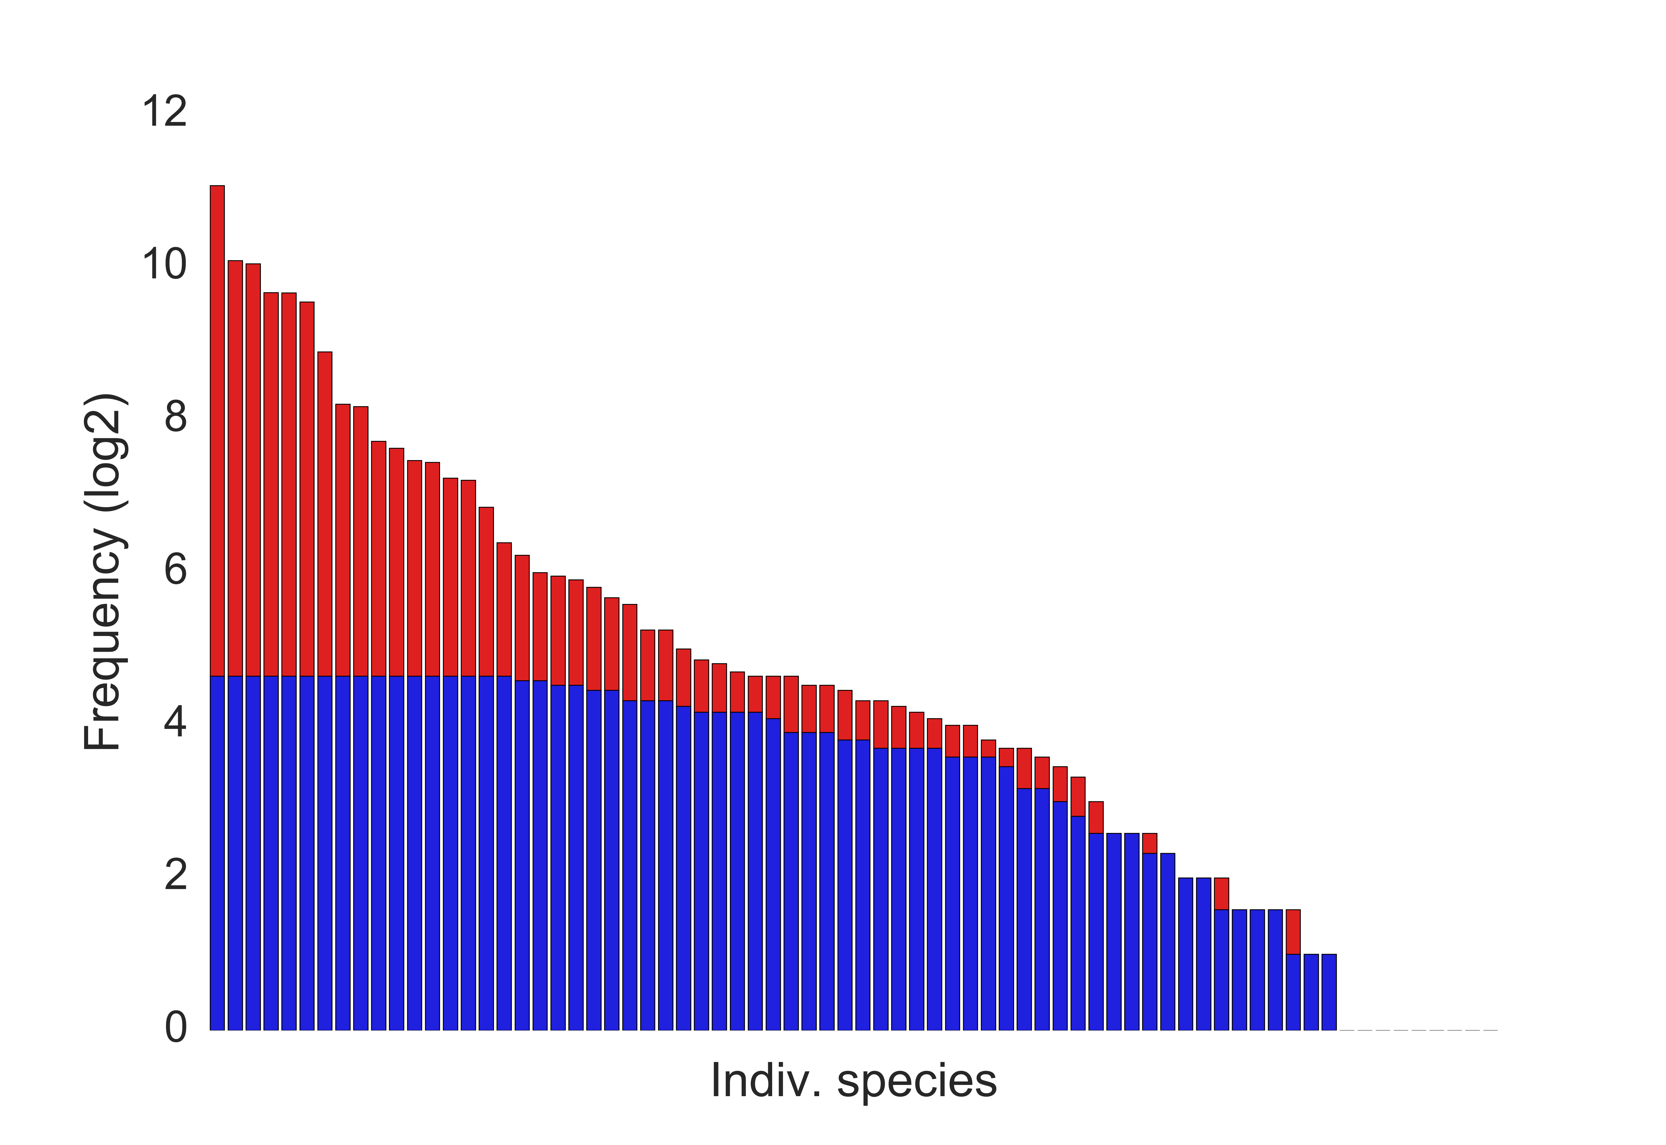

Figure S1. Example input frequency distribution in log₂ scale based on scaling the input data by coarsening the 10 cm x 10 cm data. Red: original resolution. Blue: scaled to 200 cm x 200 cm. Flatwoods distribution on the left; Sandhills on the right.

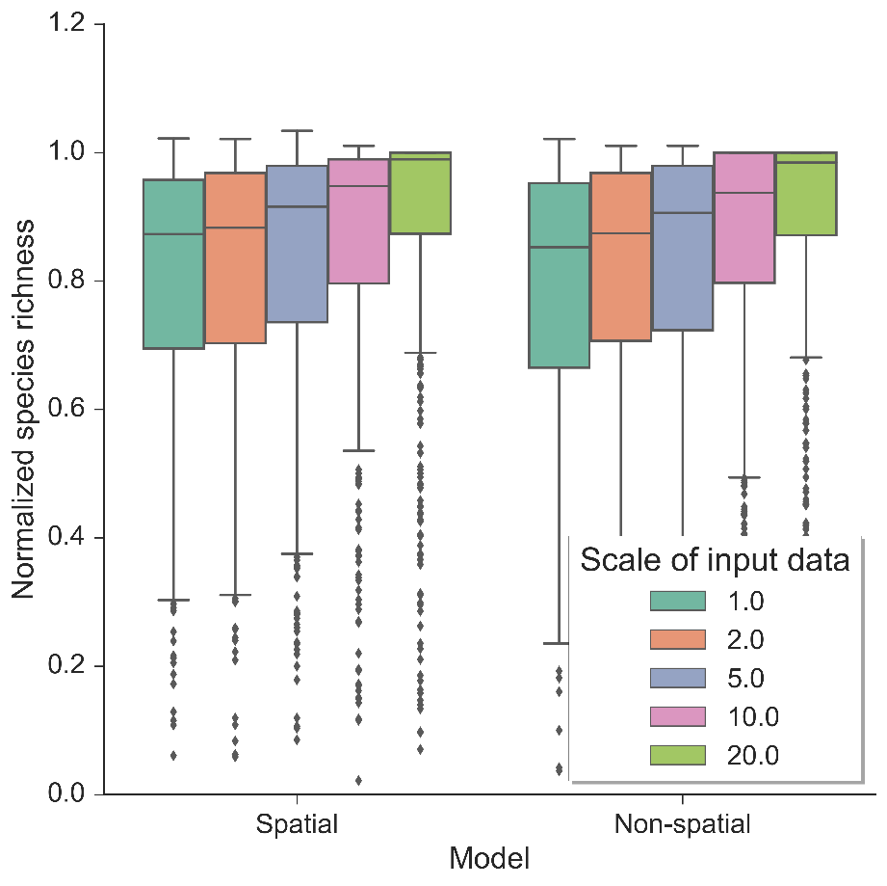
Figure S2. Normalized species richness of the autonomous agent model at various scales. Normalized species richness is the species richness change from time zero compared to the last time step (year 50) of each model run using the flatwoods habitat data. Normalized species richness is illustrated between scales of input data and spatial vs. non-spatial dispersal models.

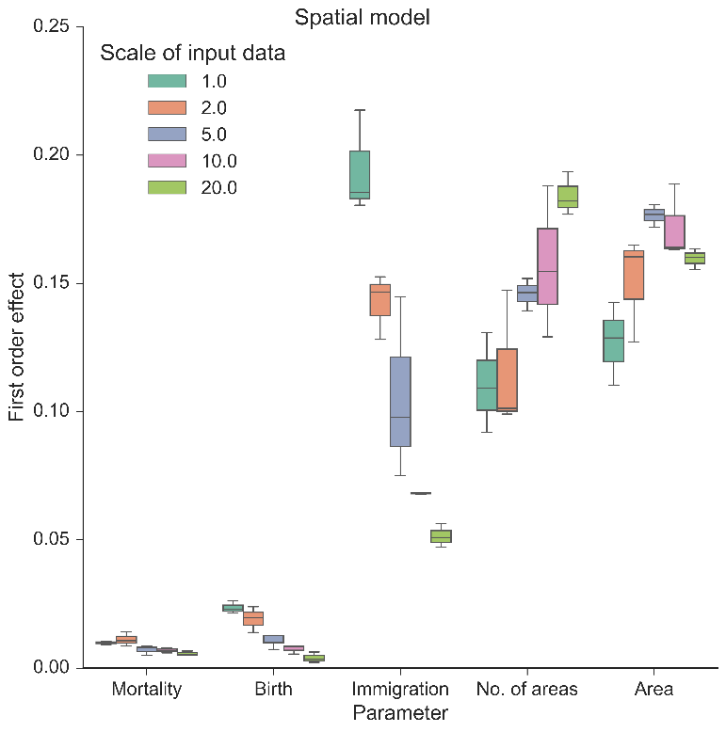 A.
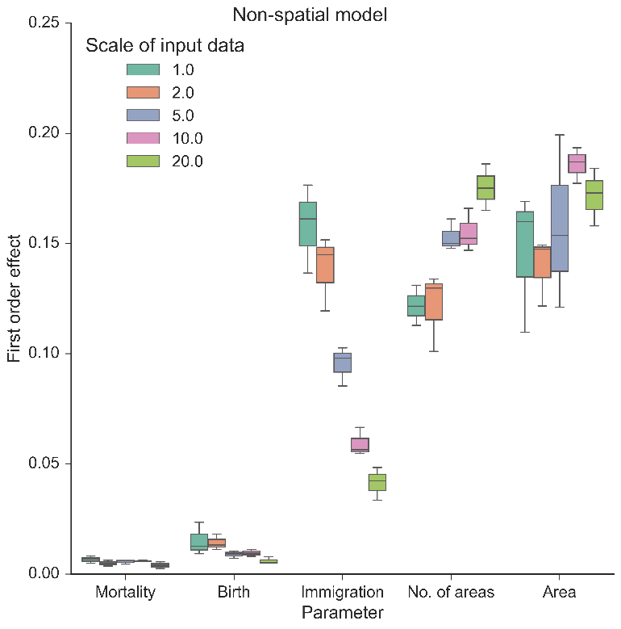 B.
Figure S3. First order (%) effect of the three neutral parameters (mortality, birth, and immigration) and spatial boundary parameters (area and number of areas) on simulated normalized richness using different scales of input data in the flatwoods habitat using the spatial model (A.) and non-spatial model (B.). The legend illustrates the resolution (in dm) in which the data was created from the empirical data, including the original resolution of the data (1.0: 10 cm x 10 cm). Boxplots represent variance across three replicates of the model run using 500 FAST parameter combinations.

