SUPPLEMENTARY MATERIAL
SUPPLEMENTARY TABLE S1: Frequency distribution of CNAs in B-ALL and T-ALL cases
 |  |  | B-ALL (n=121) |  | T-ALL (n=27)
S.No. | Gene ID | Chr | LOSS  Cases (%) | GAIN  Cases (%) | LOSS  Cases (%) | GAIN  Cases (%)
1 | TAL1 | 1 | 0 | 0 | 5 (18.5%) | 0
2 | STIL | 1 | 0 | 0 | 5 (18.5%) | 0
3 | IKZF2 | 2 | 1 (0.8%) | 0 | 0 | 0
4 | FHIT | 3 | 0 | 1 (0.8%) | 0 | 0
5 | CD200 | 3 | 5 (4%) | 1 (0.8%) | 0 | 0
6 | BTLA | 3 | 7 (5.8%) | 1 (0.8%) | 0 | 0
7 | TBL1XR1 | 3 | 10 (8.3%) | 1 (0.8%) | 1 (~4%) | 0
8 | LEF1 | 4 | 2 (1.7%) | 12 (9.9%) | 1 (~4%) | 2 (7.4%)
9 | NR3C2 | 4 | 3 (2.5%) | 14 (12%) | 0 | 1 (~4%)
10 | NR3C1 | 5 | 2 (1.7%) | 7 (5.8%) | 0 | 0
11 | PDGFRB | 5 | 2 (1.7%) | 7 (5.8%) | 0 | 0
12 | EBF1 | 5 | 5 (4%) | 7 (5.8%) | 1 (~4%) | 0
13 | CASP8AP2 | 6 | 6 (5%) | 18 (15%) | 3 (11%) | 2 (7.4%)
14 | MYB | 6 | 2 (1.7%) | 19 (16%) | 0 | 3 (11%)
15 | IKZF1 | 7 | 27 (22%) | 3 (2.5%) | 2 (7.4%) | 0
16 | EPHA1 | 7 | 4 (3.3%) | 3 (2.5%) | 2 (7.4%) | 0
17 | EZH2 | 7 | 4 (3.3%) | 4 (3.3%) | 1 (~4%) | 1 (~4%)
18 | TOX | 8 | 0 | 10 (8.3%) | 1 (~4%) | 0
19 | JAK2 | 9 | 10 (8.3%) | 2 (1.7%) | 4 (~15%) | 0
20 | MLLT3 | 9 | 17 (14%) | 1 (0.8%) | 4 (15%) | 0
21 | MTAP | 9 | 17 (14%) | 1 (0.8%) | 9 (33.3%) | 0
22 | CDKN2A | 9 | 27 (22%) | 2 (1.7%) | 16 (59%) | 0
23 | CDKN2B | 9 | 27 (22%) | 2 (1.7%) | 16 (59%) | 0
24 | PAX5 | 9 | 23 (19%) | 3 (2.5%) | 3 (11%) | 0
25 | ABL1 | 9 | 0 | 2 (1.7%) | 0 | 2 (7.4%)
26 | NUP214 | 9 | 0 | 2 (1.7%) | 0 | 2 (7.4%)
27 | NOTCH1 | 9 | 0 | 4 (3.3%) | 0 | 1 (~4%)
28 | PTEN | 10 | 0 | 23 (19%) | 4 (14.8%) | 0
29 | ADD3 | 10 | 1 (0.8%) | 8 (6.6%) | 0 | 0
30 | LMO1 | 11 | 0 | 4 (3.3%) | 0 | 0
31 | LMO2 | 11 | 0 | 5 (4%) | 0 | 0
32 | CD44 | 11 | 0 | 1 (0.8%) | 0 | 1 (~4%)
33 | RAG2 | 11 | 2 (1.7%) | 6 (5%) | 0 | 0
34 | ETV6 | 12 | 17 (14%) | 2 (1.7%) | 0 | 0
35 | BTG1 | 12 | 8 (6.6%) | 4 (3.3%) | 0 | 0
36 | RB1 | 13 | 5 (4%) | 0 | 0 | 0
37 | IGHM | 14 | 11 (9%) | 20 (16.5%) | 0 | 0
38 | SPRED1 | 15 | 0 | 2 (1.7%) | 0 | 0
39 | CREBBP | 16 | 1 (0.8%) | 2 (1.7%) | 0 | 0
40 | CTCF | 16 | 6 (5%) | 1 (0.8%) | 0 | 0
41 | TP53 | 17 | 6 (5%) | 21 (17%) | 0 | 0
42 | NF1 | 17 | 0 | 18 (15%) | 2 (7.4%) | 0
43 | SUZ12 | 17 | 3 (2.5%) | 18 (15%) | 2 (7.4%) | 0
44 | IKZF3 | 17 | 1 (0.8%) | 17 14%) | 0 | 1 (~4%)
45 | PTPN2 | 18 | 0 | 9 (7.4%) | 0 | 0
46 | ERG | 21 | 5 (4%) | 37 (30.6%) | 0 | 1 (~4%)
47 | RUNX1 | 21 | 2 (1.7%) | 39 (32.2%) | 0 | 1 (~4%)
48 | VPREB1 | 22 | 22 (18%) | 3 (2.5%) | 0 | 0
49 | IGLL1 | 22 | 2 (1.7%) | 0 | 0 | 0
50 | PAR1 | X | 2 (1.7%) | 23 (19%) | 2 (7.4%) | 0
51 | CRLF2 | X | 1 (0.8%) | 19 (15.7%) | 2 (7.4%) | 0
52 | CSF2RA | X | 1 (0.8%) | 19 (15.7%) | 2 (7.4%) | 0
53 | IL3RA | X | 1 (0.8%) | 19 (15.7%) | 2 (7.4%) | 0
54 | P2RY8 | X | 1 (0.8%) | 19 (15.7%) | 2 (7.4%) | 0
55 | DMD | X | 1 (0.8%) | 16 (13.2%) | 0 | 0
56 | PHF6 | X | 0 | 24 (19.8%) | 1 (~4%) | 1 (~4%)

SUPPLEMENTARY TABLE S2: Cases with Hyperdiploidy status (>51 chromosomes) analyzed by dMLPA (n=19)
I.D. | Hyperdiploidy (Non-random chromosomal Gain) | Karyotyping | CNAs  Gene Deletions
ID52 | 6, 14, 16, 17, 18, 21, X | 53XY,+X,+6,+13,+14 | CTCF
ID53 | 4, 6, 10, 14, 17, 18, 21, X | NA | CDKN2A/B
ID54 | 4, 6, 14, 17,18, 21, X | HYPERDIPLOID
ID55 | 4, 6, 10, 14, 17, 21, X | NA
ID56 | 4, 10, 14, 17, 18, 21, X | FAILED | ETV6
ID57 | 1, 4, 6, 10, 14, 17, 18, 21, X | NA
ID58 | 8, 10, 18, 19, 21, 22, X | NA | IKZF1
ID59 | +6, 10, 14, 21, XX | NA
ID60 | 6, 8, 10, 14, 18, 21, X | NA
ID61 | 6, 10, 14, 17, 18, 21, X | NA
ID62 | 4, 6, 8, 10, 17, 18, 21, X | FAILED
ID63 | 4, 6, 8, 14, 17, 18, 21, X | NA | TBL1XR1, ERG, VPREB1
ID64 | 5, 6, 10, 14, 17, 18, 21, X | NA
ID65 | 6, 7, 17, 18, 21, X | FAILED | CDKN2A/B, MTAP
ID66 | 6, 8, 14, 21, XX | 52XX,+6,+8
ID67 | 4,7,8, 10, 14, 17, 18, 21, X | NA | CASP8AP2
ID68 | 10, 14, 17, 21, X | NA
ID69 | 4, 6, 14, 17, 18, 21, X | NA
ID70 | 6, 10, 21, XX | NA | RAG2

SUPPLEMENTARY TABLE S3: Concordance between dMLPA and conventional MLPA
 | dMLPA | P202+P335  (n=61) | P327 (n=35) | P383 (n=20)
EBF1 | 6 | 6 | - | -
IKZF1 | 17 | 17 | - | -
JAK2 | 4 | 4 | - | -
CDKN2A | 34 | 24 | - | 8
CDKN2B | 24 | 17 | - | 6
PAX5 | 18 | 18 | - | -
ETV6 | 11 | 11 | - | -
BTG1 | 3 | 3 | - | -
RB1 | 2 | 3 | - | -
IGHM | 2 | 1 | - | -
PAR1 | 1 | 2 | - | -
CRLF2 | 1 | 2 | - | -
CSF2RA | 3 | 4 | - | -
IL3RA | 4 | 6 | - | -
P2RY8 | 2 | 3 | - | -
ERG | 34 | - | 34 | -
RUNX1 | 35 | - | 34 | -
TAL1 | 4 | - | - | 4
STIL | 4 | - | - | 4
LEF1 | 2 | - | - | 2
CASP8AP2 | 4 | - | - | 4
EZH2 | 1 | - | - | 3
MLLT3 | 5 | - | - | 5
MTAP | 7 | - | - | 7
ABL1 | 2 | - | - | 2
NUP214 | 2 | - | - | 2
PTEN | 1 | - | - | 1
CD44 | 1 | - | - | 1
NF1 | 2 | - | - | 2
SUZ12 | 2 | - | - | 2
PHF6 | 8 | - | - | 8

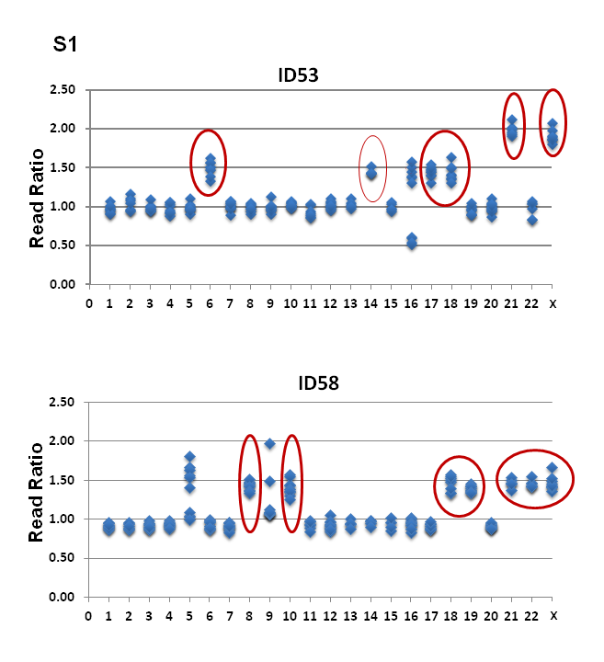

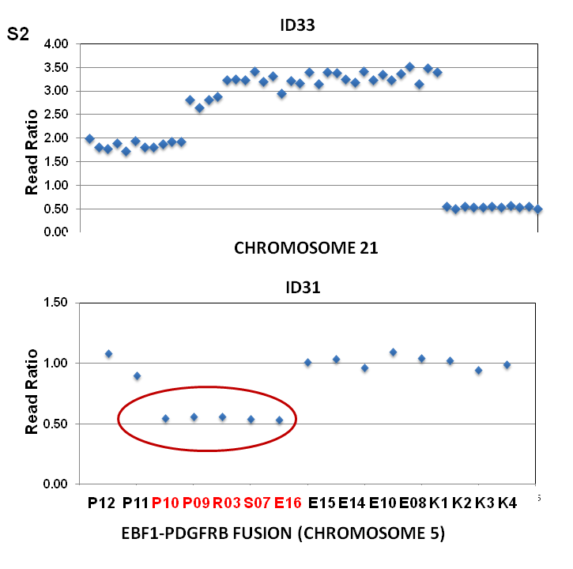

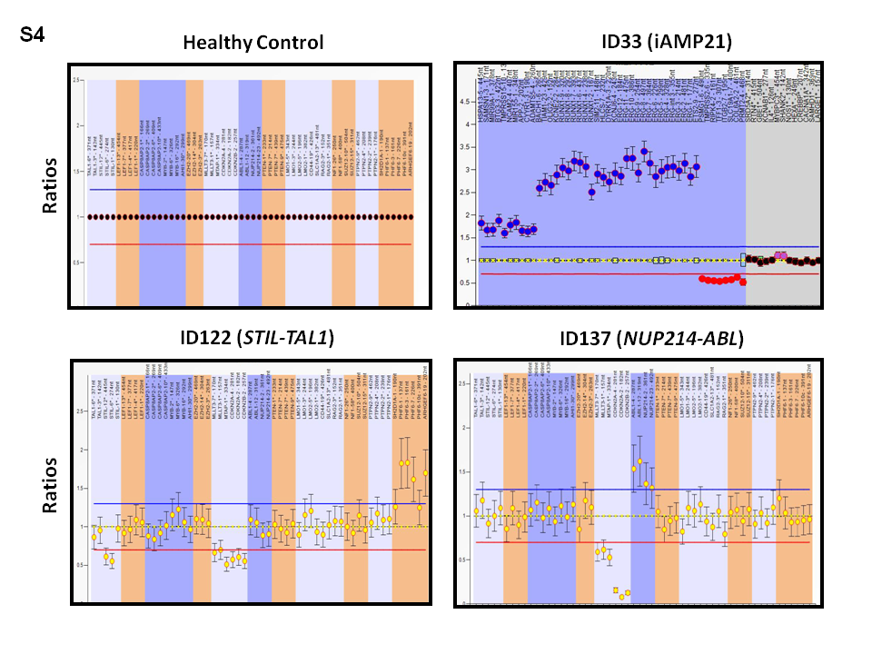

Supplementary Figure Legends:
SUPPLEMENTARY FIGURE S1: Hyperdiploidy status identified in B-ALL samples by dMLPA. (A) A representative B-ALL case showing gain of 1 copy of chromosome 6, 14, 17 and 18 and gain of 2 copies of chromosomes 21 and X highlighted by red circles. (B) Gain of single copy of chromosome 8, 10, 18, 19, 21, 22 and X shown in a representative case. The y-axis represents read ratios relative to the reference samples and x-axis shows the chromosome number.

SUPPLEMENTARY FIGURE S2: Plot showing iAMP21 amplification in a representative sample (top panel). Intrachromosomal gene fusion EBF1-PDGFRB detected by dMLPA showing read ratios on y-axis and region of exon deletions (bottom panel). Red circle highlights the deleted exons as a result of fusion between Exon 9 of PDGFRB and exon 16 of EBF1. The y-axis represents read ratios relative to the reference samples and x-axis shows the probes represented by each dot.

SUPPLEMENTARY FIGURE S3: (A) Plot showing intrachromosomal fusion of STIL-TAL1 in 5 cases (B) Plot showing NUP214-ABL1 amplification in two cases of T-ALL. Red circle highlights the deleted exons. The y-axis represents read ratios relative to the reference samples and x-axis shows the probes represented by each dot.

SUPPLEMENTARY FIGURE S4: Validation of dMLPA data by conventional MLPA. Representative plot showing read ratios in a reference sample (Top left panel). Plot showing read ratios of iAMP21 amplification (Top right panel). STIL-TAL1 intrachromosomal fusion and deletions in MLLT3, MTAP and CDKN2A detected by MLPA P383 probemix (Bottom left panel). ID122 is the same as ID1 in T-ALL heat map (Figure 5). NUP214-ABL1 amplification detected by standard MLPA (Bottom right panel). ID137 is the same sample as ID16 in T-ALL heat map (Figure 5).

