Supplementary Material

1. Study Site: Southern Java (Indonesia)

1.1 Site description
The study was carried out in the coastal area of the Gunung Sewu karst region, which stretches along the southern central coast of Java (Indonesia). The area has a warm and moist tropical monsoon climate with a mean annual temperature of 27 °C, a high humidity of ~80%, and an annual precipitation of around 2000 mm (Flathe and Pfeiffer 1965; Haryono and Day 2004). In general, the rainy season lasts from November to April with precipitation rates of about 150-350 mm per month. The dry season lasts from May to October with precipitation rates of about 24-150 mm per month (Brunsch et al. 2011).
Morphologically, the area is known for its cone-karst hills, which are in a mature stadium. Two different types of limestones (bioclastic and reef) dominate in the region. These limestones are either karstified and physically hard, or chalky/chalichic and soft. In general, the limestone formation gently dips southward towards the Indian Ocean. Towards the hinterland mountains which consist of sediments and volcanic deposits occur (Oehler et al. 2018). At the coast strongly karstified massive coral reef-limestone, with intercalated clay and volcanic ash lenses predominantly occur (van Bemmelen 1949; Flathe and Pfeiffer 1965; Waltham et al. 1983; Haryono and Day 2004). The coastline consists of cliffs with heights of 25 to 100 m (Haryono and Day 2004), which are frequently disrupted by several hundred of meter wide bays. Similar to other karstic areas, there is negligible surface runoff (except in cases of torrential runoff) and ephemeral streams, because rainfall directly penetrates in the ground. Coastal and submarine freshwater springs can be observed all along the coast, which are fed by perennial underground rivers (Kusumayudha et al. 2000). A very steep bathymetry leads to very strong and dangerous rip currents. The detailed site under study is a small embayment at the Gunung Sewu coastline which has a surface area of ~24,000 m² and an average water depth of about 1-2 m. The embayment receives groundwater from a submarine spring and has one connection to the open sea (supplementary Figure A).

1.2 Water sampling & analyses
Sampling campaigns were carried out in November 2015 before the wet season and in April 2016 at the end of the wet season. Coastal and offshore water sampling was conducted from small fishing boats or via snorkeling directly at the beach. Water samples for DSi and salinity measurements were further collected close to the submarine spring and within the center of the embayment over a tidal cycle. The water level was simultaneously measured using a Hobo water level logger (HOBO U20L) which was deployed at the seafloor. Several known coastal and intertidal springs were sampled for groundwater endmembers along the coastline (supplementary Figure A).
For radium analyses about 100 liters of seawater and 20 L of groundwater were sampled and processed at the beach based on the procedure described in Moore and Reid (1973). Water samples for radium were filtered at <1 L min⁻¹ through 15 g of MnO₂ impregnated acrylic fibers to quantitatively extract the radium isotopes (Moore et al. 1995). After processing the MnO₂ fiber was immediately sent to a laboratory in Germany (Oldenburg) for analysis.
Once in the lab the fibers were rinsed with tap water and partially dried with compressed air until the water to fiber ratio was 1:1 (Sun and Torgersen 1998). The samples were then measured using a Radium Delayed Coincidence Counter (RaDeCC) in order to determine ²²⁴Ra (T_{1/2}=3.66 days) (Moore and Arnold 1996) and ²²⁶Ra (T_{1/2}=1622 years) (Waska et al. 2008). Four weeks after sampling, samples were re-counted to obtain ²²⁸Th activity for excess ²²⁴Ra determination (herein referred to as ²²⁴Ra_{ex}) (Garcia-Solsona et al. 2008). DSi samples were filtered with cellulose acetate filters (pore size 0.45 µm) in the field, poisoned with HgCl₂ and stored on ice until analysis using standard photometrical methods (Grasshoff et al. 2009). Salinity was measured in the field using a handheld salinity meter (WTWTM TetraCon 925-P).

1.3 Calculations
The residence time of the coastal water in the embayment was calculated based on a tidal prism approach after Sanford et al. (1992):
$Tf=\frac{V*T}{(1-b)*P}$ (eq. 3)
where Tf is the residence time (in days), V the volume of the embayment (in m³), T is the tidal period (in days), b is the return flow factor (no unit) and P is the tidal prism (m³). V is calculated as the average water depth multiplied by the surface area of the embayment, and P is the tidal range multiplied by the surface area. The return flow factor b can be calculated with equation 4 (Moore et al. 2006):
$b=\frac{(c_{f}-c_{sw})}{(c_{e}-c_{sw})}$ (eq. 4)
with c_{f} as the concentration of a tracer during flood tide, c_{SW} as the concentration of a tracer in seawater, and c_{e} as the concentration of a tracer during ebb tide. We used time series data of DSi to calculate the return flow factor.
SGD fluxes were calculated based on a simple mass balance approach with
$SGD=\frac{V}{Tf}*\frac{c_{coast}-c_{sw}}{c_{endmember}}$ (eq. 5)
Where c_{coast} is the average concentration of a tracer in the coastal water and c_{endmember} is the endmember concentration of a tracer in groundwater. This calculation assumes that DSi behaves conservatively. Dividing eq. 5 by the area under study leads to a SGD velocity (typically in cm day⁻¹), which is commonly used in SGD studies.

Study Site Spiekeroog (North Sea)

2.1 Site description
The Wadden Sea is the largest tidal flat system in the temperate world stretching for almost 500 km along the Dutch, German and Danish North Sea coast. Due to its outstanding natural value, the Wadden Sea has been inscribed to the World Heritage List in 2009 and often serves as a worldwide reference for comparisons with other tidal flat systems. The area has a temperate climate with a mean annual temperature of 10°C and an annual precipitation of around 760 mm (DWD German weather service). In the southern part, the tidal flat area is bordered by the coastline and a chain of barrier islands which is located some kilometers offshore. The semi-enclosed area belonging to one barrier island is called tidal basin. Tidal inlets between the barrier islands enable water exchange between the tidal basins and the North Sea. The tidal basins are composed of sand, mixed, and mud flats, which are subdivided according to their proportions of sand and clay (Flemming 2000).
The study was carried out in the tidal basin of Spiekeroog Island, NW Germany, which is affected by semi diurnal tides and an average tidal range of 2.6 m (Flemming and Davies Jr. 1994). The intertidal area covers about 80% of the tidal basin (Stanev et al. 2003), i.e. large parts of the tidal flat area are exposed for approximately 6 hours during low tide. Tidal flat margins slope towards tidal channels initiating submarine groundwater flow from tidal flat sediments to channel waters around low tide (Riedel et al. 2010). Therefore, a sizeable fraction of up to 1% of the water in the tidal basin at low tide is groundwater derived from the adjacent tidal flats (Moore et al. 2011).

2.2 Sample collection and analyses
A permanently installed time series station is monitoring DSi in the tidal inlet of Spiekeroog Island since 2006 (Grunwald et al. 2007). Continuous DSi measurements have been performed in surface waters using Micromac 1000 (2006-2012) or Micromac C (2012-2017) analyzers (Systea, Italy). The hourly measuring interval enables to resolve seasonal as well as tidal dynamics. Accuracy of the analyses is controlled by measurements in the laboratory using samples taken at the time series station every two weeks.
Discrete Ra and DSi samples were taken close to the time series station using RV Senckenberg in September 2015, November 2017, and May 2018 to resolve tidal dynamics. DSi samples were filtered through 0.45 µm surfactant-free cellulose acetate syringe filters, filled into ultrapure water and sample rinsed high-density polyethylene vials, and poisoned with HgCl₂ to obtain a final concentration of 0.01% (v/v). Afterwards the samples were stored cool and dark. DSi was analyzed photometrically after Grasshoff et al. (1999).
For each Ra sample a volume of 40 L was collected. Subsequently, all samples were filtered (~1 L min⁻¹) through columns filled with synthetic filter floss to retain particles as well as 14 g manganese dioxide coated acrylic fiber to quantitatively adsorb dissolved Ra (Moore 1976). Prior to analysis with Radium Delayed Coincidence Counters (RaDeCC) (Moore and Arnold 1996), the fibers were rinsed with tap water to remove sea salt and particles (Sun and Torgersen 1998) and then dried to a water-to-dry-weight fiber ratio of one. ²²⁴Ra measurements were performed using the procedure by Garcia-Solsona et al. (2008) and references therein. The ²²⁴Ra system efficiency was monitored on a regular basis with two standard samples prepared from an aged ²³²Th solution. The trueness was better than 5 % and the precision better than 8 % based on repeated standard measurements. The standard reference activities were initially cross-checked with other standards (kindly provided by M. Rutgers v. d. Loeff, Alfred Wegener Institute, Bremerhaven and Jan Scholten, University of Kiel) by repeated measurements on the same RaDeCC systems. After one month, the fibers were counted again to measure ²²⁸Th adsorbed onto particles, the radiogenic precursor of ²²⁴Ra. The ²²⁸Th activity was subtracted from the ²²⁴Ra activity to obtain the unsupported excess ²²⁴Ra_{ex} activity.

Supplementary Figures and Tables
Supplementary Table A: Salinity, DSi, ²²⁴Ra_{ex,} ²²³Ra, ²²⁶Ra and ²²⁸Ra samples of springs, coastal water and seawater at Pantai Ngrenehean (southern Java, Indonesia)
 | Station | Date | Latitude | Longitude | Salinity | DSi  (µM) |  | ²²⁴Ra_{ex}  (dpm 100L⁻¹) |  |  | ²²³Ra  (dpm 100L⁻¹) | ²²⁶Ra  (dpm 100L⁻¹) |  | ²²⁸Ra  (dpm 100L⁻¹)
Karstic springs | Spring 1 | Apr 16 | -8.1284 | 110.5482 | 0.20 | 335.3 | 10.3 |  |  |  | 0.5 | 39.8 | 71.2
 | Spring 2 | Apr 16 | -8.1399 | 110.5821 | 3.19 | 349.8 | 38.7 |  |  |  | 9.2 | 12.5 | 4.3
 | Spring 3 | Apr 16 | -8.1196 | 110.5053 | 0.24 | 423.3
 | Spring 4 | Nov 15 | -8.1284 | 110.5482 | 0.25 | 407.9
 | Spring 5 | Nov 15 | -8.1399 | 110.5821 | 4.39 | 326.6
 | Spring 6 | Nov 15 | -8.1399 | 110.5821 | 9.64 | 273.9 | 27.2 |  |  |  | 3.9 | 17.6 | 4.2
 | Spring 7 | Nov 15 | -8.1196 | 110.5053 | 0.34 | 324.6
 | Spring 8 | Apr 16 | -8.1219 | 110.5143 | 11.27 | 202.1
Coastal water & seawater | CW 1 | Apr 16 | -8.1249 | 110.5130 | 29.77 | 32.4 | 5.3 |  |  |  | 0.2 | 9.2 | 11.2
 | CW 2 | Apr 16 | -8.1232 | 110.5136 | 28.51 | 70.2 | 8.9 |  |  |  | 0.2 | 9.8 | 9.2
 | CW 3 | Apr 16 | -8.1219 | 110.5139 | 23.69 | 79.2 | 10.2 |  |  |  | 0.5 | 11.6 | 6.9
 | CW 4 | Apr 16 | -8.1216 | 110.5140 | 24.56 | 59.7 | 11.5 |  |  |  | 0.6 | 11.1 | 5.1
 | CW 5 | Apr 16 | -8.1217 | 110.5143 | 24.41 | 68.3 | 11.6 |  |  |  | 0.6 | 11.3 | 3.9
 | CW 6 | Apr 16 | -8.1215 | 110.5146 | 21.97 | 87.8 | 14.1 |  |  |  | 0.5 | 14.9 | 3.4
 | CW 7 | Apr 16 | -8.1242 | 110.5138 | 28.13 | 27.5 | 9.0 |  |  |  | 0.4 | 10.2 | 8.6
 | CW 8 | Apr 16 | -8.1216 | 110.5142 | 19.84 | 108.1 | 10.0 |  |  |  | 0.5 | 13.0 | 3.8
 | CW 9 | Apr 16 | -8.1214 | 110.5139 | 17.99 | 123.5 | 16.3 |  |  |  | 0.8 | 13.3 | 4.1
 | CW 10 | Apr 16 | -8.1219 | 110.5143 | 23.64 | 72.8 | 12.8 |  |  |  | 0.3 | 11.9 | 3.0
 | CW 11 | Nov 15 | -8.1211 | 110.5138 | 21.73 | 102.8 | 13.1 |  |  |  | 0.6 | 21.9 | 3.1
 | CW 12 | Nov 15 | -8.1231 | 110.5137 | 30.09 | 64.7 | 9.0 |  |  |  | 0.3 | 16.4 | 2.8
 | CW 13 | Nov 15 | -8.1219 | 110.5143 | 23.09 | 82.7 | 6.6 |  |  |  | 0.4 | 23.7 | 2.2
 | CW 15 | Nov 15 | -8.1270 | 110.5118 | 31.91 | 9.0 | 7.8 |  |  |  | 0.3 | 16.3 | 2.9
 | SW 1 | Nov 15 | -8.1264 | 110.5149 | 32.40 | 8.5 | 3.3 |  |  |  | 0.2 | 14.6 | 3.8

Supplementary Table B: Time series data of salinity and DSi taken in the coastal water of the embayment of Pantai Ngrenehean (southern Java, Indonesia)
Station | Date (UTC) | Time (UTC) | Water  level (m) | Salinity | DSi  (µM)
Spring 1.1 | 25.04.2016 | 03:48 | 3.49 | 23.6 | 72.8
Spring 1.2 | 25.04.2016 | 10:00 | 1.81 | 11.3 | 202.1
Spring 1.3 | 26.04.2016 | 02:00 | 3.49 | 23.3 | 86.6
Spring 1.4 | 26.04.2016 | 03:00 | 3.23 | 25.5 | 59.2
Spring 1.5 | 26.04.2016 | 04:30 | 3.68 | 23.6 | 77.4
Spring 1.6 | 26.04.2016 | 07:30 | 2.37 | 20.9 | 105.1
Spring 1.7 | 26.04.2016 | 09:00 | 2.20 | 18.2 | 143.6
Coast 1.1 | 26.04.2016 | 02:00 | 3.49 | 23.6 | 73.8
Coast 1.2 | 26.04.2016 | 03:00 | 3.23 | 24.2 | 68.9
Coast 1.3 | 26.04.2016 | 04:30 | 3.68 | 24.5 | 65.4
Coast 1.4 | 26.04.2016 | 06:00 | 3.00 | 23.4 | 83.2
Coast 1.5 | 26.04.2016 | 07:30 | 2.37 | 21.7 | 91.6
Coast 1.6 | 26.04.2016 | 09:00 | 2.20 | 17.9 | 139.4

Supplementary Figures
Supplementary Figure A. Sampling sites for coastal surface water (dots), seawater (square) and coastal, intertidal and submarine springs (diamonds) in southern Java. In the upper right panel all springs which were sampled along the coastline are shown.
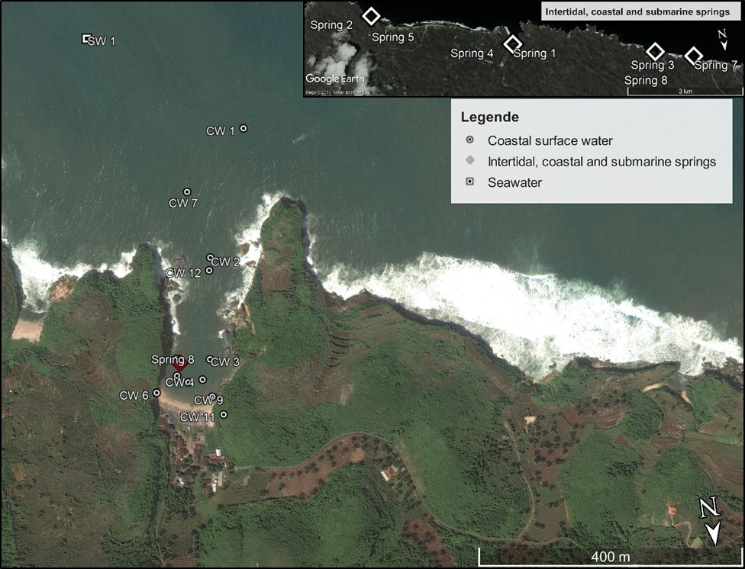

References
van Bemmelen, R. 1949. Geological evolution of the physiographic units-Java Vol IA, p. 554–559. In The geology of Indonesia. Government Printing Office.
Brunsch, A., T. N. Adji, D. Stoffel, M. Ikhwan, P. Oberle, and F. Nestmann. 2011. Hydrological assessment of a karst area in southern Java with respect to climate phenomena. Asian Trans-Disciplinary Karst Conf. Yogyakarta Indones. 55–68.
Flathe, H., and D. Pfeiffer. 1965. Grundzüge der Geomorpholgie, Geologie und Hydrogeologie im Karstgebiet Gunung Sewu (Java, Indonesien). Geol. Jahrbuch, B 83: 533–562.
Flemming, B. W. 2000. A revised textural classification of gravel-free muddy sediments on the basis of ternary diagrams. Cont. Shelf Res. doi:10.1016/S0278-4343(00)00015-7
Flemming, B. W., and R. A. Davies Jr. 1994. Holocene evolution, morphodynamics and sedimentology of the Spiekeroog barrier isalnd system (southtern North Sea). Senckenbergiana Maritima 24: 117–155.
Garcia-Solsona, E., J. Garcia-Orellana, P. Masqué, and H. Dulaiova. 2008. Uncertainties associated with 223Ra and 224Ra measurements in water via a Delayed Coincidence Counter (RaDeCC). Mar. Chem. 109: 198–219. doi:10.1016/J.MARCHEM.2007.11.006
Grasshoff, K., K. Kremling, and M. Ehrhardt. 2009. Methods of seawater analysis, John Wiley & Sons.
Grunwald, M., O. Dellwig, G. Liebezeit, B. Schnetger, R. Reuter, and H.-J. Brumsack. 2007. A novel time-series station in the Wadden Sea (NW Germany): First results on continuous nutrient and methane measurements. Mar. Chem. 107: 411–421. doi:10.1016/j.marchem.2007.04.003
Haryono, E., and M. Day. 2004. Landform differentiation within the Gunung Kidul Kegelkarst, Java, Indonesia. J. Cave Karst Stud. 66: 62–69.
Kusumayudha, S. B., M. T. Zen, S. Notosiswoyo, and R. S. Gautama. 2000. Fractal analysis of the Oyo River, cave systems, and topography of the Gunungsewu karst area, central Java, Indonesia. Hydrogeol. J. 8: 271–278. doi:10.1007/s100400050014
Moore, W. S. 1976. Sampling 228Ra in the deep ocean. Deep Sea Res. 23: 647–651.
Moore, W. S., and R. Arnold. 1996. Measurement of 223 Ra and 224 Ra in coastal waters using a delayed coincidence counter. J. Geophys. Res. 101: 1321. doi:10.1029/95JC03139
Moore, W. S., H. Astwood, and C. Lindstrom. 1995. Radium isotopes in coastal waters on the Amazon shelf. Geochim. Cosmochim. Acta 59: 4285–4298. doi:10.1016/0016-7037(95)00242-R
Moore, W. S., M. Beck, T. Riedel, M. Rutgers van der Loeff, O. Dellwig, T. J. Shaw, B. Schnetger, and H.-J. Brumsack. 2011. Radium-based pore water fluxes of silica, alkalinity, manganese, DOC, and uranium: A decade of studies in the German Wadden Sea. Geochim. Cosmochim. Acta 75: 6535–6555. doi:10.1016/J.GCA.2011.08.037
Moore, W. S., J. O. Blanton, and S. B. Joye. 2006. Estimates of flushing times, submarine groundwater discharge, and nutrient fluxes to Okatee Estuary, South Carolina. J. Geophys. Res. 111: C09006. doi:10.1029/2005JC003041
Moore, W. S., and D. F. Reid. 1973. Extraction of radium from natural waters using manganese-impregnated acrylic fibers. J. Geophys. Res. 78: 8880–8886. doi:10.1029/JC078i036p08880
Oehler, T., E. Eiche, D. Putra, D. Adyasari, H. Hennig, U. Mallast, and N. Moosdorf. 2018. Seasonal variability of land-ocean groundwater nutrient fluxes from a tropical karstic region (southern Java, Indonesia). J. Hydrol. 565: 662–671. doi:10.1016/J.JHYDROL.2018.08.077
Riedel, T., K. Lettmann, M. Beck, and H.-J. Brumsack. 2010. Tidal variations in groundwater storage and associated discharge from an intertidal coastal aquifer. J. Geophys. Res. 115: C04013. doi:10.1029/2009JC005544
Sanford, L. P., W. C. Boicourt, and S. R. Rives. 1992. Model for Estimating Tidal Flushing of Small Embayments. J. Waterw. Port, Coastal, Ocean Eng. 118: 635–654. doi:10.1061/(ASCE)0733-950X(1992)118:6(635)
Stanev, E. V, J.-O. Wolff, H. Burchard, K. Bolding, and G. Flöser. 2003. On the circulation in the East Frisian Wadden Sea: numerical modeling and data analysis. Ocean Dyn. 53: 27–51.
Sun, Y., and T. Torgersen. 1998. The effects of water content and Mn-fiber surface conditions on 224Ra measurement by 220Rn emanation. Mar. Chem. 62: 299–306. doi:10.1016/S0304-4203(98)00019-X
Waltham, A., P. Smart, H. Friederich, and A. Eavis. 1983. The caves of Gunung Sewu, Java. Cave Sci. 10: 55–96.
Waska, H., S. Kim, G. Kim, R. N. Peterson, and W. C. Burnett. 2008. An efficient and simple method for measuring (226)Ra using the scintillation cell in a delayed coincidence counting system (RaDeCC). J. Environ. Radioact. 99: 1859–62. doi:10.1016/j.jenvrad.2008.08.008
DWD German weather service, station Helgoland. Dtsch. Wetterdienst, Zentraler Vertrieb Klima und Umwelt, Offenbach, Ger. https://www.dwd.de/DE/leistungen/klimadatendeutsch.

