Predictive and prognostic value of selected microRNAs in luminal breast cancer
Amorim et al, Supplementary Material

Supplementary Tables
Supplementary Table 1 - Specific target sequence of mature miRNAs tested.
Gene | Target sequence | MirBase accession
SNORD38B (hsa) | UCUCAGUGAUGAAAACUUUGUCCAGUUCUGCUACUGACAGUAAGUGAAGAUAAAGUGUGUCUGAGGAGA | NA
hsa-miR-30b-5p | UGUAAACAUCCUACACUCAGCU | MIMAT0000420
hsa-miR-30c-5p | UGUAAACAUCCUACACUCUCAGC | MIMAT0000244
hsa-miR-181a-5p | AACAUUCAACGCUGUCGGUGAGU | MIMAT0000256
hsa-miR-182-5p | UUUGGCAAUGGUAGAACUCACACU | MIMAT0000259
hsa-miR-200b-3p | UAAUACUGCCUGGUAAUGAUGA | MIMAT0000318
hsa-miR-205-5p | UCCUUCAUUCCACCGGAGUCUG | MIMAT0000266
NA-Not applicable

Supplementary Figures

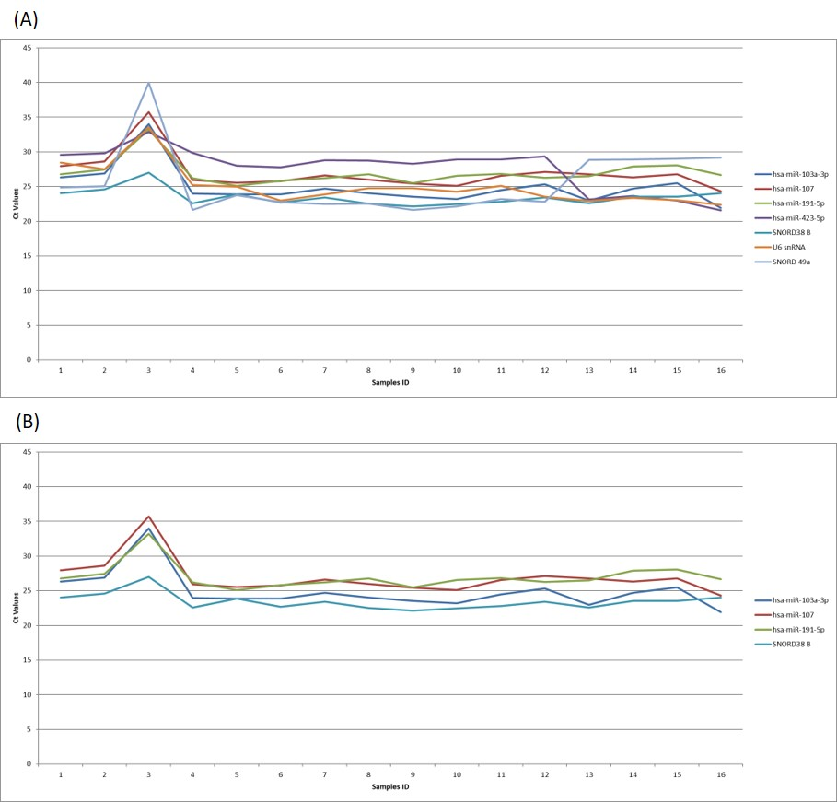
Supplementary Figure 1. (A) Ct values across the samples for the candidate reference genes. (B) Ct values across the samples for the selected reference genes.

