Supplementary Table 1. Differentially expressed miRNA in the comparison of TBM with VM and HCs groups.
No. | miRNAs | TBM vs. VM |  | TBM vs. HCs
 |  | Fold change | P-value | Fold change | P-value
1 | hsa-miR-126-3p | 0.220 | 0.003 | 0.457 | 0.014
2 | hsa-miR-130a-3p | 0.244 | 0.006 | 0.518 | 0.041
3 | hsa-miR-151a-3p | 0.418 | 0.033 | 0.589 | 0.047
4 | hsa-miR-199a-5p | 0.386 | 0.015 | 0.624 | 0.042
5 | hsa-miR-642a-3p | 1.656 | 0.018 | 1.842 | 0.008
6 | hsa-miR-4299 | 1.611 | 0.026 | 1.554 | 0.014
7 | hsa-let-7e-5p | 0.454 | 0.023 | 0.711 | 0.236
8 | hsa-miR-103a-3p | 0.644 | 0.009 | 0.935 | 0.620
9 | hsa-miR-1273g-3p | 1.580 | 0.001 | 1.463 | 0.003
10 | hsa-miR-146b-5p | 1.923 | 0.003 | 1.164 | 0.212
11 | hsa-miR-150-5p | 1.670 | 0.003 | 0.970 | 0.643
12 | hsa-miR-151a-5p | 0.425 | 0.030 | 0.757 | 0.332
13 | hsa-miR-15b-5p | 0.626 | 0.005 | 1.197 | 0.401
14 | hsa-miR-185-5p | 0.534 | 0.001 | 0.740 | 0.024
15 | hsa-miR-197-5p | 1.656 | 0.009 | 1.429 | 0.046
16 | hsa-miR-199a-3p | 0.266 | 0.004 | 0.638 | 0.101
17 | hsa-miR-21-5p | 0.612 | 0.007 | 1.153 | 0.328
18 | hsa-miR-221-3p | 0.563 | 0.036 | 0.891 | 0.618
19 | hsa-miR-223-3p | 0.641 | 0.034 | 1.474 | 0.032
20 | hsa-miR-23b-3p | 0.520 | 0.019 | 0.803 | 0.230
21 | hsa-miR-24-3p | 0.636 | 0.011 | 0.831 | 0.210
22 | hsa-miR-27b-3p | 0.465 | 0.013 | 0.786 | 0.216
23 | hsa-miR-324-5p | 0.660 | 0.028 | 0.912 | 0.459
24 | hsa-miR-3653 | 1.769 | 0.017 | 0.938 | 0.703
25 | hsa-miR-3960 | 1.613 | 0.032 | 0.667 | 0.365
26 | hsa-miR-6087 | 1.570 | 0.038 | 1.316 | 0.008
27 | hsa-miR-6125 | 1.505 | 0.033 | 1.073 | 0.541
28 | hsa-miR-6127 | 1.998 | 0.001 | 1.416 | 0.114
29 | hsa-miR-324-3p | 1.459 | 0.071 | 1.502 | 0.034
30 | hsa-miR-424-5p | 1.109 | 0.589 | 1.655 | 0.028
31 | hsa-miR-451a | 3.825 | 0.106 | 6.064 | 0.033
32 | hsa-miR-574-5p | 0.839 | 0.232 | 0.523 | 0.027
TBM, tuberculous meningitis, n = 4; VM, viral meningitis, n = 4; HCs, healthy controls, n = 4.
The 6 overlapping miRNAs in the comparison of TBM with VM and HCs were in bold.

Supplementary Table 2. Validation of the differential miRNAs in the first independent sample set.
miRNA | Validation in PBMCs* |  |  |  |  |  | Validation in CSF#
 | Fold Change (TBM/VM) | P-value | Fold Change (TBM/HCs) |  |  | P-value | Fold Change (TBM/VM) | P-value
hsa-miR-126-3p | 0.466 | 0.00054 | 0.432 |  |  | 3.24E-06 | 0.336 | 0.017
hsa-miR-130a-3p | 0.360 | 7.28E-06 | 0.511 |  |  | 2.05E-05 | 0.216 | 0.0042
hsa-miR-151a-3p | 0.427 | 0.00015 | 0.556 |  |  | 0.00023 | 0.303 | 0.00074
hsa-miR-199a-5p | 0.357 | 3.75E-05 | 0.402 |  |  | 0.0035 | NA | NA
hsa-miR-642a-3p | 1.059 | 0.758 | 1.256 |  |  | 0.261 | - | -
hsa-miR-4299 | 1.208 | 0.223 | 1.923 |  |  | 0.00075 | - | -
TBM, tuberculous meningitis; VM, viral meningitis; HCs, healthy controls.
* Validation in PBMCs was performed in 32 TBM, 30 VM and 34 HCs.
# Validation in CSF was performed in 36 TBM and 34VM patients.

Supplementary Table 3. ROC analysis of the 3 differentially expressed miRNAs in CSF for discriminating TBM from VM groups.
Signatures | AUC (95% CI) | Sensitivity (95% CI) | Specificity (95% CI)
hsa-miR-126-3p | 0.784 (0.670 – 0.874) | 72.2 (54.8 – 85.8) | 64.7 (46.5– 80.3)
hsa-miR-130a-3p | 0.763 (0.646 – 0.857) | 91.7 (77.5 – 98.2) | 50.0 (32.4 – 67.6)
hsa-miR-151a-3p | 0.815 (0.703 – 0.898) | 83.3 (67.2 – 93.6) | 69.7 (51.3 – 84.4)
TBM, tuberculous meningitis, n = 36; VM, viral meningitis, n = 34.
ROC, receiver operating characteristic curve; AUC, the area under the ROC curve.

Supplementary Table 4. Validation of the 4 miRNAs in diagnostic panel in the second independent sample set.
miRNAs | TBM vs. VM |  | TBM vs. HCs |  | TBM vs. other non-TBM
 | Fold change | P-value | Fold change | P-value | Fold change | P-value
hsa-miR-126-3p | 0.471 | 0.019 | 0.279 | 3.15E-05 | 0.491 | 0.0032
hsa-miR-130a-3p | 0.408 | 0.013 | 0.146 | 0.0028 | 0.490 | 0.0033
hsa-miR-151a-3p | 0.444 | 0.014 | 0.296 | 1.99E-05 | 0.447 | 0.0009
hsa-miR-199a-5p | 0.445 | 0.047 | 0.164 | 7.18E-06 | 0.595 | 0.019
TBM, tuberculous meningitis, n = 11; VM, viral meningitis, n = 10; HCs, healthy controls, n = 15; Non-TBM, n = 13.
Validation of the 4 miRNAs in PBMCs.

Supplementary Table 5. ROC analysis of the diagnostic panel consisting of 4 miRNAs in discriminating TBM from VM, HCs and other non-TBM in the second independent sample set.
 | AUC (95% CI) | Sensitivity (95% CI) | Specificity (95% CI)
TBM vs. VM | 0.855 (0.633 – 0.968) | 81.8 (48.2 – 97.7) | 90.0 (55.5 – 99.7)
TBM vs. HCs | 1.000 (0.868 – 1.000) | 100.0 (71.5 – 100.0) | 100.0 (78.2 – 100.0)
TBM vs. other non-TBM | 0.902 (0.711 – 0.985) | 81.8 (48.2 – 97.7) | 84.6 (54.6 – 98.1)
TBM, tuberculous meningitis, n = 11; VM, viral meningitis, n = 10; HCs, healthy controls, n = 15; Non-TBM, n = 13.
ROC, receiver operating characteristic curve; AUC, the area under the ROC curve.
The diagnostic panel was generated by logistic regression with forward stepwise analysis in the basis of the expression values of the 4 miRNAs.
Supplementary Figures

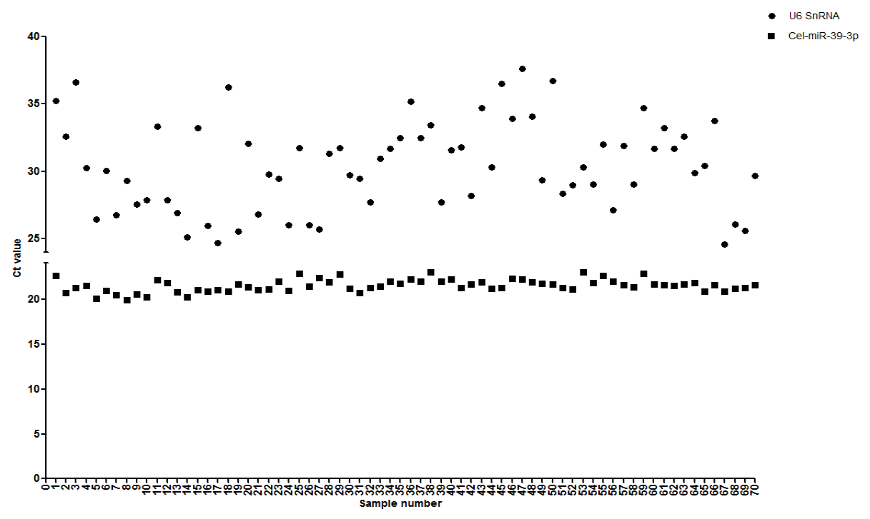
Supplementary Figure 1. The expression levels of U6 snRNA and cel-miR-39-3p in 70 CSF samples.
Horizontal bar, the cycle threshold (Ct) value in qPCR analysis.

