P.syringae ------------------------------------------------------------ 0
P.chrysogenum MLSHRSVSIALRPPV-ICHNSIRHA-PN-LLARQQ-TKGLATTTAPSDLGSTMPPNYVAR 56
P.digitatum ----------------------------------------------------MPPNYVAR 8
P.digitatum_1 MFSHRSVSIALRPPG-LCHITFRQAYPI-LLTRQQ-TKSLTTTTAPSNLGSTMPPNYVAR 57
F.oxysporum ------MSLLNASPAAMKAISLPSTAFVPTAARSMATAATQPHPQGLEKASDVPPGHLAT 54
F.venenatum ------MTLLSSSRSITRTMALSSTTVQPIMAKNMATAATQPHAESLPNASGIPPGHTAT 54
F.avenaceum ------MSLLSSSRSITRTVALSSTIPHPVVSRNMATAAAQLHAQSLPDASGIPPGHAAT 54
F.mangiferae -------------------M---------ASAAAAVAPAPQPHSPTILNASGPPPGHSVT 32
F.mangiferae_1 -------------------M---------ASAAAAVAPAPQPHSPTILNASGPPPGHSVT 32
F.fujikuroi ---------------MVRKM---------ASAAAAAAPTPQPHSPTILNASGPPPGHSIT 36

P.syringae MTNLQTFELPTEVTGCAADISLGRALIQAWQKDGIFQIKTDSEQDRKTQEAMAASKQFCK 60
P.chrysogenum VGQLKTFTLPEKATGSPGDVEMGKALINAWREDGILQIAMNPKQQDLFNKAFAASKRFFA 116
P.digitatum VGQLKTFTLPETATGSPSDVELGKAMINAWREDGILQVSMSPRQQALFENASAASKRFFA 68
P.digitatum_1 VGQLKTFTLPETATGSPSDVELGKAMINAWREDGILQVSMSPRQQALFENASAASKRFFA 117
F.oxysporum TGKLQTFILPEEVSGSEEDKKLGKAIVDAWRKDGILQIAMKPEQEGLYKAANLASKRFFS 114
F.venenatum VGKLQTFVLPEKVSGSVEDKNLGKTIIDAWKKDGILQIAMKPEQQGLYKNANLASKRFFS 114
F.avenaceum VGNLQTFVLPEKVSGSAEDKKLGKAIIDAWKKDGILQIAMKPEQQGLYKAANLASKRFFS 114
F.mangiferae AGNLQTFILPDKVSDTEANHKHDTRAA--------------------------------- 59
F.mangiferae_1 AGNLQTFILPDKVSDTEANRKLGKALVEAWQKDGILQINMTPEQHSLYKSANYASRRFFS 92
F.fujikuroi VGNLQTFILPDKVSDTEANRKLGKALVEAWQKDGILQISMTPEQHSLYKSANYASRRFFS 96
:*:** ** .:. : . .

P.syringae EPLTFKSSCVSDLTYSGYVASGEEVTAGKPDFPEIFTVCKDLSVGDQRVKAGWPCHGPVP 120
P.chrysogenum LPPNVKANCVDTQSYAGYIASGEEITDGIADYSEIFTVTKDLPLEEPRVAAKWPCHGPCP 176
P.digitatum MPPNQKAACVDTQSYAGYIASGEEITDGIADYSEIFTVTKDLPLDEPRVEAKWPCHGPCP 128
P.digitatum_1 MPPNQKAACVDTQSYAGYIASGEEITDGIADYSEIFTVTKDLPLDEPRVEAKWPCHGPCP 177
F.oxysporum KPHAQKAACIDSQTYSGYIASGEEMTDGIADYSEIFTVTEDLELDEPRVVAKWPCHGRCP 174
F.venenatum KPYAQKSACVDSQTYSGYIASGEELTDGIADYSEIFTVTKDLELDEPRVVAKWPCHGRCP 174
F.avenaceum KPHAQKSACIDSQTYSGYIASGEELTDGIADYSEIFTVTKDLDLDEPRVVAKWPCHGRCP 174
F.mangiferae --FTLQKCQLRYQTYSGYIASGEELTDGIADYSEIFTVTKDLELDEPRVVAKWPCHGRCP 117
F.mangiferae_1 KPYAQKAACVDSQTYSGYIASGEELTDGIADYSEIFTVTKHLELDEPRVVAKWPCHGRCP 152
F.fujikuroi KPYAQKAACVDSQTYSGYIASGEELTDGIADYSEIFTVTKDLELDEPRVVAKWPCHGRCP 156
: : :*:**:*****:* * *: ***** :.* : : ** * ***** *

P.syringae WPNNTYQKSMKTFMEELGLAGERLLKLTALGFELPINTFTDLTRDGWHHMRVLR---FPP 177
P.chrysogenum WPDIDTKAPIQEYMDSLGSSGETLLQLIEHGLSLEPKTLTSLTKDGWHHLRTLR---FPQ 233
P.digitatum WPDVDMRTPIQQYMDSLGKSGETLLQMIEYGLSLHPDTLTSLTKDGWHHLRILR---FPQ 185
P.digitatum_1 WPDVDMRTPIQQYMDSLGKSGETLLQMIEYGLSLHPDTLTSLTKDGWHHLRILR---FPQ 234
F.oxysporum WPDYEMKNPMERYMNSLGESGEILLKLTELGLGVPEGSLTDYTKDGWHHMRILR---FPA 231
F.venenatum WPDYEMQNPMERYMNSLRESGETLLQLTELGLDVPAGSLTDYTKDGWHHMRILR---FPA 231
F.avenaceum WPDYEMQNPMERYMNSLGESGETLLKLTELGLDVPEGSLADYTKDGWHHMRILR---FPA 231
F.mangiferae WPDYEMQNPMHRYMQSLGGVGETLLQLTELGLGVPQGSLTNYTEDGWHHLRILRHGSFPA 177
F.mangiferae_1 WPDYEMQNPMHRYMQSLGGVGETLLQLTELGLGVPQGSLTNYTEDGWHHLRILR---FPA 209
F.fujikuroi WPDYEMQNPMHRYMKSLGGVGETLLQLTELGLGVPQGSLTNYTQDGWHHLRILR---FPA 213
**: : :. :*..* ** **:: *: : :::. *.*****:* ** **

P.syringae QTST-----LSRGIGAHTDYGLLVIAAQDDVGGLYIRPPVEGEKRNRNWLPGESSAGMFE 232
P.chrysogenum NNKTNGRGKEGRGIGSHTDYGLLVIAGQDEVGGLFIRPPYSDEKL-ENWK--SSAAGFRE 290
P.digitatum NNKTNGRGKKGRGIGSHTDYGLLVIAAQDEVGGLFIRPPADDEKL-ENWK--NSAAGFRE 242
P.digitatum_1 NNKTNGRGKKGRGIGSHTDYGLLVIAAQDEVGGLFIRPPADDEKL-ENWK--NSAAGFRE 291
F.oxysporum INKTNGKGKEGRGIGSHTDYGLLVLAAADDVGALLVRPPQQGDNF-SNWE--KSAAGFKE 288
F.venenatum INKTNGKGKEGRGIGSHTDYGLLVLAAADDVGALLVRPPQEGDDF-ANWE--KSAAGFKE 288
F.avenaceum MNKTNGKGKEGRGIGSHTDYGLLVLAAADDVGALLVRPPQKGDDF-ANWE--ASAAGFKE 288
F.mangiferae INKTNGKGKEGRGIGSHTDYGLLVIAAADDVGGK-------YSTH-FSLI--SRD----- 222
F.mangiferae_1 INKTNGKGKEGRGIGSHTDYGLLVIAAADDVGGN--------------------AAGFKE 249
F.fujikuroi INKTNGKGKEGRGIGSHTDYGLLVIAAADDVGGN-------DEKL-ANWE--SSAAGFKE 263
..* .****:********:*. *:**.

P.syringae HDEPWTFVTPTPGVWTVFPGDILQFMTGGQLLSTPHKVKLNTRERFACAYFHEPNFEASA 292
P.chrysogenum HDDRWTYVPPVPGVFTVFPGDMMQFMTNSYLPSTPHKVGLNTRERYAFAYFHEPSFQAEI 350
P.digitatum DDERWVYVPPVPGVFTVFPGDIMQFMTNSYLPSTPHKVGLNTRERFAFAYFHEPSFQAVV 302
P.digitatum_1 DDERWVYVPPVPGVFTVFPGDIMQFMTNSYLPSTPHKVGLNTRERFAFAYFHEPSFQAVV 351
F.oxysporum DDEGWLFVPPAENVFTVFPGDMMQYLTNSFLPSTPHKVGLNIRERFAFAYFHEPSFQAVI 348
F.venenatum DSEGWLFVPPAENVFTVFPGDMMQYLTNSYLPSTPHKVGLNHRERFAFAYFHEPSFQAVI 348
F.avenaceum DADGWLFVPPAKNVFTVFPGDMMQYLTNSFLPSTPHKVGLNHRERFAFAYFHEPSFQATI 348
F.mangiferae ------------------------------------------------------------ 222
F.mangiferae_1 DDERWIFVPPAEN-----------YITNSALPSTPHKVGLNLRERFAFAYFHEPSFQAVV 298
F.fujikuroi DDERWVFVPPAENVFT--------YITNSALPSTPHKVGLNLRERFAFAYFHEPSFQAVV 315

P.syringae YPLFEP----SANERIHYGEHFTNMFMRCYPDRITTQRINKENRLAHLEDLKKYSDTRAT 348
P.chrysogenum SPIAKLYDGKPPDEKNHYGTHFTNMFMRNYPDRVTTERILKEDRLKLLDLPELRTK---- 406
P.digitatum SPVAKLYDGQPPVEKIHYGTHFTNMFMRNYPDRITTERIIKEDRLQLLDRPELRTQ---- 358
P.digitatum_1 SPVAKLYDGQPPVEKIHYGTHFTNMFMRNYPDRITTERIIKEDRLQLLDRPELRTQ---- 407
F.oxysporum KPLPGYNAGQEPKEGVHYGKHFTDMFMRNYPERITTQRLLEEGRYDLLKQESLRTMSP-- 406
F.venenatum NPLPGYDAGQEPKEGVHYGKHFTDMFMRNYPQRITTQRLIDEGRYDLLKQESLYTMSP-- 406
F.avenaceum KPLPGYDAGQEPKEGVHYGKHFTDMFMRNYPQRITTQRLLDEGRYDLLKQDALHTMSP-- 406
F.mangiferae ------------------------------------------------------------ 222
F.mangiferae_1 KPLPGYDVGQEPKDGIHYGKHFTNMFMRNYPQRITTQRLNDEGRYRLLGQESLQTMAP-- 356
F.fujikuroi KPLPGYDVGQEPKDGIHYGKHFTNMFMRNYPQRITTQRLNDEGRYRLLEQESLQTMAP-- 373

P.syringae GS 350
P.chrysogenum -- 406
P.digitatum -- 358
P.digitatum_1 -- 407
F.oxysporum -- 406
F.venenatum -- 406
F.avenaceum -- 406
F.mangiferae -- 222
F.mangiferae_1 -- 356
F.fujikuroi -- 373

Supplementary Figure 1: Custal omega alignment of confirmed ethylene forming enzyme (EFE) from Pseudomonas syringae (UniProtKB/Swiss-Prot: P32021.1) and Penicillium digitatum (EKV19239.1) as well as a highly similar but non active gene of Pseudomonas. chrysogenum (XP_002562422.1) with similar genes from F. oxysporum (RKK90967.1), F. venenatum (XP_025583657.1), F. avenaceum (KIL86278.1), F. fujikuroi (XP_023429962.1) and F. mangiferae (CVK86342.1). P. digitatum_1 is the sequence of P. digitatum with a signal peptide at the N-terminus encoding an amphiphatic α-helix motif encoding the mitochondrial localization signal. F. mangiferae_1 is an alternatively spliced version of the F. mangiferae sequence. However, the violet and grey highlighted regions were also annotated as an intron in the alternatively spliced version. Taking a closer look at the reading frames we identified a shift from frame 1 (purple) to reading frame 3 (light blue). Amino acids shaded in yellow when changed to the P. chrysogenum version inactivate the protein; Green shaded amino acids are predicted to bind Fe(II); Red amino acids are predicted to bind 2-oxoglutarate and correspond to EFE-siteI; Grey amino acids indicate putative mitochondrial leader sequences.

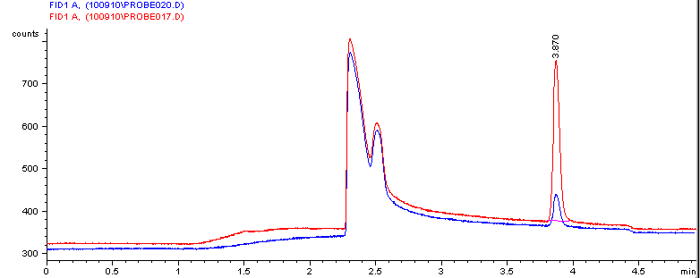
PDA + methionine
PDA

Supplementary Figure 2: GC-MS analysis of ethylene formation by F. graminearum grown on (blue) potato dextrose agar (PDA) and PDA supplemented with 20 mM methionine (red); elution of ethylene after 3.87 minutes
T.aestivum --------------MAAGDGHGENSSYFDGWKAYDMNPFHPQDNRGGVIQMGLAENQLSL 46
ACS3 -----------MSALSQRATEAVG-GLDLPWRFAPRGDYDPDHNPTGLISFGTAEN---- 44
ACS3_1 -----------MSALSQRATEAVG-GLDLPWRFAPRGDYDPDHNPTGLISFGTAEN---- 44
ACS3_FungiDB MLINLHFSVDKMSALSQRATEAVG-GLDLPWRFAPRGDYDPDHNPTGLISFGTAENALVT 59
ACS3_FungiDB_1 MLINLHFSVDKMSALSQRATEAVG-GLDLPWRFAPRGDYDPDHNPTGLISFGTAENALVT 59
ACS2 -------MTPSHANLSTRGELFASPAYRQSLLDILSDLWHPETKSSGYT--------LMH 45
ACS2_1 -------MTPSHANLSTRGELFASPAYRQSLLDILSDLWHPETKSSGYT--------LMH 45
P.citrinum ---------MTQSVLSRRAQDVVDAGSENPMWDVMKDTWHASTNPTGYVNVGVAENALMH 51
ACS1 ------------MSLSKRANDAEKAIEGMDLWEVIPNLFDQETNPDGIVSLGVAENTLMH 48
ACS1_1 ------------MSLSKRANDAEKAIEGMDLWEVIPNLFDQETNPDGIVSLGVAENTLMH 48
:: . :. . : *

T.aestivum DLIEEWSKAHPEAS---I-CTAEGA---SQFKRIANFQDYHGLPEFRQAMAQFMGQVRGW 99
ACS3 --------------------------VTISNEDFLYRGSHAGGSRFPTALAAHLNEYLTP 78
ACS3_1 --------------------------VTISNEDFLYRGSHAGGSRFPTALAAHLNEYLTP 78
ACS3_FungiDB DQLKEFADKS----------------VTISNEDFLYRGSHAGGSRFPTALAAHLNEYLTP 103
ACS3_FungiDB_1 DQLKEFADKS----------------VTISNEDFLYRGSHAGGSRFPTALAAHLNEYLTP 103
ACS2 KELIQHMTQNVKPPSHQYWVHANGFKLTITSHSLTCGDGFSGSHRLRDVLARFINRNFNP 105
ACS2_1 KELIQHMTQNVKPPSHQYWVHANGFKLTITSHSLTCGDGFSGSHRLRDVLARFINRNFNP 105
P.citrinum DELLEFINKK----------------LELPAKYLTYNDGGGGSSRLKAAIAAFLNHNLKP 95
ACS1 DVLRKHIHDN----------------LALTNPAFTYGDGTTGTKQVKKSVSRFLTKHLKP 92
ACS1_1 DVLRKHIHDN----------------LALTNPAFTYGDGTTGTKQVKKSVSRFLTKHLKP 92
: . * .. :: .: .

T.aestivum KARFDPDRVVMSGGATGAQETLAFCLANPGEAFLVPTPYYPGFDRDCCWRSGVKLLPIEC 159
ACS3 SSPITPDMIRCVGAATAMHDILAWGVADPGDGVLTSRPVYGRFELDFGNKSQAKVVYSDN 138
ACS3_1 SSPITPDMIRCVGAATAMHDILAWGVADPGDGVLTSRPVYGRFELDFGNKSQAKVVYSDN 138
ACS3_FungiDB SSPITPDMIRCVGAATAMHDILAWGVADPGDGVLTSRPVYGRFELDFGNKSQAKVVYSDN 163
ACS3_FungiDB_1 SSPITPDMIRCVGAATAMHDILAWGVADPGDGVLTSRPVYGRFELDFGNKSQAKVVYSDN 163
ACS2 HEAVTNDQLIITSGVGRAIELSGFSLCDKGDGVLLGRPHYGNFPIDFGYRAEAKIIGVSF 165
ACS2_1 HEAVTNDQLIITSGVGRAIELSGFSLCDKGDGVLLGRPHYGNFPIDFGYRAEAKIIGVSF 165
P.citrinum VIPLEPSHIMATNGVSSAIEHVAWSFADPGEGILLGRPYYGMFIPDMSLRTGSSVVPVSF 155
ACS1 FKAIEPAHITMTNGCSAAIEHLSWAVANPGDGILLGQPYYGTFVPDLTARFGAKLLPVAF 152
ACS1_1 FKAIEPAHITMTNGCSAAIEHLSWAVANPGDGILLGQPYYGTFVPDLTARFGAKLLPVAF 152
. : .. : .: ..: *:..* * * * * : .::

T.aestivum HSSNDFRITREA--VVAAYEGARSSGVRVKGILITNPSNPLGTTADRATLAMLATFATEH 217
ACS3 KTEEAFQDGIIDHFEEALLRSS-EAGIHVKMVLIVNPHNPLGRCYPKSTLVKIMQFCQKH 197
ACS3_1 KTEEAFQDGIIDHFEEALLRSS-EAGIHVKMVLIVNPHNPLGRCYPKSTLVKIMQFCQKH 197
ACS3_FungiDB KTEEAFQDGIIDHFEEALLRSS-EAGIHVKMVLIVNPHNPLGRCYPKSTLVKIMQFCQKH 222
ACS3_FungiDB_1 KTEEAFQDGIIDHFEEALLRSS-EAGIHVKMVLIVNPHNPLGRCYPKSTLVKIMQFCQKH 222
ACS2 GDVDPFSIEAVELYEKTLTDAQ-DQGIRVKALLLCNPHNPLGRCYTPEVLQAYMRLCQKH 224
ACS2_1 GDVDPFSIEAVELYEKTLTDAQ-DQGIRVKALLLCNPHNPLGRCYTPEVLQAYMRLCQKH 224
P.citrinum GELDPLSVEGVDKYEEALLEFHRTTGKKVKALMLAHPHNPLGRCYSREVLVKLMRLCQKY 215
ACS1 GEVDPLGEAAVAEYEKVILEAQ-AQGTRVSGLVISHPHNPLGRCYSRSVLIAFMKLCQKY 211
ACS1_1 GEVDPLGEAAVAEYEKVILEAQ-ARGTRVSGLVISHPHNPLGRCYSRSVLIAFVKLCQKY 211
: : . * :*. ::: :* **** .* :. ::

T.aestivum RVHLICDEIYAGSVFAKP-----EYVSIAEVIEHDAP-GADRDLIHIAYSLSKDFGLPGF 271
ACS3 RLHLLSDEIYACSVFNSD----EPATPFTSILSIDSTNLIDPDLLHVTYGLSKDFGAAGL 253
ACS3_1 GLHLLSDEIYACSVFNSD----EPATPFTSILSIDSTNLIDPDLLHVTYGLSKDFGAAGL 253
ACS3_FungiDB RLHLLSDEIYACSVFNSD----EPATPFTSILSIDSTNLIDPDLLHVTYGLSKDFGAAGL 278
ACS3_FungiDB_1 GLHLLSDEIYACSVFNSD----EPATPFTSILSIDSTNLIDPDLLHVTYGLSKDFGAAGL 278
ACS2 SLHLLSDEIYALSVWEND--NVPEAPGFTSVLSIDTNGLIDVNLVHALWGMSKDFGANGI 282
ACS2_1 SLHLLSDEIYALSVWEND--NVPEAPGFTSVLSIDTNGLIDVNLVHALWGMSKDFGANGI 282
P.citrinum QVHFISDEIYALSVFENTVDEHPPPVKFESALSIDLTGIIDPRLVHVLWGMSKDFGANGI 275
ACS1 EMHFISDEIYALSVWTNTVDQHPLSVPFESALSIDTTDIIDTDRVHVLWGMSKDFGANGI 271
ACS1_1 EMHFISDEIYALSVWTNTVDQHPLSVPFESALSIDTTDIIDTDRVHVLWGMSKDFGANGI 271
:*::.***** **: . : . :. * * :* :.:***** *:

T.aestivum RVGIVYSYNDAVVA-CARKMSSFGLVSSQTQLFLAKMLGDEEFMSRFLRESARRLAARHE 330
ACS3 RLGAIITRSQPVLRAI-EAAMRFHNPSGASLAIGNAMLEDRVWCRSFVDSSRSKLSQAHR 312
ACS3_1 RLGAIITRSQPVLRAI-EAAMRFHNPSGASLAIGNAMLEDRVWCRSFVDSSRSKLSQAHR 312
ACS3_FungiDB RLGAIITRSQPVLRAI-EAAMRFHNPSGASLAIGNAMLEDRVWCRSFVDSSRSKLSQAHR 337
ACS3_FungiDB_1 RLGAIITRSQPVLRAI-EAAMRFHNPSGASLAIGNAMLEDRVWCRSFVDSSRSKLSQAHR 337
ACS2 RIGCLITRNEAFMRAC-VANSDLSGPSSLSDLAAASILSDDAFLESFIKTNRLRLAENYK 341
ACS2_1 RIGCLITRNEAFMRAC-VANSDLSGPSSLSDLAAASILSDDAFLESFIKTNRLRLAENYK 341
P.citrinum RLGVIISQANRDIHMALTGPSLYSYASGITDHLTALILEDFDFTTRYIQQNQKLLSESYA 335
ACS1 RVGTIVSQANMSLHASIVAVGLYSSVSSISDHVTVNILEDDAFVESYIVENQKRLSAQYT 331
ACS1_1 RVGTIVSQANMSLHASIVAVGLYSSVSSISDHVTVNILEDDAFVESYIVENQKRLSAQYT 331
*:* : : : : *. : :* * : :: . *: :

T.aestivum LFTSGLREVGIGCL-GGNAGLFSWMDLRGMLREKTAE---------A----ELELWRVII 376
ACS3 HVTSQLKAMNIKYLPGSNAGFFVWIDLSPYLPSELDGEL-----------NQEFALAKRL 361
ACS3_1 HVTSQLKAMNIKYLPGSNAGFFVWIDLSPYLPSELDGEL-----------NREFALAKRL 361
ACS3_FungiDB HVTSQLKAMNIKYLPGSNAGFFVWIDLSPYLPSELDGEL-----------NQEFALAKRL 386
ACS3_FungiDB_1 HVTSQLKAMNIKYLPGSNAGFFVWIDLSPYLPSELDGEL-----------NREFALAKRL 386
ACS2 IVTEFLTNHDIPYKEGSNAGLFVWADLFAPNSALINDSVMKQDDAGAALMTMEENMTEIL 401
ACS2_1 MVTEFLTNHDIPYKEGSNAGLFVWADLFAPNSALINDSVMKQDDAGAALMTMEENMTEIL 401
P.citrinum YTANYLKEHGIEYATGCNAAFFVWMNLGKKYRELHP---------EDECENVGEQIMQRL 386
ACS1 RVVSWARKNQIEYAPGVNAAFFLWIDLGKYYMARHP---------GLETDDITDLIMSKL 382
ACS1_1 RVVSWARKNQIEYAPGVNAAFFLWIDLGKYYMARHP---------GLETDDITDLIVSKL 382
.. * * **.:* * :* :

T.aestivum RKVKLNVSPGTSFHCGEPGWFRVCHANMDDETMGVALSRIRDFVRQHQQQKAKAQRWAAR 436
ACS3 REAGVFLHPR-EEHSLEPGWFRIVYTQDP-RTVTEGLQRYVPSSFAVE-------TLK-- 410
ACS3_1 REAGVFLHPR-EEHSLEPGWFRIVYTQDP-RTVTEGLQRYVPSSFAVE-------TLK-- 410
ACS3_FungiDB REAGVFLHPR-EEHSLEPGWFRIVYTQDP-RTVTEGLQSSQGQNGNIV-------GWTLE 437
ACS3_FungiDB_1 REAGVFLHPR-EEHSLEPGWFRIVYTQDP-RTVTEGLQSSQGQNGNIV-------GWTLE 437
ACS2 LKERIFVASGGDFGTDVSGWYRIVFAHER-TYLLEGLERIVRAVKKFC-------RDS-- 451
ACS2_1 LKERIFVASGGDFGTDVSGWYRIVFAHER-TYLLEGLERIVRAVKKFC-------RDS-- 451
P.citrinum LQKKVFLASGFLFGSEKDGWFRIVFTQGH-DYLSVALERINAALEE-------------- 431
ACS1 MAKKIFLASGKGFGSEKPGWFRIVFSHDD-AYLDLGLERVINALL--------------- 426
ACS1_1 MAKKIFLASGKGFGSEKPGWFRIVFSHDD-AYLDLGLERVINALL--------------- 426
: : **:*: .:: : .*.

T.aestivum SHL-HLSLQRHGPMASQYHALSSPMAALLSPQSPLVHAAS 475
ACS3 ---------------------------------------- 410
ACS3_1 ---------------------------------------- 410
ACS3_FungiDB KRSTILAVNKVKEREGFYE--------------------- 456
ACS3_FungiDB_1 KRSTILAVNKVKEREGFYE--------------------- 456
ACS2 -KD-------------Y----------------------- 454
ACS2_1 -KD-------------Y----------------------- 454
P.citrinum ---------------------------------------- 431
ACS1 ---------------------------------------- 426
ACS1_1 ---------------------------------------- 426

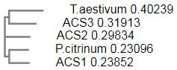

Supplementary Figure 3

Supplementary Figure 3: Clustal omega alignment of two functional ACC synthases from Penicillium citrinum (GenBank: BAA92149.1), Triticum aestivum (GenBank: AAB18416.1) and three ACC synthase candidate genes of Fusarium graminearum (ACS1 (XP_011323690.1), ACS2 (XP_011327389.1), ACS3 (XP_011328278.1), ACS3 as annotated in Fungi DB (FGRAMPH1_01T27057)). The green highlighted amino acids are important for ACS activity. Blue highlighted amino acids indicate RNA modification during sexual development. For ACS1 the probabilities of the three amino acid changes are 20% Q to R), 10% (M to V) and 17% (M to V) at position 379. In ACS2 the probability of I to M change is estimated with 39% while the changes in ACS3 have a lower likelihood with 4% (R to G) and 4% (Q to R).

ACD1 --MVTLPSPFSDIDRVQLLFNRPTDIEPLSRLTESVNNNVKLWIAREDRNSGLAFAGNKV 58
Trichoderma MATLNIPEPLASIPFESLLFG-PSPIQHLPRISAALGGKVTVYAKRDDCNSGFAYGGNKV 59
ACD2 MTVVTLPEPFASIPRENFLFG-ASPLQPLPRISAALGGKVNVYAKREDCNSGLAYGGNKV 59
:.:*.*::.* .:**. : :: * *:: ::..:*.:: *:* ***:*:.****

ACD1 RKLEYVLADALAQGADTVVTTGGIQSNHMCQTSAAAARLGLKVALYPADRVASNDAEYKY 118
Trichoderma RKLEYLAAEALSQGCDTLVSIGGVQSNHTRAVTAVAAKLGLKAATVQEHWVDWDDAGYEK 119
ACD2 RKLEYLAAEAQAEGCDTLVSIGGVQSNHTRAVTAVASKLGLKAATVQEHWVDWEDPGYEK 119
*****: *:* ::*.**:*: **:**** .:*.*::****.* . * :* *:

ACD1 LGNIQANAILGAETF------PVD--TAEETVITTLKDRGQKPYSIPPGASSHPLGGLGY 170
Trichoderma VGNIQLSRLMGGDVRLDPSLFGIEHKPTLANLKAELEGSGRKPYYIPAGASDHPLGGLGF 179
ACD2 VGNIQLSRLMGGDVRLDPSTFGIEHKTTLAKLKDELKSNGQKPYYIPAGASDHPLGGLGF 179
:**** . ::*.:. :: : .: *:. *:*** ** ***.*******:

ACD1 ARWAFELLEQEKKIGVTFDTIALVAGSCSTLGGLLAGLKLAQKEQIPGSKKRLIGFSVLH 230
Trichoderma ARWALEVEAQEKEMGVFFDTVIVCAVTGSTMAGMIAGFKLAQLKLG-SPKRKIIGIDASG 238
ACD2 ARWAFEVEAQEKELGIFFDTVIVCAVTGSTFAGMIAGFKLAQKKNG-SPARKIIGIDASG 238
****:*: ***::*: ***: : * : **:.*::**:**** : . :::**:..

ACD1 KSKKDVEALVLKTSRTTASKIGISPNEITADDFEINTSYIGDGYGQLNDSTAEAMKKLAR 290
Trichoderma KPKETF-DQVLRIAKFTAAKIGLSEADITEADVILDERFNAKIYGIPDETTIEAMKFGAR 297
ACD2 KVQQTF-DQVLRIAKNTAAKIGLSEDDITADDVILDPNYNAKVYGIPDETTLEAMRFGAA 297
* :: . **: :: **:***:* :** *. :: : .. ** :::* ***: *

ACD1 KEGILTDPVYTGKAFTGLLDLAKTGYLNGKNVLFLHTGGQAVLSAYPGLRE 341
Trichoderma TEAFITDPVYEGKSLAGMMGLIRNGEIAGGNVLYAHLGGQLALNAYSSLLD 348
ACD2 TEAFITDPVYEGKSLAGMMDLIKTGKIAGGNVLYAHLGGQLALNAYSSI-- 346
.*.::***** **:::*::.* :.* : * ***: * *** .*.** .:

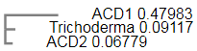

Supplementary Figure 4: Clustal omega alignment and a phylogenetic tree of a confirmed ACC deaminase of Trichoderma asperellum (ACX94231.1) and both ACC deaminase candidate genes of Fusarium graminearum (FGSG_02678 = ACD1 and FGSG_12669 = ACD2).

M ACS1 ACS3 ACD1 ACD2 C ACS2

130 kDa

100 kDa

70 kDa

55 kDa

40 kDa

Supplementary Figure 5: Confirmation of expression of ACS and ACD candidate genes of F. graminearum in E. coli. C, vector control. M, marker

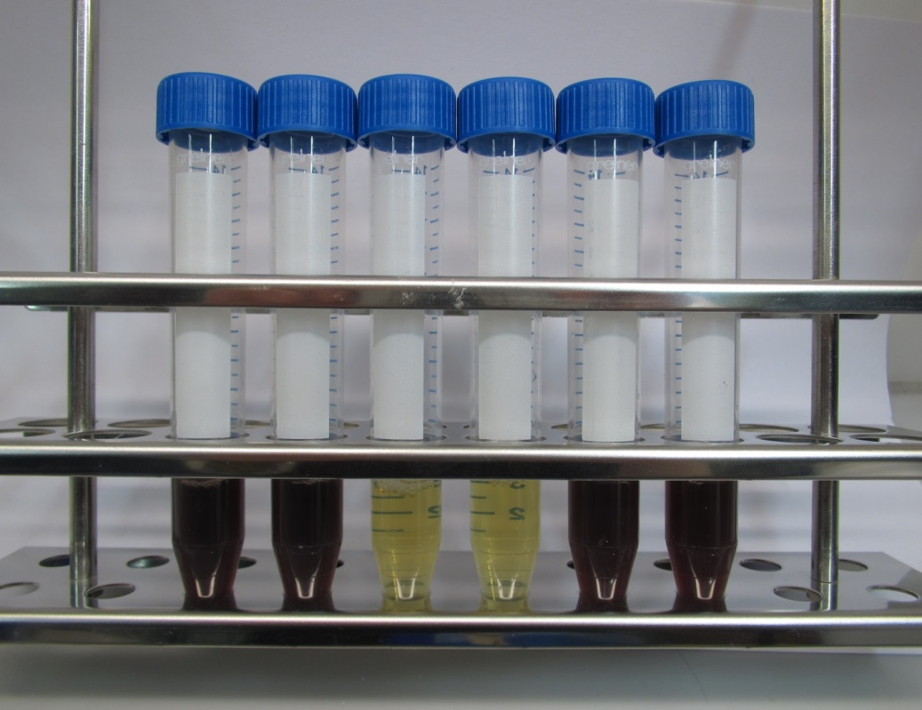
ACD2
P. putida
Negative
2
1
2
1
1
2

Supplementary Figure 6: Colorimetric assay of Acd2 activity of F. graminearum, a positive control of Pseudomonas putida and a negative control;

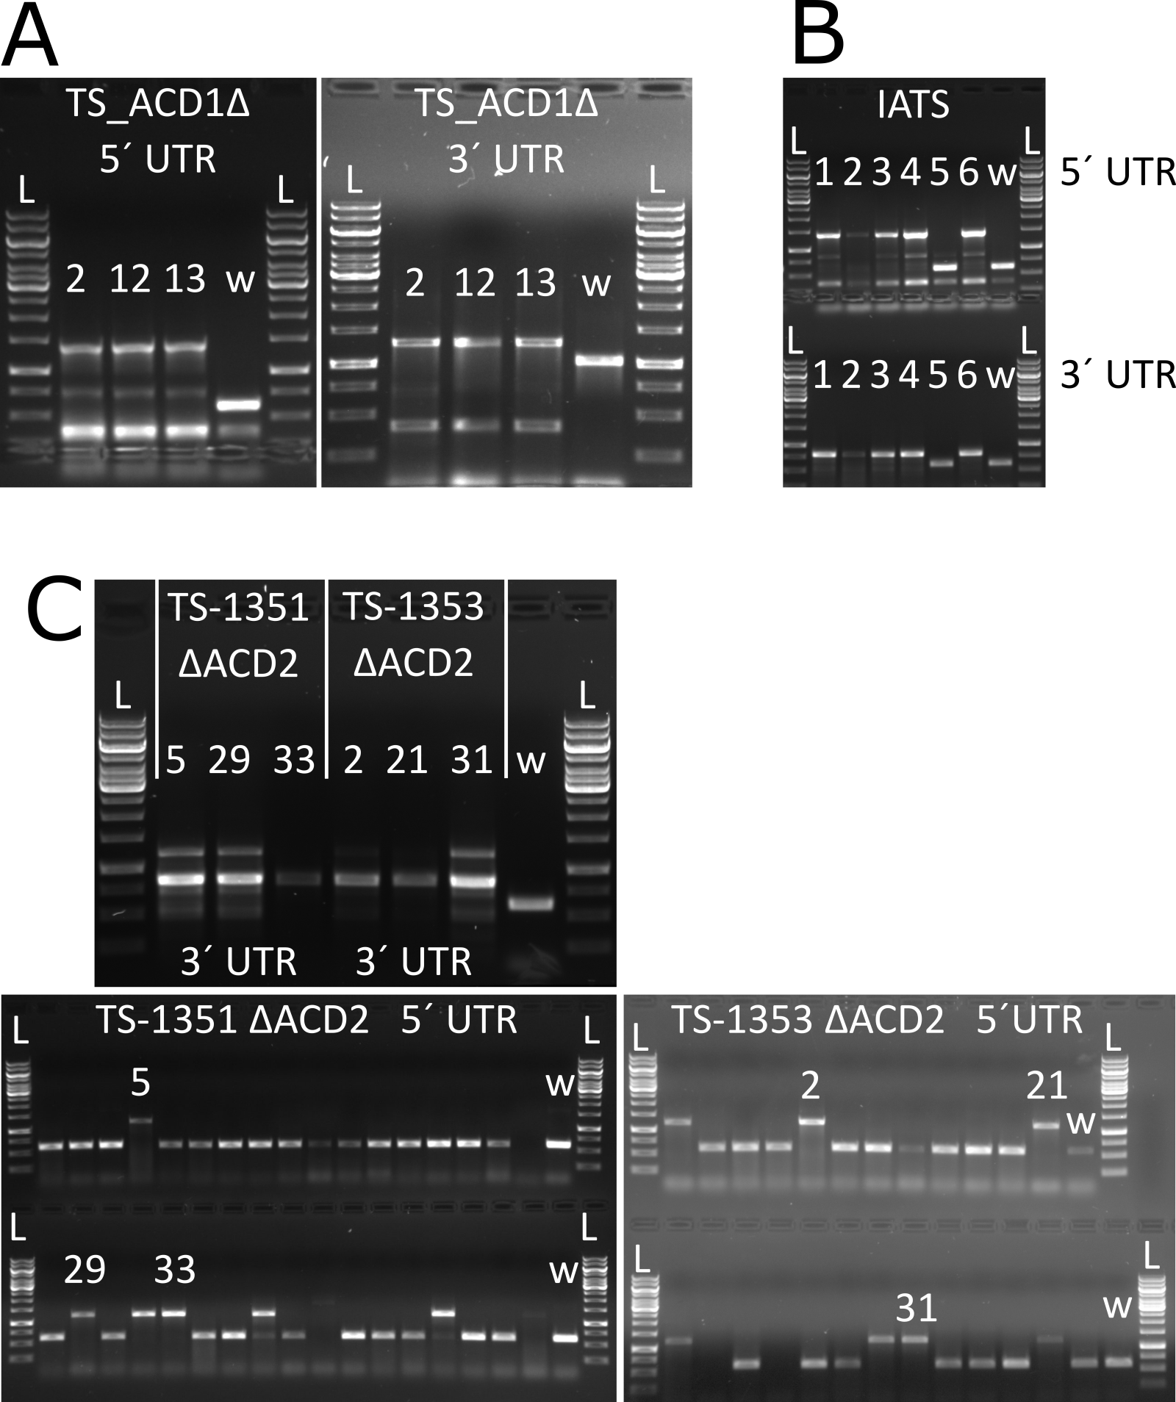

Supplementary Figure 7: Knock out screening using multiplex PCR; A) ∆ACD1 mutant: the expected lengths for the 5´ screening are 620 bp and 1434 bp for the wild type and the knock out strain, respectively (left side). Expected lengths are 1033 bp and 1287 bp for the 3´screening (right side); B) ∆ACD2 mutant: expected lengths for the 5´ screening (top) are 614 bp (w) and 1403 bp (∆) for the wild type and the knock out strain, respectively. For the 3´screening (bottom) 608 bp (w) and 804 bp (∆); C) ∆∆ACD1,2 mutant: expected lengths for the 3´-screening (top image) of the three double knock-out strains (derived from independent single knock out strains) used in this study is shown (w = 608; ∆ = 833 bp); expected lengths for the 5´screening of the ACD2 knock-out in two independent confirmed ∆ACD1 knock out strains (w = 614 bp; ∆ = 1245 bp) (bottom left and right images); w = wild type; L = Gene Ruler 1 kb DNA ladder (Thermo Scientific).

(A)
(B)
Supplementary Figure 8: A) Mean values of DON and D3G toxins including standard deviation extracted from wheat ears infected with PH-1, Δacd1 and Δacd2 knock- out strains. B) Mean values of toxins including standard deviation extracted from ears inoculated with PH-1 or six independently derived double knock out strains from two independent Δacd1 strains

