Supplementary Material
Table S1. Baseline characteristics difference between the subjects with grip strength (n=13,965) and the baseline sample (N=17,705)
Characteristics | Study sample  (N=13,965) | Study sample  (N=17,705) | P value
Age(y), mean±SDª | 59.3±10.0 | 59.1±10.2 | 0.006
Gender (%) |  |  | 0.043
Female | 7433(53.2) | 9221(52.1)
Marital status (married) (%) | 11488(82.3) | 14170(80.0) | <0.001
Educational level (%) |  |  | <0.001
≤primary school | 9666(69.2) | 11755(66.4)

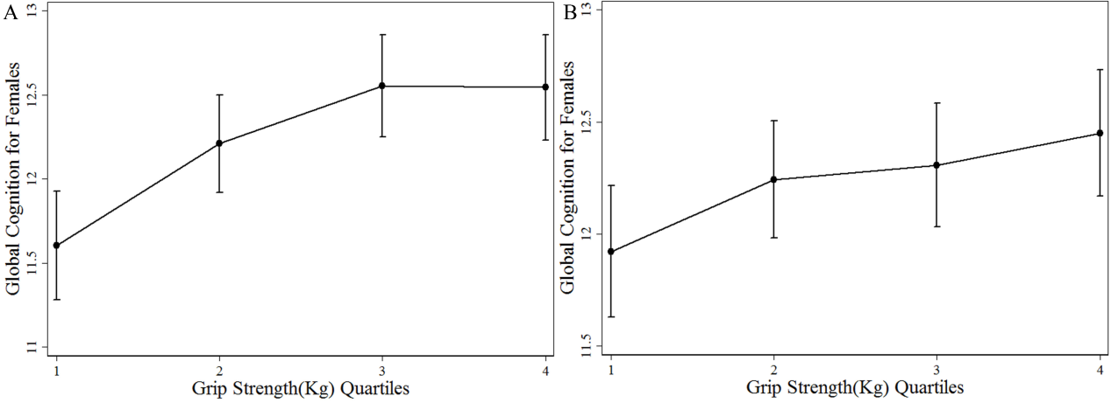
Figure S1. A and B show mean distributions of global cognition over a 4-year period using grip strength quartiles at baseline in women. A) shows data adjusted for age, education, marital status, health status, health behaviors, and body mass index. B) shows data adjusted for model 1+ baseline cognition.
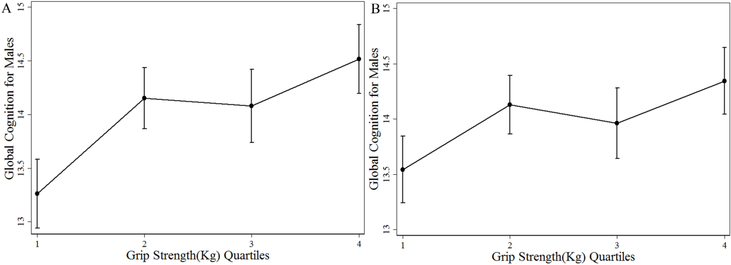
Figure S2. A and B show mean distributions of global cognition over a 4-year period using grip strength quartiles at baseline in men. A) shows data adjusted for age, education, marital status, health status, health behaviors, and body mass index. B) shows data adjusted for model 1+ baseline cognition.

