Supplementary Materials

Supplementary Figure. 1
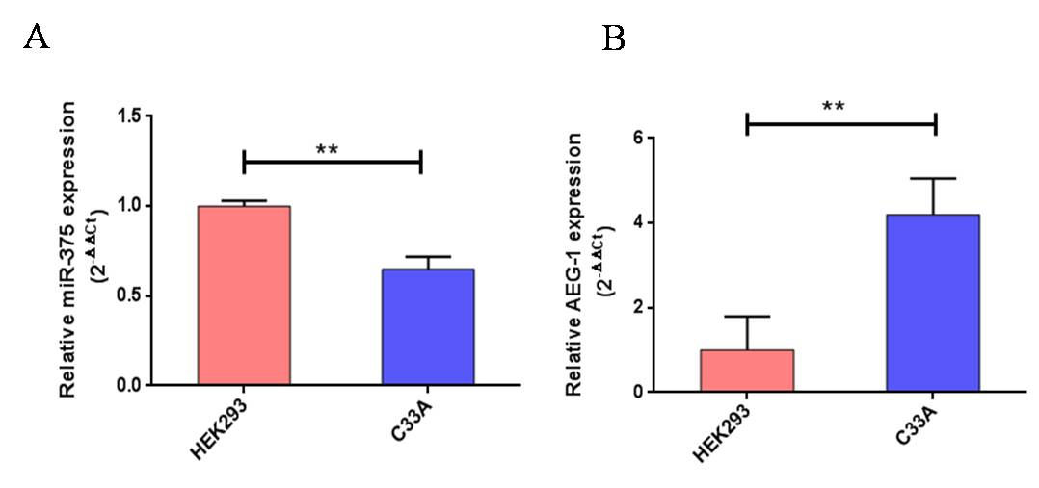
S. Fig1. Relative expression levels of miR-375 and AEG-1 in normal and C33A. Quantitative Real-Time PCR was performed to analyze the expression level of miR-375 (A) and AEG-1 (B) from normal and C33A cells, RNU6 and GAPDH were used to normalize the expression. Error bars represent mean + s.d. and P-Values are represented as **P<0.05, compared to the corresponding controls
Supplementary Figure. 2 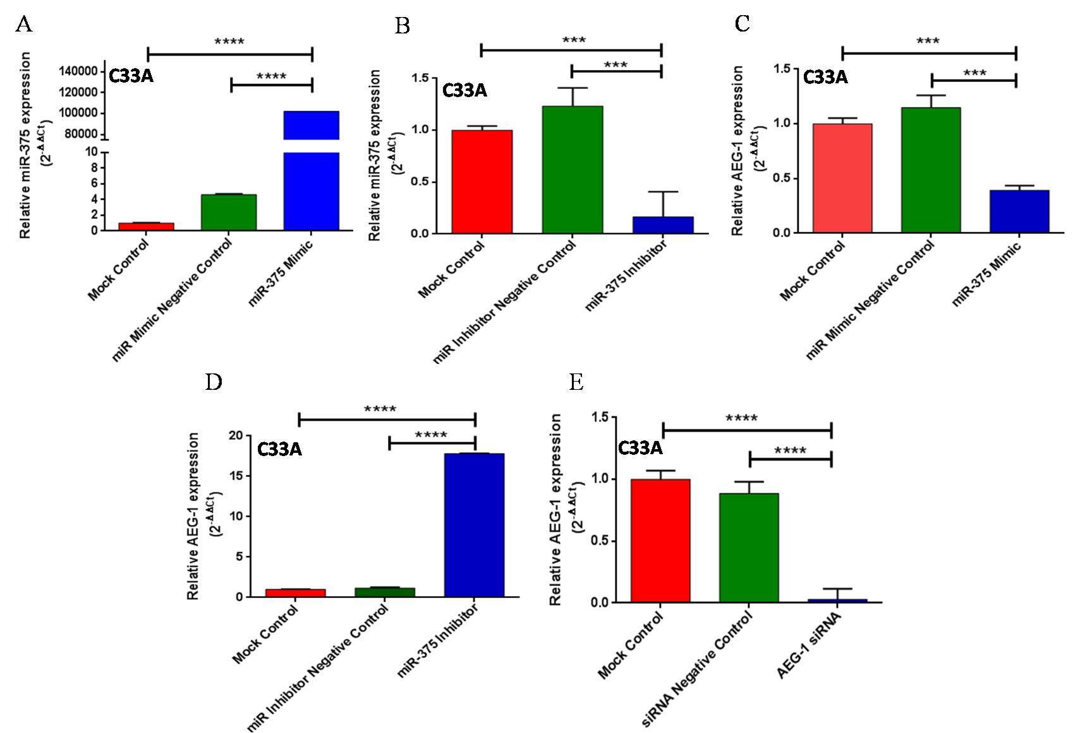
S. Fig 2. miR-375 regulates AEG-1 expression in C33A. C33A cells were transfected with Mock Control, miR-Mimic Negative Control, miR-Inhibitor Negative Control, miR-375 mimic, miR-375 Inhibitor, siRNA Negative Control and AEG-1 siRNA and the expression level of miR-375 and AEG-1 were estimated by qRT-PCR using RNU6 and GAPDH, respectively for normalization. miR-375 mimic increased endogenous miR-375 expression in C33A cells (A) miR-375 Inhibitor decreased endogenous miR-375 expression (B). Ectopic expression of miR-375 decreased AEG-1 mRNA expression (C) AEG-1 mRNA expression increased while inhibiting endogenous miR-375 by using miR-375 inhibitor (D). AEG-1 siRNA decreased AEG-1 mRNA expression (E) in CC cells. Error bars represent mean + s.d. and P-Values are represented as ***P<0.001, ****P<0.0001compared to the corresponding controls.

Supplementary Figure. 3
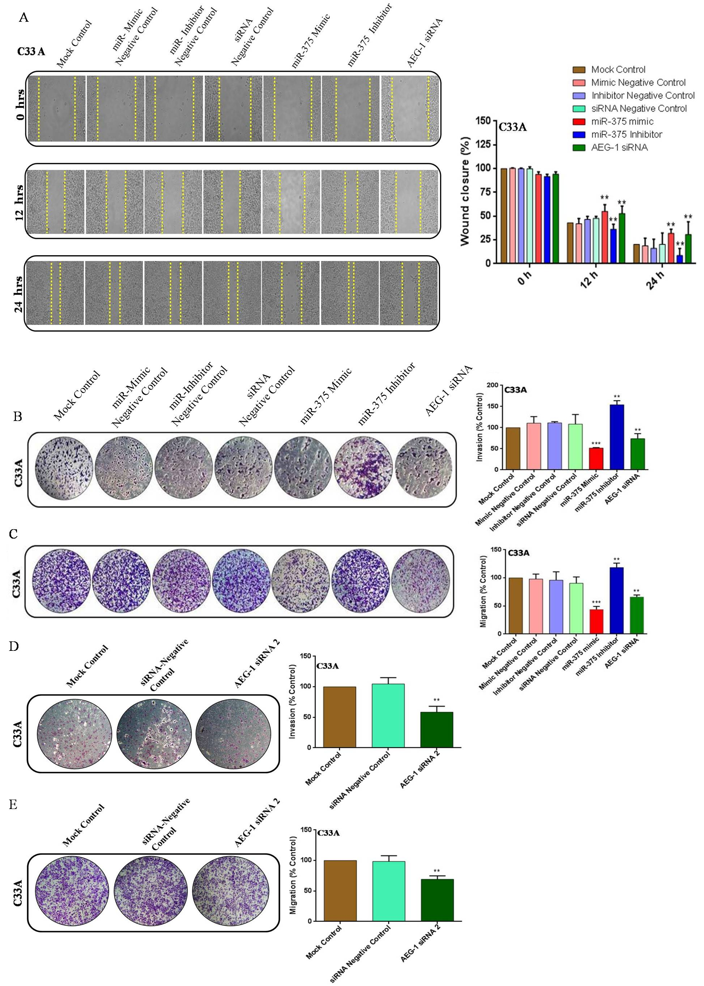

S. Fig 3. Ectopic expression of miR-375 inhibits C33A. In vitro scratch assay were performed in C33A cells at 0, 12 and 24 h post-transfection with miR-375 mimic, miR-375 Inhibitor, AEG-1 siRNA and their controls (A). Gap distance of cells was quantified by using Image J. Transwell invasion assay with Matrigel was performed in miR-375 mimic, miR-375 Inhibitor, AEG-1 siRNA and their controls transfected C33A cells (B). Transwell migration assay without Matrigel was performed in miR-375 mimic, miR-375 Inhibitor,AEG-1 siRNA and their controls transfected C33A cells (C). Transwell invasion and migration assay was performed in AEG-1 siRNA 2 and their negative control transfected C33A cells (D-E).The scale bars represent 100 µm. Error bars represent mean + s.d. and P-Values are represented as **P<0.05, ***P<0.001compared to the corresponding controls.

Supplementary Figure. 4

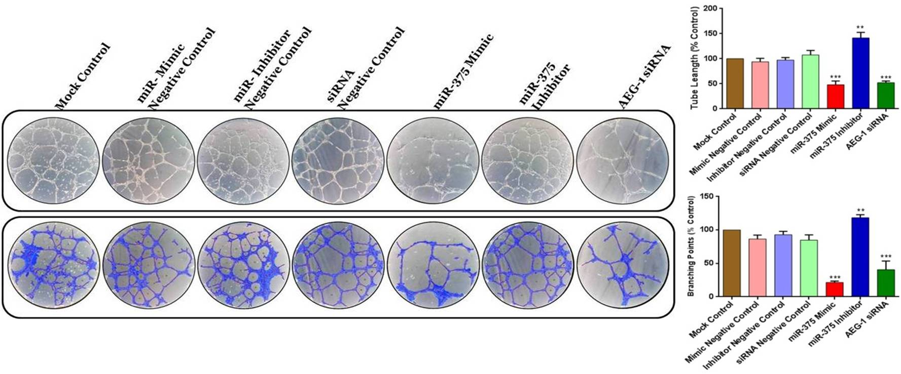

S. Fig 4. miR-375 suppressed angiogenesis in HUVECs .HUVECs were transfected with miR-375 mimic, miR-375 Inhibitor, AEG-1 siRNA and their controls and then cultured for 16 h incubation. The HUVECs capillary-like tubular structures were examined by branch points and total tube length. The scale bars represent 100 µm. Error bars represent mean + s.d. and P-Values are represented as **P<0.05, ***P<0.001compared to the corresponding controls.

Supplementary Figure. 5

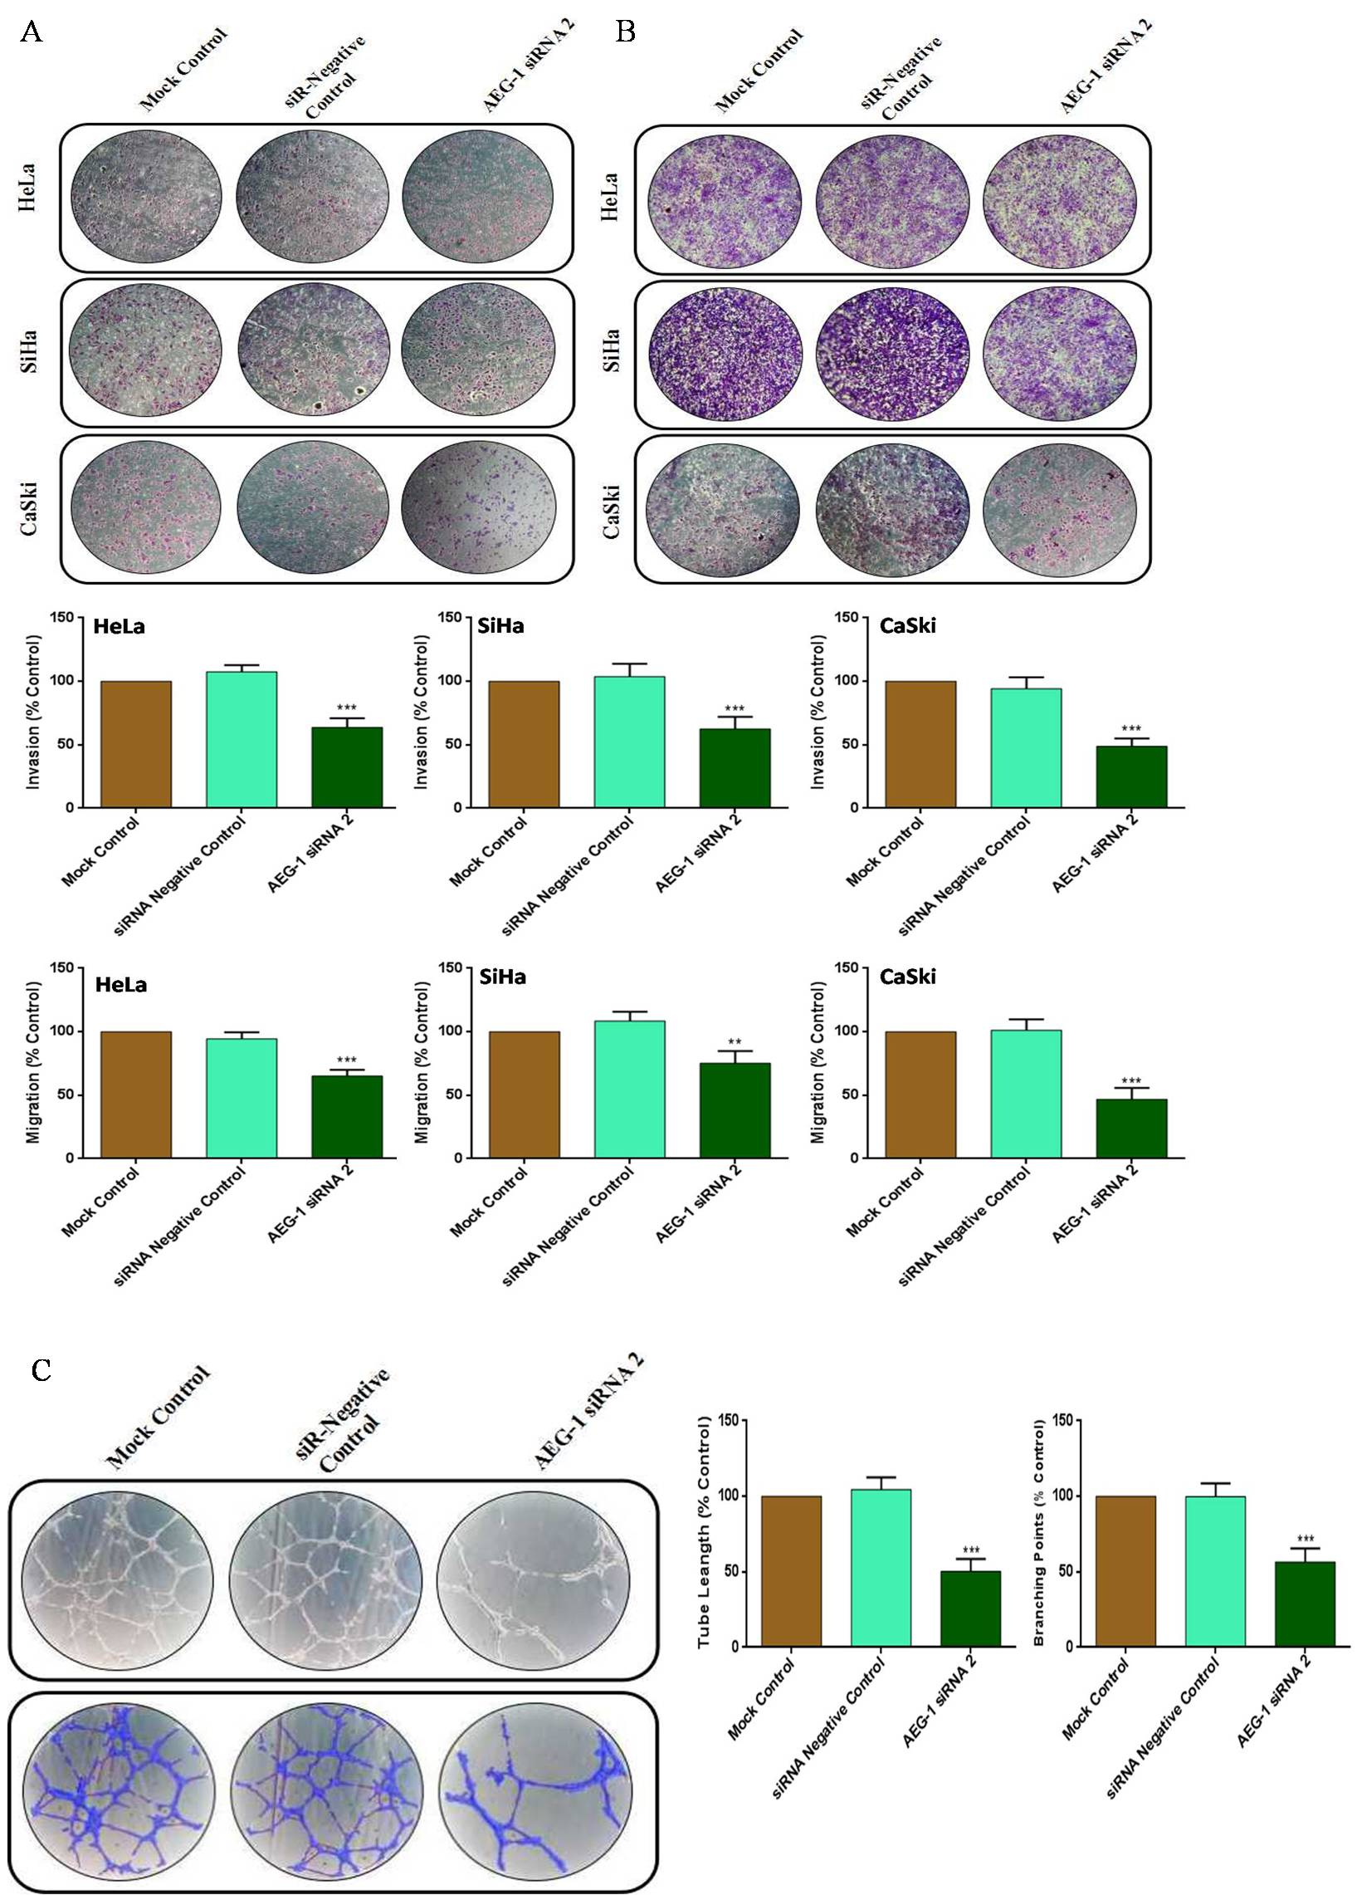
S. Fig 5. AEG-1 siRNA 2 suppressed the invasion, migration and angiogenesis of cervical cancer cells. Transwell invasion assay with Matrigel was performed in AEG-1 siRNA 2 and their controls transfected CC cells (A). Transwell migration assay without Matrigel was performed in AEG-1 siRNA 2 and their controls transfected CC cells (B). HUVECs were transfected with AEG-1 siRNA 2 and their controls and then cultured for 16 h incubation. The HUVECs capillary-like tubular structures were examined by branch points and total tube length (C). The scale bars represent 100 µm. The scale bars represent 100 µm. Error bars represent mean + s.d. and P-Values are represented as **P<0.05, ***P<0.001compared to the corresponding controls.

Supplementary Figure. 6
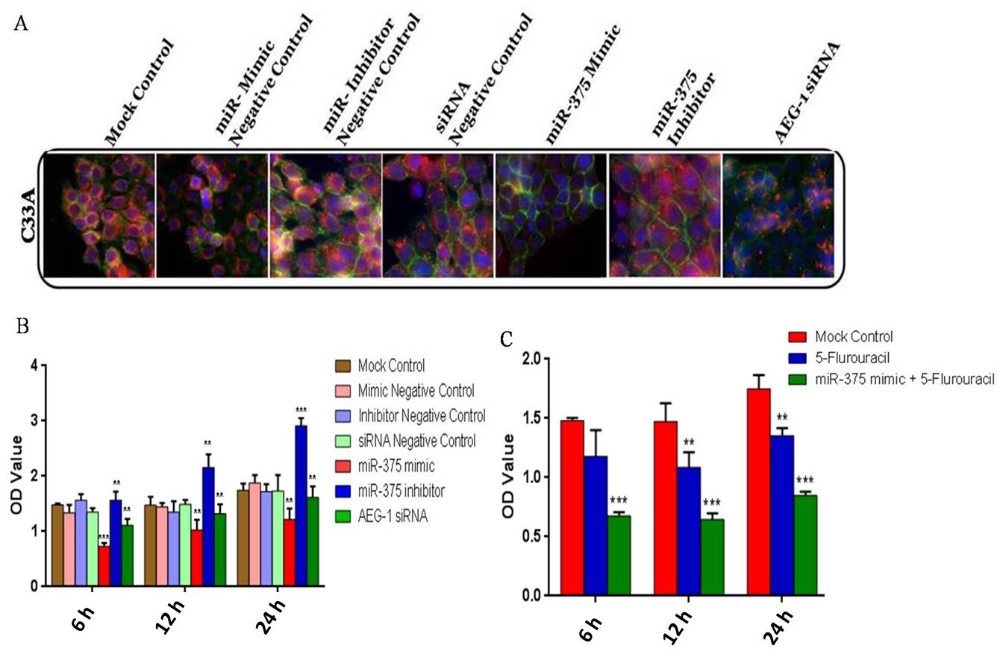
S. Fig 6. miR-375 inhibits cellular proliferation, enhance 5-Fluorouracil sensitivity and Immunocytochemistry in C33A. AEG-1 Protein expression was determined by Immunocytochemistry (A).Effect of miR-375 mimic on C33A cells proliferation of by MTT assay (B). C33A cells were transfected with a mock control, 5-Fluorouracil and then the miR-375 mimic transfected cells were treated with IC₅₀ Value of 5-Fluorouracil and incubated at different time intervals (6, 12 and 24 h) (C). The scale bars represent 100 µm. Error bars represent mean + s.d. and P-Values are represented as **P<0.05, ***P<0.001compared to the corresponding controls.

Supplementary Figure. 7
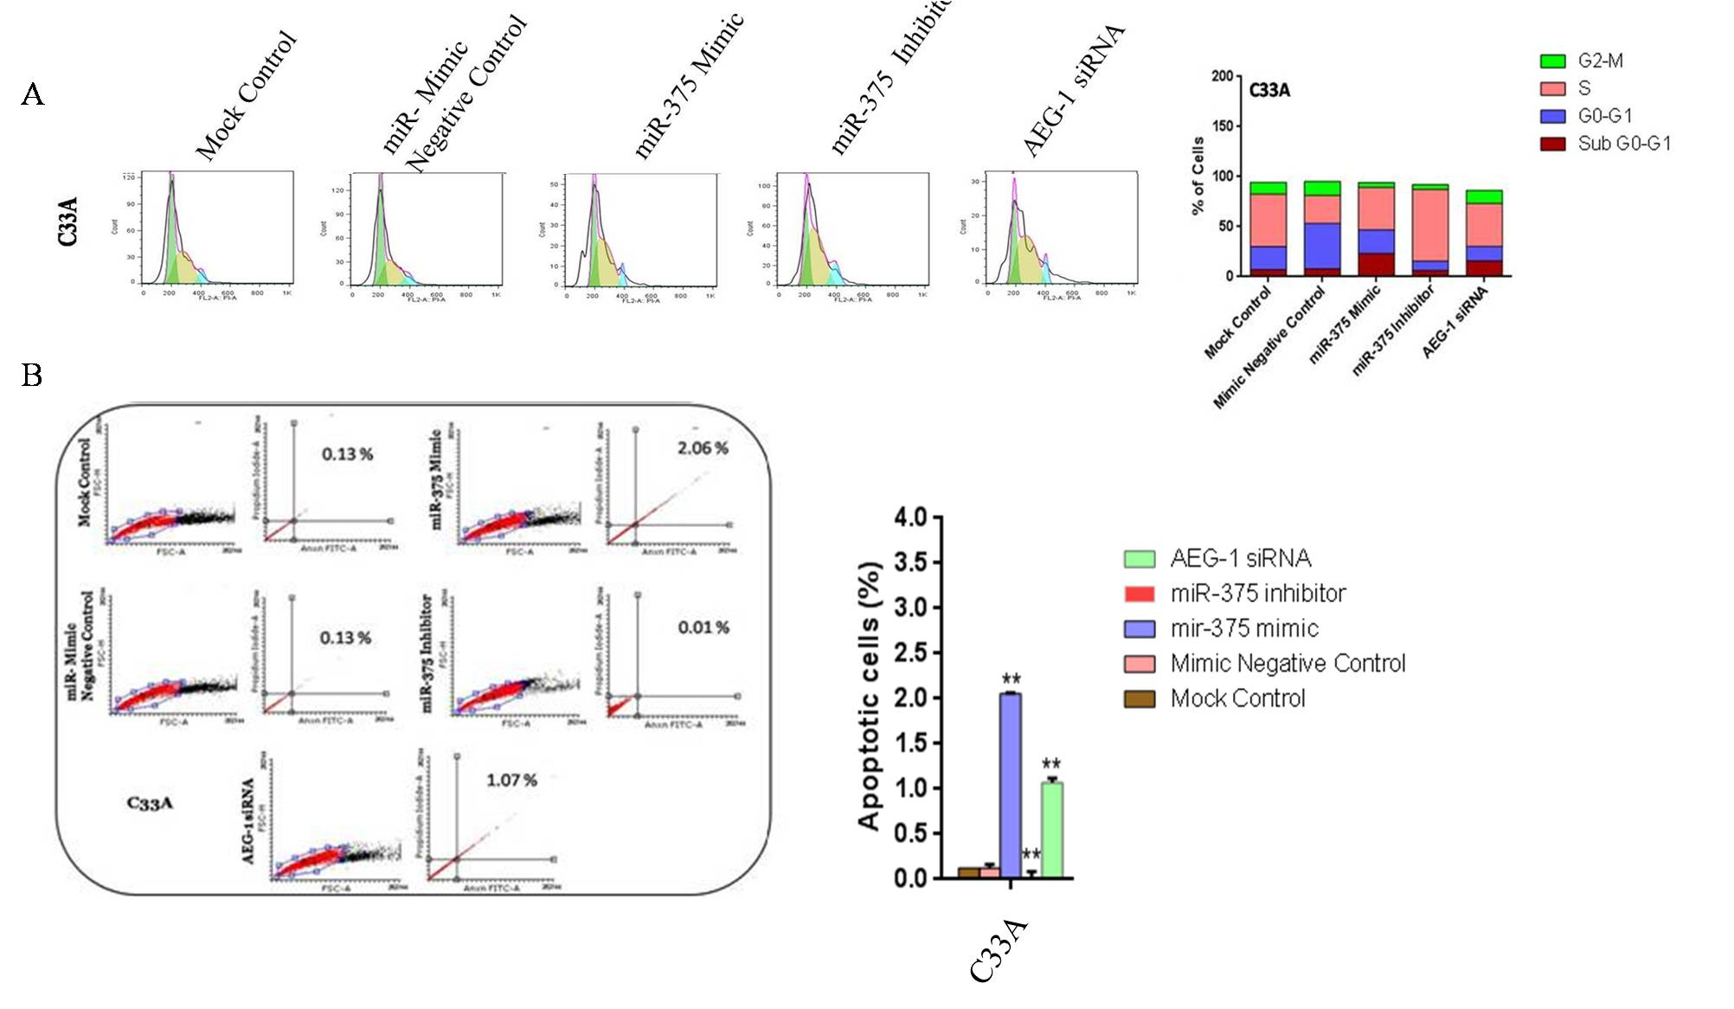
S. Fig7. miR-375 induces cell cycle arrest and apoptosis in vitro. C33A cells were transfected with miR-375 mimic, miR-375 Inhibitor,AEG-1 siRNA and their controls and 48h later, the effect of miR-375 on cell cycle was evaluated by the Flow cytometry (A). Apoptosis was assessed in cells transfected with miR-375 mimic, miR-375 Inhibitor, AEG-1 siRNA and their controls by Flow cytometry (B). Error bars represent mean + s.d. and P-Values are represented as **P<0.05 compared to the corresponding controls.

Supplementary Figure. 8
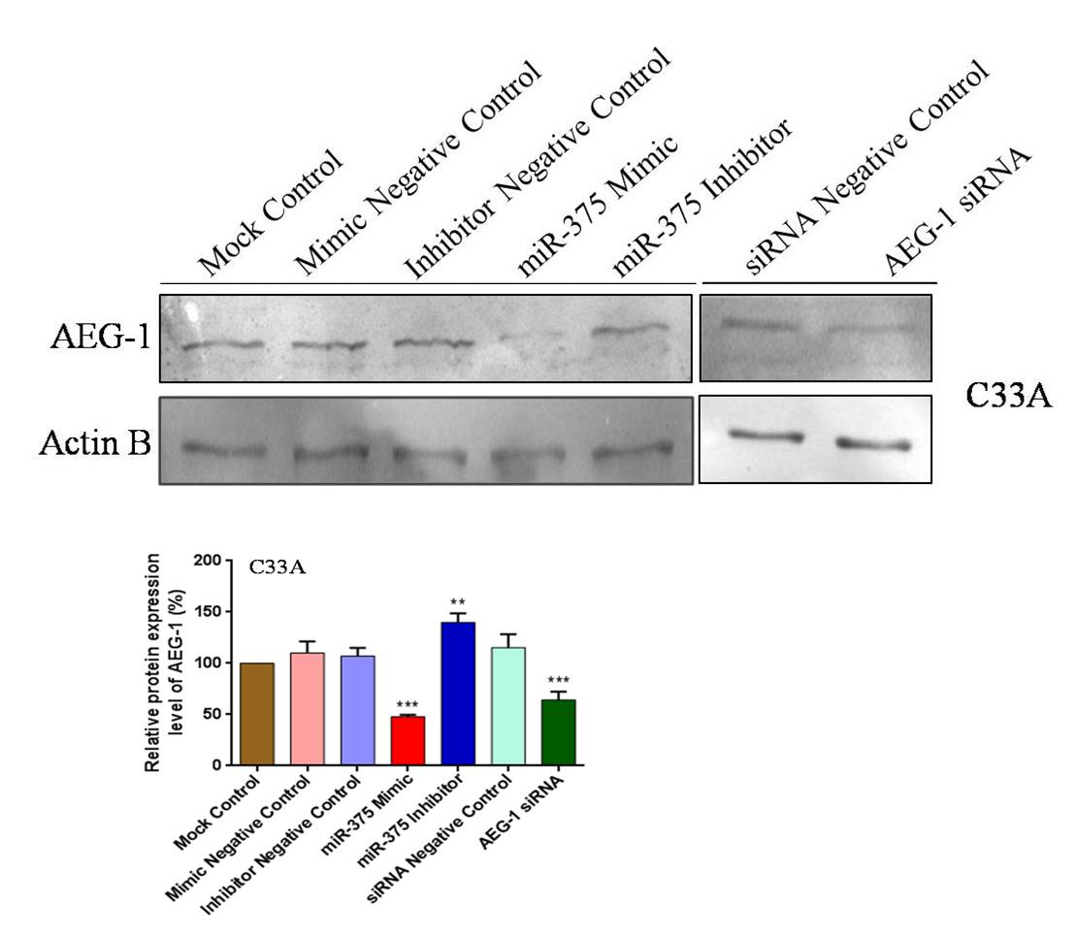
S. Fig 8. miR-375 suppresses AEG-1 protein level in C33A.Western blot validation of AEG-1 protein expression in C33A cells after transfecting miR-375 mimic, miR-375 Inhibitor, AEG-1 siRNA and their controls with β-actin as the loading control .Error bars represent mean + s.d. and P-Values are represented as **P<0.05, ***P< 0.001 compared to the corresponding controls.

Supplementry Fig . 9:
S. Fig 9. HPV 16 E6/E7 regulates miR-375 and AEG-1 expression in CaSki cell line: Effect of HPV16 E6/E7 siRNA on miR-375 expression (A) and AEG-1 expression (B). Error bars represent mean + s.d. and P-Values are represented as ***P<0.001, ****P<0.0001 compared to the corresponding controls.

Supplementary Table. 1:

miR-375 and U6 Reverse Transcription (RT) Primer
S.No | Gene | RT
1 | miR-375 | 5’-GTCGTATCCAGTGCAGGGTCCGAGGTATTCGCACTGGATACGACTCACGC-3’
2 | U6 | 5’-AACGCTTCACGAATTTGCGT-3’

Supplementary Table.2:
List of qRT-PCR Primers
S.No | Gene | Forward Primer | Reverse Primer | Length  (bp) | GC ( %) | Melting  Temperature  (⁰C)
1. | miR-375 | 5’-AGCCGTTTGTTCGTTCGGCT-3’ | 5’-GTGCAGGGTCCGAGGT-3’ | 86 | 59 | 78.29
2 | U6 | 5’-CTCGCTTCGGCAGCACA-3’ | 5’-AACGCTTCACGAATTTGCGT-3’ | 94 | 47 | 76.80
3 | AEG-1 | 5’-AAATAGCCAGCCTATCAAGACTC-3’ | 5’-TTCAGACTTGGTCTGTGAAGGAG-3’ | 178 | 43 | 73.68
4. | GAPDH | 5’-ATGGGGAAGGTGAAGGTCG-3’ | 5’-GGGTCATTGATGGCAACAATATC-3’ | 107 | 51 | 78.00
5 | HPV 16 E6 | 5’-GCAAAGACATCTGGACAAAAAG-3’ | 5’-ACCGACCCCTTATATTATGGAATC-3’ | 50 | 40 | 69.22
6. | HPV 16 E7 | 5’-GAACCGGACAGAGCCCATTA-3’ | 5’-ACACTTGCAACAAAAGGTTACA-3’ | 48 | 42 | 68.47
7. | HPV 18 E6 | 5’-GATCTGTGCACGGAACTGAACA-3’ | 5’-GGTTATTTCTATGTCTTGCAGTG-3’ | 48 | 44 | 70.41
8. | HPV 18 E7 | 5’-CAACGTCACACAATGTTGTGTA-3’ | 5’-TCAATTCTGGCTTCACACTTAC-3’ | 50 | 40 | 70.11

