Supplementary Material

Tal1_{NXtc01} in Xanthomonas translucens pv. cerealis Contributes to Virulence in Bacterial Leaf Streak of Wheat
Syed Mashab Ali Shah¹, Fazal Haq¹, Wenxiu Ma¹, Xiameng Xu¹, Sai Wang¹, Zhengyin Xu¹, Lifang Zou^{1,2}, Bo Zhu^{1,2} and Gongyou Chen^{1,2}*
¹School of Agriculture and Biology, Shanghai Jiao Tong University/Key Laboratory of Urban Agriculture by the Ministry of Agriculture of China, Shanghai, 200240, China
²State Key Laboratory of Microbial Metabolism, School of Life Science and Biotechnology, Shanghai Jiao Tong University, Shanghai, 200240, China
* Correspondence: Gongyou Chen
gyouchen@sjtu.edu.cn
Running title: Tal1_{NXtc01} contributes to virulence in X. translucens pv. cerealis

Supplementary Tables

Table S1. Bacterial strains and plasmids used in this study.
Strains and plasmids |  | Relevant characteristics | Source
Strains
Xanthomonas translucens pv. cerealis
NXtc01 | Wild-type, isolated from Triticum aestivum in Xinjiang province, China, 2016 |  | This study
Δtal1 | tal1 knockout mutant of NXtc01 |  | This study
Δtal2 | tal2 knockout mutant of NXtc01 |  | This study
TF | tal free mutant of NXtc01 |  | This study
PHZW-tal1 | Ap^{r} Sp^{r}, TF containing tal1 in trans |  | This study
PHZW-tal2 | Ap^{r} Sp^{r}, TF containing tal2 in trans |  | This study
ΔhrcC | hrcC knockout mutant of NXtc01 |  | This study
ΔhrcC/hrcC | Sp^{r}, ΔhrcC containing hrcC gene in trans |  | This study
Escherichia coli
DH5α | F⁻ endA1, thi-1, recA1, Φ80lacZ, ΔM15 |  | This lab
Plasmids
pKMS1 | Km^{r}, pUC18 polylinker, mob, oriV, sacB |  | (Zou et al., 2011)
pB | Ap^{r}, pBluescript II phagemid, pUC derivative |  | This lab
pHM1 | Sp^{r}, cosmid vector, cos, parA, IncW |  | (Hopkins et al., 1992)
pZW | Ap^{r}, pBluescript II with FLAG-tag N- (831-bp) and C- (363-bp) terminus of avrXa10. Lacks the SphI fragment containing the CRR; for expression of TAL effector genes |  | (Yang et al., 2000)
pB-tal1 | Ap^{r}, pB containing tal1 at BamHI site |  | This study
pB-tal2 | Ap^{r}, pB containing tal2 at BamHI site |  | This study
pKMSTal1 | Km^{r}, pKMS1 containing sequences at the 5’ and 3’ end of tal1; used for generating tal1 deletion mutant |  | This study
pKMSTal2 | Km^{r}, pKMS1 containing sequences at the 5’ and 3’ end of tal2; used for generating tal2 deletion mutant |  | This study
pKMShrcC | Km^{r}, pKMS1 containing sequences at the 5’ and 3’ end of hrcC; used for generating hrcC deletion |  | This study
pZW-tal1 | Ap^{r}, CRR of tal1 from SphI digested pB-tal1 were ligated into SphI-linearized, CIP-treated pZW vector |  | This study
pZW-tal2 | Ap^{r}, CRR of tal2 from SphI digested pB-tal2 were ligated into SphI-linearized, CIP-treated pZW vector |  | This study
pHZW-tal1 | Ap^{r} Sp^{r}, pZW with tal1 in pHM1 at HindIII site |  | This study
pHZW-tal2 | Ap^{r} Sp^{r}, pZW with tal2 in pHM1 at HindIII site |  | This study
pB-hrcC | Ap^{r}, pBluescript II, contains hrcC |  | This study
pH1-Flag(-) | Sp^{r}, pHM1 containing MCS with FLAG-tag bacteriophage λ T0 and E. coli rrnB T1 terminators |  | Yang Xiaofei, unpublished data
pH1-Flag(-)hrcC | Sp^{r}, pH1-Flag(-); contains hrcC at SalI/KpnI sites |  | This study
Note: Ap^{r}, ampicillin resistance; Km^{r}, kanamycin resistance; Sp^{r}, spectinomycin resistance.

Table S2. Primers used in this study.
Primers | Sequence 5’to 3’ | Description
T1Nt-F | AACTGCAGTGGATGGCTTGCCCGCTC | Amplifies 640-bp fragment upstream of tal1; used for deletion mutagenesis
T1Nt-R | GCTCTAGAGCCTGTGACCAACTGTAACG
T1Ct-F | GCTCTAGAGCAAGCATTTGATGAAGCG | Amplifies 425-bp fragment downstream of tal1; used for deletion mutagenesis
T1Ct-R | TCCCCCGGGGCGTTTTACACCCCAGCTACT
T2Ct-F | TCCCCCGGGAGGCAATAGCGTCATCA | Amplifies 698-bp fragment upstream of tal2; used for deletion mutagenesis
T2Ct-R | GCTCTAGACACAAGAACCCGTAACCT
T2Nt-F | GCTCTAGAATTATTGCTGACGATGGC | Amplifies 413-bp fragment downstream of tal2; used for deletion mutagenesis
T2Nt-R | AACTGCAGGGAGAAGATCAAACCGAAG
hrcC-up-F | TCCCCCGGGGTGGTCAGGCAGGTATCG | Amplifies 610-bp fragment upstream of hrcC; used for deletion mutagenesis
hrcC-up-R | CGCGGATCCCCAACGCCACTGTCAAA
hrcC-do-F | CGCGGATCCCGGGATTGTCCAAGGTG | Amplifies 694-bp fragment downstream of hrcC; used for deletion mutagenesis
hrcC-do-R | CTAGTCTAGAGGAAACTTCGCTGCCTC
M13-R | AGCGGATAACAATTTCACACAGG | Universal primers used for confirmation and sequencing
M13-F | CGCCAGGGTTTTCCCAGTCACGAC
hrcC-F1 | ACGCGTCGACATGAAACAGCAACGTTCGC | Amplifies 1217-bp fragment beginning at the start codon of hrcC; used for complementation in pH1-Flag(-)
hrcC-R1 | TCCAGATGGCGGTTGTG
hrcC-F2 | CGCACCGTTCAGATGGA | Amplifies 1260- bp fragment extending from the middle of hrcC and ending before stop codon; used for complementation in pH1-Flag(-)
hrcC-R2 | CGGGGTACCGGGCGAGACCACGTGG
TALN18S-F | AGAGGCGACACACGAAGACA | Amplifies 255-bp fragment, used to confirm of SphI-ligated tal gene orientation in pZW
TalN-R | CCGCCACTATTGCTGACGAT
Note: Underlined bases indicate restriction enzyme sites.

Table S3| Predicted type III effectors in X. translucens pv. cerealis NXtc01 based on comparison with other Xanthomonas spp. included X. translucens pv. cerealis CFBP 2541, X. translucens pv. undulosa ICMP11055, X. translucens pv. translucens DSM 18974T, X. campestris pv. campestris 8004, X. oryzae pv. oryzae PX099^{A} and X. oryzae pv. oryzicola BLS256.
T3Es | NXtc01ª | CFBP2541^{b} | ICMP11055^{c} | DSM18974T^{d} | 8004e | PXO99^{Af} | BLS256^{g}
AvrBs1 | ND | + | ND | ND | + | ND | ND
AvrBs2 | ++ | ++ | ++ | ++ | + | + | +
TALEs | 2 | 2 | 7 | 8 | ND | 19 | 28
AvrXccA1 | + | ND | ND | ND | + | ND | ND
XopAA | + | + | + | + | ND | + | +
XopAD | + | + | + | + | ND | + | +
XopAF1 | + | + | + | ++ | ND | ND | +
XopAH | ND | ND | + | + | + | + | +
XopAK | ND | ND | + | + | ND | ND | +
XopAM | + | + | + | + | + | ND | ND
XopAP | + | + | + | F | ND | ND | +
XopAZ | + | ND | ND | ND | + | + | +
T3Es | NXtc01ª | CFBP2541^{b} | ICMP11055^{c} | DSM18974T^{d} | 8004e | PXO99^{Af} | BLS256^{g}
XopB | + | + | + | + | ND | ND | ND
XopC2 | + | + | + | + | ND | + | +
XopE1 | + | + | + | ND | ND | ND | ND
XopE2 | + | + | ND | + | + | ND | ND
XopE3 | ND | ND | ND | + | ND | ND | ND
XopE5 | + | + | + | ND | ND | ND | ND
XopF | ++ | ++ | ++ | ++ | + | + | +
XopG | + | + | + | + | ND | + | ND
XopJ | + | ND | ND | + | + | ND | ND
XopK | + | + | + | + | + | + | +
XopL | ++++ | ++++ | ++ | ++ | + | + | +
XopN | + | + | + | + | + | + | +
XopP | +++ | +++ | ++ | +++ | + | + | ++
XopQ | + | + | + | + | + | + | +
T3Es | NXtc01ª | CFBP2541^{b} | ICMP11055^{c} | DSM18974T^{d} | 8004e | PXO99^{Af} | BLS256^{g}
XopR | F | F | + | + | + | + | +
XopV | + | + | + | + | ND | + | +
XopX | +++ | +++ | +++ | +++ | ++ | + | +
XopY | + | + | + | + | ND | + | +
XopZ | + | + | + | + | + | ++ | +
Abbreviations: The number of plus symbols indicates the copy number of T3Es in a given strain. ND, not detected; F, frameshift mutation.
ª This study
^{b} (Pesce et al., 2015)
^{c} (Falahi Charkhabi et al., 2017)
^{d} (Jaenicke et al., 2016)
^{e} (Qian et al., 2005)
^{f} (Salzberg et al., 2008)
^{g} (Bogdanove et al., 2011)
Table S4. COG functional classifications and colors for Figure 1.

Single letter  COG class | Functional description | Color in Figure 1
A | RNA processing and modification | Orange3
B | Chromatin structure | Black
C | Energy production/conversion | RoyalBlue4
D | Cell division/chromosome partitioning | AntiqueWhite1
E | Amino acid transport/metabolism | DodgerBlue1
F | Nucleotide transport/metabolism | SkyBlue3
G | Carbohydrate transport/metabolism | Blue1
H | Coenzyme transport/metabolism | LightBlue1
I | Lipid transport/metabolism | Cyan3
J | Translation/ribosomal structure | Gold1
K | Transcription | DarkOrange1
L | Replication/recombination/repair | DarkOrange3
M | Cell wall/membrane/envelope biogenesis | PeachPuff3
N | Cell motility | MediumPurple1
O | Chaperones | PaleGreen1
P | Inorganic ion metabolism | MediumPurple4
Q | Secondary metabolite  biosynthesis/transport/catabolism | Aquamarine4
R | General function prediction | Gray90
S | Function unknown | Gray70
T | Signal transduction | Tomato1
U | Intracellular trafficking/secretion | DeepPink
V | Defense mechanisms | Pink
W | Extracellular structures | Green
Y | Nuclear structure | Yellow
Z | Cytoskeleton | Red
None | No COG category | Gray50

Supplementary Figures

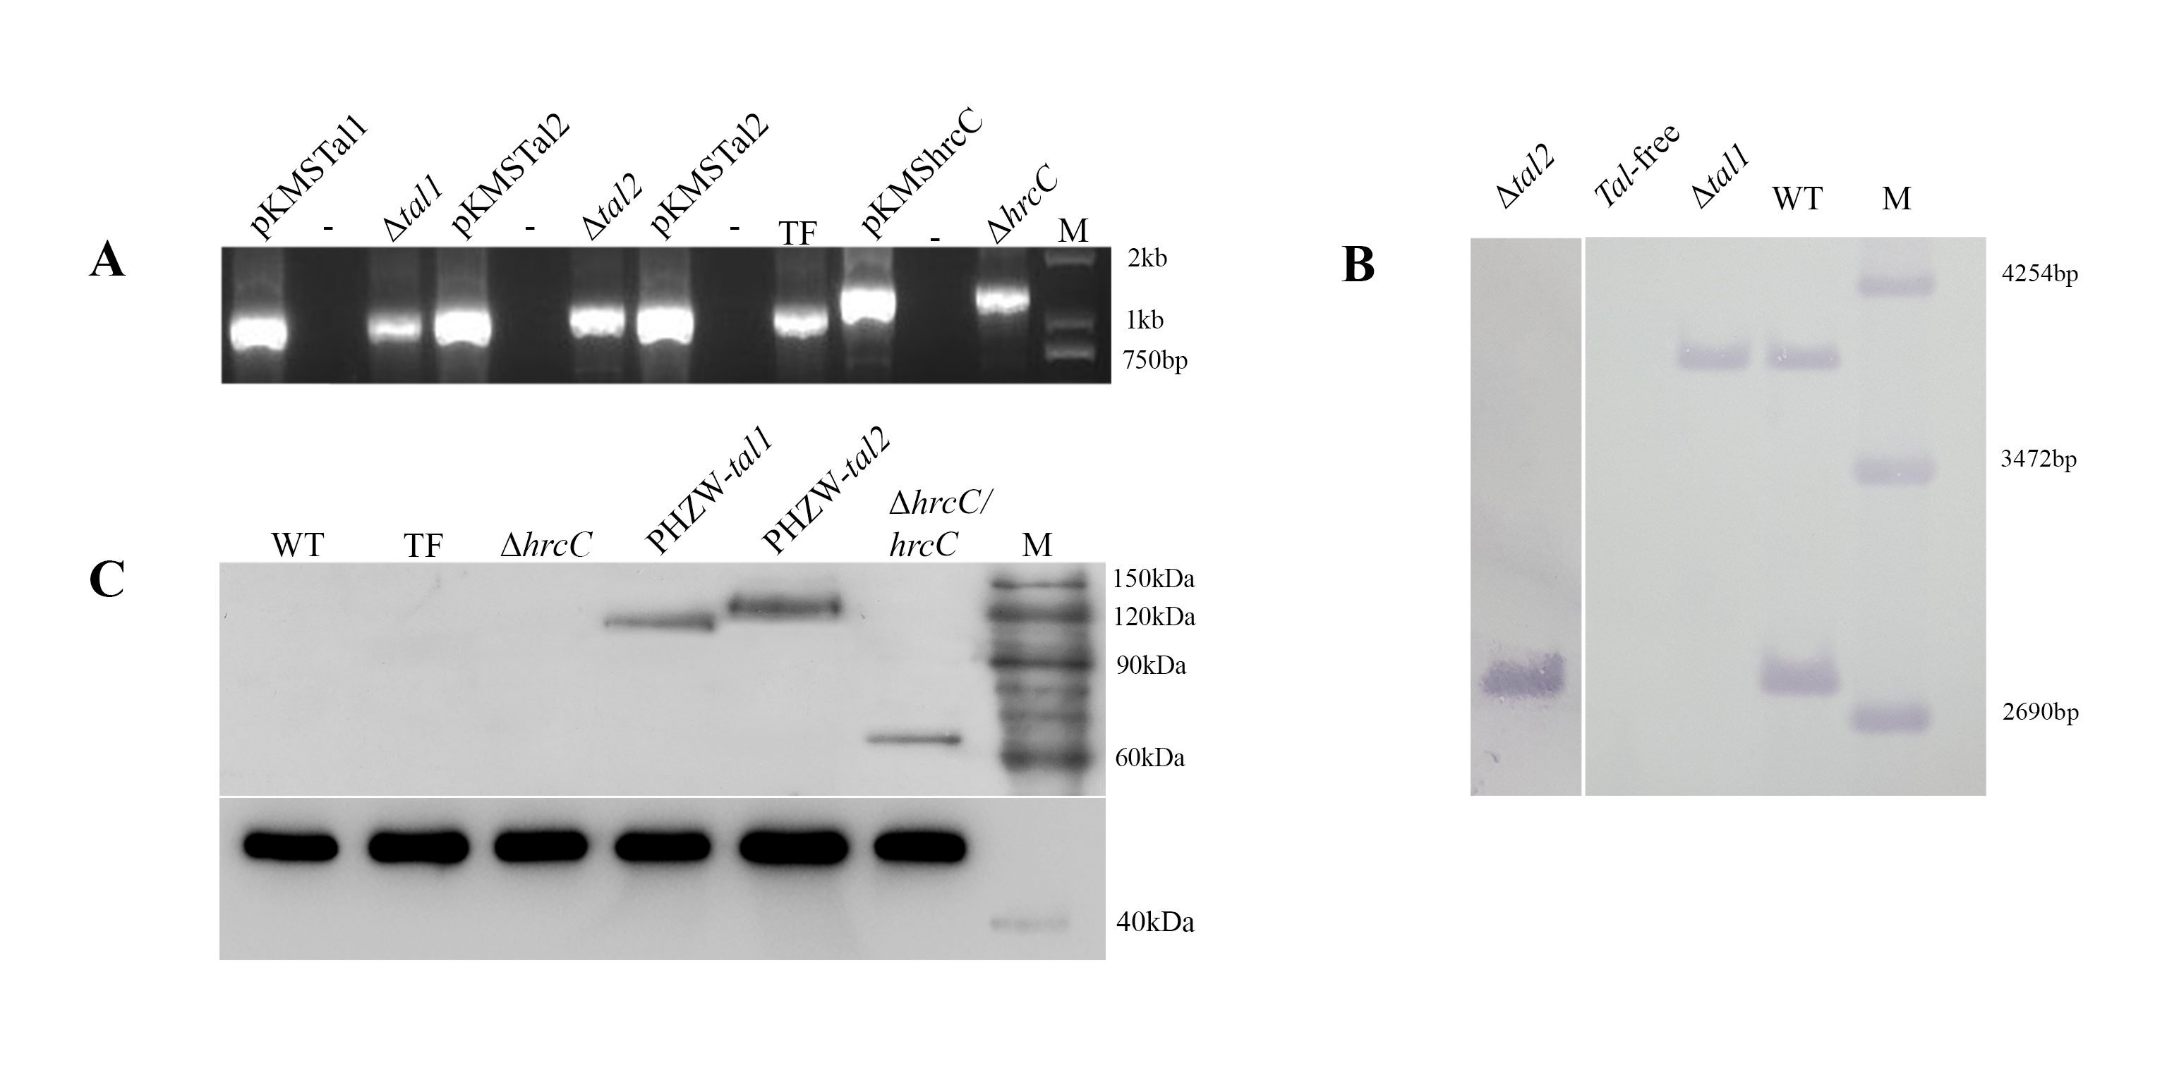
Figure S1. Knockout and complementation analysis of tal and hrcC genes in NXtc01. The tal1, tal2, tal-free and hrcC mutants were generated using suicide vector pKMS1. (A) Lanes show the constructs (pKMSTal1, pKMSTal2 and pKMShrcC) that were used as positive controls and mutants (Δtal1, Δtal2, TF and ΔhrcC) that were screened via PCR. Primers were as follows: T1Nt-F/T1Ct-R, amplifies a 1071-bp fragment; T2Ct-F/T2Nt-R, amplifies a 1124-bp fragment; and hrcC-up-F/hrcC-do-R, amplifies a 1317-bp fragment. (B) Southern blot of BamHI-digested genomic DNA of WT and mutants, probed with a DIG-labeled SphI fragment of the NXtc01 tal1 gene. (C) Immunodetection of flag-tagged Tal1 (104.8 kDa) and Tal2 (119.3 kDa) in the tal-free mutant, and flag-tagged HrcC (66.8 kDa) in the ΔhrcC mutant. WT, tal-free and the ΔhrcC mutant were included as controls. Flag-tagged proteins were detected by autoradiography. An anti-E. coli RNA polymerase α antibody was used as loading control shown in lower panel. Marker sizes are indicated on the right side of each panel.
Abbreviations: M, marker; positive control, construct used for homologous recombination; (-) negative control, PCR without template DNA; WT, wild-type Xtc NXtc01; Δtal1, NXtc01 tal1 deletion mutant; Δtal2, NXtc01 tal2 deletion mutant; TF, NXtc01 tal-free mutant; PHZW-tal1, NXtc01 TF with tal1 in trans; PHZW-tal2, NXtc01 TF with tal2 in trans; ΔhrcC, NXtc01 hrcC deletion mutant; and ΔhrcC/hrcC, NXtc01 ΔhrcC containing hrcC in trans.
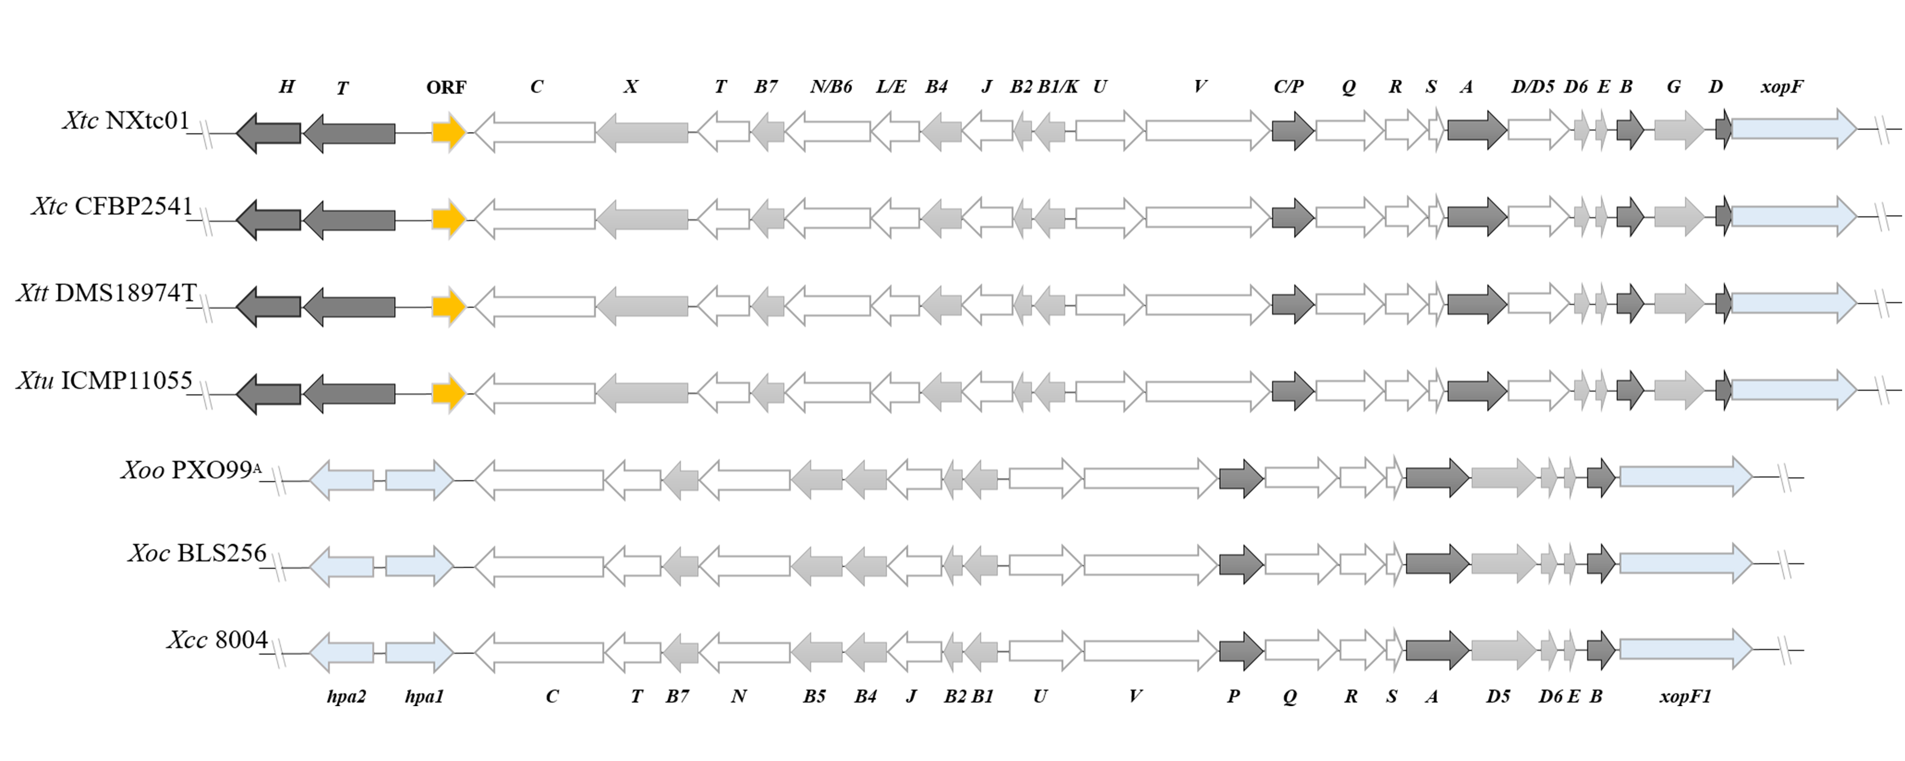
Figure S2. Comparison of the T3SS gene clusters in X. translucens pv. cerealis Nxtc01, X. translucens pv. cerealis CFBP 2541 (Pesce et al., 2015), X. translucens pv. undulosa ICMP11055 (Falahi Charkhabi et al., 2017), X. translucens pv. translucens DSM 18974T (Jaenicke et al., 2016), X. campestris pv. campestris 8004 (Qian et al., 2005), X. oryzae pv. oryzae PX099^{A} (Salzberg et al., 2008) and X. oryzae pv. oryzicola BLS256 (Bogdanove et al., 2011). The hrc, hrp, hpa, T3Es and hypothetical genes are represented by white, light gray, dark gray, light blue and gold arrows, respectively; arrowheads show the transcriptional orientation. Distance between operons are not drawn to scale.

REFERENCES
Bogdanove, A.J., Koebnik, R., Lu, H., Furutani, A., Angiuoli, S.V., Patil, P.B., et al. (2011). Two new complete genome sequences offer insight into host and tissue specificity of plant pathogenic Xanthomonas spp. Journal of bacteriology, JB. 05262-05211.
Falahi Charkhabi, N., Booher, N.J., Peng, Z., Wang, L., Rahimian, H., Shams-Bakhsh, M., et al. (2017). Complete genome sequencing and targeted mutagenesis reveal virulence contributions of Tal2 and Tal4b of Xanthomonas translucens pv. undulosa ICMP11055 in bacterial leaf streak of wheat. Frontiers in microbiology 8, 1488.
Hopkins, C.M., White, F., Choi, S., Guo, A., and Leach, J. (1992). Identification of a family of avirulence genes from Xanthomonas oryzae pv. oryzae. Mol Plant Microbe Interact 5(6), 451-459.
Jaenicke, S., Bunk, B., Wibberg, D., Spröer, C., Hersemann, L., Blom, J., et al. (2016). Complete genome sequence of the barley pathogen Xanthomonas translucens pv. translucens DSM 18974T (ATCC 19319T). Genome announcements 4(6), e01334-01316.
Pesce, C., Bolot, S., Cunnac, S., Portier, P., Fischer-Le Saux, M., Jacques, M.-A., et al. (2015). High-quality draft genome sequence of the Xanthomonas translucens pv. cerealis pathotype strain CFBP 2541. Genome announcements 3(1), e01574-01514.
Qian, W., Jia, Y., Ren, S.-X., He, Y.-Q., Feng, J.-X., Lu, L.-F., et al. (2005). Comparative and functional genomic analyses of the pathogenicity of phytopathogen Xanthomonas campestris pv. campestris. Genome research 15(6), 757-767.
Salzberg, S.L., Sommer, D.D., Schatz, M.C., Phillippy, A.M., Rabinowicz, P.D., Tsuge, S., et al. (2008). Genome sequence and rapid evolution of the rice pathogen Xanthomonas oryzae pv. oryzae PXO99A. BMC genomics 9(1), 204.
Yang, B., Zhu, W., Johnson, L.B., and White, F.F. (2000). The virulence factor AvrXa7 of Xanthomonas oryzae pv. oryzae is a type III secretion pathway-dependent nuclear-localized double-stranded DNA-binding protein. Proceedings of the National Academy of Sciences 97(17), 9807-9812.
Zou, L.-F., Li, Y.-R., and Chen, G.-Y. (2011). A non-marker mutagenesis strategy to generate poly-hrp gene mutants in the rice pathogen Xanthomonas oryzae pv. oryzicola. Agricultural Sciences in China 10(8), 1139-1150.

