PINK1/Parkin-mediated mitophagy regulation by reactive oxygen species alleviates Rocaglamide A-induced apoptosis in pancreatic cancer cells
Chunle Zhao ^{1, *} , Ruizhi He ^{1,*} , Ming Shen ^{1,*} , Feng Zhu ¹, Min Wang ¹, Yuhui Liu ¹, Hua Chen ¹, Xu Li^{1,#}, Renyi Qin^{1,#}
¹Laboratory of Biliary-Pancreatic Surgery, Department of Biliary-Pancreatic Surgery, Affiliated Tongji Hospital, Tongji Medical College, Huazhong University of Science and Technology, Wuhan, Hubei, China
*These authors equally contributed to this research
#Corresponding author: Xu Li(2013tj0574@hust.edu.cn); Renyi Qin(ryqin@tjh.tjmu.edu.cn)
Supplementary Figure 1. Roc-A inhibits growth of other gastrointestinal tumor cells growth in vitro.
Cell viability was measured by CCK-8. Data are presented as mean ± SD from three independent experiments. HK-2 (human renal tubular epithelial cell); LO2 (human live cell); TFK-1 (human cholangiocarcinoma cell); HepG2 (human hepatoma carcinoma cell); HCT-116 (human colon cancer cell).
Supplementary Figure 2. Roc-A induces cell apoptosis is not involved in ferroptosis and pyroptosis.
Western blot analyzed the levels GPX4 and Caspase-1. Cells were treated with Roc-A at the indicated concentration for 24 hours, and extracted the supernatant for western blot.
Supplementary Figure 3. Roc-A promotes mitophagy is not involved in BNIP3L and FUNDC1 in PC cells.
Western blot analyzed the protein level of BNIP3L and FUNDC1.
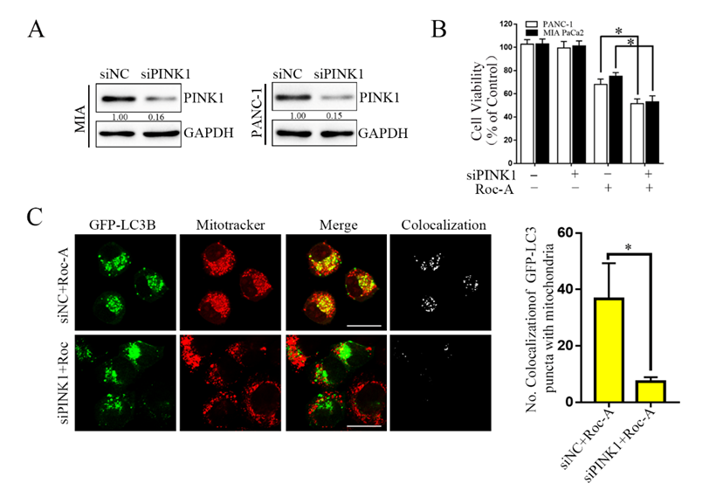
Supplementary Figure 4. Silenced PINK1 can also reduce Roc-A-induced cell viability and mitophagy.
Western blotting analyzed the protein level of PINK1 after cells were transfected with siRNA against PINK1. B. CCK-8 assay measured cell viability after cells were transfected with siRNA against PINK1 in the absence or presence with Roc-A (50 nM). Data are presented as mean ± SD from three independent experiments. The asterisks indicate a statistically significant effect of treatment. *, p <. 05. C. PANC-1 transfected with GFP-LC3B were incubated with or without Roc-A (50 nM) for 24 hours and stained with MitoTracker Red. Confocal microscope was used to observe and photograph images.
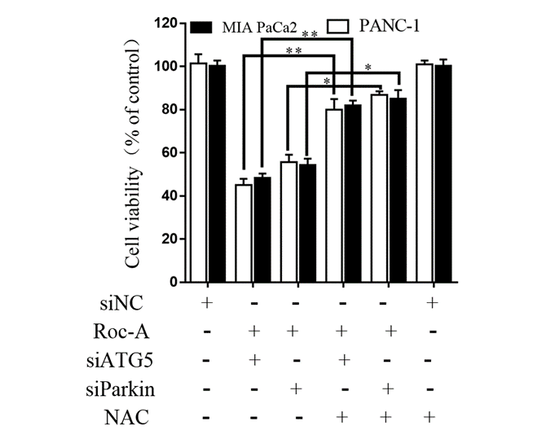
Supplementary Figure 5. NAC can decrease Roc-A together with siATG5 and siParkin induced cell death.
CCK-8 assay measured cell viability after cells were treated with Roc-A(50nM) together with siATG5 and siParkin or NAC (5 mM) for 24 hours. Data are presented as mean ± SD from three independent experiments. The asterisks indicate a statistically significant effect of treatment. *, p <. 05; **, p <. 01.

