Movie S1. An example of the blinking behavior of a female great-tailed grackle during a head-unrestrained trial with the treatment (wind) and control (noise). The female blinked 72 times per minute (12 blinks in each eye during the 10 second clip) and 36 times per minute (6 blinks in each eye during the 10 second clip), respectively, during the treatment and control.

Table S1. The effect of treatment, time period, type, and their interaction as well as sex, order, temperature, and humidity on blink rate, blink duration, and percentage of time spent blinking. F values are displayed for the overall model and t values are displayed for the comparisons; p-values are indicated in parentheses and statistically significant comparisons are indicated with an asterisk.
 | Numerator DF, Denominator DF | Blink Rate (blinks/min) | Blink Duration (s) | Time Blinking (%)
Overall model
Treatment | 1, 22 | 85.54 (<0.0001)* | 29.27 (<0.0001)* | 155.26 (<0.0001)*
Time Period | 2, 22 | 84.87 (<0.0001)* | 9.03 (0.0014)* | 118.44 (<0.0001)*
Type | 1, 22 | 0.71 (0.41) | 1.73 (0.20) | 0.48 (0.49)
Treatment*Time Period*Type | 7, 22 | 20.46 (<0.0001)* | 16.01 (<0.0001)* | 42.96 (<0.0001)*
Sex | 1, 22 | 1.13 (0.30) | 0.34 (0.57) | 0.14 (0.71)
Order | 1, 22 | 62.17 (<0.0001)* | 0.04 (0.84) | 2.18 (0.15)
Temperature | 1, 22 | 0.33 (0.57) | 0.22 (0.64) | 1.90 (0.18)
Relative humidity | 1, 22 | 10.54 (0.0037)* | 7.27 (0.013)* | 61.24 (<0.0001)*
Comparisons
Head-restrained
Wind before vs. Control before | 1, 22 | 1.01 (0.32) | 0.32 (0.75) | 1.47 (0.16)
Wind during vs. Control during | 1, 22 | 11.44 (<0.0001)* | 7.40 (<0.0001)* | 14.60 (<0.0001)*
Wind after vs. Control after | 1, 22 | 0.35 (0.73) | 2.20 (0.039) | 1.22 (0.24)
Head-unrestrained
Wind before vs. Control before | 1, 22 | 1.47 (0.16) | 0.67 (0.51) | 1.31 (0.20)
Wing during vs. Control during | 1, 22 | 12.58 (<0.0001)* | 5.50 (<0.0001)* | 13.45 (<0.0001)*
Wind after vs. Control after | 1, 22 | 2.94 (0.0075)* | 1.20 (0.24) | 4.92 (<0.0001)*
Wind
Before: Head restrained vs. Head unrestrained | 1, 22 | 0.46 (0.65) | 2.40 (0.026) | 0.34 (0.74)
During: Head restrained vs. Head unrestrained | 1, 22 | 0.40 (0.69) | 1.90 (0.071) | 1.49 (0.15)
After: Head restrained vs. Head unrestrained | 1, 22 | 1.13 (0.27) | 2.08 (0.049) | 1.47 (0.16)
Control
Before: Head restrained vs. Head unrestrained | 1, 22 | 0.10 (0.92) | 2.75 (0.012)* | 0.61 (0.55)
During: Head restrained vs. Head unrestrained | 1, 22 | 2.81 (0.010)* | 1.91 (0.070) | 0.70 (0.49)
After: Head restrained vs. Head unrestrained | 1, 22 | 0.77 (0.45) | 2.79 (0.011)* | 1.53 (0.14)

Figure S1. Experimental set-up for a head-unrestrained trial with a female great-tailed grackle.
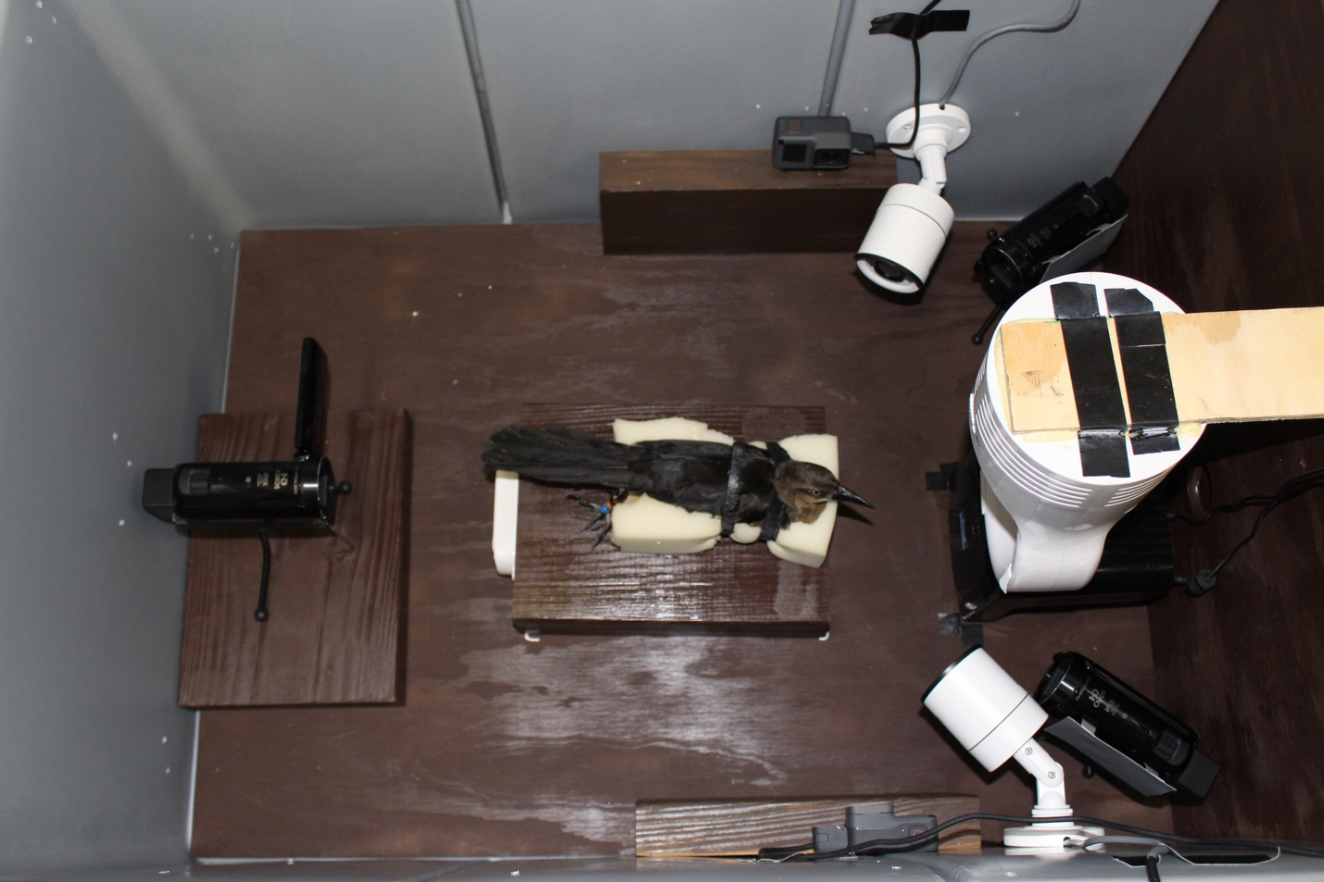

Figure S2. The left eye of a female great-tailed grackle when she is not blinking (A) and when she is blinking (B).
A.  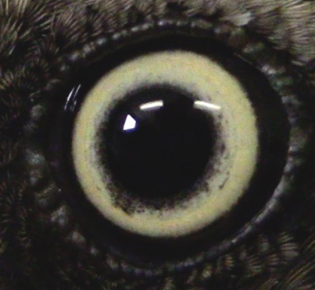 | B.  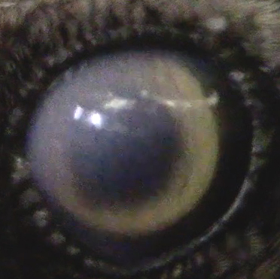

Figure S3. Blink rate before, during, and after the control or wind treatment (n=25). Means ± standard errors are displayed. Horizontal lines indicate statistically significant comparisons.

Figure S4. Duration of blinks before, during, and after the control or wind treatment (n=25). Means ± standard errors are displayed. Horizontal lines indicate statistically significant comparisons.

Figure S5. Percentage of time spent blinking before, during, and after the control or wind treatment (n=25). Means ± standard errors are displayed. Horizontal lines indicate statistically significant comparisons.

