Table S1: Genbank number of eight segments of A/Guangdong/1057/2010 (GD1057).
Sequence | Genbank number
PB2 | MN244305
PB1 | MN244306
PA | MN244307
HA | MN244309
NP | MN244308
NA | MN244310
M | MN244311
NS1 | MN244312

Table S2: Primers for RT-PCR.
Primers | Sequence
CU | AGCAAAAGCAGG
HA-BSAI-F | TATTGGTCTCAGGGAGCAAAAGCAGGGG
HA-BSAI-R | ATATGGTCTCGTATTAGTAGAAACAAGGGTGTTTT
NA-BSMBI-F | TATTCGTCTCAGGGAGCAAAAGCAGGAGTAA
NA-BSMBI-R | ATATCGTCTCGTATTAGTAGAAACAAGGAGTTTTT
NP-AarI-F | ATCACCTGCTGGCGGGAGCAAAAGCAGGGTA
NP-AarI-R | TATCACCTGCGCCGTATTAGTAGAAACAAGGGTATTTT
M-BSMBI-F | TATTCGTCTCAGGGAGCAAAAGCAGGTAGATATTG
M-BSMBI-R | ATATCGTCTCGTATTAGTAGAAACAAGGTAGTTTTTAC
NS-BSMBI-F | TATTCGTCTCAGGGAGCAAAAGCAGGGTG
NS-BSMBI-R | ATATCGTCTCGTATTAGTAGAAACAAGGGTGTTTT
PA-AarI-F | ATCACCTGCTGGCGGGAGCGAAAGCAGGTAC
PA-AarI-R | TATCACCTGCGCCGTATTAGTAGAAACAAGGTACT
PB1-AarI-F | ATCACCTGCTGGCGGGAGCGAAAGCAGGCA
PB1-AarI-R | TATCACCTGCGCCGTATTAGTAGAAACAAGGCATTT
PB2-BbsI-F | TATTGAAGACTAGGGAGCGAAAGCAGGTC
PB2-BbsI-R | ATATGAAGACTGTATTAGTAGAAACAAGGTCGTTT
pHW2000-F | CTAGAGAACCCACTGCTTAC
pHW2000-R | TTGGGGACAGGTGTCCGTGT
pJET 1.2F | CGACTCACTATAGGGAGAGCGGC
pJET 1.2R | AAGAACATCGATTTTCCATGGCAG

Table S3: Primers for mutation.
Primers | Sequence
H1N1-PA-X-61aa-F | TTAGAGCCTATGTGGATGGATTCGAGC
H1N1-PA-X-61aa-R | CCACATAGGCTCTAAAGTTTTCAAGGCT
H1N1-PB1-F2-F A153C | CCATGGACACAGTCAACAGAACACACC
H1N1-PB1-F2-R A153C | TGACTGTGTCCATGGTGTATCCTGTTCC
H1N1-PB1-F2-F A291G | CAGACTGTGTTCTGGAGGCTATGGC
H1N1-PB1-F2-R A291G | CCAGAACACAGTCTGTTTGTGCATA
H1N1-PB1-F2-F A381G | CAAACAAGGGTGGATAAACTAACTC
H1N1-PB1-F2-R A381G | AGTTTATCCACCCTTGTTTGTTGAA

Table S4: Primers for Q-PCR.
Primers | Sequence
GAPDH-F | TGGCCTTCCGTGTTCCTAC
GAPDH-R | GAGTTGCTGTTGAAGTCGCA
NLRP3-F | ATTACCCGCCCGAGAAAGG
NLRP3-R | TCGCAGCAAAGATCCACACAG
Caspase-1-F | ACAAGGCACGGGACCTATG
Caspase-1-R | TCCCAGTCAGTCCTGGAAATG
IL-1β-F | GCAACTGTTCCTGAACTCAACT
IL-1β-R | ATCTTTTGGGGTCCGTCAACT
IL-6-F | TAGTCCTTCCTACCCCAATTTCC
IL-6-R | TTGGTCCTTAGCCACTCCTTC
IL-18-F | GACTCTTGCGTCAACTTCAAGG
IL-18-R | CAGGCTGTCTTTTGTCAACGA
TNF-α-F | CCTGTAGCCCACGTCGTAG
TNF-α-R | GGGAGTAGACAAGGTACAACCC

Table S5: Log₁₀(TCID₅₀mL⁻¹) of stock viruses before inoculating in MDCK and PK-15.
Pdm09_PAX_41/F2_11 | Pdm09_PAX_61/F2_11 | Pdm09_PAX_41/F2_90 | Pdm09_PAX_61/F2_90
8.5 | 8.39 | 8.61 | 7.71
8.32 | 8.34 | 8.69 | 7.52
8.61 | 8.44 | 8.5 | 7.9

Table S6: Log₁₀(TCID₅₀mL⁻¹) of stock viruses before inoculating in mice.
Pdm09_PAX_41/F2_11 | Pdm09_PAX_61/F2_11 | Pdm09_PAX_41/F2_90 | Pdm09_PAX_61/F2_90
8.2 | 8.75 | 8.5 | 8.33
8.2 | 8.58 | 8.43 | 8.24
8.2 | 8.86 | 8.6 | 8.39

dpi | Pdm09_PAX_41/F2_11 | Pdm09_PAX_61/F2_11 | Pdm09_PAX_41/F2_90 | Pdm09_PAX_61/F2_90
12hpi | 5.64 | 5.6 | 5.64 | 7.36
 | 5.84 | 5.47 | 5.16 | 6.88
 | 5.5 | 5.33 | 5.25 | 7.16
24hpi | 8 | 9.5 | 9 | 10
 | 8.33 | 9.5 | 9 | 10.33
 | 8.25 | 9.45 | 9.25 | 10
36hpi | 9 | 11.33 | 9.5 | 8.67
 | 9.5 | 11 | 10 | 9
 | 9.33 | 11.25 | 9.67 | 8.88
48hpi | 10.67 | 8.67 | 11.5 | 8.23
 | 10.16 | 8.63 | 12 | 8.25
 | 10.25 | 8.25 | 11.68 | 8.25
Table S7: Log₁₀(TCID₅₀mL⁻¹) in MDCK cells.

Table S8: Log₁₀(TCID₅₀mL⁻¹) in PK-15 cells.
hpi | Pdm09_PAX_41/F2_11 | Pdm09_PAX_61/F2_11 | Pdm09_PAX_41/F2_90 | Pdm09_PAX_61/F2_90
12hpi | 5.69 | 5.16 | 5.31 | 8.16
 | 5.5 | 5 | 5.31 | 7.88
 | 5.45 | 5.25 | 5.25 | 8
24hpi | 9 | 7.25 | 8.16 | 10
 | 8.83 | 7 | 8 | 9.23
 | 8.71 | 7.5 | 8.36 | 9.5
36hpi | 8.39 | 8.23 | 5.63 | 7.67
 | 8.23 | 7.83 | 5.83 | 8.67
 | 8.17 | 8.16 | 5.75 | 8
48hpi | 7 | 5 | 4.75 | 6.23
 | 5.83 | 4.67 | 5 | 7
 | 6.25 | 4.75 | 5.15 | 5.45

Table S9: Log₁₀(TCID₅₀mL⁻¹) in lungs of infected mice.
dpi | Pdm09_PAX_41/F2_11 | Pdm09_PAX_61/F2_11 | Pdm09_PAX_41/F2_90 | Pdm09_PAX_61/F2_90
1dpi | 3.75 | 4.55 | 3.6 | 5.5
 | 4.5 | 4.5 | 4.5 | 5
 | 4 | 4.75 | 4.25 | 5.25
3dpi | 5 | 3.75 | 4.5 | 5.25
 | 4.75 | 4.75 | 5.16 | 5.36
 | 5 | 4.5 | 4.75 | 4.75
5dpi | 5.16 | 4.6 | 5.84 | 4.16
 | 5 | 4.75 | 5.31 | 4
 | 5.25 | 4.75 | 5.45 | 4.36

Figure S1: PA-X detected by western blotting with specific antibody.
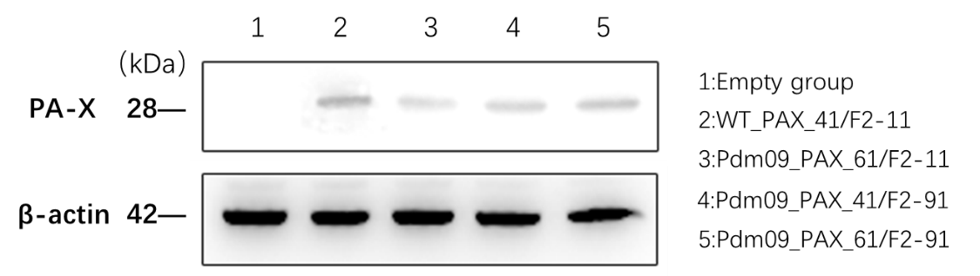

Figure S2: The mean fluorescent intensity was calculated using FlowJo (TreeStar) software.

