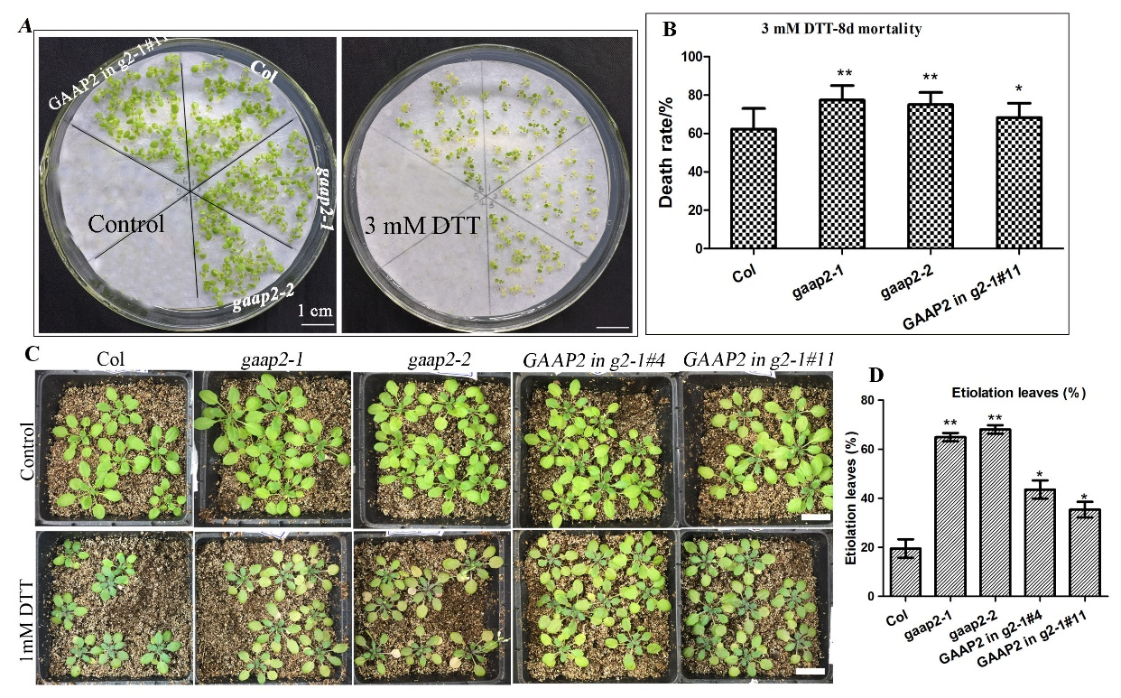
Supplementary Fig.S1 GAAP2 enhanced the resistance of plants to ER stress under treatment with DTT. (A-B) Col, gaap2-1, gaap2-2, and GAAP2 in gaap2-1 seedlings were grown on 1/2 MS medium for 3 d and then transferred to a medium with 0–3 mM DTT for another 8 d (A) and the death rates of seedlings treated with DTT (B). Error bars depict a standard error of approximately 3–4 independent experiments. Significant differences compared with Col plants, as indicated by asterisks (χ² test, *p<0.05, ** P < 0.01, n>80). (C-D) Growth (C) and leaf etiolation rates (D) of 15-day-old Col, gaap2-1, gaap2-2, gaap2gaap3, GAAP2 in gaap2-1 #4 and #11, which were treated with 1 mmol L⁻¹ DTT and recovered for 21 d. Bar = 2 cm, n = 9~16, mean ± SD, * P < 0.05, ** P < 0.01, χ² test.

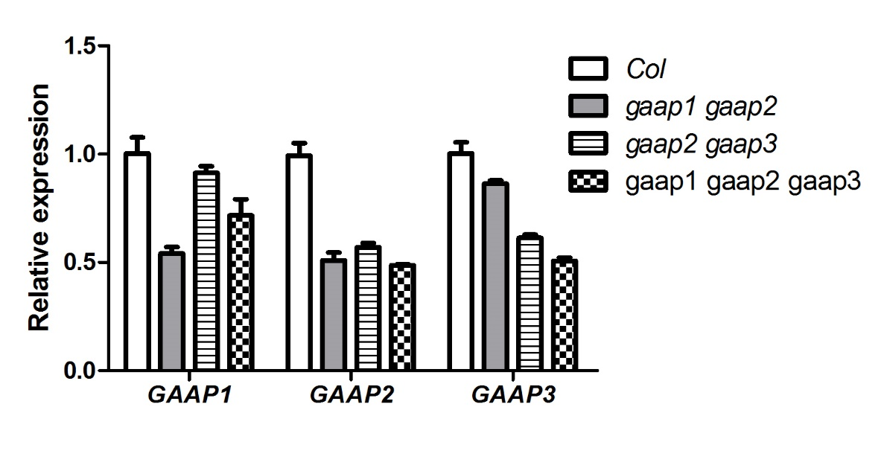
Supplementary Fig.S2 The expression level of GAAP1, GAAP2 and GAAP3 in the 7-d old seedlings of gaap1gaap2, gaap2gaap3 and gaap1gaap2gaap3 assayed by qRT-PCR.

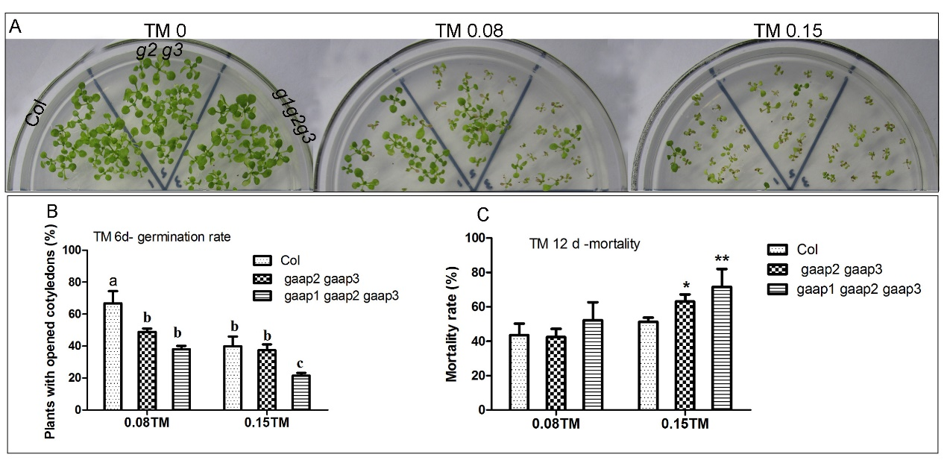
Supplementary Fig.S3 The double and triple mutations in GAAP1, GAAP2 and GAAP3 enhanced plant sensitivity toward ER stress. (A) Growth of Col, gaap2gaap3, and gaap1gaap2gaap3 seedlings on 1/2 MS medium supplied with different concentrations ( 0, 0.08 and 0.15 μg mL⁻¹ ) of TM for 12 days. (B) The percentage of seedlings with opened cotyledons which grew on 1/2MS medium with different concentrations of TM for 6 days. Error bars represent the standard error and different letters indicate significant differences between different plants subjected to χ test. (C) The percentage of death plants which grew on 1/2MS medium with different concentrations of TM for 12 days. Error bars depict standard error of 4 independent experiments. Significant differences compared with Col plants, as indicated by asterisks (χ² test, *p<0.05, ** P < 0.01, n = 150).

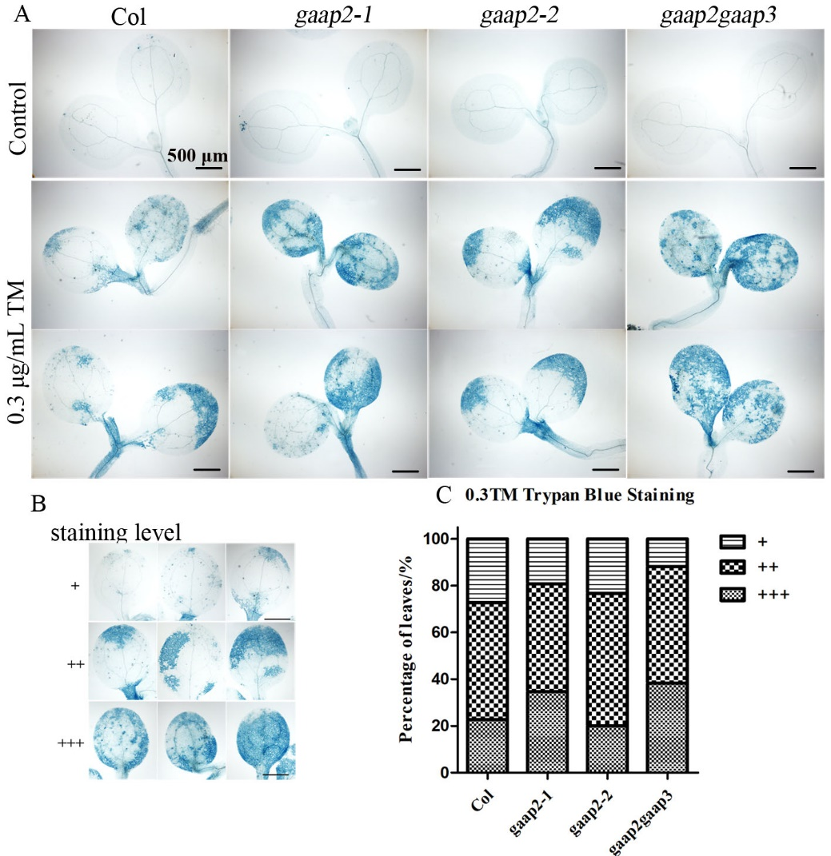
Supplementary Fig.S4 GAAP2 and GAAP3 inhibited the cell death induced by ER stress. (A) The 3-day-old seedlings that were vertically cultured were incubated in 0.3 μg mL⁻¹ TM for 48 h. Cotyledon cells of Col, gaap2-1, gaap2-2 and gaap2gaap3 were stained by trypan-blue. Bar = 500 μm. (B-C) The cell death severity was analyzed by quantifying the staining degree. Trypan blue staining intensity was classified in 3 levels, namely, faint, medium, and strong, and depicted as “+” “++” and “+++” respectively (B), and the percentage of each group was calculated (C). (n≧20).

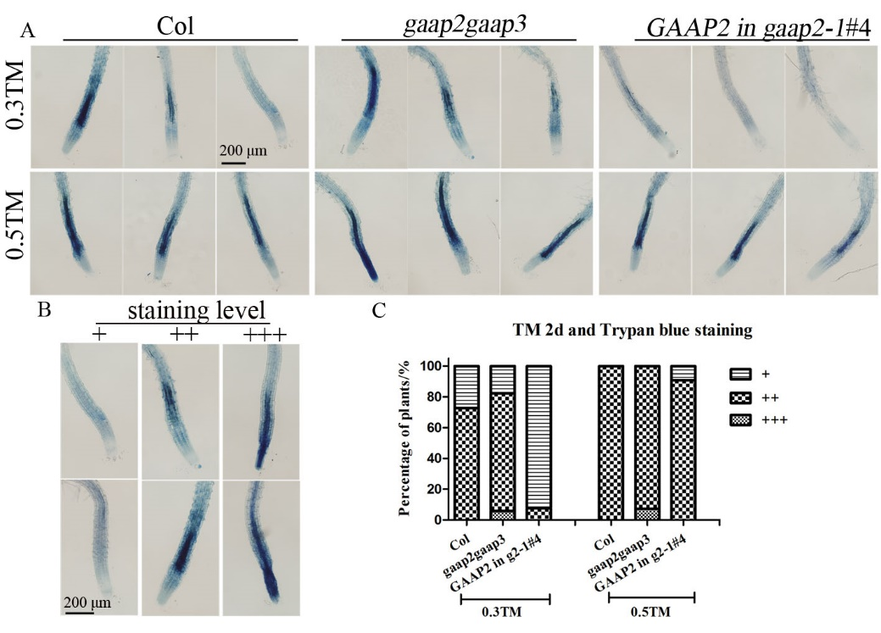
Supplementary Fig.S5 GAAP2 and/ or GAAP3 inhibited the cell death induced by ER stress. (A) The 3-day-old seedlings that were vertically cultured were incubated in liquid medium containing different concentrations of TM for 48 h. Root cells of Col, gaap2gaap3 and GAAP2 in gaap2-1 #4 were stained by trypan-blue. (B-C) The cell death severity was analyzed by quantifying the staining degree. Trypan blue staining intensity was classified in 3 levels, namely, faint, medium, and strong, and depicted as “+”, “++” and “+++”, respectively (B), and the percentage of each group was calculated (C) (n≧20).
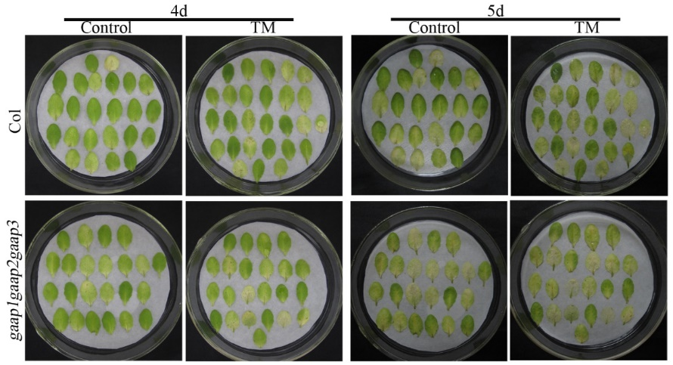
Supplementary Fig.S6 The PCD induced by starvation was enhanced in gaap1gaap2gaap3 mutant. The leaves were taken from 30– day old of Col and gaap1gaap2gaap3 which were grew in soil and put on the wet filter paper containing 0 and 0.15μg mL⁻¹ TM under dark for 4 d and 5d.

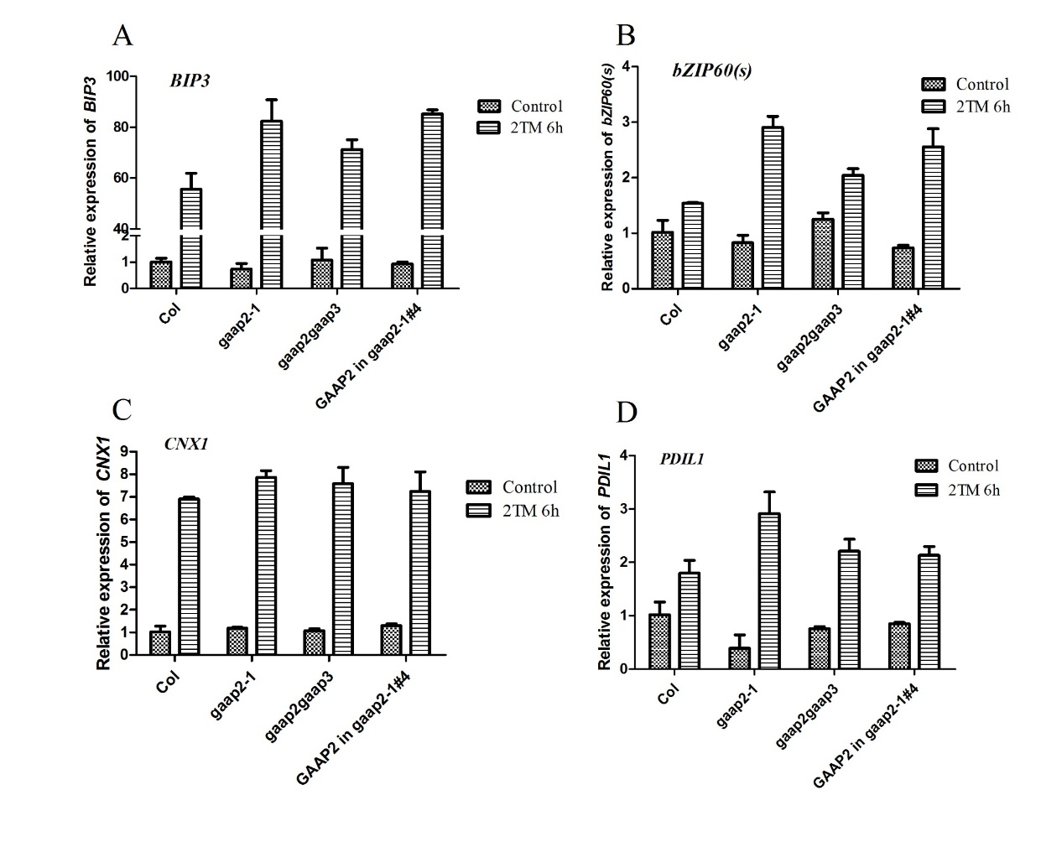
Supplementary Fig.S7 GAAP2 mutation or overexpressing had little effect on the induction of UPR genes upon acute ER stress. Total RNA was isolated from 7 days–old seedlings of Col, gaap1-1 and 35S::GAAP1-OX#4 were treated with 2.0 μg mL⁻¹ Tunicamycin or 0.1% DMSO (control) for 6 h. The transcript levels of selected ER marker genes were quantified by qRT–PCR. Gene expression was normalized to ACTIN8 and the value of each control of WT (Col) was set at 1. Data are from 3 to 3 biological replicates (±SD). No statistically significance between different plant lines according to Tukey’s range (honestly significant difference) test and two-way analysis of variance (p< 0.05).

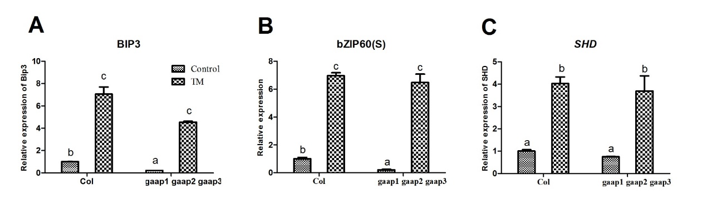
Supplementary Fig.S8 GAAP1 to GAAP3 mutations had little effect on the induction of UPR genes upon acute ER stress. Total RNA was isolated from 7 days–old seedlings of Col, gaap1-1 and 35S::GAAP1-OX#4 were treated with 5.0 μg mL⁻¹ Tunicamycin or 0.1% DMSO (control) for 6 h. The transcript levels of selected ER marker genes were quantified by qRT–PCR. Gene expression was normalized to ACTIN8 and the value of each control of WT (Col) was set at 1. Data are from 3 to 3 biological replicates (±SD). Statistically significance was analyzed according to Tukey’s range (honestly significant difference) test and two-way analysis of variance (p< 0.05).

Supplementary Table S1. Primers used.
gene/mutant/constructs name | T-DNA lines/AGI number | Purpose | Primer name | Primer sequences (5' to 3')
gaap2-1 | CS814747 | Genotyping | LP | TGATCGGTACGGTACTCCTTG
 |  |  | RP | CTGGCAGAGATCTTTTCAACG
gaap2-2 | SALK_052507C | Genotyping | LP1 | GGAGGGACCTTCACAAAGAAG
 |  |  | RP1 | AATCTGTGATTTTGACCGCTG
GAAP2 | AT3G63310 | RT-PCR | AT3G63310 F2 | agatccAAGATGTGGAATCAGAAGCATGA
 |  |  | AT3G63310 R2 | gaattcTCTGAAAGAGACAAGACTGCCTAA
PGAAP2::GUS | AT3G63310 | GUS assay | AT3G63310 PF1 | AT3G63310 PF1
 |  |  | AT3G63310 PR1 | AT3G63310 PR1
PGAAP2::GAAP2 | AT3G63310 | Full gene driven by its own promoter in mutant | AT3G63310 PF1 | AT3G63310 PF1
 |  |  | AT3G63310 R1 | AT3G63310 R1
PR2 | AT3G57260 | qRT-PCR | PR2 qFW | AAGGAGCTTAGCCTCACCAC
 |  |  | PR2 qRV | CACAACGTCCGATGGACTTG
PR1 | AT2G14610 | qPCR for PR-1 | PR1 qFW | CCTGGGGTAGCGGTGACTT
 |  |  | PR1 qRV | CGTGTTCGCAGCGTAGTTGT
NAC089 | AT5G22290 | qRT-PCR | NAC089 qPCRF1 | ACTGGGAAAGAGCGTGATGT
 |  |  | NAC089 qPCRR1 | TGGTGCCTTCTGACTTGTAC
NAC094 | AT5G39820 | qRT-PCR | NAC094 qPCR F1 | TCCAACGATTCCTGACAACA
 |  |  | NAC094 qPCR R1 | TCGTTGACTGGAGAAGGAAT
ATPase | AT5G40010 | qRT-PCR | ATPaseqPCRF1 | GACTAATACGGGCTCTGCTC
 |  |  | ATPaseqPCRR1 | CATAGACATCGCTTCGCTTG
AtNRP1 | AT2G03440 | qRT-PCR | qRT-AtNRP1 F | CAAACGCCAGCTTTTCGGAT TG
 |  |  | qRT-AtNRP1 R | TGAGCACGCTCTTCTTGCTTT CA
ANAC036 | AT2G17040 | qRT-PCR | qRT-ANAC036 F | TCCTCTTTCGTCTTCCGAGA
 |  |  | qRT-ANAC036 R | TGCATTTGGATCTTGTTTGC
GAMMA-VPE | AT4G32940 | qRT-PCR | qRT-VPEg F | TGCTGGGCAACCTCTAGTC
 |  |  | qRT- VPEg R | GTACTGAGACAGCGATCCA
BiP3 | At1g09080 | qRT-PCR | BiP3 F1 | CGAAACGTCTGATTGGAAGAA
 |  |  | BiP3 R1 | GGCTTCCCATCTTTGTTCAC
ACT8 | AT1G49240 | qRT-PCR | Act8 F1 | TCAGCACTTTCCAGCAGATG
 |  | qRT-PCR | Act8 R1 | ATGCCTGGACCTGCTTCAT
bZIP60 | AT1G42990 | qRT-PCR | bZIP60 F4 | GAAGGAGACGATGATGCTGTGGCT
 |  | qRT-PCR | bZIP60U B1 | GCAGGGATTCCAACAAGAGCACAG
 |  | qRT-PCR | bZIP60S B2 | AGCAGGGAACCCAACAGCAGACT
PDIL1 | At1g21750 | qRT-PCR | qPDIL1F | CTCGTGAAGCTGAGGGTATTG
 |  | qRT-PCR | qPDIL1R | TGTGCGAAATCTAACTCAGAG
SHD | AT4G24190 | qRT-PCR | qSHD F | GAAGGAAGCATTCAAGGAGCTA
 |  | qRT-PCR | qSHD R | TCTTTGATGATAGGGTGTCGTG
HSP70 | AT4G16660 | qRT-PCR | qHSP70 F | GGACTTGGAGGACAGAGTATGG
 |  | qRT-PCR | qHSP70 R | GGGTAATTGTGCTCCTGAAGTC
CNX1 | At5g61790 | qRT-PCR | CNX1 qFW | TTCTTCTCGCTCTTCCTCAAGC
 |  | qRT-PCR | CNX1 qRV | GCGGTTTCTTCCTTCTTCTCC

