**Supplemental information**

**Efficient transfer hydrogenation of nitro compounds to amines enabled by mesoporous N-stabilized Co-Zn/C**



**Fig. S1** TG curve of fresh Co-Zn/N-C-800

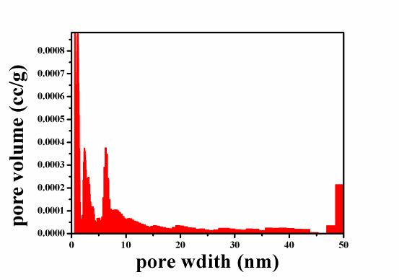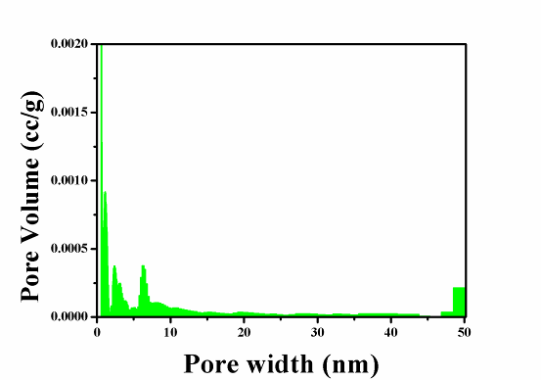

**Fig. S2** Pore distribution of Co-Zn/N-C-800 (red) and Co/N-C-800 (green)



**Fig. S3** The high resolution XPS of C 1s of reused Co-Zn/N-C-800, Co/N-C-800, and fresh Co-Zn/N-C-800.

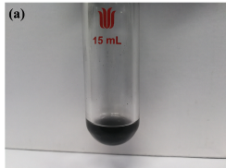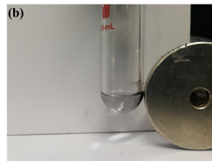

**Fig. S4** The image of magnetism presentation of Co-Zn/N-C-800

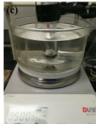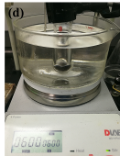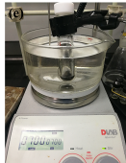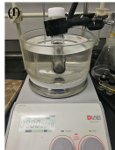

**Fig. S5** The Images of reaction systems with different stirring speeds: 500 rpm (c), 600 rpm (d), 700 rpm (e), 800 rpm (f).

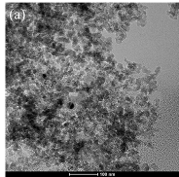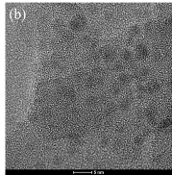

**Fig S6.** The high resolution TEM images of reused Co-Zn/N-C-800.

**GC-MS spectra of different products**

