SUPPLEMENTARY FIGURE

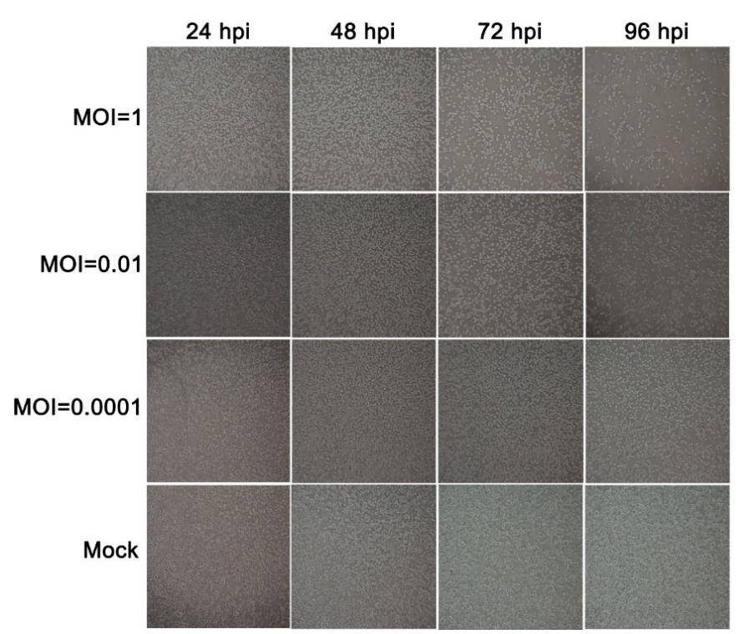
Supplementary Figure 1: Replication of TANAV isolate YN15_103_01 in C6/36 mosquito cells. Phase contrast photomicrographs of infected cells at 24-96 h p.i. (MOI=1, 0.01, 0.0001) and mock-infected (Objective lens×10).

